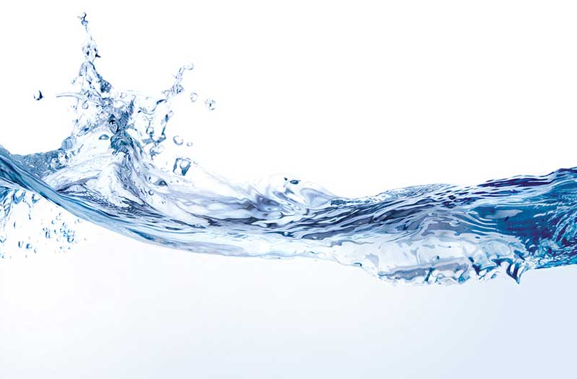
Edwards Air Force Base
California

2019 Water Quality Report

2019 Monitoring Results for Edwards AFB – AFRL (Public Water System ID: 1510702)
Prepared By: 412th Test Wing – Bioenvironmental Engineering Flight
Treatment Process

Our water is treated with chlorine, a disinfectant which kills dangerous bacteria and other microorganisms that may be in the water. The 412th Civil Engineering Squadron monitors the disinfectant levels on a daily basis.
Este informe contiene información muy importante sobre su agua potable. Tradúzcalo o hable con alguien que lo entienda bien.

Annual Consumer Report

We feel it is important that our consumers know about where our water comes from, what it contains, and how it compares to requirements set by regulatory agencies. This report is a snapshot of last year's water quality.

Last year, our tap water met or exceeded all U.S. Environmental Protection Agency (USEPA) and state drinking water health requirements. See page 6 for detailed information regarding lead sample results and education.

Through regular monitoring, any contaminates found were verified to be within regulatory standards. The detected amounts and the associated standards, are included in the tables published within this report.
Where Does Our Water
Come From?

The AFRL Drinking Water System draws water from one source - groundwater. In 2019, groundwater was supplied from wells located within the Edwards Air Force Base and AFRL boundary. These wells are fed by the Antelope Valley Aquifer and recharged through normal rainfall and groundwater flow.

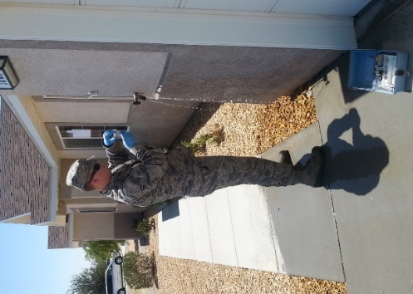
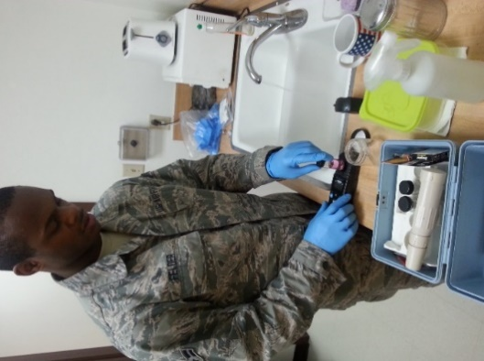
Source Water Assessment

The 412th Civil Engineering (CE) Squadron completed our Source Water Assessment on 18 June 2003 and it is on file in the CE Water & Gas office (661-277-5000). This assessment looks at possible contamination sources that may affect the base water supply. Possible contaminating activities for the wells surveyed in this assessment include nearby abandoned wells, storm drainage discharge, above ground water storage tanks, and nearby roads. The health risks from these activities are diminished through weekly monitoring of the potable water system.

EAFB is aware that many buildings at AFRL use bottled water. EAFB is not responsible for sampling or for reporting on bottled water. Water quality reports for your bottled water may be obtained by contacting your building’s bottled water vendor.

Pictured above: Technicians from the 412th Operational Medical Readiness Squadron, Bioenvironmental Engineering Flight conducting routine water testing at locations spanning the water distribution system. Water samples are collected, tested by a certified laboratory, and results are submitted to the State Water Resources Control Board to demonstrate compliance with all requirements and regulations.

Consumption Note for Susceptible Individuals

Some people may be more vulnerable to contaminants in drinking water than the general population. Immuno-compromised persons such as persons with cancer undergoing chemotherapy, persons who have undergone organ transplants, people with HIV/AIDS or other immune system disorders, some elderly, and infants can be particularly at risk from infections. These people should seek advice about drinking water from their health care providers. USEPA/Centers for Disease Control (CDC) guidelines on appropriate means to lessen the risk of infection by Cryptosporidium and other microbial contaminants are available from the Safe Drinking Water Hotline (1-800-426-4791).
What Is In Drinking Water?

Drinking water, including bottled water, may reasonably be expected to contain at least small amounts of some contaminants. The presence of contaminants does not necessarily indicate that the water poses a health risk. More information about contaminants and potential health effects can be obtained by calling the Environmental Protection Agency's (EPA) Safe Drinking Water Hotline (1-800-426-4791).

The sources of drinking water (both tap water and bottled water) include rivers, lakes, streams, ponds, reservoirs, springs, and wells. As water travels over the surface of the land or through the ground, it dissolves naturally-occurring minerals and, in some cases, radioactive material, and can pick up substances resulting from the presence of animals or from human activity.

Contaminants that may be present in source water include:

• Microbial contaminants, such as viruses and bacteria, that may come from sewage treatment plants, septic systems, agricultural livestock operations, and wildlife.
• Inorganic contaminants, such as salts and metals, that can be naturally-occurring or result from urban stormwater runoff, industrial or domestic wastewater discharges, oil and gas production, mining, or farming.
• Pesticides and herbicides, that may come from a variety of sources such as agriculture, urban stormwater runoff, and residential uses.
• Organic chemical contaminants, including synthetic and volatile organic chemicals, that are byproducts of industrial processes and petroleum production, and can also come from gas stations, urban stormwater runoff, agricultural application, and septic systems.
• Radioactive contaminants, that can be naturally-occurring or be the result of oil and gas production and mining activities.

In order to ensure that tap water is safe to drink, the U.S. Environmental Protection Agency (USEPA) and the State Water Resources Control Board (State Board) prescribe regulations that limit the amount of certain contaminants in water provided by public water systems. The State Board regulations also establish limits for contaminants in bottled water that provide the same protection for public health.

Water Quality Data Table

All sources of drinking water contain some naturally occurring contaminants. At low levels, these substances are generally not harmful in our drinking water. Removing all contaminants would be extremely expensive, and in most cases, would not provide increased protection of public health. Additionally, some naturally occurring minerals provide benefits by improving the taste of drinking water and providing nutritional value at low levels.

In order to ensure that tap water is safe to drink, the USEPA prescribes regulations which limit the amount of contaminants in water provided by public water systems. The tables on the following pages list all of the drinking water contaminants that were detected during the 2018 calendar year of this report. Many more contaminants were tested than listed on the following table; only those substances listed below were detected in our water. The State does not require annual sampling of some contaminants because the concentrations of these contaminants do not change frequently. As such, some of our data is more than one year old but is still representative and the most recent result.

The USEPA and state allow us to monitor for some contaminants less than once per year because the concentrations of these contaminants do not change frequently, or because the system is not considered vulnerable to this type of contamination. As such, some of our data, though representative, is more than one year old.

In these tables you may find terms and abbreviations that might not be familiar to you. To help you better understand these terms, we have provided the definitions below.

Important Terms Used
Term | Definition
AL | Action Level: The concentration of a contaminant which, if exceeded, triggers treatment or other requirements which a water system must follow.
MCL | Maximum Contaminant Level: The highest level of a contaminant that is allowed in drinking water. Primary MCLs are set as close to the PHGs (or MCLGs) as is economically and technologically feasible. Secondary MCLs are set to protect the odor, taste, and appearance of drinking water.
MCLG | Maximum Contaminant Level Goal: The level of a contaminant in drinking water below which there is no known or expected risk to health. MCLGs are set by the U.S. Environmental Protection Agency.
MFL | MFL: million fibers per liter, used to measure asbestos concentration
mg/L | Mg/L: Milligrams per Liter
MRDL | Maximum residual disinfectant level. The highest level of a disinfectant allowed in drinking water. There is convincing evidence that addition of a disinfectant is necessary for control of microbial contaminants.
MRDLG | Maximum residual disinfection level goal. The level of a drinking water disinfectant below which there is no known or expected risk to health. MRDLGs do not reflect the benefits of the use of disinfectants to control microbial contaminants.
N/A | Not Applicable
ND | Not Detected
pCi/L | pCi/L: picocuries per liter (a measure of radioactivity)
PDWS | Primary Drinking Water Standards: MCLs and MRDLs for contaminants that affect health along with their monitoring and reporting requirements, and water treatment requirements.
PHG | Public Health Goal: The level of a contaminant in drinking water below which there is no known or expected risk to health. PHGs are set by the California Environmental Protection Agency.
ppb | ppb: parts per billion, or micrograms per liter (µg/L)
ppm | ppm: parts per million, or milligrams per liter (mg/L)
SDWS | Secondary Drinking Water Standards: MCLs for contaminants that affect taste, odor, or appearance of the drinking water. Contaminants with SDWSs do not affect the health at the MCL levels.
µs/cm | µs/cm: micro Siemens per centimeter (a measure of conductivity of a solution)
Water Quality Data Table
Contaminant | MCL | PHG | Average | Range | Sample Date | Violation | Number of Schools Requesting Lead Sampling | Major Sources in Drinking Water
Inorganic Contaminants (PDWS)
Aluminum (mg/L) | 1 | 0.6 | 0.118 | 0.109 – 0.126 | 2015 | No |  | Erosion of natural deposits; residue from some surface water treatment processes
Arsenic (µg/L) | 10 | 0.004 | 7.87 | 6.8-8.7 | 2019 | No |  | Erosion of natural deposits; runoff from orchards; glass and electronics production wastes
Barium (mg/L) | 1 | 2 | 0.0315 | 0.031 – 0.032 | 2018 | No |  | Discharges of oil drilling wastes and from metal refineries; erosion of natural deposits
Total Chromium (µg/L) | 50 | MCLG=  100 | 8.4 | 8.0 – 8.8 | 2018 | No |  | Discharge from steel and pulp mills and chrome plating; erosion of natural deposits
Hexavalent Chromium (ppb) | 10¹ | 0.02 | 5.67 | 5.38 – 5.95 | 2014 | No |  | Discharge from electroplating factories, leather tanneries, wood preservation,  chemical synthesis, refractory production, and textile manufacturing facilities; erosion of natural deposits
Fluoride (mg/L) | 2 | 1 | 0.32 | 0.30 – 0.33 | 2018 | No |  | Erosion of natural deposits; water additive that promotes strong teeth; discharge from fertilizer and aluminum factories
Nitrate (as N) (mg/L) | 10 | 10 | 0.225 | ND – 0.49 | 2019 | No |  | Runoff and leaching from fertilizer use; leaching from septic tanks and sewage; erosion of natural deposits
Nitrite (as N) (mg/L) | 1 | 1 | 0.46 | 0.45 – 0.49 | 2016 | No |  | Runoff and leaching from fertilizer use; leaching from septic tanks and sewage; erosion of natural deposits
Lead (µg/L) | AL=90% of bldgs. <15 | 0.2 | 4.71 | 10 sites sampled; 2 sites over AL | 2018² | No | N/A | Internal corrosion of household water plumbing systems; discharges from industrial manufacturers; erosion of natural deposits
Copper (mg/L) | AL=90% of bldgs. <1.3 | 0.3 | 0.0062 | 10 sites sampled; 0 sites over AL | 2018² | No |  | Internal corrosion of household plumbing systems; erosion of natural deposits; leaching from wood preservatives
Radioactive Contaminants (PDWS) |  |  |  |  |  |  |  |  |  |  |  |  |  |  | 0 sites over AL
Gross Alpha (pCi/L) | 15 | MCLG= 0 | ND | ND | 2015 | No | Erosion of natural deposits
Uranium (pCi/L) | 20 | 0.43 | 2.68 | N/A - 2.68 | 2016 | No | Erosion of natural deposits
Disinfectants & Disinfection By Products (PDWS)
Total Trihalomethanes (µg/L) | 80 | N/A | 5 | 5 | 2019 | No | Byproduct of drinking water disinfection
Haloacetic Acids (µg/L) | 60 | N/A | 4.3 | 4.3 | 2019 | No | Byproduct of drinking water disinfection |  | 2019 |  |  |  |  | No |  |  | Byproduct of drinking water disinfection
- 2018 results were ND. The 2015 sample is listed as a reference to the public until 9 years after that sample event or until there is a reportable detection.
- There is currently no MCL for hexavalent chromium. The previous MCL of 0.010 mg/L (10 ppb) was withdrawn on September 11, 2017
- Lead and Copper sampling are conducted every 3 years. The latest samples were collected September 2018.

Contaminant | MCL | PHG | Average | Range | Sample Date | Violation | Major Sources in Drinking Water
Microbiological Contaminants (PDWS)
Total Coliform Bacteria | 1 positive monthly sample | 0 | ND | ND | 2019 | No | Naturally present in the environment
Secondary Standard Contaminants (SDWS)
Calcium (mg/L) | N/A | N/A | 22.95 | 17.6 - 28.3 | 2015 | No | Leaching from natural deposits
Chloride (mg/L) | 500 | N/A | 9.31 | 6.32-12.3 | 2015 | No | Runoff/leaching from natural deposits; seawater influence
Color (units) | 15 | N/A | 2 | ND – 4 | 2015 | No | Naturally-occurring organic materials
Hardness (mg/L) | N/A | N/A | 78 | 58-98 | 2015 | No | The sum of polyvalent cations present in the water, generally naturally occurring magnesium and calcium
Iron (mg/L) | 0.3 | N/A | 204 | ND –408¹ | 2015 | No | Leaching from natural deposits; industrial wastes
Manganese (mg/L) | 0.05 | N/A | 0.97 | ND - 1.94 | 2015 | No | Leaching from natural deposits
Sodium (mg/L) | N/A | N/A | 58.8 | 50.4-67.2 | 2015 | No | Leaching from natural deposits
Specific Conductance (µs/cm) | 1600 | N/A | 396.5 | 394-399 | 2015 | No | Substances that form ions when in water; seawater influence
Sulfate (mg/L) | 500 | N/A | 62.35 | 55.2-69.5 | 2015 | No | Runoff/leaching from natural deposits; industrial wastes
Total Dissolved Solids (mg/L) | 1000 | N/A | 274.5 | 266-283 | 2015 | No | Runoff/leaching from natural deposits
Turbidity (units) | 5 | N/A | 0.573 | 0.205-0.941 | 2015 | No | Soil runoff
Zinc (mg/L) | 5 | N/A | ND | ND | 2015 | No | Runoff/leaching from natural deposits; industrial wastes
- The elevated measurement for iron above the MCL is based off of one sample, at one well. Finished water is a mixture of water from all AFRL wells; the “Average” column is most representative for consumers.
Common Water Quality Observations

The 412th Bioenvironmental Engineering Flight and 412th Civil Engineering Squadron make every effort to ensure the water provided to EAFB is safe for consumption and the installation is notified should water quality deteriorate.

Some locations may experience brown or rusty water coming from their faucets; more often in older buildings or houses. This is usually caused by a higher concentration of minerals in the water. This does not mean that the water is not safe. Any brown or rusty water that does not run clear after running faucets for several minutes should be reported to housing or facility maintenance.

Another common occurrence is white cloudy water. This is due to more oxygen in the water and most often noticed during colder months. Any cloudy water that does not clear up after sitting for a couple minutes should be reported to facility or housing maintenance.

Tips for Protecting Your Water

- Eliminate excess use of lawn and garden fertilizers and pesticides – they contain hazardous chemicals that can reach your drinking water source.
- Pick up after your pets.
- Dispose of chemicals properly; take used motor oil to a recycling center.

For more information regarding this report, please contact either:

- 412th Aerospace Medicine Squadron –
Bioenvironmental Engineering Flight
(661-277-3272)

- 412th Test Wing – Public Affairs
(661-277-1454)
Additional Information
Regarding Arsenic

While your drinking water meets federal and state standard for arsenic, it does contain low levels of arsenic. The arsenic standard balances the current understanding of arsenic's possible health effects against the costs of removing arsenic from drinking water. The U.S. Environmental Protection Agency continues to research the health effects of low levels of arsenic which is a mineral known to cause cancer in humans at high concentrations and is linked to other health effects such as skin damage and circulatory problems.

Additional Information Regarding Lead

If present, elevated levels of lead can cause serious health problems, especially for pregnant women and young children. Lead in drinking water is primarily from materials and components associated with service lines and home plumbing. 412th Bioenvironmental Engineering Flight and 412th Civil Engineering Squadron are responsible for providing high quality drinking water, but cannot control the variety of materials used in plumbing components. When your water has been sitting for several hours, you can minimize the potential for lead exposure by flushing your tap for 30 seconds to 2 minutes before using water for drinking or cooking. If you do so, you may wish to collect the flushed water and reuse it for another beneficial purpose, such as watering plants. If you are concerned about lead in your water, you may wish to have your water tested. Information on lead in drinking water, testing methods, and steps you can take to minimize exposure is available from the Safe Drinking Water Hotline (800-426-4791) or at http://www.epa.gov/lead.

Infants and young children are typically more vulnerable to lead in drinking water than the general population. It is possible that lead levels at your home may be higher than at other homes in the community as a result of materials used in your home’s plumbing. If you are concerned about elevated lead levels in your home’s water, you may wish to have your water tested and/or flush your tap for 30 seconds to 2 minutes before using tap water. Additional information is available from the U.S. EPA Safe Drinking Water Hotline (1-800-426-4791).

Additional Information
Regarding Fluoride

The AFRL water systems contain naturally occurring fluoride. AFRL does not add additional fluoride to the water system due to State requirements and the scope/size of the EAFB water distribution system. The natural level of fluoride present in the water system is below the maximum contamination limit (MCL) of 2.0 parts per million (ppm).

In 2015, the U.S. Department of Health and Human Services released a Public Health Service recommendation of 0.7 ppm as the optimal fluoride level in drinking water to prevent tooth decay. Your local dentist or pediatrician can prescribe daily fluoride brushing, tablets, or drops for you and your children to ensure you receive enough fluoride.

