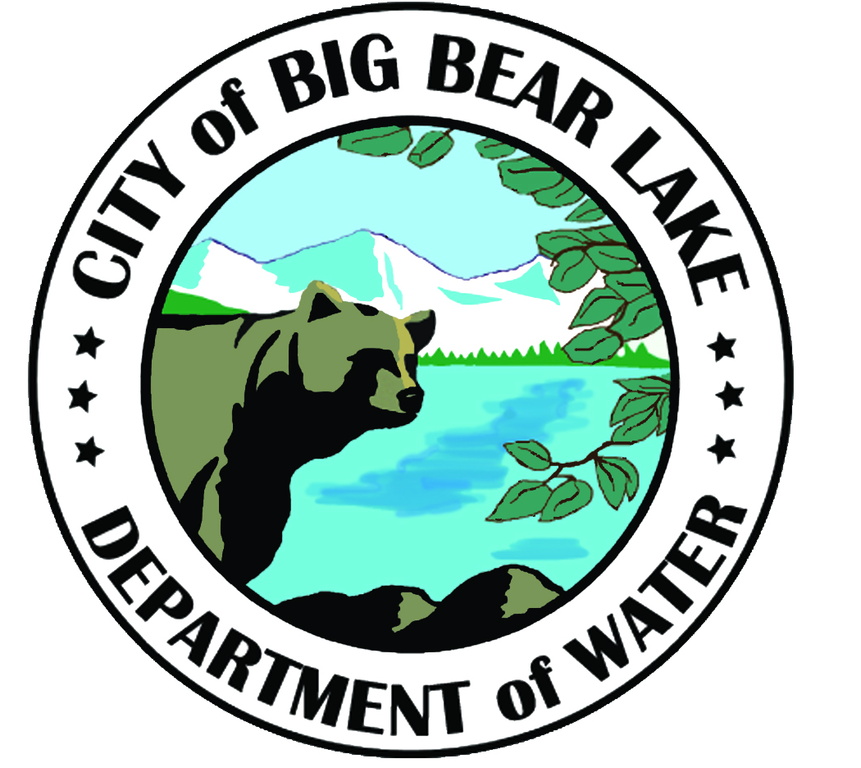
2018 Annual
Consumer Confidence Report
Big Bear Lake & Moonridge Water System
This report is a summary of the quality of water provided to our customers.
We test the drinking water quality for many constituents as required by state and federal regulations. This report shows the results of our monitoring for the period of January 1 - December 31, 2018.
Este informe contiene informacion muy importante sobre su agua potable.
Traduzcalo o hable con alguien que lo entienda bien.
Drinking Water Sources
The sources of drinking water (both tap water and bottled water) include rivers, lakes, streams, ponds, reservoirs, springs, and wells. As water travels over the surface of the land or through the ground, it dissolves naturally-occurring minerals and, in some cases, radioactive material, and can pick up substances resulting from the presence of animals or from human activity. As a result, all drinking water, including bottled water, may reasonably be expected to contain at least small amounts of some contaminants. The presence of contaminants does not necessarily indicate that the water poses a health risk. More information about contaminants and potential health effects can be obtained by calling the USEPA's Safe Drinking Water Hotline at (800)426-4791.
DWP’s Sources
The City of Big Bear Lake Department of Water produces all its water from local ground water sources. There are 37 wells, 17 boosters, and 9 reservoirs with a total storage capacity of 6.5 million gallons in the Big Bear Lake/Moonridge system. We also have 2 permanent backup generators, 4 portable generators, and 2 portable booster pumps. In 2018 there were 458.30 million gallons of water produced out of the Big Bear Lake/Moonridge system.
Water System Information
Throughout the year we have conducted many tests for multiple types of water contaminants. In order to ensure that tap water is safe to drink, the USEPA and the State Water Resources Control Board prescribe regulations that limit the amount of certain contaminants in water provided by public water systems. Department regulations also establish limits for contaminants in bottled water that provide similar protection for public health.
The City of Big Bear Lake Department of Water is located at 41972 Garstin Drive Big Bear Lake, CA 92315 and is open Monday through Friday from 8:00 a.m. until 4:30 p.m. Our Board of Directors meets on the fourth Tuesday of every month at 9:00 a.m. at our Garstin office. The public is welcome to participate in these meetings. Our phone number is (909) 866-5050. For questions regarding your water quality, ask for Jason Hall, or contact The Environmental Protection Agency's Safe Drinking Water Hotline at (800) 426-4791.

Contaminants that may be present in source water before we treat it include:
- Microbial contaminants, such as viruses and bacteria, that may come from sewage treatment plants, septic systems, agricultural livestock operations, and wildlife.
- Inorganic contaminants, such as salts and metals, that can be naturally-occurring or result from urban stormwater runoff, industrial or domestic wastewater discharges, oil and gas production, mining, or farming.
- Pesticides and herbicides, that may come from a variety of sources such as agriculture, urban stormwater runoff, and residential uses.
- Organic chemical contaminants, including synthetic and volatile organic chemicals, that are byproducts of industrial processes and petroleum production, and can also come from gas stations, urban stormwater runoff, agricultural application, and septic systems.
- Radioactive contaminants, that can be naturally-occurring or be the result of oil and gas production and mining activities.
Water Quality Data for 2018
The following tables list all of the drinking water contaminants that were detected during the most recent sampling for the constituent. The presence of these contaminants in the water does not necessarily indicate that the water poses a health risk. The state requires us to monitor for certain contaminants less than once per year because the concentrations of these contaminants do not change frequently. Some of the data, though representative of the water quality, is more than one year old.
The following terms and abbreviations are used in tables 1, 2, 3 and 4:
- Public Health Goal (PHG): The level of a contaminant in drinking water below which there is no known or expected risk to health. PHG's are set by the California Environmental Protection Agency.
- Maximum Contaminant Level Goal (MCLG): The level of a contaminant in drinking water below which there is no known or expected risk to health. MCLGs are set by the Environmental Protection Agency (USEPA).
- Maximum Contaminant Level (MCL): The highest level of a contaminant that is allowed in drinking water. Primary MCLs are set as close to the PHGs (or MCLGs) as is economically and technologically feasible. Secondary MCLs are set to protect the odor, taste, and appearance of drinking water.
- Regulatory Action Level (AL): The concentration of a contaminant which, if exceeded, triggers treatment or other requirements that a water system must follow.
- Nephelometric Turbidity Units (NTU). This is a measure of suspended material in water.
- N/A: not applicable
- N/S: no standard
- ND: not detectable at testing limit.
- ppm: parts per million or milligrams per liter
- ppb: parts per billion or micrograms per liter
- pCi/L: picocuries per liter (a measure of radiation)
Some people may become more vulnerable to contaminants in drinking water than the general population. Immuno-compromised persons such as persons with cancer undergoing chemotherapy, persons who have undergone organ transplants, people with HIV/AIDS or other immune system disorders, some elderly, and infants can be particularly at risk from infections. These people should seek advice about drinking water from their health care providers. USEPA/Centers for Disease Control (CDC) guidelines on appropriate means to lessen the risk of infection by Cryptosporidium and other microbial contaminants are available from the Safe Drinking Water Hotline (800) 426-4791.

Table 1: Primary Regulated Contaminants
Regulated Contaminants | Last Sampled | Unit | Goal (PHG or MCLG) | State MCL | Detected Level (Average) | Detected Level (Range) | Major Sources
Microbiological (sampled Weekly)
Total Coliform Bacteria | 2018 | # positive | 0 | 48/month | 0 | 0 | Naturally present in the environment
Clarity (sampled every 3 years, last sampled in 2017)
Turbidity | 2017 | NTU | N/A | 5 | 0.1 | ND - .9 | Soil runoff
Inorganic Chemicals (sampled every 3 years, except Nitrates which are every year)
Aluminum | 2017 | ppb | 600 | 1000 | 3.4 | ND - 62 | Erosion of natural deposits
Arsenic | 2017 | ppb | 4 | 10 | 0 | ND | Erosion of natural deposits
Barium | 2017 | ppb | 2000 | 1000 | 18.3 | ND - 130 | Erosion of natural deposits
Fluoride | 2017 | ppm | 1 | 2 | 0.3 | ND - 1.3 | Erosion of natural deposits
Nitrate (as NO3-N) | 2018 | ppm | 10 | 10 | 1.0 | ND - 2.6 | Erosion of natural deposits
Radioactivity (sampled every 9 years)
Gross Alpha Activity | 2011 | pCi/L | 0 | 15 | 0.3 | ND - 3.5 | Erosion of natural deposits
Uranium | 2011 | pCi/L | 0.43 | 20 | 0 | ND | Erosion of natural deposits
Additional Constituents (sampled every 3 years)
PH | 2017 | units | N/S | N/S | 7.6 | 7.3 - 8.1 | N/A
Hardness (CaCO3) | 2017 | ppm | N/S | N/S | 248 | 69 - 360 | N/A
Calcium | 2017 | ppm | N/S | N/S | 57.5 | ND - 93 | N/A
Magnesium | 2017 | ppm | N/S | N/S | 25.5 | 6 - 42 | N/A
Sodium | 2017 | ppm | N/S | N/S | 18.4 | 4.5 - 43 | N/A
Potassium | 2017 | ppm | N/S | N/S | 2.4 | 1.2 - 5 | N/A
Bicarbonate | 2017 | ppm | N/S | N/S | 278 | 110 - 420 | N/A
Total Alkalinity | 2017 | ppm | N/S | N/S | 228 | 94 - 340 | N/A
Disinfectant Byproducts, Disinfectant Residuals, and Disenfectant Byproduct Precursors (Next sample 2019)
Total Trihalomethanes | 2018 | ppb | N/S | 80 | 1.3 | 0 – 2.6 | Byproduct of Disinfection
Haloacetic Acids | 2018 | ppb | N/S | 60 | 0 | 0 | Byproduct of Disinfection

Table 2: Secondary Standards
Regulated Contaminants | Last Sampled | Unit | Goal (PHG or MCLG) | State MCL | Detected Level (Average) | Detected Level (Range) | Major Sources
Secondary Standards (sampled every 3 years)
Odor-Threshold | 2017 | units | N/S | 3 | 1 | 1 - 1 | Naturally-occurring organic materials
Chloride | 2017 | ppm | N/S | 500 | 11.6 | 2 - 16 | Runoff/leaching from natural deposits
Sulfate | 2017 | ppm | N/S | 500 | 36.4 | 1.7 - 93 | Runoff/leaching from natural deposits
Total Dissolved Solids | 2017 | ppm | N/S | 1000 | 305 | 130 - 450 | Runoff/leaching from natural deposits
Iron | 2017 | ppb | N/S | 300 | 6.1 | ND - 110 | leaching from natural deposits
Manganese | 2017 | ppb | N/S | 50 | 1.1 | ND - 20 | leaching from natural deposits

Secondary Standards are for contaminants that can affect the taste, odor, or appearance of the drinking water. There are no PHGs, or mandatory standard health effects language for these constituents because secondary MCLs are set on the basis of aesthetics.

Table 3: Lead and Copper
Regulated Contaminants | No. of samples collected | Unit | Goal (PHG or MCLG) | State AL | Detected Level (90th percentile) | No. of sites exceeding AL | Major Sources
Lead and Copper (sampled every 3 years, last sampled in 2017)
*Lead | 20 | ppm | 0.002 | 0.015 | 0 | 0 | Internal corrosion of household water plumbing systems
Copper | 20 | ppm | 0.17 | 1.3 | 0.2 | 0 | Internal corrosion of household water plumbing systems

*Lead: If present, elevated levels of lead can cause serious health problems, especially for pregnant women and young children. Lead in drinking water is primarily from materials and components associated with service lines and home plumbing. The City of Big Bear Lake Department of Water is responsible for providing high quality drinking water, but cannot control the variety of materials used in plumbing components. When your water has been sitting for several hours, you can minimize the potential for lead exposure by flushing your tap for 30 seconds to 2 minutes before using water for drinking or cooking. If you are concerned about lead in your water, you may wish to have your water tested. Information on lead in drinking water, testing methods, and steps you can take to minimize exposure is available from the Safe Drinking Water Hotline (800) 426-4791 or at https://www.epa.gov/safewater/lead.
Lead in Schools: We conducted lead sampling at four schools, including Baldwin Lane Elementary School, North Shore Elementary School, Big Bear Middle School and Big Bear Elementary School. We collected four samples at each site; all of them were non-detect.
Table 4: Unregulated Contaminants
Unregulated Contaminants | Last Sampled | Unit | Goal (PHG or MCLG) | State MCL | Detected Level (Average) | Detected Level (Range) | Major Sources
Unregulated Inorganic Chemicals (sampled every 3 years)
Vanadium | 2017 | ppb | N/S | 50 | 3.2 | ND - 12 | Erosion of natural deposits

The City of Big Bear Lake Department of Water sampled for over 80 regulated and unregulated chemicals, both organic and inorganic. Unless noted, the other results were non-detectable.
A source water assessment was conducted of the domestic water wells for the City of Big Bear Lake Department of Water "Big Bear Lake / Moonridge system" in December 2001. A copy of the complete assessment may be viewed at the Water Department's office at 41972 Garstin Drive in Big Bear Lake or at the SWRCB San Bernardino District office, 464 West 4th Street, Suite 437, San Bernardino, CA 92401. You may also request a summary of the assessment be sent to you by contacting Jason Hall, Production Supervisor, City of Big Bear Lake Department of Water, P.O. Box 1929, Big Bear Lake, CA 92315, or call (909) 866-5050.

Service, Quality, Community

www.BBLDWP.com

