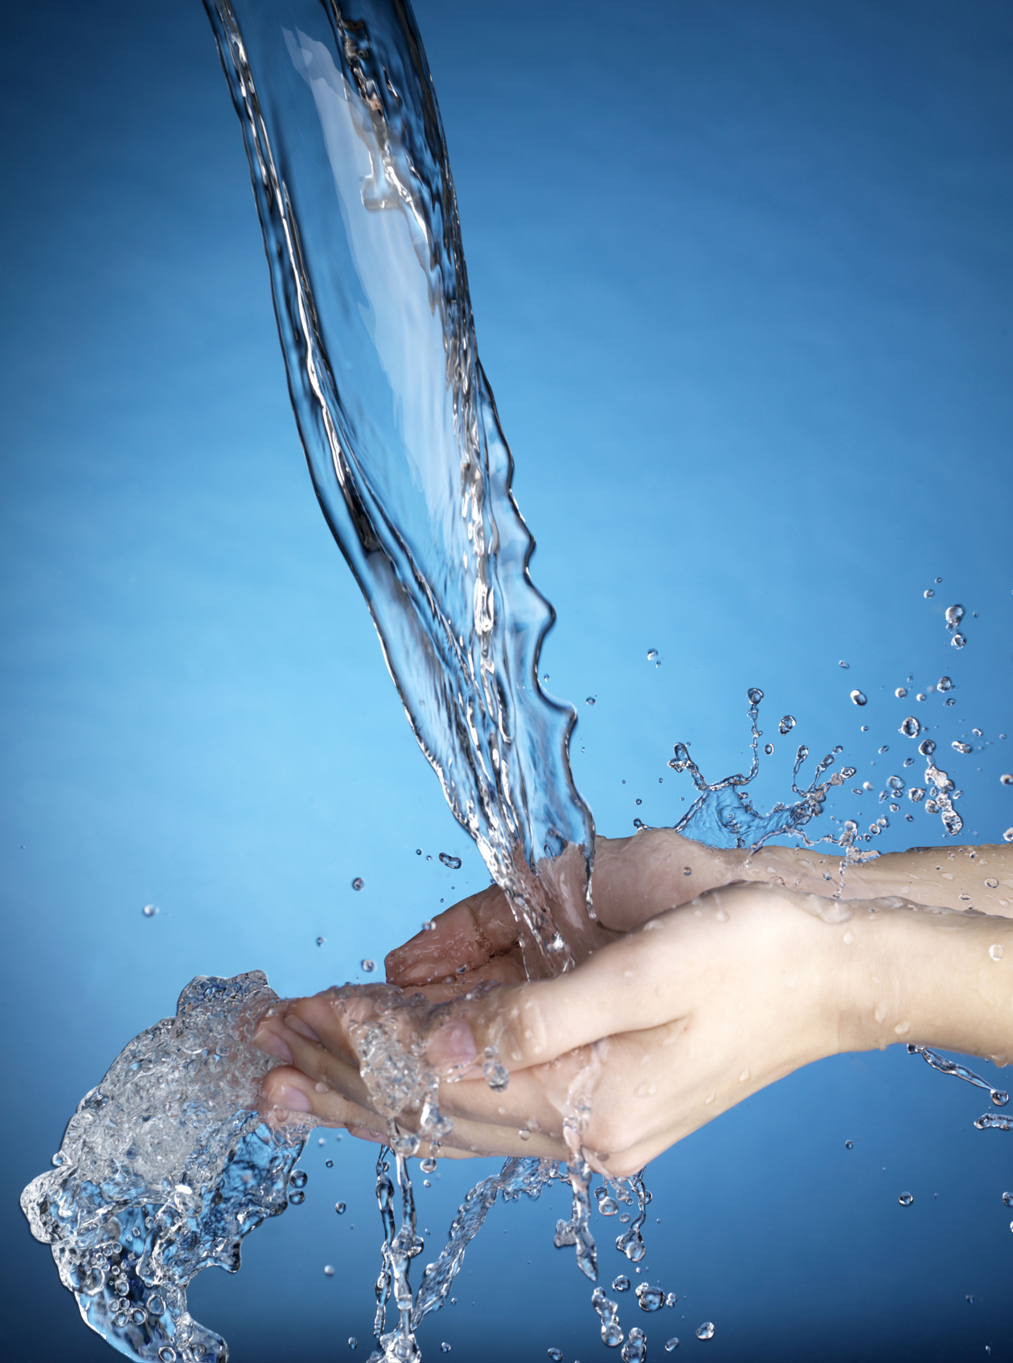
City of Chowchilla

Annual CONSUMER
CONFIDENCE
REPORT
Reporting Year 2021

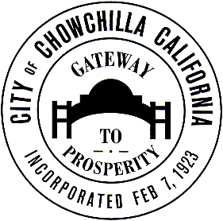

This report is available at the Chowchilla Civic Center and on the internet at www.CityOfChowchilla.org
Este reporte está disponible en Español en la oficina de la Ciudad de Chowchilla y por la internet, www.CityOfChowchilla.org

Your Water, Your Report
The City of Chowchilla presents our annual consumer confidence report (C.C.R) required by the California State Department of Health Services that summarizes the water quality sampling results for 2021 for all of our water customers. We continually strive to enhance our water system delivery infrastructure and we are committed to make improvements to deliver the best quality drinking water to you. The City spends significant time and expense to ensure you are provided with water that meets (is within drinking water standards) or exceeds (is better than) the standard for drinking water quality. As new challenges to drinking water safety emerge, we remain committed to meeting the goals of source water protection, water conservation and community education.
Questions?
Please remember that we are available to assist you. For more information about this report, or if you have any questions about your drinking water, please contact the City of Chowchilla Public Services Department at (559) 665-8615, ext. 789. You can also email us at PublicServices@CityOfChowchilla.org.
Community Participation
The City Council meets the second and fourth Tuesday of the month beginning at 7:00 p.m. at the Chowchilla Civic Center, 130 S. Second Street. The public is welcome and encouraged to attend these meetings.
Important Health Information
Some people may be more vulnerable to contaminants in drinking water than the general population. Immune-compromised persons such as persons with cancer undergoing chemotherapy, persons who have undergone organ transplants, people with HIV/AIDS or other immune system disorders, some elderly, and infants can be particularly at risk from infection. These people should seek advice from their health care providers about drinking water. U.S. EPA/CDC (Centers for Disease Control and Prevention) guidelines on appropriate means to lessen the risk of infection by Cryptosporidium and other microbial contaminants are available from the Safe Drinking Water Hotline at (800) 426-4791 or http://water.epa.gov/drink/hotline.
Health Effects for Inorganic Contaminants
Nitrate in drinking water at levels above 45mg/L is a health risk for infants or those less than six months of age. Such nitrate levels in drinking water can interfere with the capacity of the infant’s blood to carry oxygen, resulting in serious illness; symptoms include shortness of breath and blueness of the skin. Nitrate levels above 45 mg/L may also affect the ability of the blood to carry oxygen in other individuals, such as pregnant women and those with certain specific enzyme deficiencies. If you are caring for an infant, or if you are pregnant, you should seek advice from your health care provider.
Constituents That Could Be in Water
The source of drinking water (both tap water and bottled water) includes rivers, lakes, streams, ponds, reservoirs, springs, and wells. As water travels over the surface of the land or through the ground, it dissolves naturally-occurring minerals and in some cases, radioactive material and can pick up substances resulting from the presence of animals or human activity.
In order to ensure that tap water is safe to drink, the U.S. Environmental Protection Agency (USEPA) and the SWRCB, Division of Drinking Water prescribe regulations that limit the amount of certain contaminants in water provided by public water systems. Drinking water, including bottled water, may reasonably be expected to contain at least small amounts of some contaminants. The presence of contaminants does not necessarily indicate that water poses a health risk. More information about contaminants and potential health effects may be obtained by calling the U.S. EPA’s Safe Drinking Water Hotline (800) 426-4791.
Contaminants that could be present in source water include:
Microbial Contaminants, such as viruses and bacteria that may come from sewage treatment plants, septic systems, agricultural livestock operations and wildlife;
Inorganic Contaminants, such as salts and minerals that can be naturally-occurring or result from urban storm water runoff, industrial or domestic wastewater discharges, oil and gas production, mining or farming;
Pesticides and Herbicides, that may come from a variety of sources such as agriculture, urban water runoff, and residential uses;
Organic Chemical Contaminants, including synthetic and volatile organic chemicals that are by-products of industrial processes and petroleum production, and can also come from gas stations, urban storm water runoff, agricultural application and septic systems;
Radioactive Contaminants that can be naturally-occurring or be the result of oil and gas production and mining activities.
Well Water Treatment
Each well site has a chlorine pump metering chlorine dosage placed into the distribution system, which is approximately 0.30 – 0.40 parts per million.
Conserve For Our Future
Be conservative while watering outside; drip irrigation systems are a low-flow way to water landscape areas. Soaker hoses are a less expensive alternative and they work well in narrow areas and odd-shaped beds and gardens to prevent over-spray from sprinklers. Rain shut-off devices that prevent automatic sprinklers from turning on when it rains.
It is important to not allow water to run-off lawns and landscaping or flow into the gutters; plus sidewalks do not need water.
The Chowchilla City Council passed resolutions to modify the City Municipal Code to conserve water year-round. Everyone needs to know what these changes are and how they directly affect you. Essentially, the action regulates all outdoor use of water during the restricted periods including but not limited to automated irrigation systems, sprinklers, hand-held hose watering of lawns, landscape areas and gardens, and the washing of driveways and sidewalks.
The City’s Outdoor Water Use Program intends to encourage water conservation. Watering lawns, gardens, etc., with automated irrigation systems and sprinklers is the #1 cause of water pressure problems in the community. Watering schedules are designed to help our customers meet the requirements of the City’s water conservation ordinance. If everyone would comply with their watering schedule our water pressure problems would lessen and we could conserve water for our future needs. Everyone is asked to help and follow the requirements of the Outdoor Water Use Program. The City of Chowchilla can issue Administrative Citations and assess penalty fines for watering violations per City Ordinance #13.04.215.
The City of Chowchilla’s odd/even schedule allows:
- Even number addresses to water on Tuesday and Saturday;
- Odd number addresses to water on Wednesday and Sunday;
- Schools, parks and landscape medians are allowed to water on Monday and Friday;
- NO WATERING ALLOWED on Thursday:
- No mid-day watering is allowed between the times of 10 am and 7 pm.
Source Water Assessment
In accordance with the State of California Drinking Water Source Assessment and Protection (DWSAP) Program, a source water assessment was conducted for the Chowchilla Municipal Water Division water system in May of 2002 and updated in 2003. The sources considered vulnerable from the following activities associated with contaminants detected in the water supply include: apartments, condominiums, high-density housing, parks, utility stations-maintenance areas, recreational areas-surface water source. Sources considered vulnerable to the following activities not associated with any detected contaminants in the water supply include: automobile gas stations, historic gas stations, machine shops, sewer collection systems.
Definitions
MCL (Maximum Contaminant Level): The highest level of a contaminant that is allowed in drinking water. Primary MCLs are set as close to the PGHs (or MCLGs) as is economically and technologically feasible. Secondary MCLs are set to protect the odor, taste and appearance of drinking water.
MCLG (Maximum Contaminant Level Goal): The level of a contaminant in drinking water below which there is no known or expected risk to health. MCLGs are set by the U.S. EPA.
PDWS (Primary Drinking Water Standard): MCLs for contaminants that affect health, along with their monitoring and reporting requirements and water treatment requirements.
PHG (Public Health Goal): The level of a contaminant in drinking water below which there is no known or expected risk to health. PHGs are set by the California Environmental Protection Agency.
Vulnerability
While quarterly sampling well #10 in 2021 the average Nitrate level results were 3.7 mg/L, which did not exceed greater than 50% of the MCL. Levels have improved from 2020 Results of 23 mg/L. Regulations require the city to take quarterly samples to ensure the nitrates levels do not meet the maximum level of 45mg/L.
This report contains important information about your drinking water. Translate it, or speak with someone who understands it.
Este reporte contiene información muy importante sobre su agua, prtable. Tradúzcalo o hable con alguien que lo entienda bien.

Sampling Results
This table lists the drinking water contaminants that we tested for according to State drinking water requirements. The presence of these contaminants in the water does not necessarily indicate that the water poses a health risk. During 2021, the City of Chowchilla collected 153 bacteriological (Total Coliform Bacteria, Fecal Coliform and E. coli) samples throughout the water distribution system. The 153 samples collected were all in compliance with the State Water Resources Control Board (SWRCB). The State allows the City of Chowchilla to monitor for some contaminants less than once per year because the concentration of these contaminants does not change frequently. Results in the table below reflect samples collected from five (5) groundwater source wells enumerated as #1A, #5A, #10, #11 and #14. Some of the following data, though representative, is more than one year old with data that ranged from 2019 to 2021.

PRIMARY STANDARDS | MCL | PHG (MCLG) | RANGE  LOW-HIGH | AVERAGE DETECTED | UoM | TYPICAL SOURCE OF CONTAMINANT
Arsenic | 10 | N/A | N/D–2.63 | 0.46 | ug/L | Erosion of natural deposits, runoff from orchards, glass and electronics production wastes
Barium | 1 | 2 | 0.11–0.35 | 0.18 | mg/L | Discharges of oil drilling wastes and from metal refineries, erosion of natural deposits
Nitrate [as NO3] | 10 | 10 | 0.54–4.4 | 1.5 | mg/L | Runoff and leaching from fertilizer use, leaching from septic tanks and sewage, erosion of natural deposits
Dibromochloropropane [DBCP] | 200 | N/A | N/D–N/D | N/D | ug/L | Banned nematocide that may still be present in soils due to runoff/leaching from former use on soybeans, cotton, vineyards, tomatoes and tree fruit
Ethylene Dibromide [EDB] | 50 | 0.01 | N/D–N/D | N/D | mg/L | Discharge from petroleum refineries, underground gas tank leaks, banned nematocides that may still be present in soils due to runoff and leaching from grain and fruit crops
SECONDARY STANDARDS | MCL | PHG (MCLG) | RANGE  LOW-HIGH | AVERAGE DETECTED | UoM | TYPICAL SOURCE OF CONTAMINANT
Chloride | 250 | N/A | 18-50 | 26.6 | mg/L | Runoff /leaching from natural deposits, seawater influence
Iron | 300 | N/A | N/D–N/D | N/D | ug/L | Leaching from natural deposits, industrial wastes
Odor | 3 | N/A | N/D–N/D | N/D | TON | Naturally occurring organic materials
pH [Laboratory] | 6.5-8.5 | N/A | 7.5–8.0 | 7.8 | Std. Units
Specific Conductance | 900 | N/A | 200-590 | 300 | umho/cm | Substances that form ions when in water, seawater influence
Total Dissolved Solids [TDS] | 500 | N/A | 180–380 | 224 | mg/L | Runoff/leaching from natural deposits
Sulfate | 250 | N/A | 2.0–11 | 4 | mg/L | Runoff/leaching from natural deposits, industrial wastes
Lab Turbidity | 5 | N/A | N/D–0.23 | 0.118 | NTU | Soil runoff
Total Chromium | 50 | N/A | N/D–N/D | N/D | ug/L
GENERAL MINERALS | MCL | PHG (MCLG) | RANGE  LOW-HIGH | AVERAGE DETECTED | UoM | TYPICAL SOURCE OF CONTAMINANT
Bicarbonate | N/A | N/A | 67–200 | 96.8 | mg/L
Calcium | N/A | N/A | 15-63 | 26.8 | mg/L
Copper | 1300 | 80 | 90th percentile (60) | N/D | mg/L | Internal corrosion of household plumbing systems, erosion of natural deposits, leaching from wood preservatives
Fluoride | 2 | N/A | N/D–0.066 | 0.066 | mg/L | Erosion of natural deposits
Lead | 15 | <0.005 | 90th percentile 0.005 | 0.014 | mg/L | Internal corrosion of household plumbing systems, discharge from industrial manufacturers, erosion of natural deposits
Magnesium | N/A | N/A | 3.9-16 | 6.9 | mg/L
Potassium | N/A | N/A | 4.0-5.9 | 4.58 | mg/L
Sodium | N/A | N/A | 18–31 | 21 | mg/L
Total Alkalinity | N/A | N/A | 67–200 | 96.8 | mg/L
Total Hardness [as CaCO3] | N/A | N/A | 54–220 | 94.8 | mg/L
ORGANICS | MCL | PHG (MCLG) | RANGE  LOW-HIGH | AVERAGE DETECTED | UoM | TYPICAL SOURCE OF CONTAMINANT
Bromoform | N/A | 0.50 | N/D–N/D | N/D | ug/L
Tetrachloroethylene [PCE] | 5 | 60 | N/D-N/D | N/D | ug/L | Discharge from factories, dry cleaners and auto shops (metal degreaser)
RADIOACTIVITY | MCL | PHG (MCLG) | RANGE  LOW-HIGH | AVERAGE DETECTED | UoM | TYPICAL SOURCE OF CONTAMINANT
Gross Alpha | 15 pCi/L | N/A | 1.04–5.48 | 2.1 | pCi/L | Erosion of natural and man-made deposits
Uranium | 20 pCi/L | N/A | N/D–2.6 | 0.52 | pCi/L | Erosion of natural deposits

Abbreviation Key
MCL – Maximum Contaminant Level N/A – Not Applicable AL – Action Level
MCLG – Maximum Contaminant Level Goal pCi/L – Picocuries per Liter umho/cm – Micromhos per Centimeter
mg/L – Milligrams per Liter or parts per million N/D – Non-Detect NTU – Nephelometric Turbidity
ug/L – Micrograms per Liter or parts per billion PHG – Public Health Goal TON – Threshold odor number
UoM – Unit of Measurement

