city of millbrae

2019 Water Quality Report
Consumer Confidence
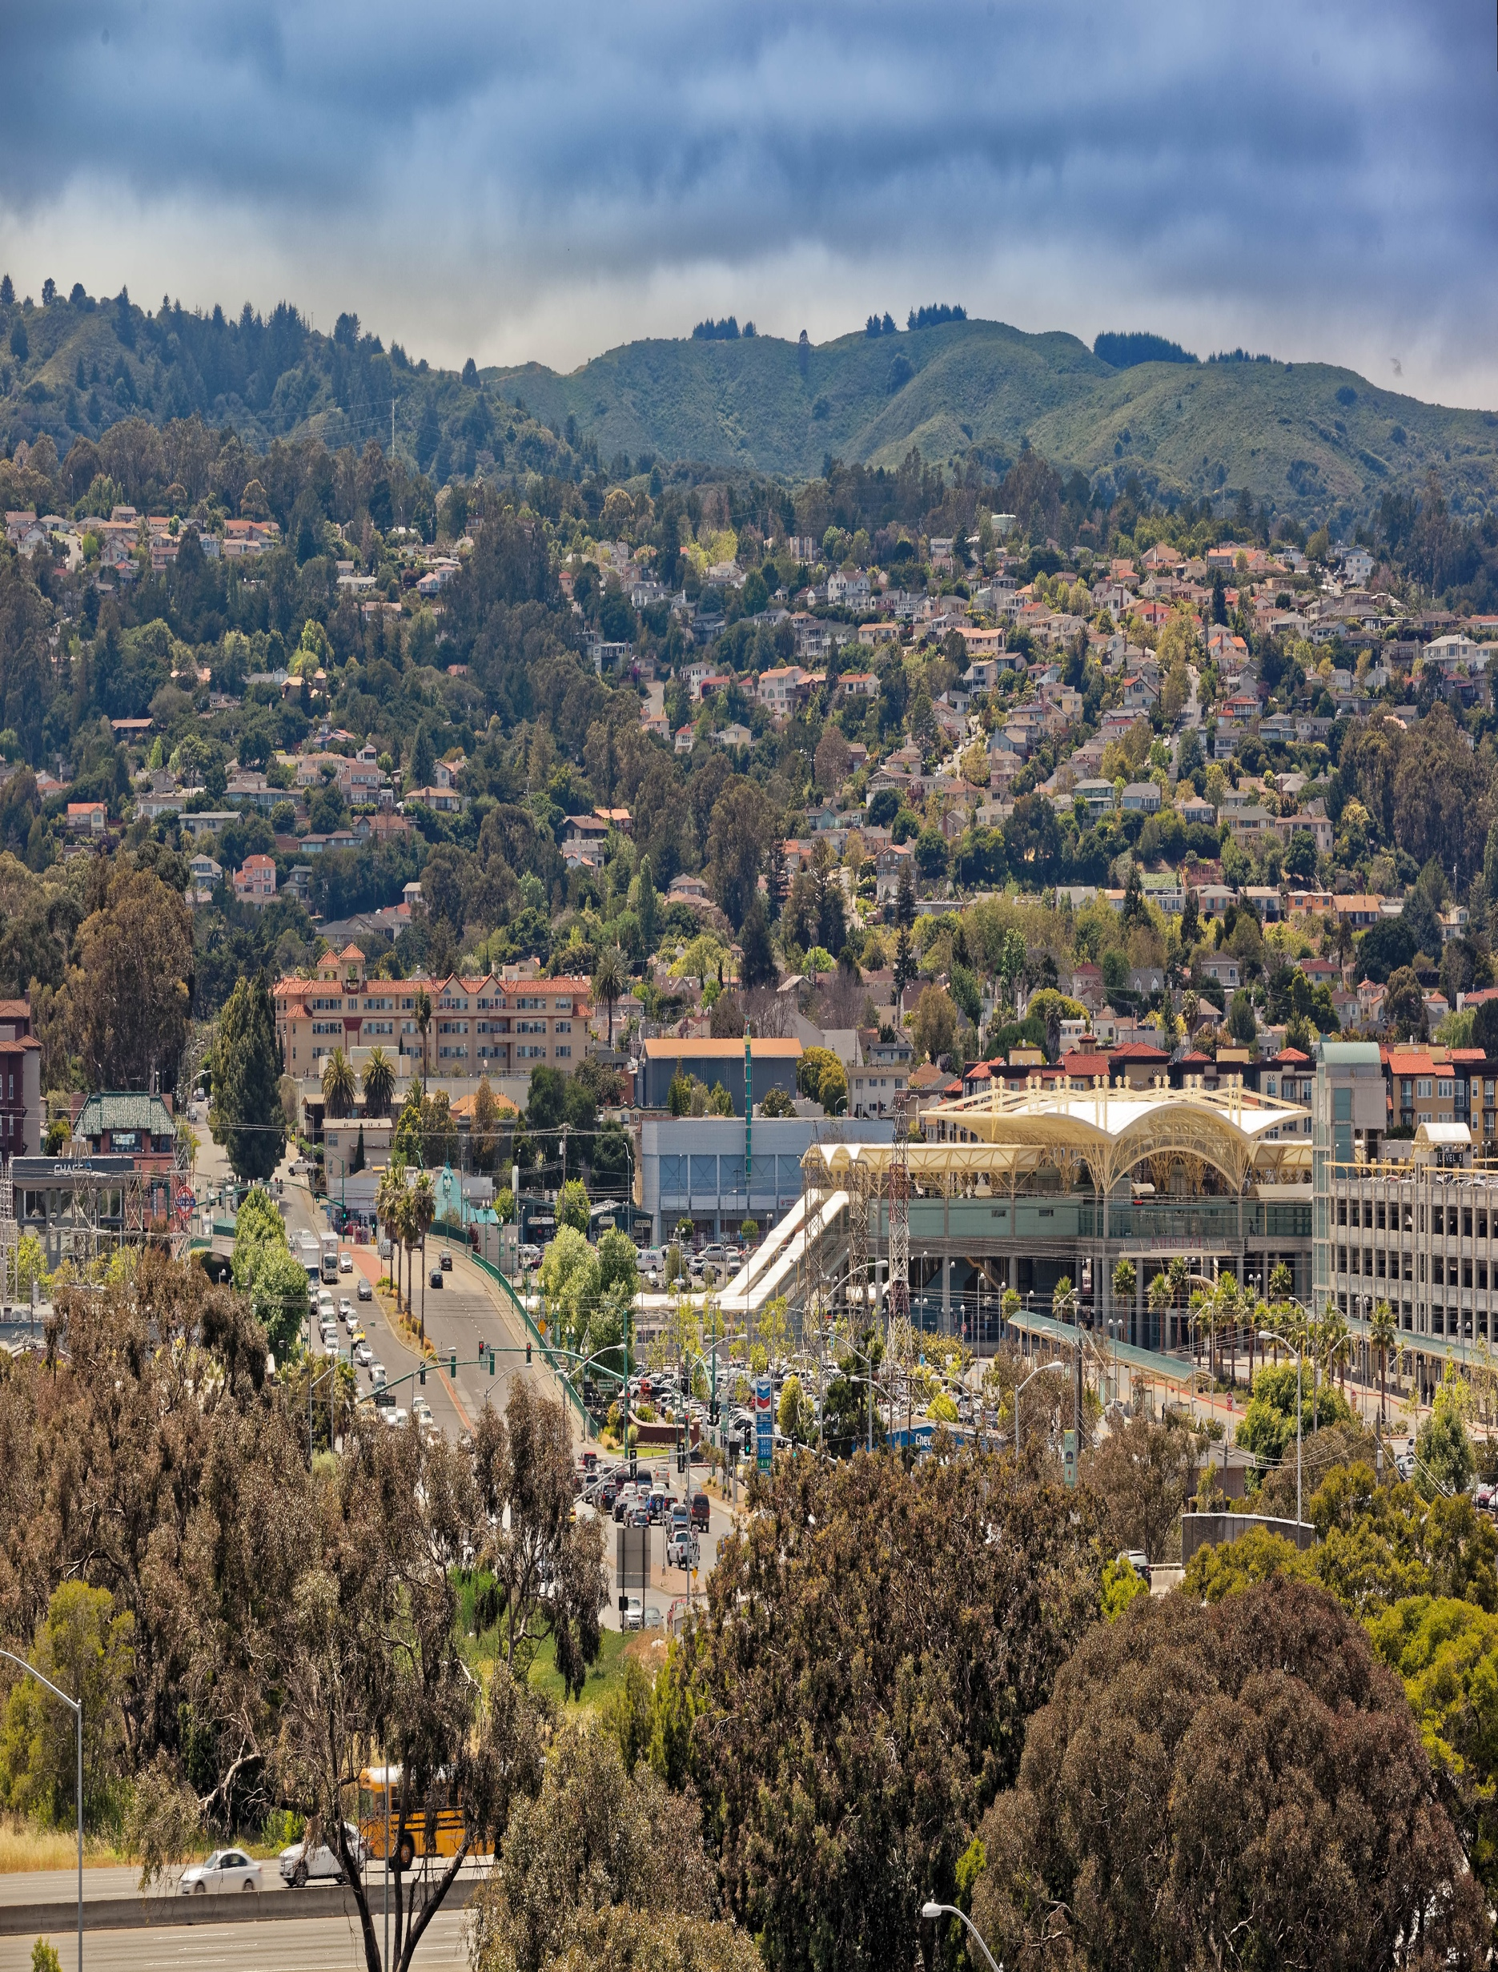

The City of Millbrae Public Works Department is pleased to present you the 2019 Water Quality Report. Pursuant to federal regulations mandated by the Safe Drinking Water Act, all water consumers are to be provided annual information about their water and its sources.

This report explains he origin of the drinking water supply and the specific treatment(s) it receives by the City of Millbrae, Public Works, Utilities & Operations staff and the San Francisco Public Utilities Commission (SFPUC).

The City of Millbrae believes it is in everyone’s interest to obtain a high quality and reliable water supply because it is integral to personal health, environmental integrity and community prosperity.

for more information:

City of Millbrae | Public Works Department | (650) 259-2374 | www.ci.millbrae.ca.us
SF Public Utilities Commission (SFPUC) | Customer Service | (415) 551-3000 | www.sfwater.org
SF Water Resources Control Board | Drinking Water | (916) 449-5577 | www.swrcb.ca.gov
US Environmental Protection USEPA | Safe Drinking Water Hotline | (800) 429-9791 | www.epa.gov
American Water Works Assoc. | AWWA Contact Line | (800) 926-7337 | www.aawa.org

PLEASE USE WATER WISELY

Please see last page of this report for water use guidelines, and water-wise tips and resources.

Water Quality and You

Water quality is extremely important because we cannot survive without a clean and reliable source of it. The City of Millbrae, along with our water supplier, The San Francisco Public Utilities Commission (SFPUC), the California Department of Public Health (CDPH), and the United States Environmental Protection Agency (USEPA) are all working simultaneously to ensure that we provide the highest quality water and to educate water consumers and encourage their involvement in relevant decisions. Consumers who familiarize themselves with the basic drinking water information contained in this report will be able to participate more effectively in this decision-making process. Together, we can be a great force to promote programs that will aid us in continuing to deliver water that meets the highest possible standards.

Millbrae Water Quality Assurance Program

The Millbrae Water Division conducts a comprehensive water quality assurance program. We collect and report over forty samples a month throughout our system to regularly monitor water quality. We send samples to a state certified laboratory for testing and are pleased to report that all samples have tested negative for coliforms and that the City had zero violations related to any maximum contaminant level (MCL) in the calendar year 2019.

Other water samples are collected periodically to check for levels of lead and copper, disinfection by-products trihalomethanes and haloacetic acids (THMs and HAAs) and general physical components as required by state and federal regulations. The City of Millbrae received a waiver for asbestos sampling.

The City of Millbrae continually monitors all five main entry points to our distribution system and also other key points in the distribution system such as tank sites and pump locations. These sites are monitored by our computerized SCADA (Supervisory Control and Data Acquisition) system that provides our Water Division managers and continuous automated water quality information.

In addition, the Millbrae Water Division, along with the San Mateo County Environmental Health Department administers and manages a cross-connection prevention program to eliminate possible contamination to our drinking water through backflow prevention devices. The program includes yearly testing all city-owned backflow devices and monitoring of compliance on privately owned backflow devices.*

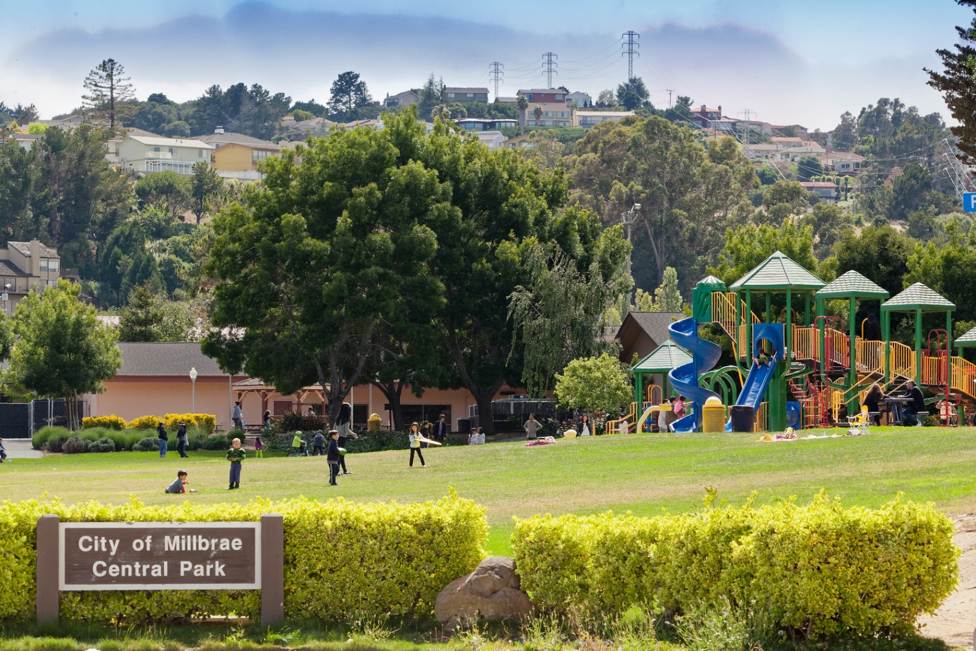
*A note to residents and business owners who have backflow prevention devices: State regulations require that all backflow prevention devices be tested annually by a certified inspector.

Watersheds Protection

SFRWS conducts watershed sanitary surveys for the Hetch Hetchy source annually and for the local water sources and UNHHS every five years. The latest local sanitary survey was completed in 2016 for the period of 2011-2015. The last watershed sanitary survey for UNHHS was conducted in 2015 as part of SFRWS’s drought response plan efforts. All these surveys together with the stringent watershed protection management activities were completed by SFRWS with support from partner agencies including National Park Service and US Forest Service. The purposes of the surveys are to evaluate the sanitary conditions and water quality of the watersheds and to review results of watershed management activities conducted in the preceding years. Wildlife, stock, and human activities are continued to be the potential contamination sources. You may contact the San Francisco District office of the State Water Resources Control Board’s Division of Drinking Water (SWRCB-DDW) at 510-620-3474 for the review of these reports.

Special Health Needs

Some people may be more vulnerable to contaminants in drinking water than the general population. Immuno-compromised persons, such as those with cancer undergoing chemotherapy, persons who have undergone organ transplants, people with HIV/AIDS or other immune system disorders, some elderly people and infants, can be particularly at risk from infections.
These people should seek advice about drinking water from their healthcare providers. USEPA/CDC guidelines on appropriate means to lessen the risk of infection by Cryptosporidium and other microbial contaminants are available from the USEPA's Safe Drinking Water Hotline 800-426-4791 or at www.epa.gov/safewater.

Drinking Water & Lead

Exposure to lead, if present, can cause serious health effects in all age groups, especially for pregnant women and young children. Infants and children who drink water containing lead could have decreases in IQ and attention span and increases in learning and behavior problems. Lead exposure among women who are pregnant increases prenatal risks. Lead exposure among women who later become pregnant has similar risks if lead stored in the mother’s bones is released during pregnancy. Recent science suggests that adults who drink water containing lead have increased risks of heart disease, high blood pressure, kidney or nervous system problems.

Lead in drinking water is primarily from materials and components associated with service lines and home plumbing. There are no known lead service lines in our water distribution system. We are responsible for providing high quality drinking water, but we cannot control the variety of materials used in plumbing components. You share the responsibility for protecting yourself and your family from the lead in your home plumbing. You can take responsibility by identifying and removing lead materials within your home plumbing and taking steps to reduce your family’s risk. Before drinking, flush your pipes for several minutes by running your tap, taking a shower, doing laundry or a load of dishes. You can also use a filter certified to remove lead from drinking water. If you are concerned about lead in your water you may wish to have your water tested, call 650-259-2374 for lead test. Information about lead in drinking water, testing methods, and steps you can take to minimize exposure is available at www.epa.gov/safewater/lead

As previously reported in 2018, we completed an inventory of lead user service lines (LUSL) in our system and there are known or no known pipelines and connectors between water mains and meters made of lead. Our policy is to remove and replace and LUSL promptly if it is discovered during pipeline repair and/or maintenance.

Our Drinking Water Sources & Treatment

SFRWS’s major water source is in Yosemite National Park and originates from spring snowmelt flowing down the Tuolumne River to storage in Hetch Hetchy Reservoir. The well-protected Sierra water source is exempt from federal and State’s filtration requirements. To meet the appropriate drinking water standards for consumption, water from Hetch Hetchy Reservoir receives treatment consisting of ultraviolet light and chlorine disinfection, pH adjustment for optimum corrosion control, fluoridation for dental health protection, and chloramination for maintaining disinfectant residual and minimizing the formation of regulated disinfection byproducts.
The Hetch Hetchy water supply is supplemented with surface water from local watersheds and upcountry non-Hetch Hetchy sources (UNHHS). Rainfall and runoff from the 35,000-acre Alameda Watershed in Alameda and Santa Clara counties are first collected in Calaveras Reservoir and San Antonio Reservoir

for storage followed by delivery to the Sunol Valley Water Treatment Plant (SVWTP) for treatment. Rainfall and runoff from the 23,000-acre Peninsula Watershed in San Mateo County are stored in Crystal Springs Reservoir, San Andreas Reservoir and Pilarcitos Reservoir, and are delivered to the Harry Tracy Water Treatment Plant. Water delivered to the two treatment plants are subject to filtration, disinfection, fluoridation, optimum corrosion control, and taste and odor removal to ensure the water supplied to our customers meet the federal and state drinking water standards. SFRWS did not use the UNHHS in 2019.

Water Quality

SFWRS regularly collects and tests water samples from reservoirs and designated sampling points throughout the sources and the transmission system to ensure the water delivered to you meets or exceeds Federal and State drinking water standards. In 2019, SFRWS conducted more than 53,650 drinking water tests in the sources and the transmission system. This is in addition to the extensive treatment process control monitoring performed by SFRWS’s certified operators and online instruments.

Drinking water, including bottled water, may reasonably be expected to contain at least small amounts of some contaminants. The presence of contaminants does not necessarily indicate that water poses a health risk. In order to ensure that tap water is safe to drink, the United States Environmental Protection Agency (USEPA) and the SWRCB-DDW prescribe regulations that limit the amount of certain contaminants in water provided by public water systems. The U.S. Food and Drug Administration regulations and California law also establish limits for contaminants in bottled water that provide the same protection for public health.

Flouridation and Dental Fluorosis

Mandated by State law, water fluoridation is a widely accepted practice proven to be safe and effective for preventing and controlling tooth decay. The fluoride target level in the water is 0.7 milligram per liter (mg/L, or part per million, ppm), consistent with the May 2015 State regulatory guidance on optimal fluoride level. Infants fed formula mixed with water containing fluoride at this level may still have a chance of developing tiny white lines or streaks in their teeth. These marks are referred to as mild to very mild fluorosis and are often only visible under a microscope. Even in cases where the marks are visible, they do not pose any health risk. The Centers of Disease Control (CDC) considers it safe to use optimally fluoridated water for preparing infant formula. To lessen this chance of dental fluorosis, you may choose to use low fluoride bottled water to prepare infant formula. Nevertheless, children may still develop dental fluorosis due to fluoride intake from other sources as food, toothpaste and dental products.

Contact your healthcare provider or SWRCB-DDW if you have concerns about dental fluorosis. For additional information about fluoridation or oral health, visit SWRCB-DDW website:
https://www.waterboards.ca.gov/drinking_water/certlic/drinkingwater/Fluoridation.html, or the CDC website www.cdc.gov/fluoridation.

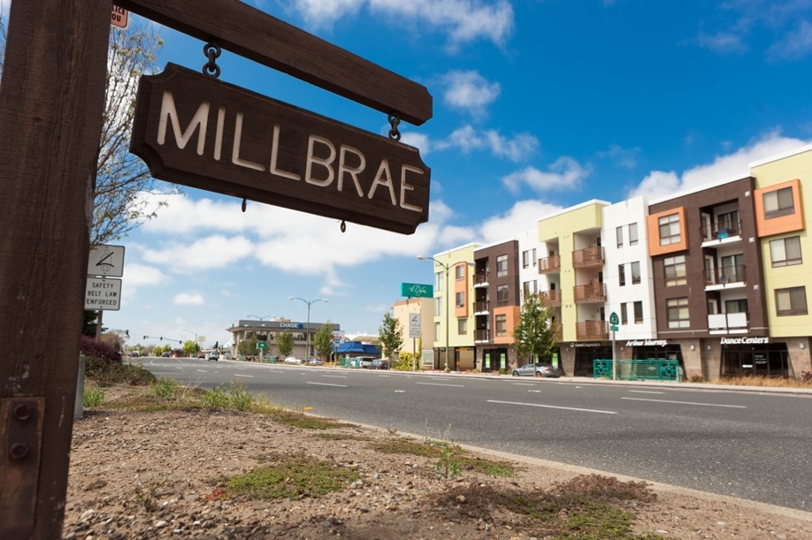

Quinoline Monitoring

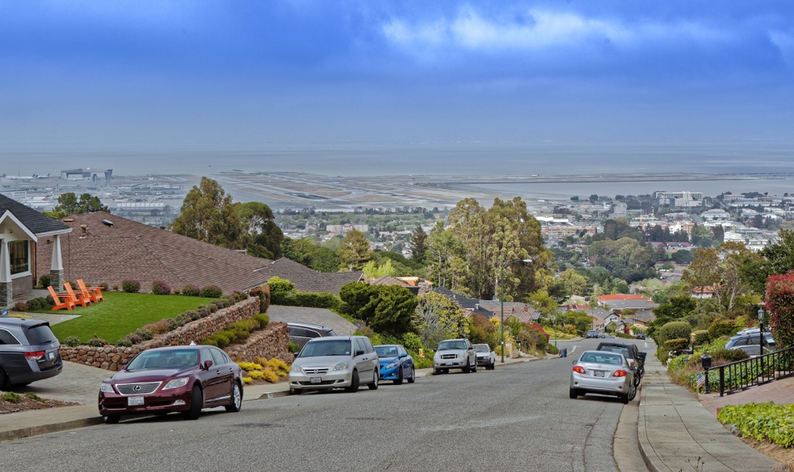
SFRWS conducted a special round of voluntary monitoring for the contaminant quinoline. The monitoring effort was part of SFRWS’ assessment to identify if quinoline a contaminant of concern in its water sources and/or transmission system. The monitoring results confirm that the raw water sources and transmission system have no quinoline detected.

Monitoring of Per- and Polyfluoroalkyl Substances (PFAS)

PFAS is a group of approximately 5,000 man-made chemicals used in a variety of industries and consumer products. These chemicals are very persistent in the environment and human body. SFRWS conducted a special round of PFAS monitoring of its water sources and transmission system in 2019. The monitoring effort was not under any Federal or State order/permit requirements; it was proactively conducted on a voluntary basis with the objective to identify if SFRWS’s water supplies are impacted by PFAS. Using the State’s stringent sampling procedures and based on the currently approved/certified method of
analysis for 18 PFAS contaminants, SFRWS confirmed no PFAS was detected

in its water sources and transmission system. Considering USEPA’s recent development of a newer method of analysis for additional PFAS contaminants, SFWRS intends to conduct another round of monitoring when the new analytical method is available at its contract laboratory. For additional information about PFAS, visit SWRCB-DDW website waterboards.ca.gov/pfas and/or USEPA website epa.gov/pfas.

Groundwater Storage and Recovery (GSR) Project

Groundwater is a renewable source of naturally occurring fresh water that is found in underground reservoirs called aquifers that are replenished primarily by rainfall. The use of groundwater helps diversify water sources and makes drinking water supply even more reliable. SFRWS recently completed Phase 1 of the GSR project, in which a total of eight deep-water wells were installed to provide groundwater for the water system. The groundwater will be treated and blended with its surface water supplies before it is delivered to our customers. For the past decade, SFRWS has collected water quality and quantity data from Westside Basin aquifer, from which the groundwater will be extracted. With extensive testing and water level monitoring, SFRWS knows that after adding groundwater to its water supplies, it will continue providing our customers with high-quality drinking water that meets or exceeds all regulatory health-based and aesthetic standards set by the SWRCB-DDW and the USEPA. Testing of the wells will be conducted throughout the year of 2020.
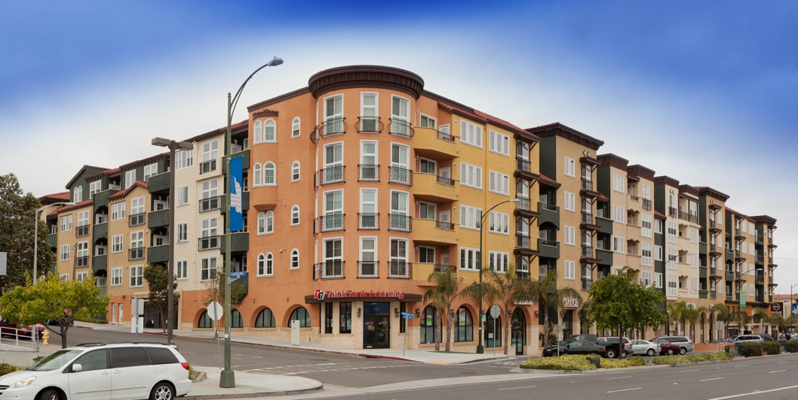

Contaminants and Regulations
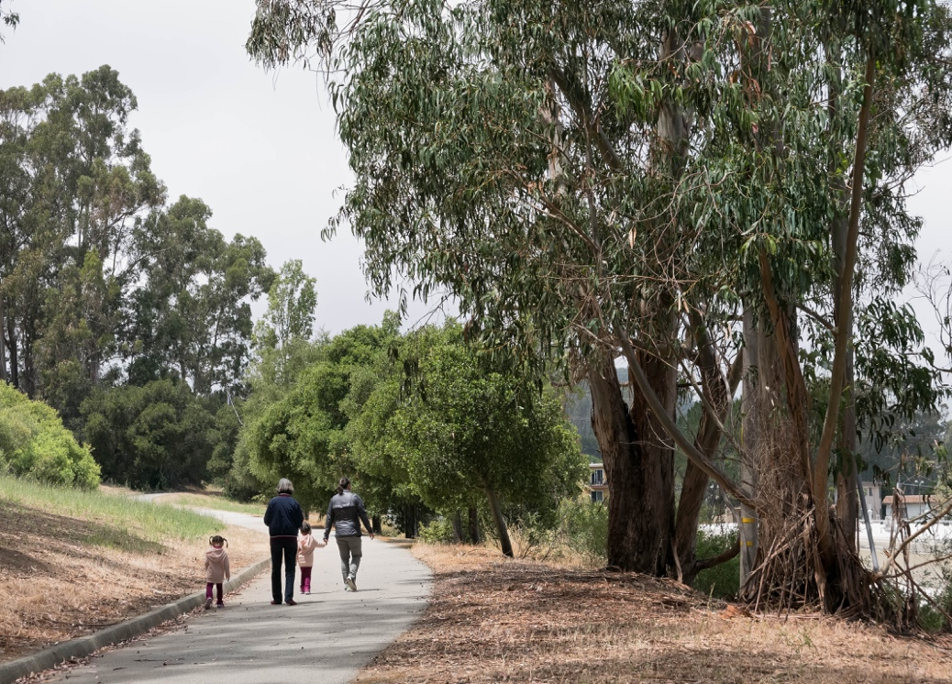
Generally, the sources of drinking water (both tap water and bottled water) include rivers, lakes, oceans, streams, ponds, reservoirs, springs and wells. As water travels over the sureface of the land or through the ground, it dissolves naturally occurring minerals and, in some cases, radioactive material, and can pick up substances resulting from the presence of animals or human activity. Such substances are called contaminants, and may be present in source water as:

Microbial contaminants. such as viruses and bacteria that may come from sewage treatment plants, septic systems, agricultural livestock operations and wildlife.

Inorganic contaminants, such as salts and metals, that can be naturally occurring or result from urban stormwater runoff, industrial or domestic wastewater discharges, oil and gas production, mining or farming.

Pesticides and herbicides that may come from a variety of sources such as agriculture, urban stormwater runoff and residential uses.

Organic chemical contaminants, including synthetic and volatile organic chemicals, which are by-products of industrial processes and petroleum production, can also come from gas stations, urban stormwater runoff, agricultural application and septic systems.

Radioactive contaminants, which can be naturally occurring or be the result of oil and gas production and mining activities.

More information about contaminants and potential health effects can be obtained by calling USEPA’s Safe Drinking Water Hotline 800-426-4791, or at www.epa.gov/safewater.

Key Water Quality Terms

The following are definitions of key terms referring to standards and goals of water quality noted on the data table.

Public Health Goal (PHG): The level of a contaminant in drinking water below which there is no known or expected risk to health. PHGs are set by the California Environmental Protection Agency.

Maximum Contaminant Level Goal (MCLG): The level of a contaminant in drinking water below which there is no known or expected risk to health. MCLGs are set by the USEPA.

Maximum Contaminant Level (MCL): The highest level of a contaminant that is allowed in drinking water. Primary MCLs are set as close to the PHGs or MCLGs as is economically and technologically feasible. Secondary MCLs (SMCLs) are set to protect the odor, taste, and appearance of drinking water.

Maximum Residual Disinfectant Level (MRDL): The highest level of a disinfectant allowed in drinking water. There is convincing evidence that addition of a disinfectant is necessary for control of microbial contaminants.

Maximum Residual Disinfectant Level Goal (MRDLG): The level of a drinking water disinfectant below which there is no known or expected risk to health. MRDLGs do not reflect the benefits of the use of disinfectants to control microbial contaminants.

Primary Drinking Water Standard (PDWS): MCLs and MRDLs for contaminants that affect health along with their monitoring and reporting requirements, and water treatment requirements.

Regulatory Action Level: The concentration of a contaminant which, if exceeded, triggers treatment or other requirements that a water system must follow.

Treatment Technique (TT): A required process intended to reduce the level of a contaminant in drinking water.

Turbidity: A water clarity indicator that measures cloudiness of the water and is also used to indicate the effectiveness of the filtration system. High turbidity can hinder the effectiveness of disinfectants.

Cryptosporidium is a parasitic microbe found in most surface water. SFRWS regularly tests for this waterborne pathogen and found it at very low levels in source water and treated water in 2019. However, current test methods approved by the USEPA do not distinguish between dead organisms and those capable of causing disease. Ingestion of Cryptosporidium may produce symptoms of nausea, abdominal cramps, diarrhea, and associated headaches. Cryptosporidium must be ingested to cause disease, and it may be spread through means other than drinking water.

City of Millbrae

Water Quality Data for 2019

The table below lists all 2019 detected drinking water contaminants and the information about their typical sources. Contaminants below detection limits for reporting are not shown, in accord with regulatory guidance. SFRWS holds a SWRCB-DDW monitoring waiver for some contaminants in its surface water supply and therefore the associated frequencies are less than annual.

DETECTED CONTAMINANTS |  | UNIT |  | MCL |  | PHG or (MCLG) | Range or Level Found | Average or [Max] | Major Sources in Drinking Water
TURBIDITY
Unfiltered Hetch Hetchy Water |  | NTU |  | 5 |  | N/A | 0.3-0.7 ⁽²⁾ | [2.1] | Soil runoff
Filtered Water from Sunol Valley Water Treatment Plant  (SVWTP) |  | NTU  - |  | 1⁽³⁾  Min 95% of samples  ≤ 0.3 NTU⁽³⁾ |  | N/A  N/A | -  99.89% - 100% | [1]  - | Soil runoff  Soil runoff
Filtered Water from Harry Tracy Water Treatment Plant (HTWTP) |  | NTU  - |  | 1⁽³⁾  Min 95% of samples  ≤ 0.3 NTU ⁽³⁾ |  | N/A  N/A | -  100% | [0.1]  - | Soil runoff  Soil runoff
DISINFECTION BYPRODUCTS AND PRECURSOR
Total Trihalomethanes | ppb |  | 80 |  | N/A |  | 12.2-48.5 | 30.35 |  | Byproduct of drinking water disinfection
Haloacetic Acids | ppb |  | 60 |  | N/A |  | 4.4-41 | 22.7 |  | Byproduct of drinking water disinfection
Total Organic Carbon⁽⁵⁾ | ppm |  | TT |  | N/A |  | 1.6 – 2.6 | 2.1 |  | Various natural and man-made sources
MICROBIOLOGICAL
Total Coliform ⁽⁶⁾ | - |  | NoP≤5.0% of  monthly samples |  | (0) |  | - | N/A |  | Naturally present in the environment
Giardia lamblia | cyst/L |  | TT |  | (0) |  | 0 – 0.09 | 0.02 |  | Naturally present in the environment
INORGANICS
Fluoride (source water)⁽⁷⁾ | ppm |  | 2.0 |  | 1 |  | ND – 0.9 | 0.3 ⁽⁸⁾ |  | Erosion of natural deposits; water additive to promote strong teeth
Chloramine (as chlorine) | ppm |  | MRDL = 4.0 |  | MRDLG = 4 |  | 1-3.3 | 2.2 |  | Drinking water disinfectant added for treatment

CONSTITUENTS WITH SECONDARY STANDARDS | UNIT | SMCL | PHG | Range | Average | Major Sources of Contaminant
Aluminum⁽¹⁰⁾ | ppb | 200 | 600 | ND – 68 | ND | Erosion of natural deposits; some surface water treatment residue
Chloride | ppm | 500 | N/A | <3 – 17 | 8.7 | Runoff/leaching from natural deposits
Color | unit | 15 | N/A | <5 – 10 | <5 | Naturally-occurring organic materials
Specific Conductance | µS/cm | 1600 | N/A | 32 – 234 | 158 | Substances that form ions when in water
Sulfate | ppm | 500 | N/A | 1 -29 | 15 | Runoff / leaching from natural deposits
Total Dissolved Solids | ppm | 1000 | N/A | <20 – 119 | 76 | Runoff / leaching from natural deposits
Turbidity | NTU | 5 | N/A | ND – 0.5 | 0.2 | Soil runoff

LEAD AND COPPER | UNIT | AL | PHG | Range | 90th Percentile | Major Sources in Drinking Water
Copper | ppb | 1300 | 300 | 0-55 mgl | 48mg/l | Internal corrosion of household water plumbing systems
Lead | ppb | 15 | 0.2 | 0-25.5 ug/l | 5.3 ug/l | Internal corrosion of household water plumbing systems

OTHER WATER QUALITY PARAMETERS | UNIT | ORL | Range | Average
Alkalinity (as CaCo₃) | ppm | N/A | 3.5-97 | 46
Boron | ppb | 1000 (NL) | ND – 107 | ND
Calcium (as Ca) | ppm | N/A | 3.3-20 | 12
Chlorate ⁽¹³⁾ | ppb | 800 (NL) | 40 – 220 | 84
Chromium (VI) ⁽¹⁴⁾ | ppb | NA | 0.04-0.19 | 0.12
Hardness (as CaCO₃₎ | ppm | N/A | 8.9-77 | 47
Magnesium | ppm | N/A | 0.2-6.6 | 4.2
pH | - | N/A | 8.8-10.1 | 9.3
Potassium | ppm | N/A | 0.3-1.2 | 0.8
Silica | ppm | N/A | 4.9-8 | 6.1
Sodium | ppm | N/A | 2.8-21 | 14
Strontium | ppb | N/A | 13-230 | 107

KEY
< / ≤ | = less than / less than or equal to
AL | = Action level
Max | = Maximum
Min | = Minimum
N/A | = Not Available
ND | = Non-detect
NL | = Notification Level
NoP | = Number of Coliform-Positive Sample
NTU | = Nephelometric Turbidity Unit
ORL | = Other Regulatory Level
ppb | = part per billion
ppm | = part per million
µS/cm | = microSiemens/centimeter

Footnotes:
(1) All results met State and Federal drinking water health standards
(2) These are monthly average turbidity values measured every 4 hours daily.
(3) There is no turbidity MCL for filtered water. The limits are based on the TT requirements for filtration systems.
(4) This is the highest locational running annual average value.
(5) Total organic carbon is a precursor for disinfection byproduct formation. The TT requirement applies to the filtered water from the SVWTP only.
(7) In May 2015, the SWRCB recommended an optimal fluoride level of 0.7 ppm be maintained in the treated water. In 2019, the range and average of the fluoride levels were 0.2 ppm – 0.7 ppm, respectively.
(8) The natural fluoride level in the Hetch Hetchy supply was ND. Elevated fluoride levels in the SVWTP and HTWTP raw water were attributed to the transfer of fluoridated Hetch Hetchy water into the local reservoirs.
(9) This is the highest running annual average value.
(10) Aluminum has a primary MCL of 1,000 ppb.
(11) The most recent Lead and Copper rule monitoring was in 2019. 2 of 30 site samples collected at consumer taps had copper concentrations above the AL.
(12) The most recent Lead and Copper Rule monitoring was in 2019. 0 of 30 site samples collected at consumer taps had lead concentrations above the AL.
(13) The detected chlorate in the treated water is a degradation product of sodium hypochlorite used by SFRWS for water disinfection.
(14) Chromium (VI) has a PHG of 0.02 ppb but no MCL of 10 ppb was withdrawn by the SWRCB-DDW on September 11, 2017. Currently, the SWRCB-DDW regulates all chromium through a MCL of 50 ppb for Total Chromium, which was not detected in our water in 2019.

Boron Detection Above Notification Level in Source Water

In 2019, boron was detected at a level of 1.49 ppm in raw water stored in Pond F3 East, one of SFRWS’s approved sources in Alameda Watershed. A similar level was also detected in the same pond in 2017. Although the detected value is above the California Notification Level of 1 ppm for source water, the corresponding level in the treated water from the SVWTP was only 0.1 ppm. Boron is an element in nature and is typically released into air and water when soils and rocks naturally weather.

This report contains important information about our drinking water. Please contact our Public Works at 650-259-2374 for assistance.

Este informe contiene información importante sobre nuestra agua potable. Por Favor Comuníquese con el departamento de las Obras Públicas al 650-259-2374 para ayuda en español.

本報告包含有關我們飲用水的重要信息。請致電650-259-2374聯系公共工程部尋求幫助。

WATER CONSERVATION
Please use water wisely!

Please continue to conserve water by following the guidelines and the water saving tips below. California is prone to droughts and we all need to do our part and conserve water!

For more information on free resources and workshops, guidelines and more, please visit www.ci.millbrae.ca.us/waterconservation

Millbrae Water Use Guidelines
Refer to the City’s Municipal Code for additional regulations

- Use of water is not allowed which results in flooding or runoff in gutters, driveways, or streets.
- Hoses used for any purpose must be fitted with shut off nozzles.
- Repair leaks right away.
- Place covers over swimming pools to reduce water lost to evaporation.

WATER SAVING TIPS & RESOURCES

- Install a low flow showerhead and take 5 minute or les shower. Free showerheads and timers are available.

- Catch water in a watering can or bucket while waiting for water to get hot.

- Replace your toilet with a high-efficiency model or place a water displacement bag in each toilet tank. Free displacement bags are available.

- Fix all leaky toilets, faucets and pipes. Install low flow faucet aerators in the kitchen and bathroom. Free low, flow aerators are available.

- Scrape plates and run the garbage disposal less frequently. Compost food scraps instead.

- Turn off water while brushing your teeth and shaving.

- Run only full loads in dishwashers and clothes washers. Replace these appliances with water efficient machines.

- Water lawn and landscaping between 6:00 pm and 10:00 am. Be sure not to over water landscaping. Check and adjust sprinkler heads seasonally. Plant drought-tolerant and native plants. Instant rebates are available for smart irrigation controllers. https://bawsca.rachio.com

- Use a carwash facility or use a bucket of water and one short rinse to wash your car; wash on a permeable surface (grass or gravel).

- Sweep (never hose) driveways, patios and sidewalks.

Pick up free water saving devices at City Hall’s Public Works counter
Monday – Friday, 8:30 AM – 5:00 PM
Showerheads, faucet aerators, shower timers, toilet leak tablets, and water-wise and garden landscaping guides. Rebates are available for rain barrels and cisterns, and smart irrigation controllers.

For more information and tips, visit www.ci.millbrae.ca.us/waterconservation or call 650-259-2348
Also visit: http://saveourwater.com
Sweep, (never hose) driveways, patios and sidewalks.

