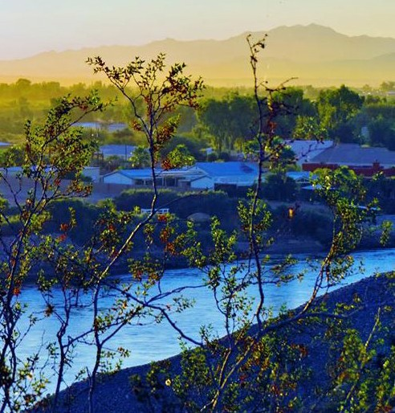
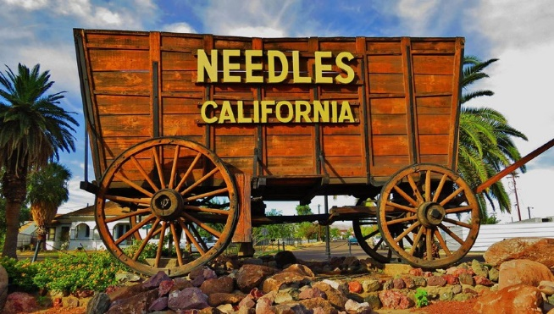
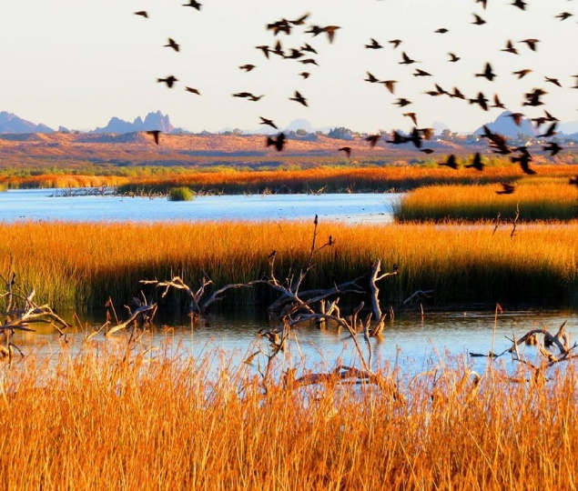

Annual Water Quality Consumer Confidence Report 2021

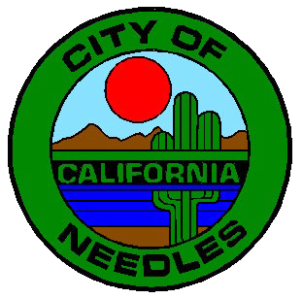

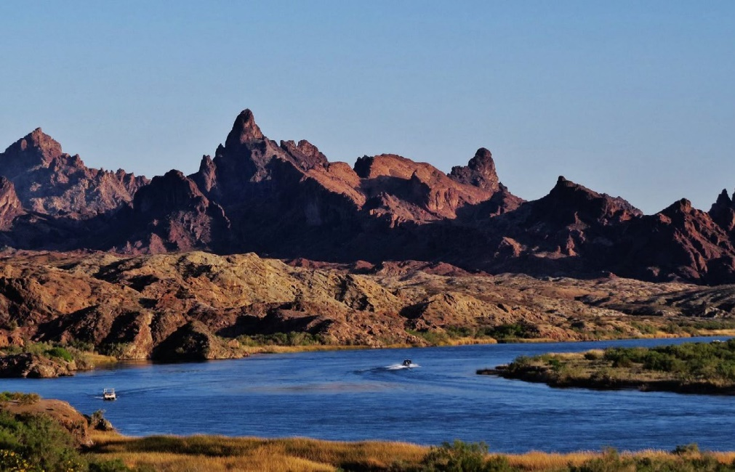

An Overview of
Your 2021 Consumer
Confidence Report
Each year, the City of Needles Water Department prepares our annual Consumer Confidence Report.This report identifies what we test our water for, what was present and provides a snapshot of the water quality requirements set
by the California State Water Resources Control Board (State Board) and the United States Environmental Protection Agency (USEPA).

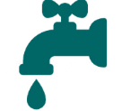
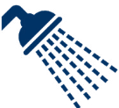
To ensure our water meets all State and Federal regulatory standards, we sample and test our water system regularly and send these samples to an independent lab for processing. We test for a variety of contaminants on a regular basis. Contaminants are things that might be present in the water and could compromise its safety.
Water Saving Tips
Find and Fix Leaks
Check toilets and faucets for leaks, and repair them promptly.
Take Shorter Showers
Shortening your shower by 1-2 mins. can save up to 700 gallons per year!
Wash Full Loads (Clothes & Dishes) Only run your dishwasher and clothes washer when they’re full.
Avoid Watering Mid-Day
Water only in the early mornings or late evenings to minimize evaporation and wind.
Choose the Right Plants
Replace a portion of your lawn with native and CA Friendly plants that use less water.
Install Smart Sprinklers
Use water efficient technology like drip irrigation, rotating sprinkler nozzles, and
Do you know where your
water comes from?
One hundred percent of our water supply in the City of Needles comes from groundwater!
Many contaminants that we test for are naturally occurring, but depending on the amount, could cause health concerns.
Within this Consumer Confidence Report, we have provided data tables that show what we test for, if there was a detection, and if so, at what level. It’s important to remember that if there is a
detection, that doesn’t mean the water is not safe to drink. Many naturally occurring elements found in water are detected at low levels but are only known to have an adverse health affect at very high levels, over a long period of time. Ensuring water
quality is a complex process and the information
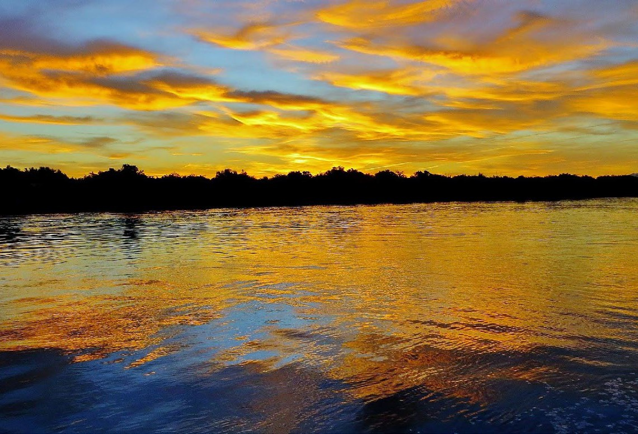
we provide may seem complicated. We want to make sure to answer any questions or concerns you may have. If you have any questions, please contact the City of Needles at 760-326-5700.

Message from the United States Environmental Protection Agency
The sources of drinking water (both tap water and bottled water) include rivers, lakes, streams, ponds, reservoirs, springs, and wells. As water travels over the surface of the land or through the ground, it dissolves naturally occurring minerals (and, in some cases, radioactive material) and can pick up substances resulting from the presence of animals or from human activity. Contaminants that may be present in source water include:
- Microbial contaminants, such as viruses and bacteria, that may come from sewage treatment plants, septic systems, agricultural livestock operations, and wildlife.
- Inorganic contaminants, such as salts and metals, that can be naturally occurring or result from urban stormwater runoff, industrial or domestic wastewater discharges, oil and gas production, mining, or farming.
- Pesticides and herbicides, that may come from a variety of sources such as agriculture, urban stormwater runoff, and residential uses.
- Organic chemical contaminants, including synthetic and volatile organic chemicals, that are by- products of industrial processes and petroleum production, and can also come from gas stations, urban stormwater runoff, agricultural application, and septic systems.
- Radioactive contaminants, that can be naturally occurring or be the result of oil and gas production and mining activities.
To ensure that tap water meets all Federal and State parameters, the U.S. Environmental Protection Agency (USEPA) and the State Water Resources Control Board (State Board) prescribe regulations that limit the amount of certain contaminants in water provided by public water systems. Food and Drug Administration (FDA) regulations also establish limits for contaminants in bottled water that provide the same protection for public health.
Drinking water, including bottled water, may reasonably be expected to contain at least small amounts of some contaminants. The presence of contaminants does not necessarily indicate that water poses a health risk. For more information about contaminants and potential health effects, please call the USEPA’s Safe Drinking Water Hotline (800-426-4791).
Some people may be more vulnerable to contaminants in drinking water than the general population. Immuno- compromised persons, such as persons with cancer undergoing chemotherapy, persons who have undergone organ transplants, people with HIV/AIDS or other immune system disorders, some elderly, and infants can be particularly at risk from infections. These people should seek advice about drinking water from their health care providers. USEPA/Centers for Disease Control (CDC) guidelines on appropriate means to lessen the risk of infection by Cryptosporidium and other microbial contaminants are available from the Safe Drinking Water Hotline (1-800-426-4791).

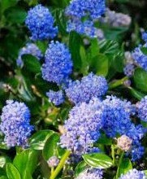

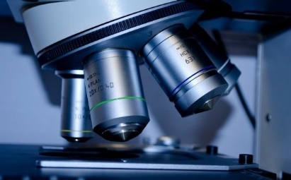
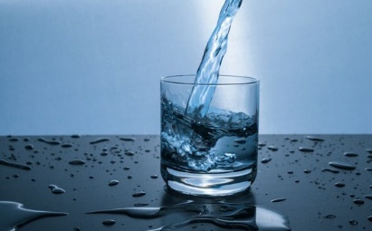

2021 Water Quality Test Results
Last year, as in years past, your tap water met all U.S. EPA and State drinking water health standards. The City of
Needles vigilantly safeguards its water supplies and once again, we are proud to report that our system has not violated a maximum contaminant level
or any other water quality standard. This brochure is a snapshot of last year’s water quality. Included are details about where your water comes from, what it contains, and how it compares to State standards. We are committed to providing you with information because informed customers are our best allies.

The State allows us to monitor for some contaminants less than once per year because the concentrations of these contaminants do not change frequently. Some of our data, though representative, are more than one year old.

R
DETECTED CONSTITUENTS
YEAR’s TESTED 2019/2021
INORGANIC CONSTITUENTS- 2019/2021
Chemical Constituent | Unit of Measure | State  MCL | MCL Goal / PHG | Needles  Range | Needles  Average | Typical Source of Contamination
Hardness | mg/L | NA | NA | 300 - 580 | 385 | Erosion of Natural Deposits
Calcium | mg/L | NA | NA | 75 - 140 | 94.25 | Erosion of Natural Deposits
Sulfate | mg/L | 500 | NA | 270-700 | 358.33 | Erosion of Natural Deposits
Chloride | ug/L | 600 | NA | 130-340 | 178.33 | Erosion of Natural Deposits
Nitrate* | mg/L | 45 | 45 | ND-1.2 | 0.60 | Erosion of Natural Deposits
Nitrate (NO3) | mg/L | 10 | 10 | ND – 1.2 | 0.60 | Erosion of Natural Deposits
Fluoride | mg/L | 2 | 1 | ND - 0 | 0.00 | Erosion of Natural Deposits
Specific  Conductance | Umho/cm | 1600 | NA | 1100 - 2400 | 1625 | Erosion of Natural Deposits
Total Dissolved Solids | mg/L | 1000 | NA | 760 - 900 | 823.33 | Erosion of Natural Deposits
Turbidity | NTU | 5 | NA | 0.29 – 2.2 | 1.04 | Erosion of Natural Deposits
Iron | ug/L | 300 | NA | ND - 690 | 172.5 | Erosion of Natural Deposits
METALS - OTHER- 2019/2021
Chemical Constituent | Unit of Measure | State  MCL | MCL Goal / PHG | Needles  Range | Needles  Average | Typical Source of Contamination
Arsenic | ug/L | 10 | 0.004 | ND-7.6 | 2.72 | Erosion of Natural Deposits
Manganese | ug/L | 50 | nl=500 | 25-160 | 23.44 | Erosion of Natural Deposits
Magnesium | mg/L | NA | NA | 27 - 57 | 36.5 | Erosion of Natural Deposits
Sodium | mg/L | NA | NA | 110 - 300 | 197.5 | Erosion of Natural Deposits
Chromium | ug/L | 50 | 100 | ND – 0 | 0.00 | Erosion of Natural Deposits
Bicarbonate | mg/L | NA | NA | 180 - 260 | 205 | Erosion of Natural Deposits
pH | units | NA | NA | 7.50 – 7.81 | 7.75 | Erosion of Natural Deposits
Barium | ug/L | 1000 | 2000 | ND - 34 | 21 | Erosion of Natural Deposits
Selenium | ug/L | 50 | 30 | ND - 7.2 | 3.22 | Erosion of Natural Deposits
MTBE | ug/L | 13 | 13 | ND | 0.00 | Leaking Underground Tanks
RADIOACTIVE CONSTITUENTS – 2019
Radioactive | Unit of Measure | MCL | MCL Goal / PHG | Range | Average | Typical Source of Contamination
Gross Alpha | pCi/L | 15 | 0 | 1.61 – 2.66 | 2.06 | Erosion of Natural Deposits

*In 2018, the City failed to monitor for nitrate as required and thus was in violation of the regulations. This failure did not constitute an emergency and the situation has been rectified. The water was tested for nitrate twice in 2019 and again in 2020 the nitrate levels were well within acceptable range.. On November 3rd 2020 the City of Needles received a notice from the California water boards to initiate quarterly monitoring on 3 of the citys water wells #8, #11 and #12 due to secondary maximum contaminate level exceedances of Iron and Manganese on well #8. and Manganese on wells #11 and #12,Well #8 and #11 have been offline for several years and are only run for sampling purposes to waste, well #12 is solely used to irrigate the golf course.

LEAD & COPPER-2019
(units) | ACTION LEVEL | PHG (MCLG) | Range of Detection | 90th % Level | MCL  Violation? | Most Recent Sampling Date | Typical Source of Constituent
Copper (mg/L) | 1.3 | 0.3 | ND -.086 | 0.013 | No | 2019 | Internal corrosion of household plumbing systems; erosion of natural deposits; leaching from wood preservatives. No samples collected exceeded the action level.
Lead (mg/L) | 15 | 0.2 | .075-.31 | 0.0019 | No | 2019 | Internal corrosion of household water plumbing systems; discharges from industrial manufacturers, erosion of natural deposits. No samples collected exceeded the action level.

Microbiological Contaminants  (units) | PRMARY MCL | PHG  (MCLG) | Value | MCL Violation? | Most Recent Sampling Date | Typical Source of Constituent
Total Coliform Bacteria (% of monthly positive samples) | More than 5% of monthly samples are positive | (0) | 0 | No | 2021 | Naturally present in the environment
Fecal Coliform and E. coli Bacteria (number of monthly positive samples) | A routine sample and a repeat sample are total coliform positive, and one is also Fecal Coliform or E.coli positive | (0) | 0 | No | 2021 | Human and animal fecal waste
DISTRIBUTION SYSTEM WATER QUALITY-2021

Water Quality Terms
Inorganic Chemicals Maximum Contaminant Level (MCL): The highest level of a contaminant that is allowed in drinking water. Primary MCLs are set as close
to the PHGs (or MCLGs) as is economically and technologically feasible. Secondary MCLs are set to protect the odor, taste, and appearance of drinking water.
Maximum Contaminant Level Goal (MCLG): The level of a contaminant in drinking water below which there is no known or expected risk to health. MCLGs are set by the U.S. Environmental Protection Agency.
Public Health Goal (PHG): The level of a contaminant in drinking water below which there is no known/expected risk to health. PHGs are set by the CA Environmental Protection Agency.
Primary Drinking Water Standard (PDWS): MCLs and MRDLs for contaminants that affect health along with their monitoring, reporting, and water treatment requirements.
Maximum Residual Disinfectant Level (MRDL): The highest level of a disinfectant allowed in drinking water. There is convincing evidence that addition of a disinfectant is necessary for control of microbial contaminants.
Maximum Residual Disinfectant Level Goal (MRDLG): The level of a drinking water disinfectant below which there is no known or expected risk to health.
MRDLGs do not reflect the benefits of the use of disinfectants to control microbial
contaminants.
Regulatory Action Level: The concentration of a contaminant which, if exceeded, triggers treatment or other requirements that a water system must follow.
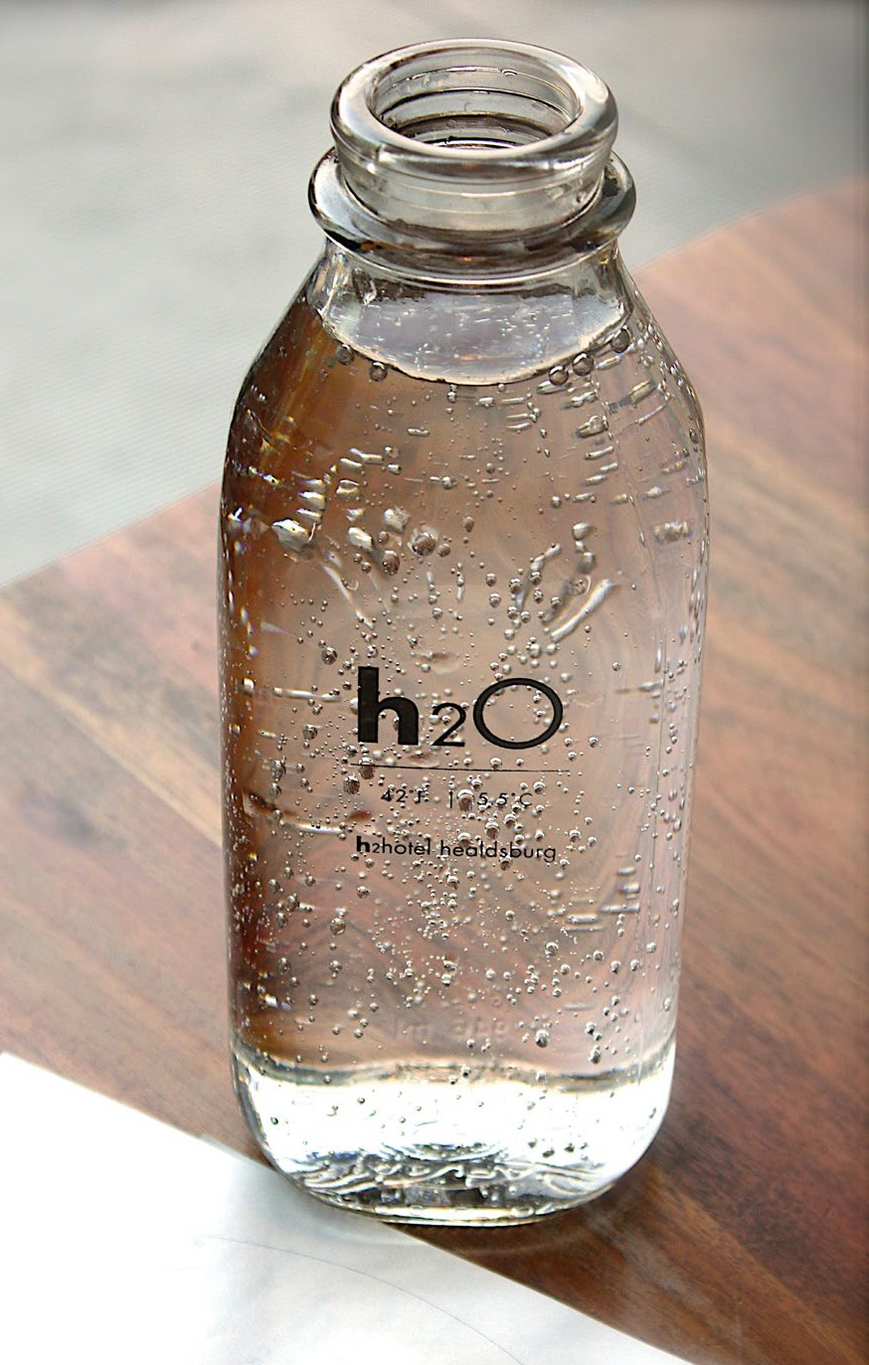
Treatment Technique (TT): A required process intended to reduce the level of a contaminant in drinking water.
List of Acronyms
DLR: Detection Limit for Purposes of Reporting GWUI: Ground Water Under the Influence of Surface Water mg/L: Milligrams per Liter or Parts Per Million (PPM) -
Equivalent to 1 second in 11.5 days ng/L: Nanograms per liter or Parts Per Trillion (PPT) - Equivalent to 1 second in nearly 32,000 years
NA: Not Applicable NC: Not Collected ND: Not Detected
NL: Notification Level NS: Not Sampled
NTU: Nephelometric Turbidity Units (Suspended Material)
pCi/L: Pico Curies per Liter
pg/L: Picograms per liter or Parts Per Quadrillion (PPQ) - Equivalent to 1 second in nearly 32,000,000 years Sequestration: Phosphates Used in Water Treatment
to Control Metal Releases
uS/cm: MicroSeimen per Centimeter
µg/L: Micrograms per Liter or Parts Per Billion (PPB) - Equivalent to 1 second in nearly 32 years

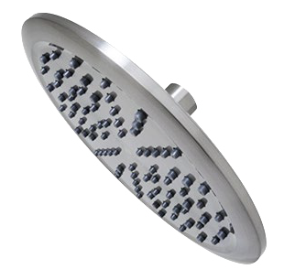
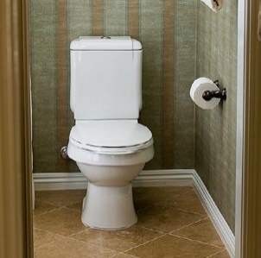
Your Coupon...

Coupon for $100 Toilet Rebate
Present this coupon to City of Needles Customer Service Staff to receive a rebate of up to $100 when you purchase a new WaterSense approved toilet. Residential accounts can apply for up to two rebates, and commercial accounts can receive up to four rebates. To qualify, your proof of purchase must also be submitted.

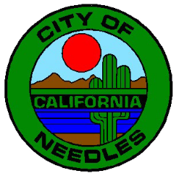

City of Needles Water Department
City Utility Services Office
817 Third Street
Needles, CA 92363
Phone: 760-326-5700

