LASSEN VOLCANIC NATIONAL PARK

2019 WATER QUALITY CONSUMER CONFIDENCE REPORT

HEADQUARTERS WATER FILTRATION PLANT

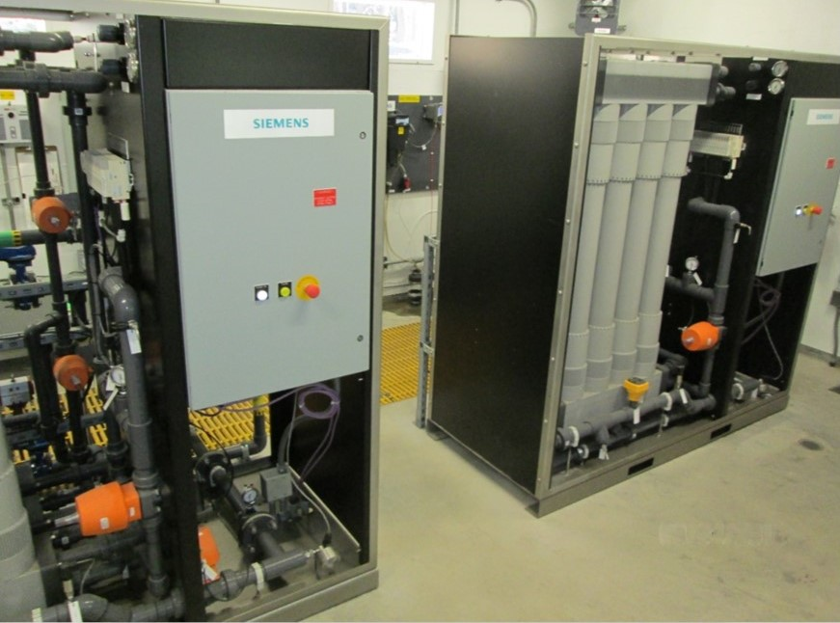

Public Water System Date of Report LAVO Water Treatment Operator
ID. No. 52-10503 November 25, 2020 Russ Young 530.595.6227

INTRODUCTION

Drinking water for the headquarters residential and park headquarters area is collected from the Martin Creek Watershed. The intake consists of a diversion dam with an infiltration galley and screened settling boxes.

The summer of 2019 saw a new raw water intake system constructed. It is an underground Streambed Filtration System. This new system will greatly reduce yearly maintenance cost and create a backup to the Martin Creek intake.

This new intake along with the microfiltration plant and new raw water main completes a 10 year drinking water rehabilitation project for the HQ system.

The intake is managed by the NPS Water Treatment Operator. The source water is delivered to the Headquarters Filtration Plant via 7700’ of underground water main. The source water is then filtered through two micro filtration membrane arrays. The final treatment is disinfection prior to storage in an underground reservoir. We test the quality of this water supply for a variety of constituents as required by California State Regulations and the National Park Service (Public Health Service).

This report details water quality data from January 1 - December 31, 2019.

Source Water Assessment

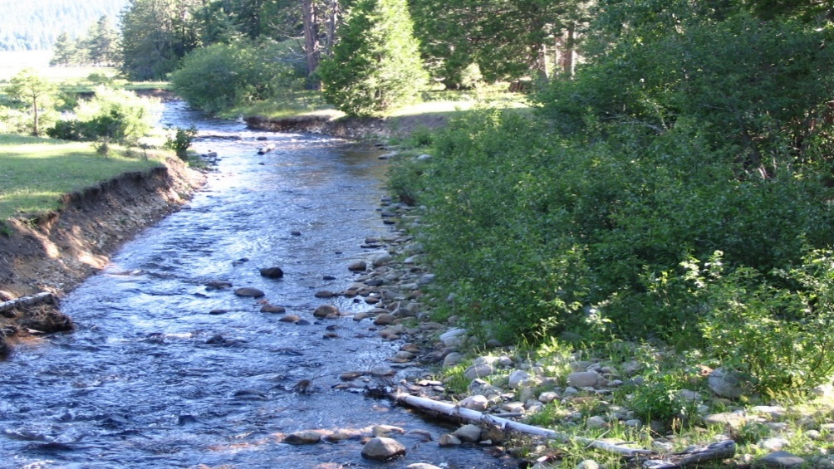

Source: Martin Creek - Mineral, Ca.
(Surface water)

Date of Last
Water Source Assessment: May, 2003

A copy of the complete assessment may be viewed at:

CWRCB Valley District Office or Lassen VNP Headquarters
364 Knollcrest Drive, Suite 101 P.O. Box 100
Redding, Ca. 96002 Mineral, Ca. 96063
Reese Crenshaw, 530.224.4845 Russ Young, 530.595.6227

The Martin Creek Watershed is located on Lassen National Forest land and is managed by the United States Forest Service (USFS). In 2003 the NPS and San Jose State University Engineering division developed a “Drinking Water Source Assessment”. The Drinking Water Source Assessment determined that the highest level threat to the source water is “Managed Forest Practices” (Typically logging, herbicides, cattle grazing etc.). We have met with USFS representatives and submitted a copy of the “Drinking Water Source Assessment”. The Lassen National Forest Service staff have been cooperative in their management practices.

The Drinking Water Source Assessment created safe distance zones in the Martin Creek Watershed. These zones protect the source water supply from possible contamination caused by “Managed Forest Practices”.

The following are fixed distances of zero “Managed Forest Practices” in each zone.

Zone A: 400 feet from primary stream boundaries.
200 feet from tributaries.

Zone B: 2,500 foot radius around the intake structure.

DROUGHT EFFECTS

In 2016 the Headquarters (Martin Creek) was heavily impacted by drought. The surface water level at Martin Creek was approximately 15% of normal for the year. This low flow was enough flow to continue supplying an adequate amount of drinking water to the Headquarters Area, Mineral and Battle Creek Ranch.

In past drought years we have experienced a complete dewatering of Martin Creek at the Headquarters drinking water intake. In such times we have excavated the creek at the diversion dam intake and rehabilitated the underground infiltration galley. This ensures a 100% capture of the raw water source that is piped into the raw water system. The unused raw water is returned to the creek bed. This was our plan if the Martin Creek surface flow receded underground prior to the diversion dam intake.

PUBLIC PARTICIPATION

Lassen Park Water Systems holds bi-annual meetings each year. We discuss the ongoing 5-year plan as well as all EPA, California Water Resource Control Board and Public Health Service rules and regulations as they pertain to the Lassen Park drinking water systems.

THE SOURCES OF DRINKING WATER (Both tap water and bottled water) include rivers, lakes, streams, ponds, reservoirs, springs and wells. As water travels over the surface of the land or through the ground, it dissolves naturally occurring minerals and even radioactive material. Surface water can also pick up substances resulting from the presence of animal or human activity.

CONTAMINANTS THAT MAY BE PRESENT IN SOURCE WATER INCLUDE:

- Microbial Contaminants, such as viruses and bacteria, which may come from sewage treatment plants, septic systems, agricultural livestock operations and wildlife.
- Inorganic Contaminants, such as salts and metals that can be naturally occurring or result from urban storm-water runoff, industrial or domestic wastewater discharges, oil and gas production, mining or farming.
- Pesticides and herbicides, which may come from a variety of sources such as agriculture, forest practices, urban storm-water runoff and residential uses.
- Organic Chemical Contaminants, including synthetic and volatile organic chemicals that are byproducts of industrial processes and petroleum production. Other sources are gas stations, urban storm-water runoff, agricultural application and septic systems.
- Radioactive Contaminants, which can be naturally occurring or be the result of oil and gas production and mining activities.

The following are definitions of some of the terms used in this report:

MAXIMUM CONTAMINANT LEVEL (MCL): The highest and lowest level of a contaminant allowed in drinking water.

PRIMARY DRINKING WATER STANDARDS: Includes MCLs for contaminants that effect health, surface water treatment requirements, and the monitoring and reporting requirements for required constituents.

SECONDARY DRINKING WATER STANDARDS (SDWS): MCLs for contaminants that affect taste, odor or appearance of the drinking water. Contaminants with SDWSs do not affect the health at the MCL levels.

PUBLIC HEALTH GOAL (PHG): The level of a contaminant in drinking water below which there is no known or expected risk to health as established by the California Environmental Protection Agency.

MAXIMUM CONTAMINANT LEVEL GOAL (MCLG): The level of a contaminant in drinking water below which there is no known or expected risk to health as established by the Federal Environmental Protection Agency.

MAXIMUM RESIDUAL DISINFECTANT LEVEL (MRDL): The level of a disinfectant added for water treatment that may not be exceeded at the consumer’s tap.

MAXIMUM RESIDUAL DISINFECTANT LEVEL GOAL (MRDLG): The level of a disinfectant added for water treatment below which there is no known or expected risk to health. MRDLGs are set by the U.S. Environmental Protection Agency.

TREATMENT TECHNIQUE (TT): A required process intended to reduce the level of a contaminant in drinking water.

REGULATORY ACTION LEVEL (LL): The concentration of a contaminant which, if exceeded, triggers treatment or other requirements which a water system must follow.

VARIANCES AND EXEMPTIONS: Department permission to exceed and MCL or not comply with a treatment technique under certain conditions.

NTU: Nephelometric Turbidity Unit (a measure of water clarity).
MG/L: Milligrams per liter or parts per million.
UG/L: Micrograms per liter or parts per billion.
ng/l: Nanograms per liter or parts per trillion.
ND: Non-detectable at testing limit.
TDS: Total dissolved solids
pCi/l: Picocuries per liter (a measure of radiation)

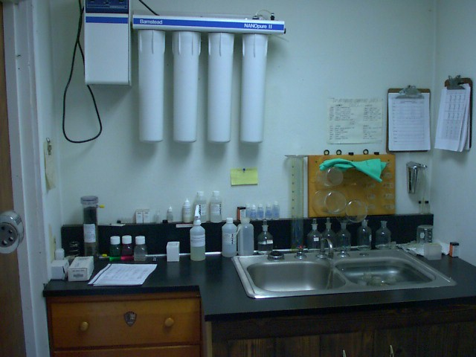

Microbiological Water Quality

The Public Health Service (PHS) and California State Water Resources Control Board Division of Drinking Water (WRCBDDW) Regulations require testing for bacteriological contaminants. Filtered-untreated water (1/month) is required by the (PHS). Analysis of the raw creek water (2/month) and distribution system analysis (2/Month) is required by the (PHS) and the (WRCBDDW). The sampling is performed regularly to verify that the water is free from Coliform bacteria.

The 2020 minimum number of distribution Coliform tests required per month for this water system, when a coliform bacterium is not present is (1). All analysis is performed at a California State Certified Laboratory. The Headquarters water system complied with drinking water standards for microbiological quality for 12 months during 2019.

Minimum number of distribution samples for the presence of Coliform bacteria required per year: 12

Number of distribution samples for the presence of Coliform bacteria conducted during the last year: 12

Number of distribution samples, which were found to contain Coliform bacteria during the year: 0

Individual tap monitoring for lead & copper

Monitoring of individual taps from locations within the water system is performed for lead & copper. This monitoring is done to verify that the delivered water does not contain lead or copper. These tests are conducted every three years.

Typical Sources of Contamination

LEAD: Internal corrosion of household water plumbing systems; discharges from industrial manufacturing; erosion of natural deposits.

COPPER: Internal corrosions of household water plumbing systems; erosion of natural deposits; leaching from wood preservatives.

This table summarizes the most recent monitoring for these constituents in micrograms per liter (ug/l):

Note that both lead and copper samples taken are below the MCL.

 | Date of most  recent samples | Number of  samples collected | Number of  samples  required | Level  detected  90th percentile  (ug/l) | Action level  (ug/l)
LEAD ==> | 2018 | 5 | 5 | 12.5 | 15
COPPER ==> | 2018 | 5 | 5 | 331.5 | 1,000

DISINFECTION BYPRODUCTS TESTING RESULTS

Generally, disinfection byproducts are the results of over chlorination. Disinfection byproducts testing from individual locations in the distribution system are required by CA State regulations. The table below summarizes the most recent sampling for disinfection byproducts.

 | Year  Tested | Level detected  (ppb) | MCL  (ppb) | PHG
Trihalomethanes | 2018 | 29.5 | 80 | none
Haloacetic Acids | 2018 | 38.2 | 60 | none

Inorganic Chemical Water Quality

These values are expressed in micrograms per liter (ug/l) unless otherwise indicated. Micrograms per liter are equivalent to parts per billion (ppb). The symbol “< “indicates less than. The letters “ND” mean that no detectable level of this chemical was found in the samples taken. Please note that not all sampling is required annually, so in some cases our results are more than one year old.

Inorganic Chemical | Date of Test | Level Detected | MCL (ug/L) | Notes
Aluminum | 09/13 | ND | 1000
Antimony | 09/13 | ND | 6
Arsenic | 09/13 | ND | 50
Asbestos | 09/20 | ND | 7 mfl
Barium | 09/13 | 4.5ppb | 1000
Beryllium | 09/13 | ND | 4
Boron | 08/12 | ND
Cadmium | 09/13 | ND | 5
Chromium | 09/13 | ND | 50
Cyanide | 01/03 | ND | 200
1,2,3-Trichloropropane | 4 Qtrs,  2018 | ND | 0.005
Copper | 08/12 | ND |  | 1000 ug/l (PHG=170 ug/l)
Fluoride | 08/05 | ND | 2 mg/l | MCLG=1mg/l
Iron | 08/16 | ND | 300
Lead | 09/13 | ND | 0.5 | PQL
Manganese | 08/12 | ND | 50
PERCHLORATE | 09/20 | ND | 6
MTBE | 08/02 | ND | 13
Mercury | 09/13 | ND | 2
Nickel | 09/13 | ND | 100
Selenium | 09/13 | ND | 50
Thallium | 09/13 | ND | 2 | MCLG = 0.5
Zinc | 08/12 | ND | 5000

Radiological Water Quality

The following are the Result of water sample analysis performed to measure radiological constituents. Headquarters water system is in compliance if the level does not exceed 5 Pico Curies per liter (pCi/l). Note: Pico Curies are the units used for the measurement of radiological activity.

Results of most recent test for radiological constituents.

Name of constituent | Date of Test | Level Detected | MCL
Gross Alpha | 07/16 | ND | 15

General Mineral and Physical Water Quality

The following constituents are not considered a health hazard but are monitored to determine consumer acceptance quality:

Name of constituent | Date of test | Level detected | MCL
Apparent-Color (unfiltered) | 09/13 | ND | 15 units
Odor - Threshold | 09/14 | ND | 3 T.O.N.
MBAS(foaming agents) | 08/12 | ND | 0.5 mg/l
Turbidity | DAILY | 0.02 Avg. | .10 NTU
Zinc | 10/95 | 0.014 | 5000 ug/l
Nitrate | 08/18 | ND | 45 mg/l
Nitrite | 08/18 | ND | 3300 ug/l
PH | DAILY | 7.00 Avg.
Fluoride | 08/12 | ND | 2 mg/l
Iron | 08/16 | ND | .3 mg/l

Name of Constituent | Date of Test | Level Detected | Recommended  Level | Short Term  Upper Level
Total Dissolved  solids | 08/12 | 60 | 500 mg/l | 1,500 mg/l
Specific Conductance | DAILY | 66 AVG. | 900  ohms/cm | 2,200 ohms/cm
Calcium | 08/12 | 5 mg/l | none | none
Chloride | 08/12 | ND | 250 mg/l | 600 mg/l
Sulfate | 08/12 | ND | 250 mg/l | 600 mg/l
Hardness | 08/12 | 16.6 | none | none
Sodium | 08/12 | 3 | 1500mg/l | 1500mg/l
TOC | 08/11 | 0.6 | - | -

GENERAL INFORMATION ON DRINKING WATER

Some people may be more vulnerable to contaminants in drinking water than the general population. Immuno-compromised persons such as persons with cancer undergoing chemotherapy, persons who have undergone organ transplants, people with HIV/AIDS or other immune system disorders, some elderly individuals, and infants can be particularly at risk from infections. These people should seek advice about drinking water from their health care providers. The USEPA/Center for disease control guidelines on appropriate means to lessen the risk of infection by cryptosporidium and other microbiological contaminants are available from the Safe Drinking Water Hotline at (1.800.426.4791).

ADDITIONAL GENERAL INFORMATION ON DRINKING WATER

Drinking water, including bottled water, may reasonably be expected to contain at least small amounts of some contamination. The presence of contamination does not necessarily indicate that the water poses a health risk. More information about contaminants and potential health effects can be obtained by calling the USEPA’s Safe Drinking Water Hotline (1-800-426-4791)

“This Consumer Confidence Report (CCR) reflects changes in drinking water regulatory requirements during 2017. All water systems are required to comply with the state Total Coliform Rule. Beginning April 1, 2016, all water systems were also required to comply with the federal Revised Total Coliform Rule. The new federal rule maintains the purpose to protect public health by ensuring the integrity of the drinking water distribution system and monitoring for the presence of microbials (i.e., total coliform and E. coli bacteria). The U.S. EPA anticipates greater public health protection as the new rule requires water systems that are vulnerable to microbial contamination to identify and fix problems. Water systems that exceed a specified frequency of total coliform occurrences are required to conduct an assessment to determine if any sanitary defects exist. If found, these must be corrected by the water system.”

Surface Water Treatment Compliance Information

The highest single day NTU on the year was .05. Regulations require treated water from the type of filtration system provided (Micro-Filtration) at this water system to meet a standard of 0.10 NTU or less, in 95% of the samples taken during the month. The Headquarters Plant met this standard in 100% of the samples taken during the year. The yearly average was .02 NTU. The treatment plant met the standard for all months in 2019.

Turbidity of the filtered water must:

- Be less than or equal to .10 NTU in 95% of measurements in a month.
- Not exceed 1.0 NTU at any time.

If you have any questions or inquiries regarding this report, please contact Russ Young at 595-6227.

