|  |  |  |  |
| --- | --- | --- | --- |
| ***2023 Consumer Confidence Report*** | | | |
|  | | | |
| The City of Fortuna is pleased to present the 2023 Consumer Confidence Report. We value our customers and want to inform you of our effort to provide a safe and dependable supply of drinking water. We test the water quality for many constituents as required by state and federal regulations. This report displays the results of monitoring for the period of January 1 through December 31, 2023 and may include earlier data. We hope this report will help you make informed choices that affect the health of you and your families. | | | |
| *Este informe contiene la información muy importante sobre su agua para beber. Favor de comunicarse la Ciudad de Fortuna a (707) 725-7600 para asistirlo en español.*  ***About Our Water***  *The City of Fortuna provides water to approximately 12,000 people and over 4,500 service connections. The City’s distribution system includes 40 miles of pipeline, 4 storage reservoirs comprising over 8 million gallons of water, and 8 booster pump stations, including 3 hydro-pneumatic stations. The City’s water originates from groundwater sources, located on Eel River Dr. between Drake Hill Rd and Kenmar Rd, where the City has 5 wells. Last year the City produced 386 million gallons of drinking water.*  *Source Water Assessments for the city’s wells were completed in April, 2003. The sources are considered most vulnerable to human and animal activity, including agricultural irrigation and drainage, grazing, and septic systems.*  ***How Our Water is Treated***  *The City of Fortuna’s water supply is treated to raise the pH, which results in reducing corrosiveness. This complies with State and Federal regulations for lead and copper. Treatment is composed of an aeration process that removes carbon dioxide gas, which is naturally dissolved in the water. After aeration, the water is then chlorinated to prevent bacteriological contamination, as required by the State Water Resources Control Board Division of Drinking Water.*  ***Storage and Pump Stations***  *The City’s 4 water storage reservoirs and 8 pump stations are inspected daily. City staff perform regular maintenance tasks, and routinely lower and fill storage reservoirs to ensure the freshest water is available for customers.*  ***Cross Connection Control Program***  *The Cross Connection Control Program protects the public water system from contamination due to backflow. A back-flow condition occurs when water from the consumer’s plumbing flows back into the City water mains. The State Board and Fortuna City Code require the installation of backflow prevention devices at all actual or potential sources of contamination, including hospitals, mortuaries, fire sprinkler systems, sewage treatment plants and customers with their own water system. These assemblies are tested annually to ensure proper operation.*  *Control (CDC) guidelines on appropriate means to lessen the risk of infection by* Cryptosporidium *and other microbial contaminants are available from the Safe Drinking Water Hotline (1-800-426-4791) or at* [*http://www.epa.gov/safewater*](http://www.epa.gov/safewater)*.*  ***Lead-Specific Language***  *If present, elevated levels of lead can cause serious health problems, especially for pregnant women and young children. Lead in drinking water is primarily from materials and components associated with service lines and home plumbing.* | ***FOR MORE INFORMATION:***  *You may attend the City of Fortuna Council meetings which are held the 1st and 3rd Mondays of the month at 6:00PM. These meetings are located in the City Hall Council Chambers at 621 11th Street, Fortuna, CA 95540 ■ (707) 725-7600 ■ FAX (707) 725-7610 ■ You may also access the agenda on the web at* [*www.friendlyfortuna.com*](http://www.friendlyfortuna.com)  ***Terms Used in This Report:***  ***MCL: Maximum Contaminant Level.*** *The highest level of a contaminant that is allowed in drinking water. Primary MCLs are set as close to the PHGs (or MCLGs) as is economically and technologically feasible. Secondary MCLs are set to protect the odor, taste, and appearance of drinking water.*  ***MCLG: Maximum Contaminant Level Goal.*** *The level of a contaminant in drinking water below which there is no known or expected risk to health. MCLGs are set by the U.S. Environmental Protection Agency (U.S. EPA).*  ***PHG: Public Health Goal.*** *The level of a contaminant in drinking water below which there is no known or expected risk to health. PHGs are set by the California Environmental Protection Agency.*  ***MRDL: Maximum Residual Disinfectant Level.*** *The highest level**of a disinfectant allowed in drinking water. There is convincing evidence that addition of a disinfectant is necessary for control of microbial contaminants.*  ***MRDLG: Maximum Residual Disinfectant Level Goal.*** *The level of a drinking water disinfectant below which there is no known or expected risk to health. MRDLGs do not reflect the benefits of the use of disinfectants to control microbial contaminants.*  ***PDWS: Primary Drinking Water Standards.*** *MCLs and MRDLs for contaminants that affect health, along with their monitoring and reporting requirements, and water treatment requirements*  ***SDWS: Secondary Drinking Water Standards.*** *MCLs for contaminants that affect taste, odor, or appearance of the drinking water. Contaminants with SDWSs do not affect the health at the MCL levels.*  ***Treatment Technique (TT):*** *A required process intended to reduce the level of a contaminant in drinking water.*  *The City of Fortuna is responsible for providing high quality drinking water, but cannot control the variety of materials used in plumbing components. When your water has been sitting for several hours, you can minimize the potential for lead exposure by flushing your tap for 30 seconds to 2 minutes before using water for drinking or cooking. If you are concerned about lead in your water, you may wish to have your water tested. Information on lead in drinking water, testing methods, and steps you can take to minimize exposure is available from the Safe Drinking Water Hotline (1-800-426-4791) or at* [*http://www.epa.gov/lead*](http://www.epa.gov/lead)*.* | ***AL: Regulatory Action Level.*** *The concentration of a contaminant which, if exceeded, triggers treatment, or other requirements that a water system must follow.*  ***ND:*** *Not detectable at testing limit.*  ***N/A:*** *Not Applicable;*  ***ppm:*** *parts per million or milligrams per liter (mg/L). Equal to 1 second in 11.5 days.*  ***ppb:*** *parts per billion or micrograms per liter (µg/L). Equal to 1 second in nearly 32 years.*  ***µS/cm:*** *Microsiemens per centimeter.*  ***The Sources of Drinking Water***  *Drinking water (both tap water and bottled water) include rivers, lakes, streams, ponds, reservoirs, springs and wells. As water travels over the surface of the land or through the ground, it dissolves naturally-occurring minerals, and, in some cases, radioactive material, and can pick up substances from the presence of animals or from human activity.*  ***Contaminants that may be present in source water include:***  ***■ Microbial Contaminants****: Viruses and bacteria that may come from sewage treatment plants, septic systems, agricultural livestock operations, and wildlife.*  ***■ Inorganic Contaminants****: Salts and metals that can be naturally-occurring or result from urban stormwater runoff, industrial or domestic wastewater discharges, oil and gas production, mining, or farming.*  ***■ Pesticides and Herbicides****: May come from a variety of sources such as agriculture, urban stormwater runoff, and residential uses.*  ***■ Organic Chemical Contaminants:*** *Include synthetic and volatile organic chemicals that are byproducts of industrial processes and petroleum production, and can also come from gas stations, urban stormwater runoff, agricultural application, and septic systems.*  ***■ Radioactive Contaminants:*** *Can be naturally-occurring or be the result of oil and gas production and mining activities.*  ***Safe Drinking Water***  *In order to ensure that tap water is safe to drink, the U.S. EPA and the State Board prescribe regulations that limit the amount of certain contaminants in water provided by public water systems. The U.S. Food and Drug Administration regulations and California law also establish limits for contaminants in bottled water that provide the same protection for public health. These agencies set water quality standards and establish testing methods and monitoring requirements for water utilities.*  *Drinking water, including bottled water, may reasonably be expected to contain at least small amounts of some contaminants. The presence of these contaminants in the water does not necessarily indicate that the water poses a health risk. More information about contaminants and potential health effects can be obtained by calling the U.S. EPA’s Safe Drinking Water Hotline (1-800-426-4791).*  *Some people may be more vulnerable to contaminants in drinking water than the general population. Immuno-compromised persons such as persons with cancer undergoing chemotherapy, persons who have undergone organ transplants, people with HIV/AIDS or other immune system disorders, some elderly, and infants can be particularly at risk for infections. These people should seek advice about drinking water from their health care providers. U.S. EPA/Centers for Disease*  ***Water Quality Monitoring Results***  *The City of Fortuna monitors for constituents in your drinking water according to state and federal laws. The State Board allows monitoring for certain contaminants less than once per year because the concentrations of these contaminants do not change frequently. Some of the data, though representative of the water quality, are more than one year old. Any violation of an AL, MCL, or MRDL is asterisked. Additional information regarding the violation is provided later in the report. You can contact the State Board at 1-530-224-4800 or* [*http://www.waterboards.ca.gov/*](http://www.waterboards.ca.gov/)*.* |

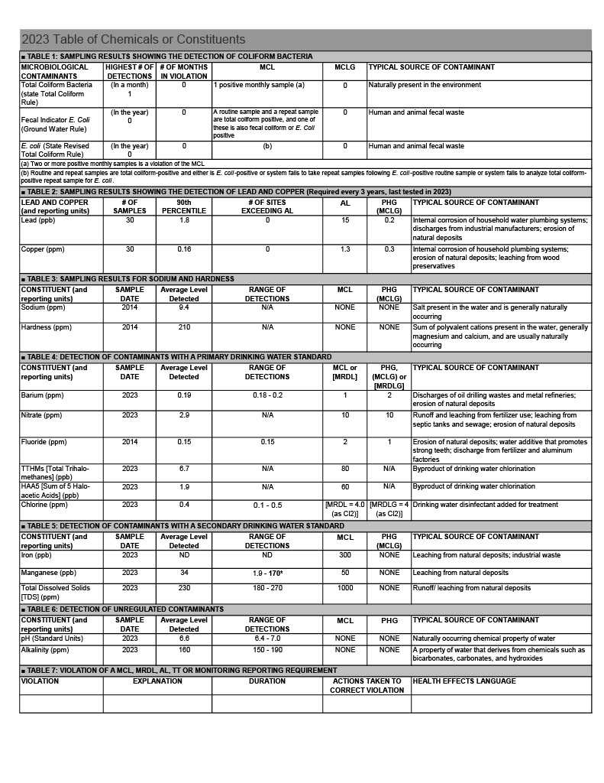

|  |
| --- |
| Water Conservation Tips for Consumers |
| Did you know that the average U.S. household uses approximately 400 gallons of water per day or 100 gallons per person per day? Luckily, there are many low-cost and no-cost ways to conserve water. Small changes can make a big difference. Visit <https://www.epa.gov/watersense> for more information.   * Take short showers – a 5 minutes shower uses 4 to 5 gallons of water compared to up to 50 gallons for a bath. * Shut off water while brushing your teeth, washing your hair, and shaving and save up to 500 gallons a month. |