2023 Consumer Confidence Report

Water System Information
Water System Name: CALIFORNIA INSTITUTION FOR MEN
Report Date: 06/01/2024
Revised: 8/27/2024
Type of Water Source(s) in Use: GROUND WATER
Name and General Location of Source(s):
DOMESTIC WELLS 1, 1A, 3A, 11A, 15, 16 ALL ARE LOCATED IN THE CHINO BASIN
Drinking Water Source Assessment Information:
Source assessment performed in 2001 for wells 1A, 3A and well 11A. All wells found to be vulnerable to Nitrate detection: Animal feeding operations, Wastewater Treatment, non-irrigated crops, Agricultural drainage and sewers. All source wells are treated.
Time and Place of Regularly Scheduled Board Meetings for Public Participation:
Inmates submit complaints to Housing Unit Officers.
For More Information, Contact:

Mr. Alex Martinez, Chief Engineer Phone: 909-606-7082

About This Report
We test the drinking water quality for many constituents as required by state and federal regulations. This report shows the results of our monitoring for the period of January 1 to December 31, 2023 and may include earlier monitoring data.

Importance of This Report Statement in Five Non-English Languages (Spanish, Mandarin, Tagalog, Vietnamese, and Hmong)
Este informe contiene información muy importante sobre su agua para beber. Favor de comunicarse CALIFORNIA INSTITUTION FOR MEN a 909-606-7207 para asistirlo en español.
这份报告含有关于您的饮用水的重要讯息。请用以下地址和电话联系 CALIFORNIA INSTITUTION FOR MEN以获得中文的帮助: 5997 EDISON AVENUE CHINO, CALIFORNIA 91710
Ang pag-uulat na ito ay naglalaman ng mahalagang impormasyon tungkol sa inyong inuming tubig. Mangyaring makipag-ugnayan sa CALIFORNIA INSTITUTION FOR MEN 5997 EDISON AVENUE CHINO, CALIFORNIA 91710 o tumawag sa 909-606-7207 para matulungan sa wikang Tagalog.
Báo cáo này chứa thông tin quan trọng về nước uống của bạn. Xin vui lòng liên hệ CALIFORNIA INSTITUTION FOR MEN tại 909-606-7207 để được hỗ trợ giúp bằng tiếng Việt.
Tsab ntawv no muaj cov ntsiab lus tseem ceeb txog koj cov dej haus. Thov hu rau CALIFORNIA INSTITUTION FOR MENntawm 909-606-7207rau kev pab hauv lus Askiv.

Terms Used in This Report
Term | Definition
Level 1 Assessment | A Level 1 assessment is a study of the water system to identify potential problems and determine (if possible) why total coliform bacteria have been found in our water system.
Level 2 Assessment | A Level 2 assessment is a very detailed study of the water system to identify potential problems and determine (if possible) why an E. coli MCL violation has occurred and/or why total coliform bacteria have been found in our water system on multiple occasions.
Maximum Contaminant Level (MCL) | The highest level of a contaminant that is allowed in drinking water. Primary MCLs are set as close to the PHGs (or MCLGs) as is economically and technologically feasible. Secondary MCLs are set to protect the odor, taste, and appearance of drinking water.
Maximum Contaminant Level Goal (MCLG) | The level of a contaminant in drinking water below which there is no known or expected risk to health. MCLGs are set by the U.S. Environmental Protection Agency (U.S. EPA).
Maximum Residual Disinfectant Level (MRDL) | The highest level of a disinfectant allowed in drinking water. There is convincing evidence that addition of a disinfectant is necessary for control of microbial contaminants.
Maximum Residual Disinfectant Level Goal (MRDLG) | The level of a drinking water disinfectant below which there is no known or expected risk to health. MRDLGs do not reflect the benefits of the use of disinfectants to control microbial contaminants.
Primary Drinking Water Standards (PDWS) | MCLs and MRDLs for contaminants that affect health along with their monitoring and reporting requirements, and water treatment requirements.
Public Health Goal  (PHG) | The level of a contaminant in drinking water below which there is no known or expected risk to health. PHGs are set by the California Environmental Protection Agency.
Regulatory Action Level  (AL) | The concentration of a contaminant which, if exceeded, triggers treatment or other requirements that a water system must follow.
Secondary Drinking Water Standards (SDWS) | MCLs for contaminants that affect taste, odor, or appearance of the drinking water. Contaminants with SDWSs do not affect the health at the MCL levels.
Treatment Technique  (TT) | A required process intended to reduce the level of a contaminant in drinking water.
Variances and Exemptions | Permissions from the State Water Resources Control Board (State Board) to exceed an MCL or not comply with a treatment technique under certain conditions.
ND | Not detectable at testing limit.
ppm | parts per million or milligrams per liter (mg/L)
ppb | parts per billion or micrograms per liter (µg/L)
ppt | parts per trillion or nanograms per liter (ng/L)
Ppq | parts per quadrillion or picogram per liter (pg/L)
pCi/L | picocuries per liter (a measure of radiation)

Sources of Drinking Water and Contaminants that May Be Present in Source Water
The sources of drinking water (both tap water and bottled water) include rivers, lakes, streams, ponds, reservoirs, springs, and wells. As water travels over the surface of the land or through the ground, it dissolves naturally-occurring minerals and, in some cases, radioactive material, and can pick up substances resulting from the presence of animals or from human activity.
Contaminants that may be present in source water include:
- Microbial contaminants, such as viruses and bacteria, that may come from sewage treatment plants, septic systems, agricultural livestock operations, and wildlife.
- Inorganic contaminants, such as salts and metals, that can be naturally-occurring or result from urban stormwater runoff, industrial or domestic wastewater discharges, oil and gas production, mining, or farming.
- Pesticides and herbicides, that may come from a variety of sources such as agriculture, urban stormwater runoff, and residential uses.
- Organic chemical contaminants, including synthetic and volatile organic chemicals, that are byproducts of industrial processes and petroleum production, and can also come from gas stations, urban stormwater runoff, agricultural application, and septic systems.
- Radioactive contaminants, that can be naturally-occurring or be the result of oil and gas production and mining activities.

Regulation of Drinking Water and Bottled Water Quality
In order to ensure that tap water is safe to drink, the U.S. EPA and the State Board prescribe regulations that limit the amount of certain contaminants in water provided by public water systems. The U.S. Food and Drug Administration regulations and California law also establish limits for contaminants in bottled water that provide the same protection for public health.

About Your Drinking Water Quality

Drinking Water Contaminants Detected
Tables 1, 2, 3, 4, 5, and 8 list all of the drinking water contaminants that were detected during the most recent sampling for the constituent. The presence of these contaminants in the water does not necessarily indicate that the water poses a health risk. The State Board allows us to monitor for certain contaminants less than once per year because the concentrations of these contaminants do not change frequently. Some of the data, though representative of the water quality, are more than one year old. Any violation of an AL, MCL, MRDL, or TT is asterisked. Additional information regarding the violation is provided later in this report.
Table 1. Sampling Results Showing the Detection of Coliform Bacteria
Complete if bacteria are detected.

Microbiological Contaminants | Highest No. of Detections | No. of Months in Violation | MCL | MCLG | Typical Source of Bacteria
E. coli | 0 | 0 | (a) | 0 | Human and animal fecal waste

(a) Routine and repeat samples are total coliform-positive and either is E. coli-positive or system fails to take repeat samples following E. coli-positive routine sample or system fails to analyze total coliform-positive repeat sample for E. coli.

Table 1.A. Compliance with Total Coliform MCL between January 1, 2023 and December 31, 2023 (inclusive)

Microbiological Contaminants | Highest No. of Detections | No. of Months in Violation | MCL | MCLG | Typical Source of Bacteria
Total Coliform Bacteria | 0 | 0 | 2 or more positive monthly samples (a) | 0 | Naturally present in the environment
Fecal Coliform and E. coli | 0 | 0 | 0 | None | Human and animal fecal waste
(a) For systems collecting fewer than 40 samples per month: two or more positive monthly samples is a violation of the total coliform MCL
For violation of the total coliform MCL, include potential adverse health effects, and actions taken by water system to address the violation: [N/A]

Table 2. Sampling Results Showing the Detection of Lead and Copper
Complete if lead or copper is detected in the last sample set.

Lead and Copper | Sample Date | No. of Samples Collected | 90th Percentile Level Detected | No. Sites Exceeding AL | AL | PHG | Typical Source of  Contaminant
Lead (ppb) | 2023 | 20 | 3.8 | 0 | 15 | 0.2 | Internal corrosion of household water plumbing systems; discharges from industrial manufacturers; erosion of natural deposits
Copper (ppb) | 2023 | 20 | 410 | 0 | 1300 | 300 | Internal corrosion of household plumbing systems; erosion of natural deposits; leaching from wood preservatives
Table 3. Sampling Results for Sodium and Hardness
Chemical or Constituent (and reporting units) | Sample Date | Level Detected | Range of Detections | MCL | PHG (MCLG) | Typical Source of Contaminant
Sodium (ppm) | 01/2023-12/2023 | 33.39 | 23.00 -  60.00 | None | None | Salt present in the water and is generally naturally occurring
Hardness (ppm) | 01/2023-12/2023 | 285.65 | 150.00 -  410.00 | None | None | Sum of polyvalent cations present in the water, generally magnesium and calcium, and are usually naturally occurring

Table 4. Detection of Contaminants with a Primary Drinking Water Standard
Chemical or Constituent  (and  reporting units) | Sample Date | Level Detected | Range of Detections | MCL [MRDL] | PHG (MCLG) [MRDLG] | Typical Source of Contaminant
Arsenic (ppb) | 01/2023-12/2023 | 0.85 | 0.00 -  5.60 | 10 | 4 | Erosion of natural deposits; runoff from orchards; glass and electronics production wastes
Barium (ppb) | 01/2023-12/2023 | 100.35 | 61.00 -  120.00 | 1,000 | 2,000 | Discharge of oil drilling wastes and from metal refineries; erosion of natural deposits
Chromium (ppb) | 01/2023-12/2023 | 10.84 | 0.00 -  27.00 | 50 | 100 | Discharge from steel and pulp mills and chrome plating; erosion of natural deposits
Fluoride (ppm) | 01/2023-12/2023 | 0.15 | 0.11 -  0.29 | 2 | 1 | Erosion of natural deposits; water additive which promotes strong teeth; discharges from fertilizer and aluminum factories
Nickel (ppb) | 01/2023-12/2023 | 1.03 | 0.00 –  7.70 | 100 | 12 | Erosion of natural deposits; discharge from metal factories
Nitrate (as nitrogen, N) (NO3-N) (ppm) | 01/2023-12/2023 | 2.40 | 4.18 –  6.40 | 10 | 45 as NO3 (=10 as N) | Runoff and leaching from fertilizer use; leaching from septic tanks and sewage; erosion of natural deposits
Perchlorate (ppb) | 01/2023-  12/2023 | 1.48 | 0.00 –  4.65 | 6 | 1 | Perchlorate is an inorganic chemical used in solid rocket propellant, fireworks, explosives, flares, matches, and a variety of industries. It usually gets into drinking water as a result of environmental contamination from historic aerospace or other industrial operations that used or use, store, or dispose of perchlorate and its salts
Selenium  (ppb) | 01/2023-12/2023 | 5.97 | 0.00 -  11.00 | 50 | 30 | Discharge from petroleum, glass and metal refineries; erosion of natural deposits; discharge from mines and chemical manufacturers; runoff from livestock lots (feed additive)
Table 5. Detection of Contaminants with a Secondary Drinking Water Standard
Chemical or Constituent (and reporting units) | Sample Date | Level Detected | Range of Detections | SMCL | PHG (MCLG) | Typical Source  of  Contaminant
Aluminum (ppb) | 01/2023-12/2023 | 29.35 | 0.00 -  170.00 | 200 | 0.6 | Erosion of natural deposits; residual from some surface water treatment processes
Chloride (ppm) | 01/2023-12/2023 | 60.57 | 21.00 -  130.00 | 500 | N/A | Runoff/leaching from natural deposits; seawater influence
Iron (ppm) | 01/2023-12/2023 | 0.13 | 0.00 -  0.86 | 0.3 | N/A | Leaching from natural deposits; industrial wastes
Manganese  (ppb) | 01/2023-12/2023 | 4.98 | 0.00 -  31.00 | 50 | N/A | Leaching from natural deposits
Specific Conductance (µS/cm) | 01/2023-12/2023 | 713.48 | 470.00 -  1100.00 | 1,600 | N/A | Substances that form ions when in water; seawater influence
Sulfate(ppm) | 01/2023-12/2023 | 65.91 | 33.00 –  130.00 | 500 | N/A | Runoff/leaching from natural deposits; industrial wastes
Total Dissolved Solids (TDS) (ppm) | 01/2023-12/2023 | 473.04 | 290.00 -  700.00 | 1,000 | N/A | Runoff/leaching from natural deposits
Turbidity (Units) | 01/2023-12/2023 | 1.03 | 0.00 -  10.00 | 5 Units | N/A | Soil runoff
Zinc (ppm) | 01/2023-12/2023 | 0.619 | 0.00 -  14.00 | 5 | N/A | Runoff/leaching from natural deposits; industrial wastes

Table 6. Disinfection Byproducts, Disinfectant Residuals, and Disinfection Byproduct Precursors
Chemical or Constituent (and reporting units) | Sample Date | Level Detected | Range of Detections | MCL [MRDL] | PHG (MCLG) | Typical Source  of  Contaminant
TTHMs [Total Trihalomethanes] (µg/L) | 2023 | 0.28 | 0 -  0.56 | 80 | N/A | Byproduct of drinking water disinfection
HAA5 [Sum of 5 Haloacetic Acids] (µg/L) | 2023 | ND | ND | 60 | N/A | Byproduct of drinking water disinfection
Chlorine (mg/L) | 2023 | 1.19 | 0.94 –  1.49 | 4.0 | 4.0 | Byproduct of drinking water disinfection

Additional General Information on Drinking Water
Drinking water, including bottled water, may reasonably be expected to contain at least small amounts of some contaminants. The presence of contaminants does not necessarily indicate that the water poses a health risk. More information about contaminants and potential health effects can be obtained by calling the U.S. EPA’s Safe Drinking Water Hotline (1-800-426-4791).
Some people may be more vulnerable to contaminants in drinking water than the general population. Immuno-compromised persons such as persons with cancer undergoing chemotherapy, persons who have undergone organ transplants, people with HIV/AIDS or other immune system disorders, some elderly, and infants can be particularly at risk from infections. These people should seek advice about drinking water from their health care providers. U.S. EPA/Centers for Disease Control (CDC) guidelines on appropriate means to lessen the risk of infection by Cryptosporidium and other microbial contaminants are available from the Safe Drinking Water Hotline (1-800-426-4791).
Lead-Specific Language: If present, elevated levels of lead can cause serious health problems, especially for pregnant women and young children. Lead in drinking water is primarily from materials and components associated with service lines and home plumbing. California Institution for Men is responsible for providing high quality drinking water, but cannot control the variety of materials used in plumbing components. When your water has been sitting for several hours, you can minimize the potential for lead exposure by flushing your tap for 30 seconds to 2 minutes before using water for drinking or cooking. [Optional: If you do so, you may wish to collect the flushed water and reuse it for another beneficial purpose, such as watering plants.] If you are concerned about lead in your water, you may wish to have your water tested. Information on lead in drinking water, testing methods, and steps you can take to minimize exposure is available from the Safe Drinking Water Hotline (1-800-426-4791) or at http://www.epa.gov/lead.

Nitrate in drinking water at levels above 10 mg/L is a health risk for infants of less than six months of age. Such nitrate levels in drinking water can interfere with the capacity of the infant’s blood to carry oxygen, resulting in serious illness; symptoms include shortness of breath and blueness of the skin. Nitrate levels above 10 mg/L may also affect the ability of the blood to carry oxygen in other individuals, such as pregnant women and those with specific enzyme deficiencies. If you are caring for an infant, or you are pregnant, you should ask advice from your health care provider.

While your drinking water meets the federal and state standard for arsenic, it does contain low levels of arsenic. The arsenic standard balances the current understanding of arsenic’s possible health effects against the cost of removing arsenic from drinking water. The U.S. Environmental Protection Agency continues to research the health effects of low levels of arsenic, which is a mineral known to cause cancer in humans at high concentrations and is linked to other health effects such as skin damage and circulatory problems

For Water Systems Providing Groundwater as a Source of Drinking Water
Table 7. Sampling Results Showing Fecal Indicator-Positive Groundwater Source Samples
Microbiological Contaminants (complete if fecal-indicator detected) | Total No. of Detections | Sample Dates | MCL [MRDL] | PHG (MCLG) [MRDLG] | Typical Source of Contaminant
E. coli | 0 | N/A | 0 | (0) | Human and animal fecal waste
Enterococci | 0 | N/A | TT | N/A | Human and animal fecal waste
Coliphage | 0 | N/A | TT | N/A | Human and animal fecal waste

Summary Information for Fecal Indicator-Positive Groundwater Source Samples, Uncorrected Significant Deficiencies, or Violation of a Groundwater TT
Special Notice of Fecal Indicator-Positive Groundwater Source Sample
None

Special Notice for Uncorrected Significant Deficiencies:

IMPORTANT INFORMATION ABOUT YOUR DRINKING WATER
Este informe contiene informacion muy importante sobre su agua potable.
Traduzcalo o hable con alguien lo entienda bien.

California Institution for Men Failed to Comply with a Corrective Action Plan/Schedule to Correct a Significant Deficiencies
Our water system recently violated a drinking water requirement. Although this incident was not an emergency, as our customers, you have a right to know what happened and what we did (are doing) to correct this situation.
An Inspection conducted on February 9, 2022 by the State Water Resource Control Board, Division of Drinking Water (DDW) found deficiencies in our water system.
As required by the Ground Water Rule, we were required to take action to:
Comply with Title 22, Code of Regulations, Section 64430, provide proof of practice documents showing the start of the design phase for replacement of:
- Ion Exchange Treatment Vessels
- CIW Transmission line.
- Plan stating the interim measures to maintain the pressure during the construction phase of the High Tank replacement.
- Replace corroded Raw Water Transmission Lines.
- Replace Fire Pump
However, we failed to take this action by the deadline established by the DDW.

What should I do?
- This is not an emergency. If it had been, you would have been notified within 24 hours.
- There is nothing you need to do. You do not need to boil your water or take other corrective actions. However, if you have specific health concerns, consult your doctor.
- People with severely compromised immune systems, infants, and some elderly may be at increased risk. These people should seek advice about drinking water from their health care providers. General guidelines on ways to lessen the risk of infection by microbes are available from U.S. EPA's Safe Drinking water Hotline at I (800) 4264791.

What happened? What is being done?
CITATION NO. 05_13 23c_027 FAILURE TO COMPLY WITH THE STATE-APPROVED CORRECTIVE ACTION PLAN FOR 2022 SANITARY SURVEY SIGNIFICANT DEFICIENCIES.
FMRCB has determined a new scheduled date by which design will be released for the three violations noted in the citation below.

The new dates for large projects have been assigned as follows:
- Treatment Vessels - Project #2223-00132.
- Replace CIW Transmission line- Project #2223-00129.
- The plan to maintain water pressure during the high tank construction phase- release for design- Project #2223-00130.
- Raw Water Main Lines Repairs.
- Replace Fire Pump

The original dates were as follows:
- 8/12/22 - Design of replacement of water softener vessels and ion exchange treatment vessels to begin — Project #2223-00132
- 2/01/23 - Design to replace CIM to CIW water transmission to begin - Project #2223-00129
- 2/01/23 - Plan to maintain water pressure during the construction phase of the high tank replacement/repair due — Project #2223-00130
- 9/01/23 – Raw Water Main Lines
- 5/01/22 Replace Fire Pump.
.

Please share this information with all the other people who drink this water, especially those who may not have received this notice directly (for example, people in apartments, nursing homes, schools, and businesses). You can do this by posting this public notice in a public place or distributing copies by hand or mail.
Secondary Notification Requirements

Upon receipt of notification from a person operating a public water system, the following notification must be given within 10 days [Health and Safety Code Section 116450(g)]:

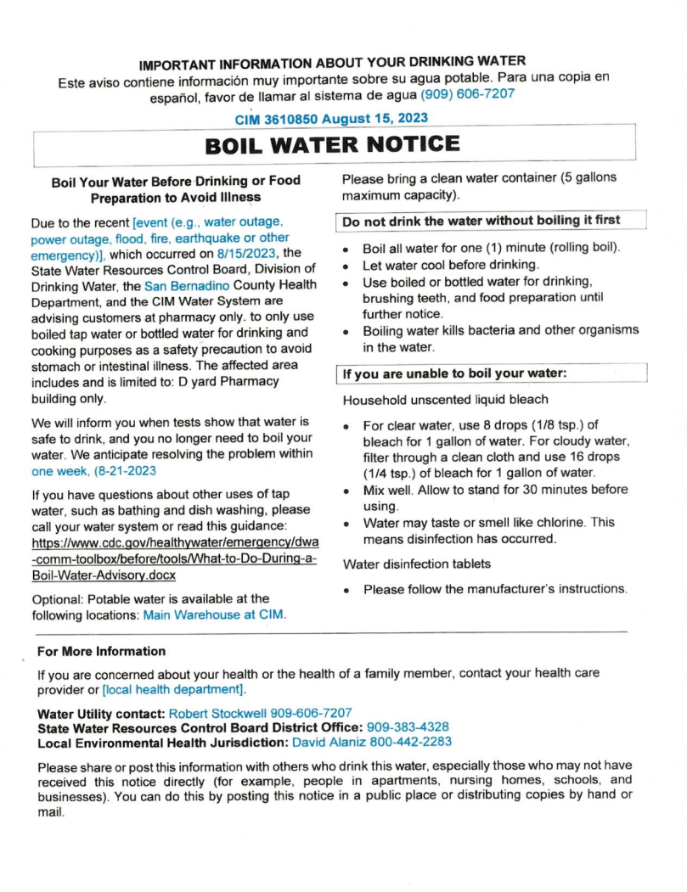
Table 8. Violation of Groundwater TT
Violation | Explanation | Duration | Actions Taken to Correct Violation | Health Effects Language
February 9, 2022  Ion Exchange treatment Vessel replacement | Aging Treatment Vessels require replacement | 24 Months | Awaiting CDCR’s  Facilities Asset Mgmt. Branch Revised (CAP). | None
February 9, 2022  CIW Transmission line. | Transmission line subject to soil erosion, relocate Transmission line | 18 Months | Awaiting CDCR’s  Facilities Asset Mgmt. Branch Revised (CAP). | None
February 9, 2022 .Plan stating the interim measures to maintain the pressure during the construction phase of the High Tank replacement. | Need to maintain Distribution Water pressure during high tank replacement construction | 12 Months | Awaiting CDCR’s  Facilities Asset Mgmt. Branch Revised (CAP). | None
February 9, 2022 Replace corroded Raw water Transmission lines | Raw water lines aged and corroded | 11 Months | Awaiting CDCR’s  Facilities Asset Mgmt. Branch Revised (CAP). | None
February 9, 2022  Existing Fire pump has outdated engine cooling system, require replacement | Replace Fire Pump | 27 Months | Awaiting CDCR’s  Facilities Asset Mgmt. Branch Revised (CAP).
February 9, 2022  Install Reservoir Tank Internal Ladder | Backup Reservoir Tank requires access ladder. | Completion 2023 | Completed 2023 | None

