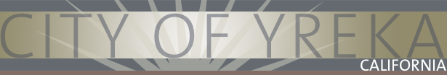
We test the drinking water quality for many constituents as required by State and Federal Regulations. This report shows the results of our monitoring for the period of January 1 – December 31, 2021

2021 Water Quality Report

We're pleased to present to you this year's Annual Drinking Water Quality Report. This report is designed to inform you about the quality of water and services we deliver to you every day. Our constant goal is to provide you with a safe and dependable supply of drinking water. We want you to understand the efforts we make to continually improve the water treatment process and protect our water resources. We are committed to ensuring the quality and safety of your water.
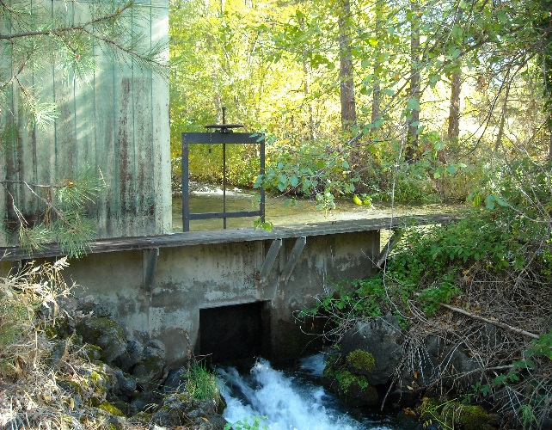
Where does your water come from? Our water source is Fall Creek, which is approximately 25 miles northeast of Yreka. This is an abundant supply of high quality water, and does not vary appreciably from season to season. The City also has an emergency water source referred to as the North Well. It is located along Yreka Creek near Montague Road. This well is on emergency standby, and is capable of producing approximately one- million gallons per day. This source meets drinking water standards as set by the State Water Resources Control Board, but the water is not as desirable as Fall Creek.

State Water Resources Control Board, Klamath District, completed an assessment of the drinking water source for Fall Creek in January of 2003. Fall Creek is considered most vulnerable to the following activities: Mining - Sand/Gravel, Surface water - streams/lakes/rivers, and Transportation corridors - Roads/Streets/Historic railroad right-of-ways. The assessment states that there have been no contaminants detected in this water supply. For more information on the Source Water Assessment, please contact the SWRCB Division of Drinking Water, Field Operations Branch at (530) 224-4800.

How is the water treated and monitored? Water from Fall Creek is chlorinated and filtered before it is delivered to our customers. All water systems using surface water are required to routinely measure the turbidity or "clarity" of the filtered water. Turbidity measurements are needed in order to monitor the effectiveness of the filtration process at removing microbiological contaminants that may be found in surface water.

How do we verify that the water is free from harmful bacteria? Water systems are required to meet a strict standard for coliform bacteria. Coliform bacteria are usually harmless, but their presence in water can be an indication of disease-causing bacteria. When coliform bacteria are found, special follow-up tests are done to determine if harmful bacteria are present in the water supply. If the standard is exceeded, the water supplier must notify the public by newspaper, television or radio. No coliform bacteria were detected in the 156 samples taken from the distribution system in 2021.

Contaminants that may be present in source water:
The sources of drinking water (both tap water and bottled water) include rivers, lakes, streams, ponds, reservoirs, springs, and wells. As water travels over the surface of the land or through the ground, it dissolves naturally-occurring minerals and, in some cases, radioactive material, and can pick up substances resulting from the presence of animals or from human activity. Contaminants that may be present in source water include:

Microbial contaminants, such as viruses and bacteria that may come from wastewater treatment plants, septic systems, agricultural livestock operations, and wildlife.
Inorganic contaminants, such as salts and metals, that can be naturally occurring or results from urban stormwater runoff, industrial or domestic wastewater discharges, oil and gas production, and mining or farming.
Pesticides and herbicides, which may come from a variety of sources such as agriculture, urban storm water runoff, and residential uses.
Organic chemical contaminants, including synthetic and volatile organic chemicals that are byproducts of industrial processes and petroleum production, and can also come from gas stations, urban stormwater runoff, and septic systems.
Radioactive contaminants, which can be naturally-occurring or be the result of oil and gas production and mining activities.

In order to ensure that tap water is safe to drink, the USEPA and the State Water Resources Control Board prescribe regulations that limit the amount of certain contaminants in water provided by public water systems. The State Board regulations also establish limits for contaminants in bottled water that must provide the same protection for public health.
Water Quality Tables: Tables 1, 2, 3, 4, and 5 list all of the drinking water contaminants and water quality indicators that were detected during the most recent sampling for the constituent. The presence of these contaminants in the water does not necessarily indicate that the water poses a health risk. The State Water Resources Control Board allows us to monitor for certain contaminants less than once per year because the concentrations of these contaminants do not change frequently. Some of the data, though representative of the water quality, are more than one year old.
Note: To help you better understand the tables, definitions are provided on the following page.

Table 1 - sampling results showing the detection of Lead and copper
Lead and Copper  sample sets are collected at least once every three years)  Sampled 08/28/19 | No. of samples collected | 90th percentile level detected | No. sites exceeding AL | Regulated Levels |  | Typical Source of Contaminant
 |  |  |  | AL | PHG
Lead (ppb) | 20 | ND | 0 | 15 | 0.20 | Internal corrosion of household water plumbing systems; discharges from industrial manufacturers; erosion of natural deposits
Copper (ppm) | 20 | ND | 0 | 1.3 | 0.30 | Internal corrosion of household plumbing systems; erosion of natural deposits; leaching from wood preservatives

TAble 2 - sampling results for sodium and hardness
Chemical or Constituent  (and reporting units) | Sample Date | Level Detected | Range of Detections | MCL | PHG  (MCLG) | Typical Source of Contaminant
Sodium (ppm) | 08/12/20 | 5.7 | N/A | none | none | Generally found in ground & surface water
Hardness (ppm) | 08/12/20 | 65 | N/A | none | none | Generally found in ground & surface water

TAble 3 - detection of contaminants with a Primary Drinking Water Standard
Chemical or Constituent  (and reporting units) | Sample Date | Level Detected | Range of Detections | MCL  [MRDL] | PHG  (MCLG)  [MRDLG] |  | Typical Source of Contaminant
Gross Alpha Radiation (pCi/L) | 08/22/18 | ND | N/A | 15 | (0) |  | Erosion of natural deposits
Aluminum (ppm) | 08/23/16 | .00083 | N/A | 1 | 0.6 |  | Erosion of natural deposits
Perchlorate (ppb) | 08/04/21 | ND | N/A | 6 | 1 |  | Inorganic chemical used in rocket propellant, fireworks,explosives, and a variety of industries
TTHMs (Total Trihalomethanes) (ppb) | 2021 | Avg: 35.2 | 14.7 – 44.1 | 80 | N/A |  | By-product of drinking water disinfection
Haloacetic Acids (ppb) | 2021 | Avg: 27.5 | 16.4 – 32.4 | 60 | N/A |  | By-product of drinking water disinfection
Chlorine (ppm) | 01/21-12/21 | N/A | 0.25 – 1.21 | [4.0] | [4.0] |  | Drinking water disinfectant added for treatment

TAble 4 - detection of contaminants with a Secondary Drinking Water Standard
Chemical or Constituent  (and reporting units) | Sample Date | Level Detected | Range of Detections | MCL | PHG  (MCLG) |  | Typical Source of Contaminant
Total Dissolved Solids (ppm) | 08/12/20 | 92 | N/A | 1000 | N/A |  | Runoff/leaching from natural deposits
Specific Conductance (uS/cm) | 08/12/20 | 150 | N/A | 1600 | N/A |  | Substances that form ions when in water
Chloride (ppm) | 08/12/20 | ND | N/A | 500 | N/A |  | Runoff/leaching from natural deposits

TAble 5 – SAMPLING RESULTS SHOWING TREATMENT OF SURFACE WATER SOURCE
Treatment Technique ^{(a)}  (Type of filtration technology used) |  |  | Direct Filtration
Turbidity Performance Standards ^{(b)}  (that must be met through the water treatment process) |  |  | Turbidity of the filtered water must:  1 – Be less than or equal to 0.30 NTU in 95% of measurements in a month.  2 – Not exceed 1.0 NTU for more than 1 hour.  3 – Not exceed 1.0 NTU for more than 8 hours.
Lowest monthly percentage of samples that met Turbidity Performance Standard No. 1. |  |  | 100% were less than or equal to 0.30 NTU
Highest single turbidity measurement during the year |  |  | May 2021: 0.11 NTU’s
Number of violations of any surface water treatment requirements |  |  | No Violations
(a) A required process intended to reduce the level of a contaminant in drinking water.
(b) Turbidity (measured in NTU) is a measurement of the cloudiness of water and is a good indicator of water quality and filtration performance. Turbidity results which meet performance standards are considered to be in compliance with filtration requirements.

In the table, there are many terms and abbreviations you might not be familiar with. To help you better understand these terms we've provided the following definitions:

TERMS USED IN THIS REPORT:
(MCL) Maximum Contaminant Level: The highest level of a contaminant that is allowed in drinking water. Primary MCLs are set as close to the PHGs (or MCLGs) as is economically and technologically feasible. Secondary MCLs are set to protect the odor, taste, and appearance of drinking water.  (MCLG) Maximum Contaminant Level Goal: The level of a contaminant in drinking water below which there is no known or expected risk to health. MCLGs are set by the U.S. Environmental Protection Agency (USEPA).  (PHG) Public Health Goal: The level of a contaminant in drinking water below which there is no known or expected risk to health. PHGs are set by the California Environmental Protection Agency.  (MRDL) Maximum Residual Disinfectant Level: The highest level of a disinfectant allowed in drinking water. There is convincing evidence that addition of a disinfectant is necessary for control of microbial contaminants.  (MRDLG) Maximum Residual Disinfectant Level Goal: The level of a drinking water disinfectant below which there is no known or expected risk to health. MRDLGs do not reflect the benefits of the use of disinfectants to control microbial contaminants. | (PDWS) Primary Drinking Water Standards: MCLs or MRDLs for contaminants that affect health along with their monitoring and reporting requirements, and water treatment requirements.  (SDWS) Secondary Drinking Water Standards: MCLs for contaminants that affect taste, odor, or appearance of the drinking water. Contaminants with SDWSs do not affect the health at the MCL levels.  (TT) Treatment Technique: A required process intended to reduce the level of a contaminant in drinking water.  (AL) Regulatory Action Level: The concentration of a contaminant which, if exceeded, triggers treatment or other requirements which a water system must follow.  Variances and Exemptions: Department permission to exceed an MCL or not comply with a treatment technique under certain conditions.  ND: not detectable at testing limit  ppm: parts per million or milligrams per liter (mg/L)  ppb: parts per billion or micrograms per liter (ug/L)  ppt: parts per trillion or nanograms per liter (ng/L)  pCi/L: picocuries per liter (a measure of radiation)  NTU: Nephelometric Turbidity Units

Only detected contaminants and the parameters that are most relevant to water quality appear in this report. Other contaminants that have been tested for, but not detected, are:
Arsenic, Antimony, Barium, beryllium, Cadmium, Fluoride, Hexavalent Chromium, Mercury, Nickel, Selenium, Thallium, Radium 228, Nitrate, Nitrite, Benzene, Toluene, Vinyl Chloride, and Xylenes.
Additional Information on Drinking Water: Drinking water, including bottled water, may reasonably be expected to contain at least small amounts of some contaminants. The presence of contaminants does not necessarily indicate that the water poses a health risk. More information about contaminants and potential health effects can be obtained by calling the USEPA’s Safe Drinking Water Hotline (1-800-426-4791).

Important Health Information: Some people may be more vulnerable to contaminants in drinking water than the general population. Immuno-compromised persons such as persons with cancer undergoing chemotherapy, persons who have undergone organ transplants, people with HIV/AIDS or other immune system disorders, some elderly, and infants can be particularly at risk from infections. These people should seek advice about drinking water from their health care providers. USEPA/Centers for Disease Control (CDC) guidelines on appropriate means to lessen the risk of infection by cryptosporidium and other microbiological contaminants are available from the Safe Drinking Water Hotline at (1-800-426-4791).

Guidance on Lead:
If present, elevated levels of lead can cause serious health problems, especially for pregnant women and young children. Lead in drinking water is primarily from materials and components associated with service lines and home plumbing. The City of Yreka Department of Public Works is responsible for providing high quality drinking water, but cannot control the variety of materials used in home plumbing components. When your water has been sitting for several hours, you can minimize the potential for lead exposure from your home plumbing by flushing your tap for 30 seconds to 2 minutes before using water for cooking or drinking. If you are concerned about lead in your water, you may wish to have your water tested at a certified lab. Information on lead in drinking water, testing methods and steps you can take to minimize exposure is available from the Safe Drinking Water Hotline at 800-426-4791 or at http://www.epa.gov/lead.
Watering Schedule – To promote water efficiency and reduce the peak water demands during the summer months, the city encourages customers to irrigate landscapes and gardens a maximum of three days per week based on the following odd-even schedule:

Addresses that end with an EVEN number (2,4,6,8,0):

Wednesday, Friday, Sunday

Addresses that end with an ODD number (1,3,5,7,9): Tuesday, Thursday, Saturday
Recommended watering hours are between 8:00 pm and 8:00 am
Properly operating drip irrigation systems and soaker hoses are encouraged and can be used on any day.
More information is available on the City of Yreka’s website.

Este informe contiene información muy importante sobre su agua potable. Tradúzcalo o hable con alguien que lo entienda bien.

Thank you for reading this Report and taking the time to learn about the efforts and challenges that are involved in providing high quality drinking water. If you have questions about this information, please contact Roy Hathaway, Water Manager, at 841-2370. Public participation is welcome at our City Council meetings, which are held at 6:30 p.m. on the first and third Tuesdays of every month at the City Council Chambers, 701 Fourth Street.

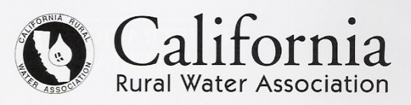
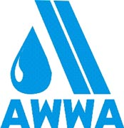
We take pride in providing safe, clean, quality water to every tap. We ask that all our customers help us protect our water sources, which are the heart of our community, our way of life and our children's future.

The City of Yreka is a proud member of:

