*Fresno County Waterworks District* 18

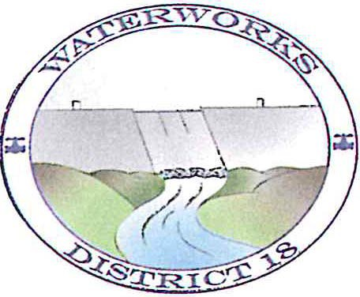

P.O Box 846

*Friant, California.* 93626-0846

(559) 822-3575

**June 25, 2023**

CONSUMER CONFIDENCE REPORT

**2022**

***Water System # 1010051***

**Fresno Count y Waterworks District #18 (Friant)**

**Este inforre contiene informacion muy importante sobre su agua potable. Traduzcalo o hable con alguien que lo entienda bien.**

**Daimntawv tshaj tawm no muaj lus tseemceeb txog koj cov dej haus. Tshab txhais nws, los yog tham nrog tej tug neeg uas totaub txog nws.**

***Water System lnformation.***

Contact persons for Waterworks District are Diego Noriega, Nathan Lopez, or Augustin Antunez. The primary telephone number is (559) 822-3575. The facsimile number is (559) 822-3577. The email address is [Noriegadiego79@gmail.com.](mailto:Noriegadiego79@gmail.com.)

District #18's members of the Board of Directors are: George Ritchie, President, Alfred Constable, Richard Davidson, Jerry Jorge and Michael Collins. The Board of Directors meets on a regular basis, the fourth Monday of every month at 6:00 p.m. at Friant Depot Shell. There are special meetings called when necessary.

During the meetings, there is an opportunity for members of the public to participate by addressing the Board on any subject concerning the District and its policies. Water board agendas are posted on bulletin boards throughout Friant.

***Source of Water.***

Surface water from Millerton Lake is the District's supply of water processed at this time. A watershed survey was completed by Keller and Wegley Consulting Engineers in 2019. This survey considered all water sources entering Millerton Lake. A copy of the most recent survey is available in the District Office for review. This survey is a requirement by California Department of Public Health (CDPH) every five (5) years.

Waterworks District 18's ongoing mission is to provide clean and refreshing water to all its' customers. ln doing so, a source water assessment was conducted for the Millerton Lake - raw water of the Fresno County Waterworks District #18 water system in January 2008. The source is considered most vulnerable to the following activities not associated with any detected contaminants:

# 1

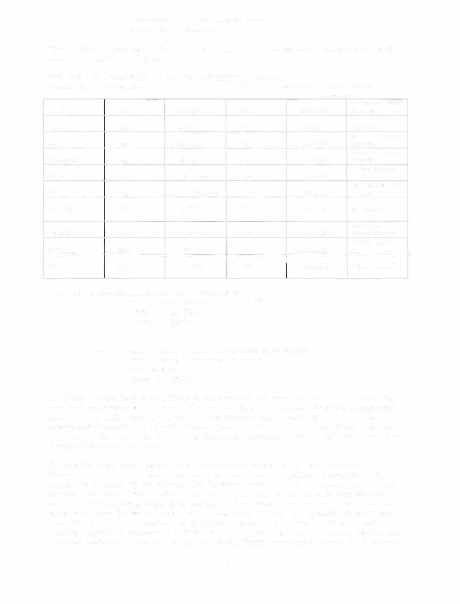Recreational area - surface water source Automobile - Gas stations

These constituents were found after running the trigger report from the Water Quality Inquire (WQI) and from the CDPH system files:

TEST RESULTS - RAW SURFACE WATER - MILLERTON LAKE 2022

**Contaminant Unit Measure MCL PHG/MCLG Units Detected Typical Source**

**Contaminant**

**ug/L**

|  |  |  |  |  |  |
| --- | --- | --- | --- | --- | --- |
| **Aluminum** | | 1000 **ug/L** | **N/A** | ND | **Erosion of Natural**  **Deposits** |
| **Arsenic** | | 50 **ug/L** | **N/A** | 2.2 Ug/L | **Erosion of Natural**  **Deposits** |
| **Iron** | | 300 **ug/L** | **N/A** | **34 ug/l** | **Erosion of Natural**  **Deposits** |
| **Manganese** | | 50 **ug/L** | **N/A** | **17 ug/l** | **Erosion of Natural**  **Deposits** |
| **Color** | | 15 **Units** | **N/A** | 15 **Units** | **Natural Sources** |
| **S.E.C.** | **ug/L** | 28 **Umho/cm** | **N/A** | 65 **ug/L** | **Ions formed when**  **in water** |
| **Turbidity** | **NTU** | 5 **NTU** | **N/A** | .89 **NTU** | **Soil Runoff** |
| **Chloride** | **mg/L** | 250 **mg/L** | **N/A** | 2.0 **mg/L** | **Runoff from**  **natural deposits** |
| **Sulfate TDS** | **mg/L mg/L** | 300 **mg/L**  500 **mg/L** | **N/A** | **1.0 mg/L** | **Natural deposits**  **Natural Runoff** |
| **N/A** | **30 mg/L** |

A copy of the complete assessments may be reviewed at:

Fresno County Waterworks District #18 17836 N. Friant Road

Friant, CA 93626

You may request a summary of the assessment be sent to you by contacting:

Fresno County Waterworks District #18

P.O. Box 846 Friant, CA 93626

The District's source water is not affected by any man made pollutants found near urban and farming areas, such as pesticides and herbicides. The water supply is routinely tested for over 100 organic and inorganic compounds, microbial and radiological constituents that are currently regulated by the Environmental Protection Agency and California Department Public Health. A copy of the annual report is attached to this report. As you can see, of these many compounds all have a "ND" (non-detected) to the right of the compound name.

The turbidity or soil runoff levels of the raw water (water entering the filtration plant before being filtered is measured and the results determine how much polymer (coagulant - Sweetwater 8809) is necessary to be mixed with the raw water and filtered to obtain a finished water product at a turbidity meeting or exceeding USEPA standards. The raw water turbidity entering the plant normally ranges from 1 to 8 NTU's, but may exceed these amounts when Millerton Lake "rolls over". This occurs when colder water enters the lake and replaces the warmer water. Turbidity has no health effects; however, high levels of turbidity can interfere with disinfection and provide a medium for microbial growth.

Turbidity may indicate the presence of disease-causing symptoms such as nausea, cramps, diarrhea and associated headaches. **The injection of chlorine into the District's water supply insures that there are no**

**2**

**contaminants in our drinking water and that the water produced meets the Primary Drinking Water Standard.**

The sources of drinking water **(both tap and bott1ed water)** include rivers, lakes, streams, ponds, reservoirs, springs and wells. As water travels over the surface of the land and through the ground, it dissolves naturally occurring minerals and in some cases, radioactive material and can pick up substances resulting from the presence of animals or from human activity.

Contaminants that may be present in source water include:

Microbial contaminants, such as viruses and bacteria that may come from sewage treatment plants, septic systems, agricultural livestock operations and wildlife.

1. Inorganic contaminants, such as salts and metals that can be naturally occurring or result from urban storm water runoff, industrial or domestic wastewater discharges, oil and gas production, mining or farming.
2. Pesticides and herbicides that may come from a variety of sources such as agriculture, urban storm water runoff and residential uses.
3. Organic chemical contaminants, including synthetic and volatile organic chemicals that are by-products of industrial processes and petroleum production and can also come from gas stations, urban storm water runoff, agricultural application and septic systems.
4. Radioactive contaminants that can be naturally occurring or be the result of oil and gas production and mining activities.

ln order to insure that tap water is safe to drink, USEPA and California Department of Water Resources prescribe regulations that limit the amount of certain contaminants in water provided by public water systems. Department regulations also establish limits for contaminants in bottle water that provide the same protection for public health. Monthly, Waterworks District #18 submits water samples for testing of contaminants. These tests are also performed for coliform or E.Coli. Fresno County Public Health Laboratory and BSK Analytical Laboratories submit the results directly to DWS electronically for their review. Fortunately for the District, we have not detected any evidence of coliform or E.Coli in any of the samples.

Drinking water, including bottled water, may reasonably be expected to contain at least small amounts of some contaminants. The presence of contaminants does not necessarily indicate that water poses a health risk. More information about contaminants and potential health effects can be obtained by calling the USEPA's Safe Drinking Water Hotline (800-426-4791).

*Ifpresent, elevated levels of lead can cause serious health problems, especially for pregnant women and young children. Lead in drinking water is primarilyfrom materials and components associated with service lines and home plumbing. Waterworks District #18 is responsible for providing high quality drinking water, but cannot control the variety of materials used in plumbing components. When your water has been sitting in your pipes for several hours, you can minimize the potential for lead exposure byflushing your tap for 30 seconds to 2 minutes before using water for drinking or cooking . Ifyou are concerned about lead in your water, you may wish to have your water tested. Information on lead in drinking water, testing methods,*

*and steps you can take to minimize exposure is availablefrom the Safe Drinking Water Hotline or at http://www. epa. govlsafewater/lead.*

Some people may be more vulnerable to contaminants in drinking water than the general population. Immune-compromised persons such as persons with cancer undergoing chemotherapy, persons who have undergone organ transplants, people with HlV/AlDS or other immune system disorders, some elderly and infants can be particularly at risk from infections. These people should seek advice about drinking water from their health care providers. USEPA Centers for Disease Control (CDC) guidelines

# 3

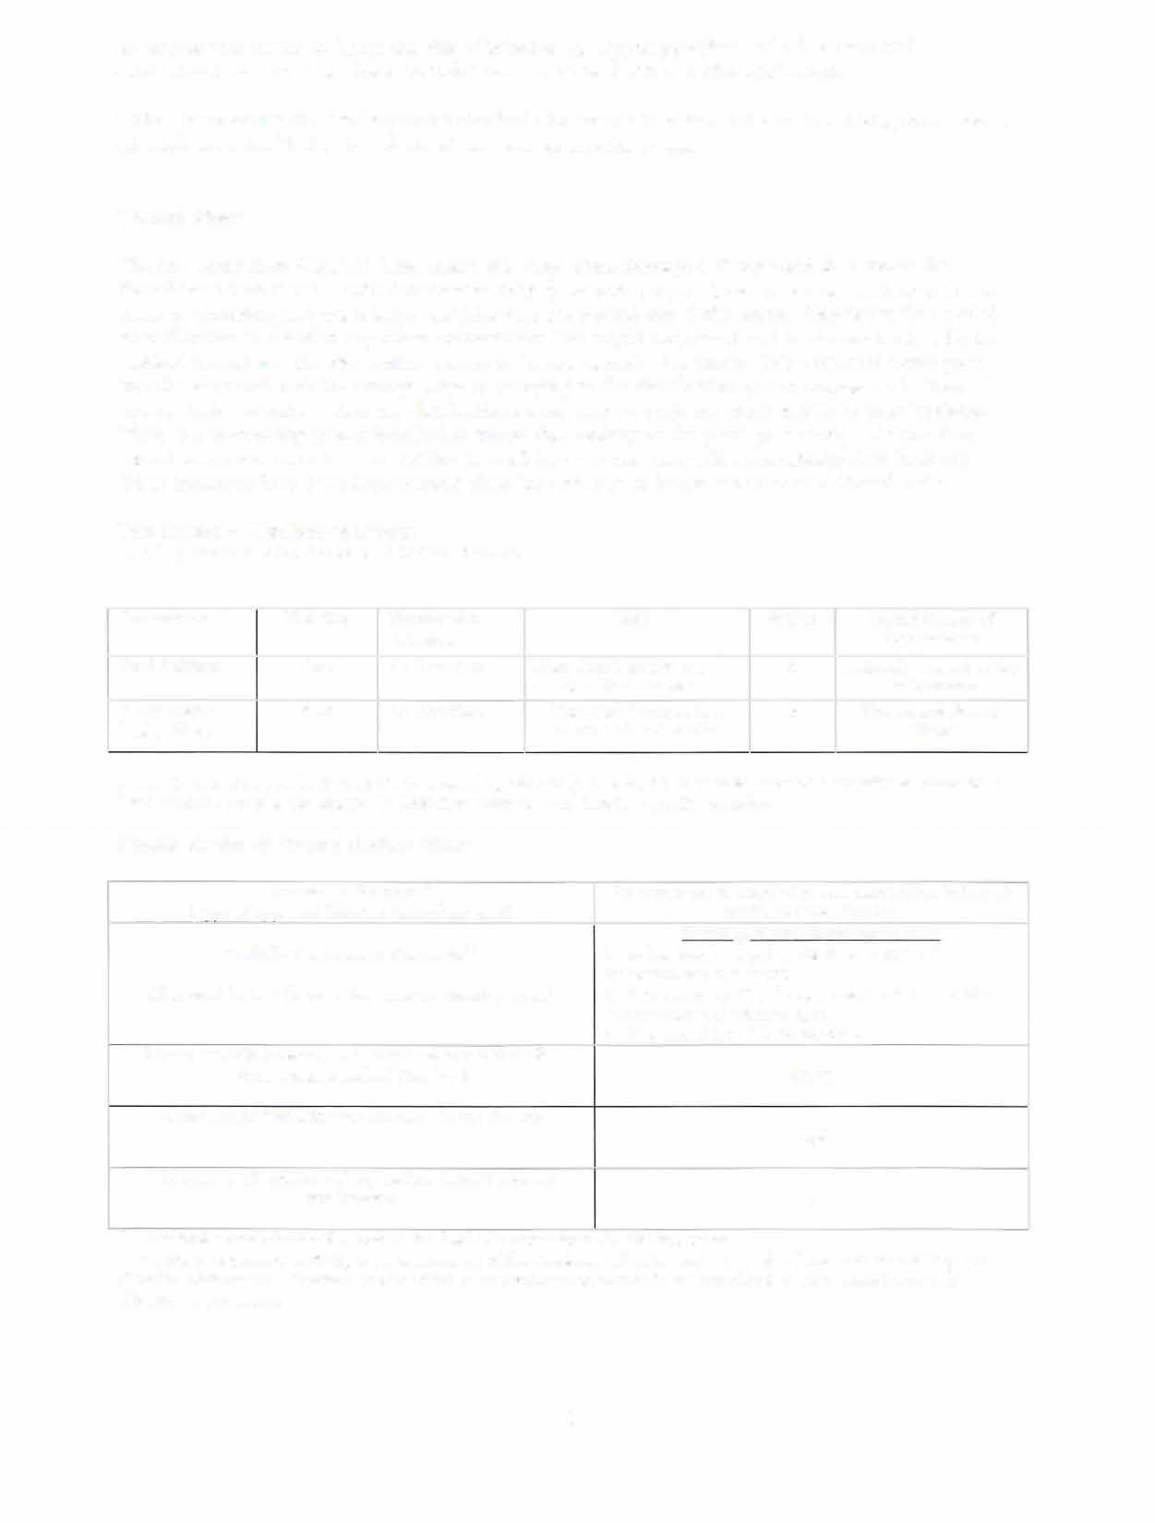*on appropriate means to lessen the risk of infection by* ***Cryptosporidium*** *and other microbial contaminants are available from the Safe Drinking Water Hotline at (800-426---4791.*

*USEPA is reviewing the drinking water standards for arsenic in water. Nitrates in drinking water above 45 mg/L are a health risk for infants of less than six months of age.*

**Treated Water**

*The raw water from Millerton Lake enters the water plant through a 6" pipe and then enters the flocculator where it mixes with Sweetwater 8809 (a cationic polymer), which causes particles in the raw water to flocculate and make larger particles that are filtered out of the water. Chlorine is then added after Altration to disinfect any other contaminants that might be present and to also maintain chlorine residual throughout the distribution system to insure bacteria free water. This processed water goes into the clear well tank for storage prior to pumping to the distribution system storage tank. From the storage tank the water enters the distribution system and through the water meters to your hook-up.*

*There is a monitoring system installed to insure that nothing at the plant goes wrong. lf a problem should occur, our operators are notified immediately and the plant will automatically shut itself off. Other measures have been implemented since June* **30, 2017** *to better secure your delivered water.*

**Test Results - Distribution System**

**Sampling results showing detection of Coliform Bacteria**

|  |  |  |  |  |
| --- | --- | --- | --- | --- |
| **Contaminant Violation** | **Months with Detections** | **MCL** | **MCLG** | **Typical Source of Contaminant** |
| **Total Coliform None** | **No Detections** | **More than 1 sample in a**  **month with a detection** | **0** | **Naturally present in the**  **environment** |
| **E. coli and/or None fecal coliform** | **No Detections** | **More than 1 sample in a month with a detection** | **0** | **Human and Animal Waste** |

**Fresno County Waterworks District** #18 **is required by Title** 22 **Section** 64423 **in regards to routine sampling to complete** 2 **Total Coliform samples per month. In** 2018 **there were no Total Coliform positive samples.**

**Sample Results of Treated Surface Water**

|  |  |
| --- | --- |
| **Treatment Technique\***  **(Type of approved filtration technology used)** | **Pre-treatment of coagulation and chlorination before tri**  **media pressure filtration** |
| **Turbidity Performance Standards\*\***  **(that must be met through the water treatment process)** | **Turbidity of the filtered water must:**   1. **Be less than or equal to** 0.3 **NTU in** 95% **of measurements in a month.** 2. **Not exceed** 1.0 **NTU for more than two consecutive measurements** 15 **minutes apart.** 3. **Not exceed** 5.0 **NTU at any time.** |
| **Lowest monthly percentage of samples that met Turbidity** |  |
| **Performance Standard Number** 1 | 5% |
| **Highest single Turbidity measurement during the year** |  |
|  | 6.0 |
| **The number of violations of any surface water treatment requirements** | 1 |

**\* A required process intended to reduce the level of a contaminant in drinking water.**

**\*\* Turbidity (measured in NTU) is a measurement of the cloudiness of water and is a good indicator of water quality and filtration performance. Turbidity results which meet performance standards are considered to be in compliance with filtration requirements.**

4

**Conservation**

The District has been told by the State of California: "Without expanded conservation efforts and more storage projects, there won't be enough water for the 15 million more people expected to live in the state by 2020". The state report also predicts that the Central Valley could fall far behind in its water needs if new water isn't found. Experts agree that conservation is the least expensive source of a water supply for the Central Valley. The economic benefits of water conservation go far beyond supply.

Saving water means saving money on future water rates and fees. Our conservation program promotes practices to "slow the flow". Please do your part in conserving water. The District has adopted "Conservation Rules" and has distributed them throughout the Community.

**Lead and Copper**

ln July of 2021, Waterworks District #18 tested ten homes and the Water Treatment Plant for lead and copper. All the test results came in as non-detected, meaning the samples had no detectable lead in them.

Out of the ten homes and the Water Treatment Plant tested for copper. Three out of ten and the Water Treatment Plant had copper in the water. All samples were below the U.S. Environmental Protection Agency 90 percentile Action Level of 1.4 mg/L. The highest individual copper sample result was .08 and the 90 percentile level was .08.

**Lead in Drinking Water:** "lf present, elevated levels of lead can cause serious health problems, especially for pregnant women and young children. Lead in drinking water is primarily from materials and components associated with service lines and home plumbing. Waterworks District #18 is responsible for providing high quality drinking water, but cannot control the variety of materials used in plumbing components. When your water has been sitting for several hours, you can minimize the potential for lead exposure by flushing your tap for 30 seconds to 2 minutes before using water for drinking or cooking. lf you are concerned about lead in your water, you may wish to have your water tested. lnformation on lead in drinking water, testing methods, and steps you can take to minimize exposure is available from the Safe Drinking Water Hotline at (800-426-4791 or at [http://www.epa.gov.safewater/lead."](http://www.epa.gov.safewater/lead)

**Additional Facts on Lead.**

* Lead is a naturally-occurring metal that for most of the 20th century was used regularly as a component of paint, piping (including water service lines), solder, brass and until the 1980's, as a gasoline additive. We no longer use lead in many of these products, but older products - such as points and plumbing fixtures in older houses - that contain lead remain. EPA and the U.S. Centers for Disease Control (CDC) report that lead paint (and the contaminated dust and soil it generates) is the leading source of lead exposure in older housing.
* While lead is rarely present in water coming from a treatment plant, it can enter tap water through corrosion of some plumbing materials.
* A number of aggressive and successful steps have been taken in recent years to reduce the occurrence of lead in drinking water.
  + ln 1986, Congress amended the national Safe Drinking Water Act to

prohibit the use of pipe, solder or flux containing high lead levels.

* + The Lead Contamination Control Act of 1988 led schools and day-care centers to repair or remove water coolers with lead-lined tanks. EPA provided guidance to inform and facilitate their action.
* Since the implementation of the Lead and Copper Rule (1991), many community drinking water systems are required to actively manage the corrosivity of water distributed to customers. ln addition, community water systems conduct routine monitoring at selected houses where lead service lines and lead solder. lf more than 10

5

of the homes tested have elevated lead levels (defined as more than 15 parts per billion), water providers must notify their consumers via several means. They must also take steps to reduce the problem, including improving corrosion control and possibly replacing lead service lines that contribute to lead contamination. ([http://www.epa.gov/OGWDW/lcrmr/pdfs/fgrg lcmr 2004.pdf)](http://www.epa.gov/OGWDW/lcrmr/pdfs/fgrglcmr2004.pdf))

* You can't see, smell or taste lead in your water. **Testing at the tap is the only way to** measure the lead levels in your home or workplace. lf you choose to have your tap water tested, be sure to use a properly certified laboratory. Testing usually costs between $20 and $100. Waterworks District #18 does these tests for you.

**Water Service Maintenance** - The District owns and maintains water services up to and including the water meter. The portion of the service line behind the meter and up to the house is the customer's responsibility to maintain. lf you have a leak behind the meter or need the water shut off for any reason, please contact the District at (559) 822-3575 to turn off the water. **Tampering with the meter is subject to a** $175.00 **penalty fee and damaging the service is a $500.00 fee.**

## Summary

The Board of Directors, operators and staff at Fresno County Waterworks District #18 do their very best to assure the highest quality and ample quantity of water to the residents of Friant as economically as possible. All operations are conducted professionally to safeguard the source water and the treated water, the water that enters your home. lf you have any questions about the treatment plant, distribution system or other concerns, please feel free to contact the District office with your questions.

## Intentionally left blank

6

Definitions

Regulatory Action Level: The concentration of a contaminant, which if exceeded, triggers treatment or others requirements that a water system must follow.

Maximum Contaminant Level or MCL: The highest level of a contaminant that is allowed in drinking water. Primary MCLs are set as close to the PHGs (or MCLGs) as is economically and technologically feasible. Secondary MCLs are set to protect the odor, taste and appearance of drinking water.

Maximum Contaminant Level Goal or MCLG: The level of a contaminant in drinking water below which there is no known or expected risk to health. MCLGs are set by the U.S. Environmental Protection Agency (USEPA).

Nephe1ometric Turbidity Unit (NTU): is a measure of the clarity of water. Turbidity in excess of 5 NTU is just noticeable to the average person.

None D tected or ND: The contaminant was not found in the drinking water.

Parts per Million (ppm): one part per million corresponds to one minute in two years or a single penny in $10,000.

Parts per Bi11ion (ppb): one part per billion corresponds to one minute in 2,000 years or a single penny in $10,000,000.

Primary Drinking Water Standard or PDWS: MCLs for contaminants that affect health along with their monitoring and reporting requirements and surface water treatments requirements.

Treatment Technique: A required process intended to reduce the level of a contaminant in drinking water.

Public Health Goal or PHG: The level of a contaminant in drinking water below which there is no known or expected risk to health. PHGs are set by the California Environmental Protection Agency.

Total Coliform: Coliforms are bacteria that are naturally present in the environment and are used as an indicator that other potentially harmful bacteria may be present.

Fecal Coliform / E.Coli: Fecal coliforms and E.Coli are bacteria whose presence indicates that the water may be contaminated with human or animal wastes. Microbes in these wastes can cause short-term effects such as diarrhea, cramps, nausea, headaches or other symptoms. They may pose a special health risk for infants, young children and people with severely compromised immune systems.

**Flocculate:** To cause to aggregate into a flocculent mass, a number of fine suspended particles.

7