2020 Annual Drinking Water Quality Report
(Consumer Confidence Report)

City of Rialto, California

Este informe contiene información muy importante acerca del Agua Potable. Tradúzcalo o hable con alguien que lo entienda bien.

CITY COUNCIL AND ELECTED OFFICIALS
Deborah Robertson, Mayor
Ed Scott, Mayor Pro Tem
Rafael Trujillo, Councilmember Andy Carrizales, Councilmember
Karla Perez, Councilmember
Edward Carrillo, City Treasurer
Barbara McGee, City Clerk

UTILITIES COMMISSION
Barbara Zrelak-Rickman, Chair
June Hayes, Vice-Chair
Kevin Kobbe, Commissioner
Richard Chitwood, Commissioner
James Shields, Commissioner

CITY EXECUTIVE STAFF
Sean Grayson, Acting City Manager
Stephen Erlandson, Deputy City Manager
Thomas. Crowley, P.E., Utilities Manager

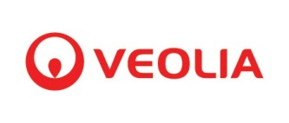

437 N. Riverside Ave Rialto, CA 92376
(909) 820-0400
Operated by

PRSRT STD ECRWSS
U.S. POSTAGE PAID
SAN BERNARDINO, CA PERMIT NO. 1506

Annual Drinking Water Report

The purpose of this report is to provide information about the quality of the water delivered to customers this past year of 2020. This report is mandated by the United States Environmental Protection Agency (USEPA) and we believe it is your right to know where your water comes from and what it contains. We are happy to report that we have consistently delivered water that has met or exceeded the standards set by State and Federal Law. More information about contaminants and potential health effects can be obtained by calling the USEPA’s Safe Drinking Water Hotline 1(800) 426-4791. For information regarding this Consumer Confidence Report please contact David Terry, Project Manager —Veolia. (909) 820-0400.

About Rialto Water Services
The City of Rialto and Rialto Utility Authority (RUA), in partnership with Rialto Water Services (RWS) formed a public-private partnership to execute a 30 year water and wastewater concession. RWS is a partnership between Table Rock Capital and the Union Labor Life Insurance Company (Ullico). RWS contracts with Veolia North America to operate the water and wastewater systems.
Under the concession agreement, the City retains full ownership of the water and wastewater systems, retains all water rights and supply, and possesses the rate-setting authority associated with the facilities. RWS provides financial backing, oversight and concession services while Veolia delivers all water and wastewater services, including billing and customer service, and oversees a $41 million capital improvement program to upgrade aging facilities.

OUR MISSION:

Rialto Water Services, operated by Veolia, is committed to the long-term performance, safety, customer and community satisfaction, and lasting cost and energy efficiencies of Rialto’s water and wastewater systems, on behalf of the City’s residents.

Customer Service: (909) 820-2546
Emergency After Hours: (909) 820-0400 On the Web: www.rialtowater.com
EPA Safe Drinking Water Hotline: (800) 426-4791
FACTS ABOUT OUR WATER SYSTEM

- In 2020, 81% of our total potable drinking water was sourced from ground water basins and 19% was surface water.

- Number of Water Service Connections = 11,945

- Miles of Water Main = 186.5

- Number of Producing Wells = 6

- Total Reservoir Capacity = 28 million gallons

- Maximum Daily Production = 15.473 million gallons

- Minimum Daily Production = 1.995 million gallons

- Average Daily Production = 7.972 million gallons

- Total Annual Production = 2.910 billion gallons

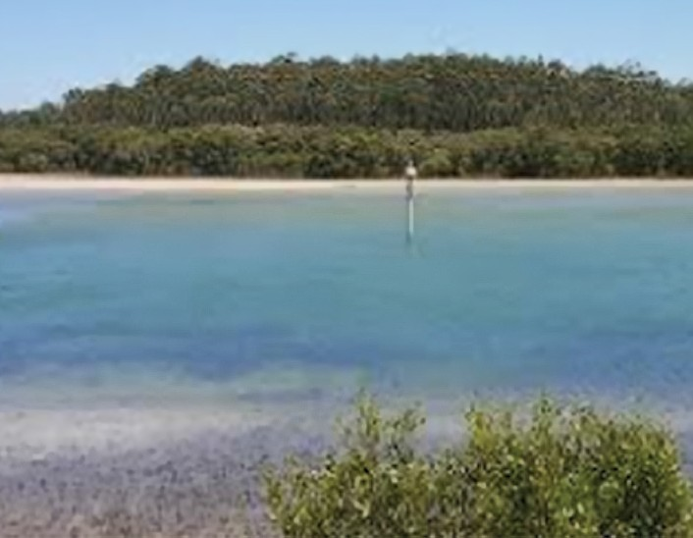
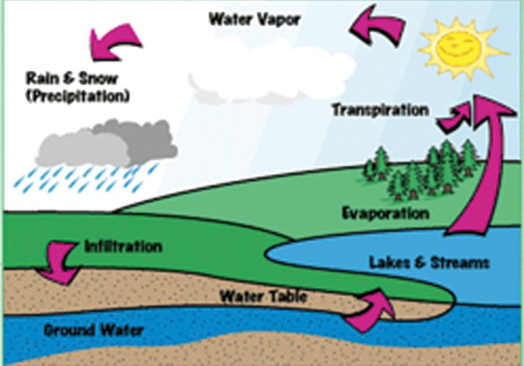

What is surface water?

It is any water that travels or is stored on top of the ground. This would be the water that is in rivers, lakes, streams, oceans--even though we can’t drink salt water. Sometimes surface water sinks into the ground and becomes ground water. Surface water is treated before it becomes drinking water.

What is ground water?

Any water that is under ground is ground water. In the water cycle, some of the precipitation sinks into the ground and goes into watersheds, aquifers and springs. Ground water flows through layers of sand, clay, rock, and gravel which cleans the water. Ground water stays cleaner than water on the surface and does not need as much treatment as surface water.

Contaminants That May be Present in Source Water:

Microbial contaminants, such as viruses and bacteria that may come from sewage treatment plants, septic systems, agricultural livestock operations, and wildlife.
Inorganic contaminants, such as salts and metals, that can be naturally-occurring or result from urban stormwater runoff, industrial or domestic wastewater discharges, oil and gas production, mining, or farming.
Pesticides and herbicides, which may come from a variety of sources such as agriculture, urban stormwater runoff and residential uses.
Organic chemical contaminants, including synthetic and volatile organic chemicals, which are byproducts of industrial processes and petroleum production, and can, also, come from gas stations, urban stormwater runoff, and septic systems.
Radioactive contaminants can naturally occur or be the result of oil and gas production and mining activities.

Perchlorate Information

Rialto has a zero tolerance policy regarding water that contains detectable levels of perchlorate.

We currently have wellhead treatment on two of our wells for the removal of perchlorate. This wellhead treatment removes the perchlorate to a non-detection level. The other wells affected by perchlorate contamination have been out of service and have not been used since the detection occurred. These responses, especially the installation of ion exchange water treatment systems, have produced a measure of success that has allowed the City to reliably deliver potable water to all of its customers.

The City of Rialto urges all of its residents to continue conserving water and to look for new ways to reduce the demand in our system. The City of Rialto continues to work with those responsible for the contamination to remediate perchlorate contamination in the water supply.

CITY OF RIALTO WATER QUALITY RESULTS FOR 2020
The State allows us to monitor for some contaminants less than once per year because the concentrations of these contaminants do not change frequently. Some of our data, though representative, are more than one year old.
PRIMARY STANDARDS - MANDATORY HEALTH -RELATED STANDARDS
Parameter | Units | MCL | PHG (MCLG) | Range Average | Water Source |  |  |  | Major Sources in Drinking Water
 |  |  |  |  | City of Rialto | West Valley Water District (WVWD) | San Bernardino Valley Municipal Water  District (BLF) | City of San Bernardino Encanto  via BLF
MICROBIOLOGICAL CONTAMINANTS

Total Coliform Bacteria  (Total Coliform Rule) | Present/ Absent (P/A) | Presence of Coliform Bacteria in 5% of Monthly Samples | N/A | 0-2% | 0.005% | 0.01% | 1% | N/A | Naturally present in the environment
Fecal Coliform and E. Coli (Total Coliform Rule) | Present/ Absent (P/A) | Presence of Total Coliform or E. Coli in a repeat sample | N/A | 0% | 0.00% | 0.00% | 0% | N/A | Human and animal feces
RADIOACTIVE CONTAMINANTS

Gross Alpha | (pCi/L) | 15 | N/A | Range | 2.14-3.71 | ND-3.9 | 3.6-5.6 | N/A | Erosion of natural deposits
 |  |  |  | Average | 3.46 | 3.1 | 4.6
Uranium | (pCi/L) | 20 | 0.43 | Range | 1.45-4.56 | NR | 3.5-5.1 | N/A | Erosion of natural deposits
 |  |  |  | Average | 2.46 | 17 | 4.3
Combined Radium 226/228 | (pCi/L) | 5 | N/A | Range | ND-0.145 | 0.60-1.8 | * | N/A | Erosion of natural deposits
 |  |  |  | Average | 0.072 | 1.3 | *
INORGANIC CONTAMINANTS

Arsenic | ug/L | 10 | 0.004 | Range | ND-3.1 | 0.70-3.9 | 1.1-1.2 | N/A | Erosion of natural deposits; runoff from orchards; glass and electronics production wastes
 |  |  |  | Average | 0.52 | 1.96 | 1.2
Barium | mg/L | 1 | 2 | Range | ND | 0.021-0.03 | 0.06-0.063 | N/A | Discharges of oil drilling wastes and from metal refineries; erosion of natural deposits
 |  |  |  | Average | ND | 0.026 | 0.062
Fluoride | mg/L | 2 | 1 | Range | 0.20-0.26 | 0.15-0.40 | 0.26-0.34 | N/A | Erosion of natural deposits; water additive that promotes strong teeth; discharge from fertilizer and aluminum factories
 |  |  |  | Average | 0.23 | 0.28 | 0.30
Hexavalent Chromium | ug/L | N/A | 0.02 | Range | * | ND | ND | N/A | Discharge from electroplating factories, leather tanneries, wood preservation, chemical synthesis, refractory  production, and textile manufacturing facilities; erosion of natural deposits
 |  |  |  | Average | * | ND | ND
Nitrate (as N) | mg/L | 10 | 10 | Range | 1.2-3.3 | 0.19-0.51 | 2.9-5.2 | N/A | Runoff and leaching from fertilizer use; leaching from septic tanks and sewage; erosion of natural deposits
 |  |  |  | Average | 2.34 | 0.33 | 3.9
Perchlorate | ug/L | 6 | 1 | Range | ND | ND | ND | N/A | Perchlorate is an organic chemical used in solid rocket propellant, fireworks, explosives, flares, matches, and a variety of industries. It usually gets into drinking water as a result of environmental contamination from historic  aerospace or other industrial operations that used or use, store, or dispose of perchlorate and its salts
 |  |  |  | Average | ND | ND | ND
Selenium | mg/L | 50 | 30 | Range | ND | ND-0.0012 | ND | N/A | Discharge from petroleum, glass, and metal refineries; erosion of natural deposits; discharge from mines and chemical  manufacturers; runoff from livestock lots (feed additive)
 |  |  |  | Average | ND | 0.0012 | ND

VOLATILE ORGANIC CONTAMINANTS

Trichloroethylene (TCE) | ug/L | 5 | 1.7 | Range | ND-0.72 | ND | ND | N/A | Discharge from metal degreasing sites and other factories
 |  |  |  | Average | .36 | ND | ND
Perfluorooctanesulfonic Acid (PFOS) | ng/L | N/A | N/A | Range | ND | * | * | N/A | Perfluoroodanesulfonic acid exposures resulted in immune suppression and cancer in laboratory animals.
 |  |  |  | Average | ND | * | *
Perfluorooct-anoic Acid (PFOA) | ng/L | N/A | N/A | Range | 3.8-4.9 | * | * | N/A | Perfluoroodanoic acid exposures resulted in increased liver weight and cancer in laboratory animals.
 |  |  |  | Average | 4.4 | * | *
SECONDARY STANDARDS - AESTHETIC STANDARDS
Parameter | Units | MCL | PHG (MCLG) | Range Average | Water Source |  |  |  | Major Sources in Drinking Water
 |  |  |  |  | City of Rialto | West Valley Water District (WVWD) | San Bernardino Valley Municipal Water  District (BLF) | City of San Bernardino Encanto via BLF

MICROBIOLOGICAL CONTAMINANTS

Aluminum | mg/L | 1 | 0.6 | Range | ND | ND-0.57 | ND | N/A | Erosion of natural deposits; residual from some surface water treatment processes
 |  |  |  | Average | ND | 0.066 | ND
Chloride | mg/L | 500 | N/A | Range | 3.9-7.8 | 1.5-56 | 9.5-10 | N/A | Run off/leaching from natural deposits; seawater influence
 |  |  |  | Average | 5.62 | 22.5 | 9.8
Foaming Agents (MBAS) | ug/L | 500 | N/A | Range | ND | ND | ND |  | Municipal and industrial waste discharges
 |  |  |  | Average | ND | ND | ND
Manganese | mg/L | 50 | NL=500 | Range | ND | ND-1.8 | 0.0020-0.0081 | N/A | Leaching from natural deposits
 |  |  |  | Average | ND | 0.03594 | 0.0057
Odor Threshold | TON | 5 | N/A | Range | ND | 1-2 | 1 | N/A | Naturally-occurring organic materials
 |  |  |  | Average | ND | 1 | 1
Specific Conductance | uS/cm | 1,600 | N/A | Range | 310-480 | 330-530 | 490-530 | N/A | Substances that form ions when in water; seawater influence
 |  |  |  | Average | 365 | 407 | 510
Sulfate | mg/L | 500 | N/A | Range | 14-52 | 22-43 | 50-51 | N/A | Run off/leaching from natural deposits; industrial wastes
 |  |  |  | Average | 22 | 33 | 51
Total Dissolved Solids (TDS) | mg/L | 1,000 | N/A | Range | 150-310 | 190-250 | 290-370 | N/A | Run off/leaching from natural deposits
 |  |  |  | Average | 216 | 220 | 324
Turbidity | Units | 5 | N/A | Range | ND-0.4 | ND-2.1 | ND-0.2 | N/A | Soil runoff
 |  |  |  | Average | 0.2 | 0.2 | 0.1
UNREGULATED Contaminants with no MCLs HEALTH EFFECTS

Boron | mg/L | N/A | NL=1 | Range | * | 0-0.082% | * | N/A | The babies of some pregnant women who drink water containing boron in excess of the notification level may have an increased risk of developmental effects, based on studies in laboratory animals
 |  |  |  | Average | * | 0.028 | *
Vanadium | ug/L | N/A | NL=50 | Range | * | ND-6.0 | 3.8-4.4 | N/A | The babies of some pregnant women who drink water containing vanadium in excess of the notification level may have an increased risk of developmental effects, based on studies in laboratory animals
 |  |  |  | Average | * | 4.3 | 4.1

OTHER PARAMETERS

Alkalinity | mg/L | N/A | N/A | Range | 130-180 | 110-200 | 180-210 | N/A | Naturally-occurring.
 |  |  |  | Average | 150 | 155 | 195
Bicarbonate | mg/L | N/A | N/A | Range | 130-180 | * | * | N/A | Biochemical role in PH buffering.
 |  |  |  | Average | 150 | * | *
Calcium | mg/L | N/A | N/A | Range | 40-72 | 32-81 | 73 | N/A | Erosion of salt deposits in soil and rock.
 |  |  |  | Average | 52 | 54 | 73
Hardness | mg/L | N/A | N/A | Range | 120-220 | 97-170 | 230 | N/A | Minerals dissolved from soil and rock.
 |  |  |  | Average | 158 | 134 | 230
Magnesium | mg/L | N/A | N/A | Range | 5.2-11 | 4.1-13 | 11-15 | N/A | Erosion of soil and rock.
 |  |  |  | Average | 6.9 | 7.8 | 13
pH | pH Units | N/A | N/A | Range | 7.8-8.2 | 7.5-8.3 | 7.7-7.9 | N/A | Characteristics of water.
 |  |  |  | Average | 8.0 | 7.9 | 7.8
Potassium | mg/L | N/A | N/A | Range | 1.7-3.2 | 1.9-3.5 | * | N/A | Erosion of salt deposits in soil and rock.
 |  |  |  | Average | 2.1 | 2.4 | *
Sodium | mg/L | N/A | N/A | Range | 11-26 | 7.9-52 | 15-16 | N/A | Erosion of salt deposits in soil and rock.
 |  |  |  | Average | 14 | 30 | 16

UNREGULATED CONTAMINANT MONITORING¹
FOURTH UNREGULATED CONTAMINANT MONITORING RULE (UCMR4)
Haloacetic Acids | ug/L | 60 | N/A | Range | ND-1.7 | ND-33 | * | N/A | Byproduct of drinking water disinfection.
 |  |  |  | Average | 0.77 | 9 | *
HAA6Br² | ug/L | N/A | N/A | Range | ND-2.2 | ND-30 | * | N/A | Unregulated contaminant monitoring helps U.S. EPA and the State Water Resources Control Board to determine where certain contaminants occur and whether the contaminants need to be regulated.
 |  |  |  | Average | 2.46 | 12 | *
HAA9³ | ug/L | N/A | N/A | Range | ND-2.2 | ND-53 | * | N/A | Unregulated contaminant monitoring helps U.S. EPA and the State Water Resources Control Board to determine where certain contaminants occur and whether the contaminants need to be regulated.
 |  |  |  | Average | 0.77 | 18 | *
Manganese | ug/L | 50 | N/A | Range | ND-70 | ND-1.8 | 1.6-6.9 | N/A | Leaching from natural deposits.
 |  |  |  | Average | 9.5 | 1.0 | 4.3

SECONDARY STANDARDS - AESTHETIC STANDARDS
Parameter | Units | MCL | PHG (MCLG) | Range Average | Water Source |  |  |  | Major Sources in Drinking Water
 |  |  |  |  | City of Rialto | West Valley Water  District (WVWD) | San Bernardino Valley Municipal Water District (BLF) | City of San Bernardino Encanto via BLF
DISINFECTION BYPRODUCTS

Total Trihalomethanes (TTHMs) | ug/L | 80 | N/A | Range | 1.6-35 | ND-73.8 | * | * | Byproduct of drinking water disinfection
 |  |  |  | Average | 11.6 | 25.8 | *
Haloacetic Acids | ug/L | 60 | N/A | Range | ND-20 | ND-25.7 | * | * | Byproduct of drinking water disinfection
 |  |  |  | Average | 2.7 | 9.0 | *
Chlorine | mg/L | 0.2-4.0 | N/A | Range | 0.6-1.50 | 0.28-2.32 | 0.64-2.12 | * | Byproduct of drinking water disinfection
 |  |  |  | Average | 1.05 | 1.17 | 1.21
CITY OF RIALTO LEAD AND COPPER

Lead | ug/L | 15 | 0.2 | # of Lead Sampling | 30 | ND | * | * | Internal corrosion of household plumbing system
 |  |  |  |  |  | ND | *
Lead - School Testing | ug/L | 15 | 0.2 | # of Schools Lead Sampling | 8 | ND-12 | * | * | Internal corrosion of household plumbing system
Copper | mg/L | 1.3 | 0.3 | # of Copper Sampling | 30 | 90th % | * | * | Internal corrosion of household plumbing system
 |  |  |  |  |  | 0.17 | *
WVWD LEAD AND COPPER

Lead | ug/L | 15 | 0.2 | # of Lead Sampling | 30 | ND | * | * | Internal corrosion of household plumbing system
 |  |  |  |  |  | ND | *
Lead - School Testing | ug/L | 15 | 0.2 | # of Schools Lead Sampling | 1 | ND | * | * | Internal corrosion of household plumbing system
Copper | mg/L | 1.3 | 0.3 | # of Copper Sampling | 30 | 90th % | * | * | Internal corrosion of household plumbing system
 |  |  |  |  |  | 0.12 | *

* Constituent not sampled for in 2020

Terms Used in This Report

Maximum Contaminant Level (MCL):
The highest level of a contaminant that is allowed in drinking water. Primary MCLs are set as close to the PHGs (or MCLGs) as is economically and technologically feasible. Secondary MCLs are set to protect the odor, taste, and appearance of drinking water.
Maximum Contaminant Level Goal (MCLG):
The level of a contaminant in drinking water below which there is no known or expected risk to health. MCLGs are set by the U.S. Environmental Protection Agency (USEPA).
Public Health Goal (PHG):
The level of a contaminant in drinking water below which there is no known or expected risk to health. PHGs are set by the California Environmental Protection Agency.
Maximum Residual Disinfectant Level (MRDL):
The level of a disinfectant added for water treatment that may not be exceeded at the consumer’s tap.
Maximum Residual Disinfectant Level Goal (MRDLG):
The level of a disinfectant added for water treatment below which there is no known or expected risk to health. MRDLGs are set by the
U.S. Environmental Protection Agency.
Primary Drinking Water Standards (PDWS):
MCLs and MRDLs for contaminants that affect health along with their monitoring and reporting requirements, and water treatment requirements.
Secondary Drinking Water Standards (SDWS):
MCLs for contaminants that affect taste, odor, or appearance of the drinking water. Contaminants with SDWSs do not affect the health at the MCL levels.

Treatment Technique (TT):
A required process intended to reduce the level of a contaminant in
drinking water.

Regulatory Action Level (AL):
The concentration of a contaminant which, if exceeded, triggers treatment or other requirements that a water system must follow.
Variances and Exemptions:
Department permission to exceed an MCL or not comply with a treatment technique under certain conditions.

NR: no range
ND: not detectable at testing limit

ppm: parts per million or milligrams per liter (mg/L) ppb: parts per billion or micrograms per liter
(ug/L) ppt: parts per billion or nanograms per liter
(ng/L) pCi/L: parts per trillion picocuries per liter (a measure of radiation)
µs/cm: microSiemen per centimeter; or micromho per centimeter (µmho/cm)

- Unregulated contaminant monitoring helps U.S. EPA and the State Water Resources Control Board to determine where certain contaminants occur and whether the contaminants need to be regulated.

- HAA6Br: Sum of Bromochloroacetic acid, bromodichloroacetic, dibromoacetic, dibromochloroacetic, monobromoacetic acid, and tribromoacetic.

- HAA9: Sum of Bromochloroacetic acid, bromodichloroacetic acid, chlorodibromoacetic acid, dibromoacetic acid, dichloroacetic acid, monobromoacetic acid, monochloroacetic acid, tribromoacetic acid and trichloroacetic acid.

Water and Employee Quality

Rialto Water Services is proud to inform residents that the Water Division has passed another annual water quality checkup. City of Rialto Water has met all the Clean Water Standards set forth by the State and Federal Governments in 2004. Part of meeting these requirements is having California Water Resources Control Board and American Water Works Association (AWWA) certified employees in water distribution, treatment and cross connection/ backflow protection. Certifications are obtained by taking college- level courses in water science and engineering. We have entered into a collective bargaining agreement that has placed even higher standards on operators and certification levels. In addition, staff continues to upgrade certifications as a part of our continuing education program. State and federal certifications allow us to operate and maintain the public water system for the City of Rialto. This is just one of the many committed efforts we put towards producing clean drinking water for our customers.

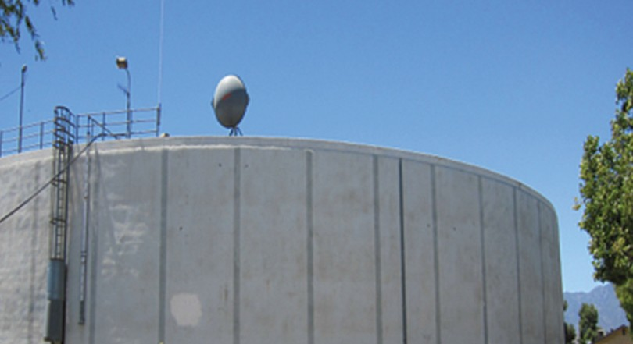
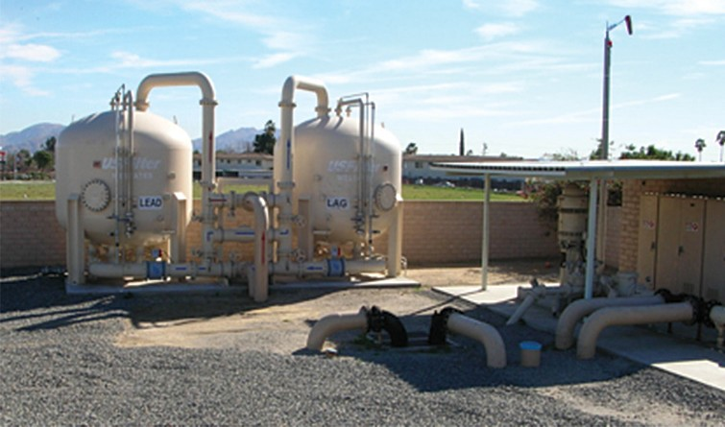
Help Us Conserve This Precious Resource

- 2020 was a dry year, now more than ever there is still a
need to conserve this precious resource. Surface water levels are not back to normal and groundwater basins, where much
of Rialto’s water comes from, are still depleted from the continuing drought. We all play an important role in meeting conservation targets set by the state, whether at home or work. Please review these simple water conservation tips and help us conserve this, our most precious natural resource.
- Fill washing machines and dishwashers before running them. Partial loads use the same amount of water as full loads.
- Little leaks add up in a hurry. A dripping faucet or a toilet leak can add up to hundreds of gallons of wasted water.
- Turn off the water while you brush your teeth.

- Be sure to use low-flow showerheads and install aerators on your kitchen and bathroom faucets. They restrict the flow without compromising water pressure.
- Do not use a hose outside to clean sidewalks and driveways. Use a broom instead.
- Follow the Stage 2 Water Alert restrictions issued by the City.

- Be waterwise and think before you turn on the tap.

The City of Rialto offers rebate programs to help you purchase high-efficiency toilets and washing machines, smart irrigation timers, high-efficiency and automatic shut off nozzles, and turf replacement. Please visit the utility’s website at www.rialtowater.com and look for the rebate application or email conservation@rialtoca.gov for more information.

For more conservation tips and other drought-related information, please visit www.rialtowaterservices.com.

