City of
Wheatland
2020
Water Quality Consumer Confidence Report

Source water Assessment:
A source water assessment has been completed for the wells serving the City of Wheatland. The sources are considered most vulnerable to the following activities not associated with any detected contaminants:
Well 3: Above ground storage tanks, construction /demolition staging areas, equipment storage areas, water supply wells, chemical/petroleum pipelines, gas stations.
Well 4: Gas stations, sewer collection systems.
Well 5: Chemical/petroleum pipelines, sewer collection systems.
Well 6: Auto & machine shops, bus terminals, grazing, septic systems, and gas stations.
Well 7: Grazing, home manufacturing, sewer collection systems.
Well 8: Sewer collection systems.
A copy of the complete assessment may be viewed at:
State Water Resource Control Board,
Division of Drinking Water or at City of Wheatland
415 Knollcrest Drive 208 4th Street
Suite 110, Redding, CA 96002 Wheatland, CA 95692
Reese Crenshaw at 530-224-4867
COVID-19 Water Information
There is no higher priority for EPA and the city than protecting the health and safety of our customers. EPA is providing this important information about COVID-19 as it relates to drinking water to provide clarity to the public. The COVID-19 virus has not been detected in drinking-water supplies. Based on current evidence, the risk to water supplies is low. Americans can continue to use and drink water from their tap as usual.
It is important to remember that water conservation is not just for drought or times of water shortage, but should be practice all the time. The City of Wheatland encourages comprehensive water-use practices that reduce the amount of stress that we place on our city resources and limits workloads from our wells, reducing wear and tear on major infrastructure such as wells and pumps, our wastewater treatment plant pumps and equipment, and the distribution systems that deliver water to our customers. Water conservation can postpone or eliminate the need for making major investments in new infrastructure. Water is not an endless resource and must be used efficiency and not be wasted. We all must do our part to learn and teach the importance of water and the wise use of it. This will ensure an adequate supply of water for us and future generations. The following tips will get you started and get you saving.
Top 10 Water Conservation Tips:
- Don’t water during daylight periods or over-water your lawn.
- Fix all water leaks quickly, especially a “running” toilet.
- Turn off the faucet while brushing your teeth or shaving.
- Only run the washing machine and dishwasher when you have a full load.
- Use a low flow shower head and faucet aerators.
- Take a shorter shower.
- Place a displacement device in the toilet tank to reduce the amount of water used per flush.
- Install a rain barrel for outdoor watering.
- Monitor and keep track of your water usage on your water bill.
- Share water saving knowledge about conservation and efficiency with your neighbors.

Please visit our web site at wheatland.ca.gov for more information

Page 7

2020 WATER QUALITY CONSUMER CONFIDENCE REPORT
Public Water System Number 5810004
2020 CALIDAD DEL AGUA INFORME DE CONFIANZA DEL CONSUMIDOR Número de sistema público de agua 5810004
Este informe contiene información muy importante sobre su agua para beber. Favor de comunicarse Ciudad de Wheatland at 111 C Street, teléfono 530-633-2761 paras asistirlo en español.
The City of Wheatland is pleased to present our 2020 annual water quality report to our customers. This edition covers all testing completed from Jan 1, 2020 through Dec 31, 2020. Last year, as in years past, your tap water met all United States Environmental Protection Agency (USEPA) and State Water Resources Control Board (SWRCB) -Division of Drinking Water health standards. City of Wheatland Water System vigilantly safeguards its water supplies and once again, we are proud to report that our system has never violated a maximum contaminant level. This brochure is a snapshot of last year’s water quality. Included are details about where your water comes from, what it contains, and how it compares to State standards. We are committed to providing you with information because informed customers are our best allies. For additional information concerning your drinking water, contact Dale Klever, Public works Director, at 530-633- 8192 or email at dklever@wheatland.ca.gov. If you wish to publicly participate in decisions affecting your drinking water quality, you may attend regularly scheduled City Council meetings on the 2nd and 4th Tues of each month. These meetings start at 6:00 pm and are located at 111 C Street, Wheatland (or by Zoom meeting). If you wish more info, you may call City Hall at 530-633-2761.
Where Does My Water Come From?
Water for the City of Wheatland originates from six groundwater sources known as Wells #3, #4, #5, #6, #7 and # 8 ranging in depth of 159 to 280 feet below ground level. The system has one ground level storage tank which holds 660,000 gals and one elevated tank that holds 72,000 gals. The elevated tank is used primarily to keep a constant pressure of approximately 48-50 psi throughout the water system. The average water consumption in the summer is approximately 1,300,000 gals per day with a peak demand of 1,740,000 gals per day. Sodium hypochlorite solution (bleach) is added at each well to disinfect and kill any possible disease-causing bacteria. The amount of bleach injected into the water is closely monitored by operators and a computer Supervisory Control And Data Acquisition (SCADA) system. The SCADA system monitors and controls the system continuously and an operator is alerted in the event of a problem, including after hours or weekends. The SCADA alarm system dials a 24-hr. standby operator on duty, so the operator may work from home to fix the problem or quickly respond if needed. The Wheatland Water System is inspected by the State Water Board -Division of Drinking Water to ensure compliance with all regulations set forth by USEPA and California Drinking Water Division, including a strict monitoring schedule. A copy of inspection reports are available upon request and shows your water meets or exceeds all state and federal standards.
Detected Contaminants in the water: These tables give a list of detected chemicals in our water as set by USEPA and the SWRCB Drinking Water Division testing schedule. Please note that not all sampling is required annually so in some cases results are more than one year old or longer. The following tables list only organic, inorganic, and secondary chemicals that were detected in your water. Your water is tested for nearly 100 other chemicals that if not listed, were not detected. The minimum detection level is typically in parts per million, parts per billion, or parts per trillion. Test results are then compared to state and federal standards to confirm your water meets all drinking water health standards. Secondary Standards contaminants are not considered to present a risk to human health
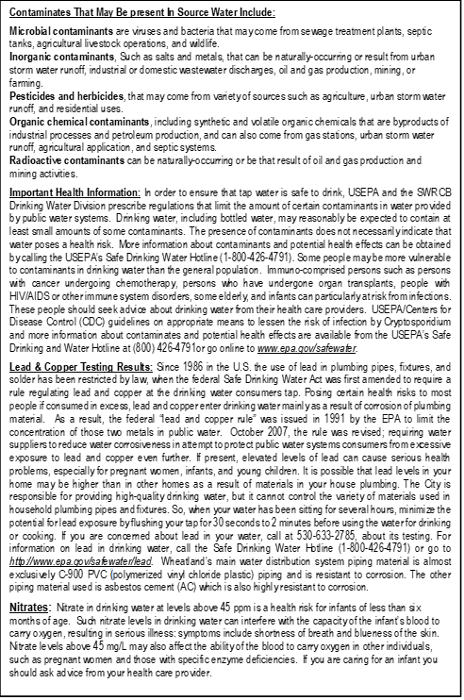
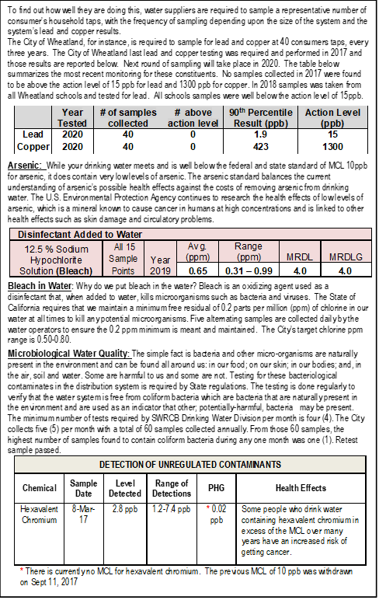
Chemical Detected | Source | Year Tested | Level Detected | MCLG | PHG | Major Source
INORGANIC CONTAMINANTS
Fluoride (Natural Source) | Well 3 | 2013 | 177 ppb | 2000 ppb | 1000 | Erosion of natural deposits; water additive which promotes strong teeth
Fluoride (Natural Source) | Well 4 | 2004 | 151 ppb | 2000 ppb | 1000
Fluoride (Natural Source) | Well 5 | 2014 | 204 ppb | 2000 ppb | 1000
Fluoride (Natural Source) | Well 6 | 2014 | 113 ppb | 2000 ppb | 1000
Fluoride (Natural Source) | Well 7 | 2013 | 151 ppb | 2000 ppb | 1000
Fluoride (Natural Source) | Well 8 | 2018 | 310 ppb | 2000 ppb | 1000
Chromium (Total) | Well 4 | 2020 | 2.4 ppb | 50 ppb | 100 | Discharge from steel and pulp mills and chrome plating; erosion of natural deposits
Chromium (Total) | Well 5 | 2020 | 3.2 ppb | 50 ppb | 100
Chromium (Total) | Well 6 | 2020 | 2.4 ppb | 50 ppb | 100
Chromium (Total) | Well 8 | 2018 | 2.7 ppb | 50 ppb | 100
Nickel | Well 4 | 2020 | 0.79 ppb | 0.05 ppm | None | Leaching from natural deposits
Nickel | Well 5 | 2020 | 0.005 ppm | 0.05 ppm | None | Leaching from natural deposits
Nickel | Well 8 | 2018 | 0.001 ppm | 0.05 ppm | None | Leaching from natural deposits
Selenium | Well 4 | 2020 | 1.2 ppb | 50 ppb | None | Discharge from petroleum, glass, and metal refineries; erosion of natural deposits; discharge from mines and chemical manufacturers; runoff from livestock lots (feed additive)
Selenium | Well 5 | 2020 | 1.6 ppb | 50 ppb | None
Selenium | Well 6 | 2020 | 1.3 ppb | 50 ppb | None
Selenium | Well 8 | 2018 | 0.78 ppb | 50 ppb | None
Barium | Well 3 | 2013 | 54 ppb | 1000 ppb | None | Discharges of oil drilling wastes and from metal refineries; erosion of natural deposits
Barium | Well 4 | 2020 | 94 ppb | 1000 ppb | None
Barium | Well 5 | 2020 | 75 ppb | 1000 ppb | None
Barium | Well 6 | 2020 | 93 ppm | 1000 ppb | None
Barium | Well 7 | 2017 | 110 ppb | 1000 ppb | None
Barium | Well 8 | 2018 | 34 ppb | 1000 ppb | None
Aluminum | Well 4 | 2020 | 2.2 ppb | 1 ppb | 0.6 | Erosion of natural deposits; residue from some surface water treatment processes
Aluminum | Well 6 | 2020 | 2.6 | 1 ppb | 0.6
Aluminum | Well 8 | 2018 | 0.015 ppb | 1 ppb | 0.6
Nitrite | Well 7 | 2009 | 0.25 ppb | 1000 ppb | None | Runoff and leaching from fertilizer use; leaching from septic tanks and sewage; erosion of natural deposits
Nitrate (as N) | Well 3 | 2020 | 2.4 ppm | 10 ppm | 10
Nitrate (as N) | Well 4 | 2020 | 4.5 ppm | 10 ppm | 10
Nitrate (as N) | Well 5 | 2020 | 3.0 ppm | 10 ppm | 10
Nitrate (as N) | Well 6 | 2020 | 4.8 ppm | 10 ppm | 10
Nitrate (as N) | Well 7 | 2020 | 2.3 ppm | 10 ppm | 10
Nitrate (as N) | Well 8 | 2020 | 0.74 ppm | 10 ppm | 10
Arsenic | Well 3 | 2019 | 1.8 ppb | 10 ppb | 0.004 | Erosion of natural deposits; runoff from orchards; glass and electronics production wastes
Arsenic | Well 4 | 2019 | 0.72 ppb | 10 ppb | 0.004
Arsenic | Well 5 | 2019 | 1.2 ppb | 10 ppb | 0.004
Arsenic | Well 6 | 2019 | 0.65 ppb | 10 ppb | 0.004
Arsenic | Well 7 | 2019 | 1.2 ppb | 10 ppb | 0.004
Arsenic | Well 8 | 2020 | 3.1 ppb | 10 ppb | 0.004
UNREGULATED CONTAMINANTS
Boron | Well 6 | 2003 | 340 ppb | UCMR | 1000 | Erosion/ Leaching of natural deposits
Boron | Well 7 | 2003 | 100 ppb | UCMR | 1000 | Erosion/ Leaching of natural deposits
Boron | Well 8 | 2006 | 360 ppb | UCMR | 1000 | Erosion/ Leaching of natural deposits
Vanadium | Well 3 | 2003 | 8.6 ppb | UCMR | None | Erosion/ Leaching of natural deposits
Vanadium | Well 4 | 2002 | 6.7 ppb | UCMR | None | Erosion/ Leaching of natural deposits
Vanadium | Well 5 | 2002 | 9.2 ppb | UCMR | None | Erosion/ Leaching of natural deposits
Vanadium | Well 6 | 2002 | 6.4 ppb | UCMR | None | Erosion/ Leaching of natural deposits
Vanadium | Well 7 | 2003 | 5 ppb | UCMR | None | Erosion/ Leaching of natural deposits
Vanadium | Well 8 | 2004 | 21 ppb | UCMR | None | Erosion/ Leaching of natural deposits
