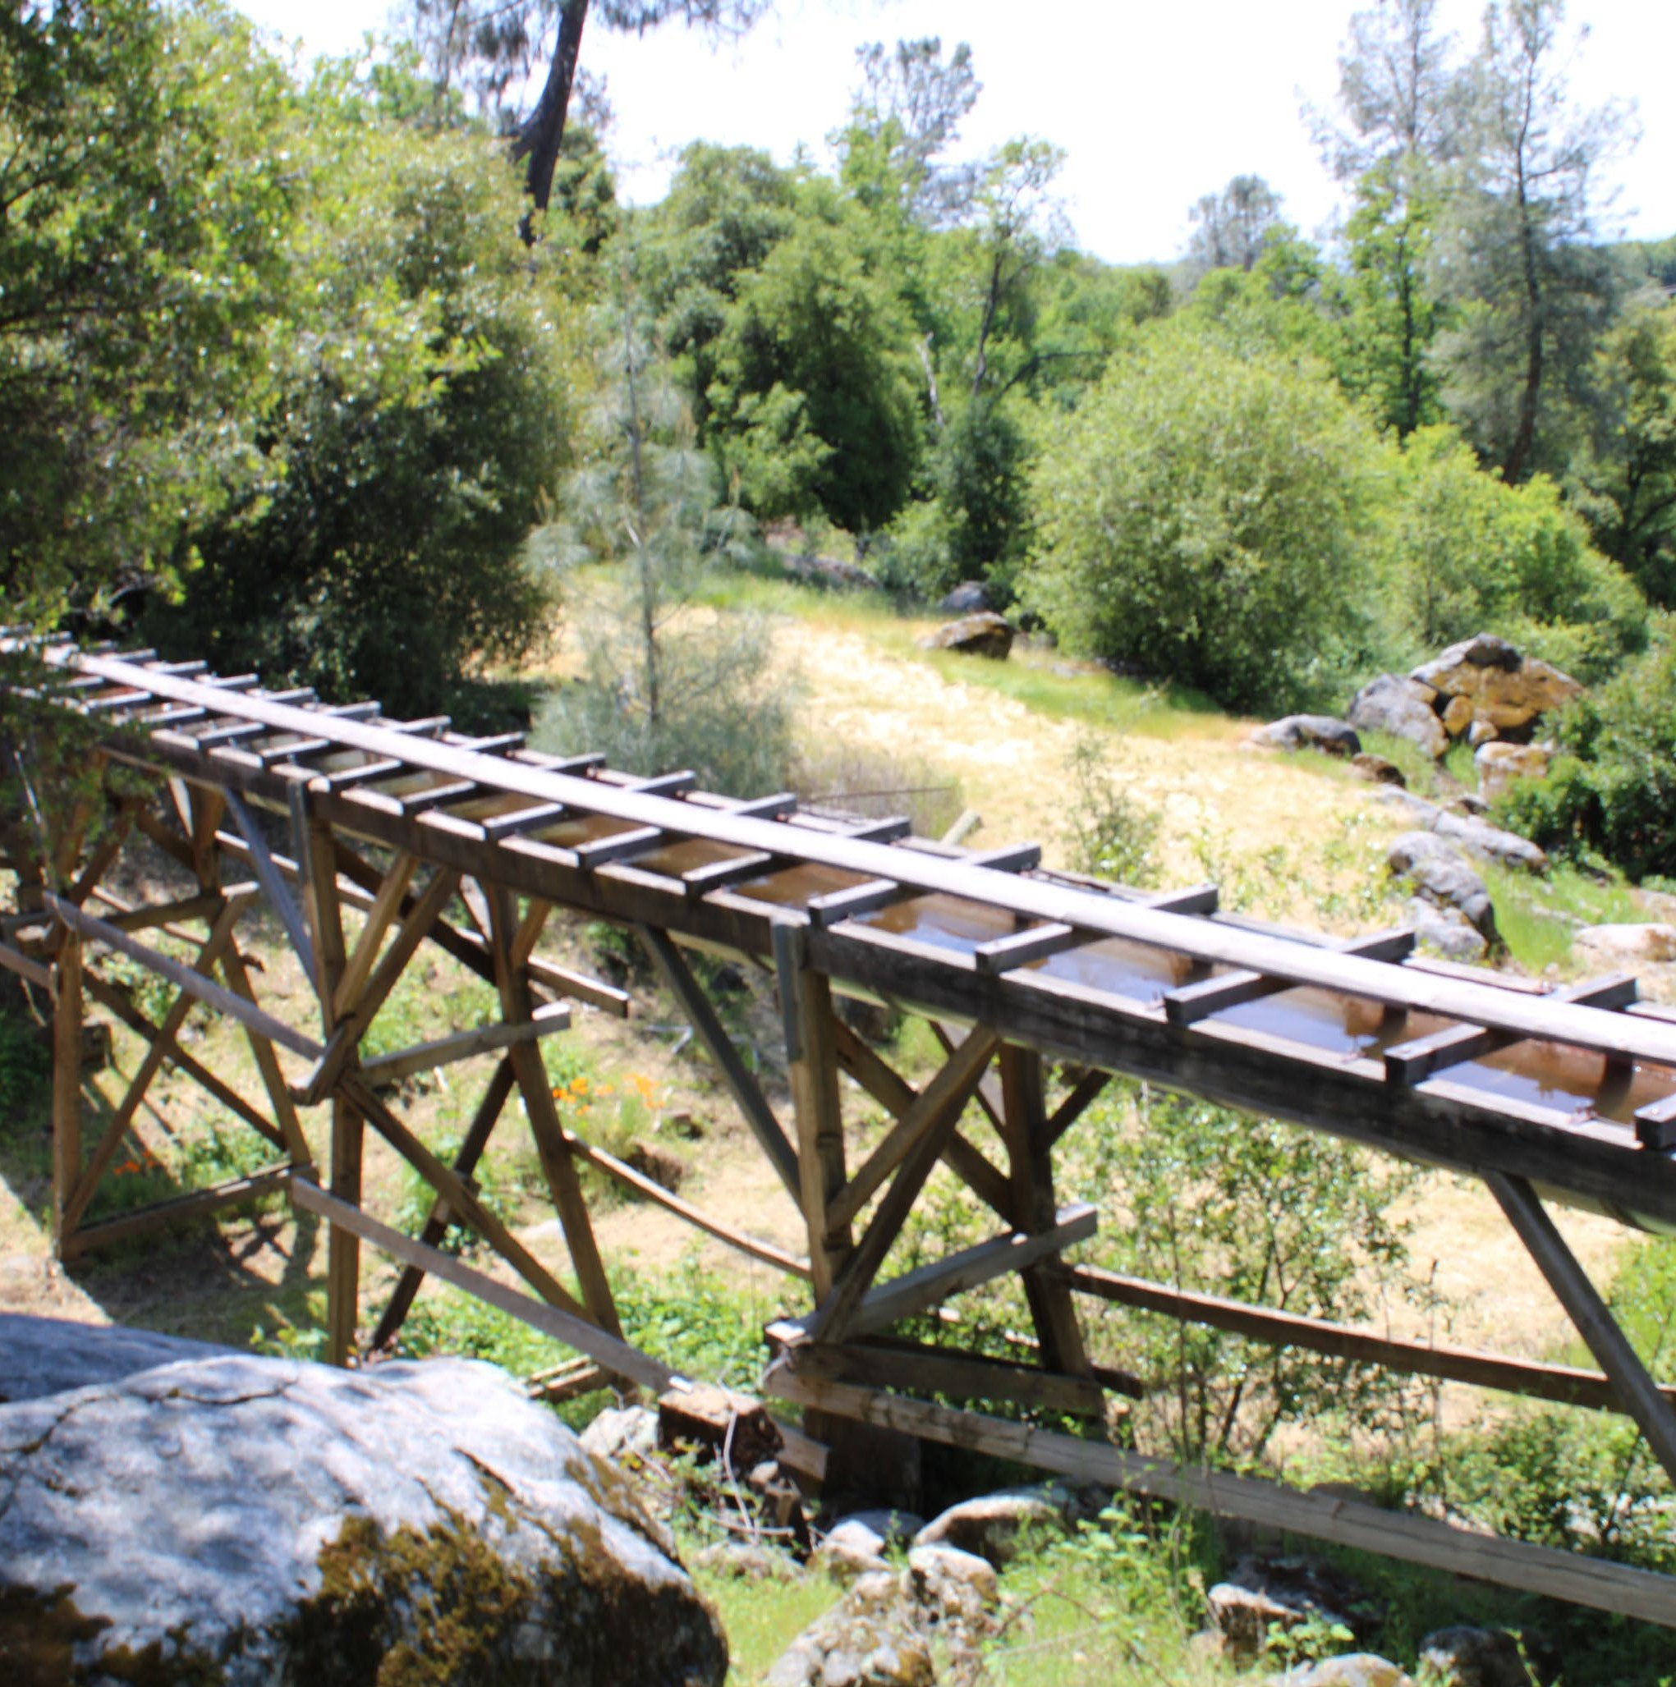



Reporting Year 2024

Presented By
Tuolumne Utilities District
Este informe contiene información muy importante sobre su agua potable. Tradúzcalo o hable con alguien que lo entienda bien.

Our Commitment
W
e are pleased to present to you this year’s annual water quality report. This report is a snapshot of last year’s water quality covering all testing performed between January 1 and December 31, 2024. Included are details about
your sources of water, what it contains, and how it compares to standards set by regulatory agencies. Our constant goal is to provide you with a safe and dependable supply of drinking water. We want you to understand the efforts we make to continually improve the water treatment process and protect our water resources. We are committed
to ensuring the quality of your water and providing you with this information because informed customers are our best allies.

Where Does My Water Come From?
T
he most important factor in water quality is the source. There are two sources of water supply from which TUD receives its water: surface water that originates from rainfall and runoff from snowpack in the Sierra Nevada mountains and groundwater from wells throughout our water system. The district is composed of 11 water service areas that include nine surface water treatment plants and
10 active wells that produce and supply quality drinking water to these service areas.
Our surface water is delivered to TUD treatment plants starting at the South Fork of the Stanislaus River at Lyons Reservoir via the Tuolumne Main Canal by agreement with Pacific Gas and Electric Company (PG&E). PG&E owns and operates Pinecrest Lake, Lyons Reservoir, and the Tuolumne Main Canal. Approximately 96 percent of TUD’s annual water needs are supplied with surface water from Lyons Reservoir and Pinecrest Lake; the other 4 percent is supplied from groundwater wells, either as a primary or backup source. To learn more about our watershed, visit U.S. EPA’s How’s My Waterway at epa.gov/waterdata/hows-my-waterway.

Community Participation
T



he public is invited and encouraged to attend the district’s regularly scheduled board meetings, which occur on the second and fourth Tuesday of each month at 9:00 a.m. These meetings are held in accordance with the federal Americans with Disabilities Act. During the meeting, members of the public who wish to comment will be invited to do so by the
board president.
Options for public access audio and video livestreaming: The public will not have access for public comments via this media option; they are available for audio and visual only. The public may observe and listen to this meeting on Tuolumne Utilities District’s (TUD) YouTube channel. The district is providing this option as a convenience to the public. If the district experiences technical difficulties and the transmission goes down, the meeting will continue in person as scheduled.

Important Health Information
S
ome people may be more vulnerable to contami- nants in drinking water than the general population. Immunocompromised persons such as persons with cancer undergoing chemotherapy, persons who have undergone organ transplants, people with HIV/AIDS or other immune system disorders, some elderly, and infants can be particularly at risk from infections. These people should seek advice about drinking water from their health-care provid-
ers. U.S. Environmental Protection Agency (U.S. EPA)/Centers for Disease Control and Prevention (CDC) guidelines on appropriate means to lessen the risk of infection by Cryptosporidium and other microbial contaminants are available from the Safe Drinking Water Hotline at (800) 426-
4791 or epa.gov/safewater.

Water Stress
ater stress occurs when the demand for water exceeds the amount available during a cer-
W
tain period or when poor water quality restricts its use. Water stress causes deterioration of freshwater resources in terms of quantity (aquifer overexploita- tion, dry rivers, etc.) and quality (eutrophication, organic matter pollution, saline intrusion, etc.).
According to the World Resources Institute (wri.org), the Middle East and North Africa remain the most water-stressed regions on Earth. However, several states in the western half of the U.S. are similarly experiencing extremely high levels of water stress from overuse. It is clear that even in countries with low overall water stress, individual communities may still be experiencing extremely stressed conditions. For example, South Africa and the United States rank 48 and 71 on WRI’s list, respectively, yet the Western Cape (the state home to Cape Town) and New Mexico experience extremely high stress levels.
There are undeniably worrying trends in water quality. But by taking action now and investing in better management, we can solve water issues before it’s too late.

Questions?
For more information about this report, or for any questions relating to your drinking water, please call Rachel Taylor, Regulatory Compliance Specialist, at (209) 532-5536,
extension 537.

Substances That Could Be in Water
What’s Your Water Footprint?
Y
ou may have some understanding about your carbon footprint, but how much do you know about your water footprint?
The water footprint of an individual, community, or business is defined as the total volume of freshwater that is used to produce the goods and services that are consumed by the individual or community or produced by the business. For example, 11 gallons of water is needed to irrigate and wash the fruit in one half-gallon container of orange juice. Thirty-seven gallons of water is used to grow, produce, package, and ship the beans in that morning cup of coffee. Two hundred and sixty-four gal- lons of water is required to produce one quart of milk, and 4,200 gallons of water is required to produce two pounds of beef.
According to the U.S. EPA, the average American uses over 180 gallons of water daily. In fact, in the developed world, one flush of a toilet uses as much water as the average person in the developing world allocates for an entire day’s cooking, washing, cleaning, and drinking. The annual American per capita water footprint is about 8,000 cubic feet, twice the global per capita average. With water use increasing sixfold in the past century, our demands for freshwater are rapidly outstripping what the planet can replenish. To check out your own water footprint, go to watercalculator.org.
T
he sources of drinking water (both tap water and bottled water) include rivers, lakes, streams, ponds, reservoirs, springs, and wells. As water travels over the surface of the land or through the ground, it dissolves naturally occurring minerals and, in some cases, radioactive material and can pick up substances resulting from the presence of animals or from
human activity.
Contaminants that may be present in source water include:
Microbial Contaminants, such as viruses and bacteria, which may come from sewage treatment plants, septic systems,
agricultural livestock operations, and wildlife.
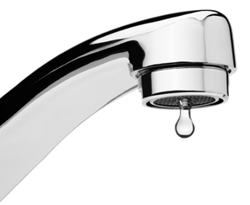
Inorganic Contaminants, such as salts and metals, which can be naturally occurring or result from urban stormwater runoff, industrial or domestic wastewater discharges, oil and gas production, mining, or farming.
Pesticides and Herbicides, which may come from a variety of sources such as agriculture, urban stormwater runoff, and residential uses.
Organic Chemical Contaminants, including synthetic and volatile organic chemicals, which are by-products of industrial processes and petroleum production and can also come from gas stations, urban stormwater runoff, agricultural application, and septic systems.
Radioactive Contaminants that can be naturally occurring or the result of oil and gas production and mining activities.
To ensure that tap water is safe to drink, the U.S. EPA and the State Water Resources Control Board (SWRCB) prescribe regulations that limit the amount of certain contaminants in water provided by public water systems. Food and Drug Administration (FDA) regulations and California law also establish limits for contaminants in bottled water that provide the same protection for public health.
Drinking water, including bottled water, may reasonably be expected to contain at least small amounts of some contaminants. The presence of contaminants does not necessarily indicate that water poses a health risk. More information about contaminants and potential health effects can be obtained by calling the U.S. EPA’s Safe Drinking Water Hotline at (800) 426-4791.

Naturally Occurring Bacteria
he simple fact is bacteria and other microorganisms inhabit our world. They can be found all around us: in
T
our food, on our skin, in our bodies, and in the air, soil, and water. Some are harmful to us and some are not. Coliform bacteria are common in the environment and generally not harmful themselves. The presence of this bacterial form in drinking water is a concern because it indicates that the water may be contaminated with other organisms that can cause dis- ease. Throughout the year, we tested many water samples for coliform bacteria. In that time, none of the samples came back positive for the bacteria.
Federal regulations require that public water that tests positive for coliform bacteria must be further analyzed for fecal coliform bacteria. Fecal coliforms are present only in human and animal waste. Because these bacteria can cause illness, it is unacceptable for fecal coliforms to be present in water at any concentration. Our tests indicate no fecal coliform is present in our water.
Fixtures With Green Stains
A
green or blue-green stain on kitchen or bathroom
fixtures is caused by tiny amounts of copper that dissolve in your home’s copper plumbing system when the water sits unused overnight. Copper staining may be the result of a leaky faucet or a faulty toilet flush valve, so be sure your plumbing is in good working order.
Copper stains may also be caused by overly hot tap water. Generally speaking, you should maintain your water temperature at a maximum of 120 degrees Fahrenheit. You should consult the owner’s manual for your heater or check with your plumber to determine your current heat setting. Lowering your water temperature will reduce the staining problem and save you money on your energy bill.
Also keep in mind that a tap that is used often throughout the day usually will not produce copper stains, so if you flush the tap for a minute or so before using the water for cooking or drinking, copper levels will be reduced.




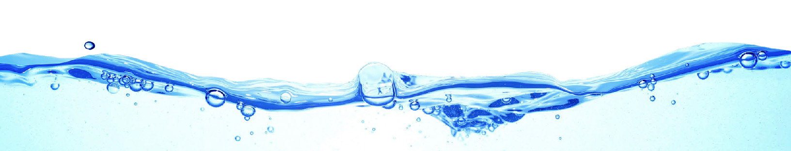
FOG (Fats, Oils, and Grease)

3.4 BILLION
The daily volume in gallons of water recycled and reused in the U.S., reducing waste and conserving resources.

28%
The percent reduction in per capita water use in the
U.S. since 1980, thanks to efficiency improvements.

99.99%
The percent effectiveness of modern water treatment plants in removing harmful bacteria and viruses from drinking water.

1.2 MILLION
The length in miles of drinking water pipes in the
U.S. delivering clean water to millions of homes and businesses daily.

1.7MILLION
The number of jobs supported by the U.S. water sector.
Y
ou may not be aware of it, but every time you pour fat, oil, or grease (FOG) down your sink (e.g., bacon grease), you
are contributing to a costly problem in the sewer collection system. FOG coats the inner walls of the plumbing in your house as well as the walls of underground piping throughout the community. Over time, these greasy materials build up and form blockages in pipes, which can lead to wastewater backing up into parks, yards, streets, and storm drains. These backups allow FOG to contaminate local waters, including drinking water. Exposure to untreated wastewater is a public health hazard. FOG discharged into septic systems and drain fields can also cause malfunctions, resulting in more frequent tank pump-outs and other expenses.
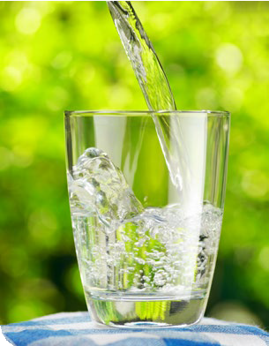
Communities spend billions of dollars every year to unplug or replace grease-blocked pipes, repair pump stations, and clean up costly and illegal wastewater spills. Here are some tips that you and your family can follow to help maintain a well-run system now and in the future:
NEVER:
- Pour FOG down the house or storm drains.
- Dispose of food scraps by flushing them.
- Use the toilet as a wastebasket.
ALWAYS:
- Scrape and collect FOG into a
waste container such as an empty coffee can, and dispose of it with your garbage.
- Place food scraps in waste containers or garbage bags for disposal with solid wastes.
- Place a wastebasket in each bathroom for solid wastes like disposable diapers, creams and lotions, and personal hygiene products, including nonbiodegradable wipes.

Protecting Your Water
B
acteria are a natural and important part of our world. There are around 40 trillion bacteria living in each of us; without them, we would not be able to live healthy lives. Coliform bacteria are common in the environment and generally not harmful themselves. The presence of this bacterial form in drinking water is a concern, however, because it indicates that the
water may be contaminated with other organisms that can cause disease.
In 2016 the U.S. EPA passed a regulation called the Revised Total Coliform Rule, which requires water systems to take additional steps to ensure the integrity of the drinking water distribution system by monitoring for the presence of bacteria like total coliform and E. coli. The rule requires more stringent standards than the previous regulation, and it requires water systems that may be vulnerable to contamination to have procedures in place that will minimize the incidence of contamination. Water systems that exceed a specified frequency of total coliform occurrences are required to conduct an assessment and correct any problems quickly. The U.S. EPA anticipates greater public health protection under this regulation due to its more preventive approach to identifying and fixing problems that may affect public health.
Though we are fortunate in having the highest-quality drinking water, our goal is to eliminate all potential pathways of contamination into our distribution system, and this requirement helps us accomplish that goal.

Source Water Assessment
A
n assessment of the drinking water sources for the TUD water system was completed in 2022. The vulnerability summary for each system is included. A copy of the complete assessment of each system may be viewed at the California Division of Drinking
Water, Yosemite District 28 Office, 265 W. Bullard Ave., Suite 101, Fresno, California 93704.

VULNERABILITY | APPLE VALLEY | PEACEFUL PINES | PHOENIX LAKE | SONORA | PONDEROSA | TUOLUMNE | UPPER BASIN | COLUMBIA | CEDAR RIDGE | SCENIC VIEW | WARDS FERRY
Sewer Collection | X |  |  | X |  | X | X | X
Septic System Low Density |  |  |  | X |  | X |  | X |  |  | X
Septic System High Density |  | X | X | X | X |  | X |  | X | X
Grazing | X |  |  |  |  |  | X |  |  |  | X
Other Animal Operations | X |  |  |  |  |  | X
Lumber Processing/ Manufacturing | X |  |  | X
Wood/Pulp/Mills |  |  |  |  |  |  |  | X
Recreational/Surface water source |  |  |  | X | X | X | X | X | X | X
Historic waste dumps/ landfills |  |  |  | X |  |  | X
Auto/Machine Shop |  |  |  | X
Car Washing |  |  |  | X
Dry Cleaners |  |  |  | X
Highways/Transportation Corridor |  |  |  | X

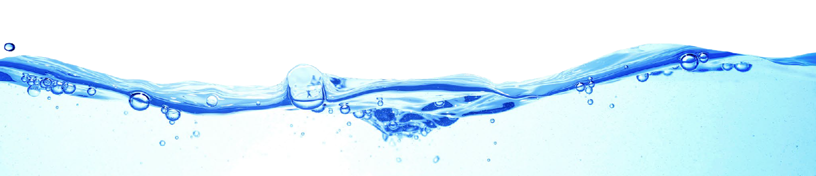
How Is My Water Treated and Purified?
T
he typical water treatment process requires several steps to ensure that your water is safe, wholesome, and free of
contaminants.
Intake from source water: This is where the water entering the treatment process is screened to remove large debris.
Groundwater Extraction: Groundwater is extracted from aquifer by pumping from wells.
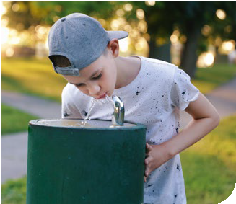
Coagulation: Small particles are brought together to form a large floc, which allows for the majority of sediment to settle out of the water.
Filtration: The remaining finer particles are filtered from the water using specially designed filter media.
Disinfection: A disinfectant is applied to the water to kill any bacteria that may be present.
Storage: The finished water product is stored in sealed tanks, from which it is delivered to the consumer.
Quality Monitoring: Water quality is monitored at the treatment process and throughout the distribution system to ensure that the water is in compliance with federal and state standards at all times.

Safeguard Your Drinking Water
rotection of drinking water is everyone’s responsibility. You can help protect your community’s drinking water source
P
in several ways:
- Eliminate excess use of lawn and garden fertilizers and pesticides – they contain hazardous chemicals that can reach your drinking water source.
- Pick up after your pets.
- If you have your own septic system, properly maintain it to reduce leaching to water sources, or consider connecting to a public water system.
- Dispose of chemicals properly; take used motor oil to a recycling center.
- Volunteer in your community. Find a watershed or wellhead protection organization in your community and volunteer to help. If there are no active groups, consider starting one. Use
U.S. EPA’s Adopt Your Watershed to locate groups in your community.
- Organize a storm drain stenciling project with others in your neighborhood. Stencil a message next to the street drain reminding people “Dump No Waste – Drains to River” or “Protect Your Water.” Produce and distribute a flyer for households to remind residents that storm drains dump directly into your local water body.

To the Last Drop
T
he National Oceanic and Atmospheric Administration (NOAA) defines drought as a deficiency in precipitation over an extended period of time, usually a season or more, resulting in a water shortage causing adverse impacts on veg- etation, animals, and people. Drought strikes in virtually all
climate zones, from very wet to very dry.
There are primarily three types of drought: Meteorological Drought refers to the lack of precipitation, or the degree of dryness and the duration of the dry period; Agricultural Drought refers to the agricultural impact of drought, focusing on precipitation shortages, soil water deficits, and reduced groundwater or reservoir levels needed for irrigation; and Hydrological Drought pertains to drought that usually occurs following periods of extended precipitation shortfalls that can impact water supply (e.g., stream flow, reservoir and lake levels, groundwater).
Drought is a temporary aberration from normal climatic conditions; thus, it can vary significantly from one region to another. Although normally occurring, human factors such as water demand can exacerbate the duration and impact that drought has on a region. By following simple water conservation measures, you can help significantly reduce the lasting effects of extended drought.

Table Talk
et the most out of the Testing Results data table with this simple suggestion. In less than a minute, you will know
G
all there is to know about your water:
For each substance listed, compare the value in the Amount Detected column against the value in the MCL (or AL, SMCL) column. If the Amount Detected value is smaller, your water meets the health and safety standards set for the substance.

Other Table Information Worth Noting
Verify that there were no violations of the state and/or federal standards in the Violation column. If there was a violation, you will see a detailed description of the event in this report.
If there is an ND or a less-than symbol (<), that means that the substance was not detected (i.e., below the detectable limits of the testing equipment).
The Range column displays the lowest and highest sample readings. If there is an NA showing, that means only a single sample was taken to test for the substance (assuming there is a reported value in the Amount Detected column).
If there is sufficient evidence to indicate from where the substance originates, it will be listed under Typical Source.

What’s a Cross-Connection?
Cany point where a drinking water line connects to equipment (boilers), systems containing chemicals (air-conditioning
ross-connections that contaminate drinking water distribution lines are a major concern. A cross-connection is formed at
systems, fire sprinkler systems, irrigation systems), or water sources of questionable quality. Cross-connection contamination can occur when the pressure in the equipment or system is greater than the pressure inside the drinking water line (backpres- sure). Contamination can also occur when the pressure in the drinking water line drops due to fairly routine occurrences (main breaks, heavy water demand), causing contaminants to be sucked out from the equipment and into the drinking water line (backsiphonage).
Outside water taps and garden hoses tend to be the most common sources of cross-connection contamination at home. The garden hose creates a hazard when submerged in a swimming pool or attached to a chemical sprayer for weed killing. Garden hoses that are left lying on the ground may be contaminated by fertilizers, cesspools, or garden chemicals. Improperly installed valves in your toilet could also be a source of cross-connection contamination.
Community water supplies are continuously jeopardized by cross-connections unless appropriate valves, known as backflow prevention devices, are installed and maintained. We have surveyed industrial, commercial, and institutional facilities in the service area to make sure that potential cross-connections are identified and eliminated or protected by a backflow preventer. We also inspect and test backflow preventers to make sure that they provide maximum protection. For more information on backflow prevention, contact the Safe Drinking Water Hotline at (800) 426-4791.

What Causes the Pink Stain on Bathroom Fixtures?
T
he reddish-pink color frequently noted in bathrooms on shower stalls, tubs, tile, toilets, sinks, and toothbrush holders and on pets’ water bowls is caused by the growth of the bacterium Serratia marcescens. Serratia is commonly isolated from soil, water, plants, insects, and vertebrates (including humans). The bacteria can be introduced into the house through any of these sources. The
bathroom provides a perfect environment (moist and warm) for bacteria to thrive.
The best solution to this problem is to clean and dry these surfaces to keep them free from bacteria. Chlorine-based compounds work best, but keep in mind that abrasive cleaners may scratch fixtures, making them more susceptible to bacterial growth. Chlorine bleach can be used periodically to disinfect the toilet and help eliminate the occurrence of the pink residue. Keeping bathtubs and sinks wiped down using a solution that contains chlorine will also help to minimize its occurrence. Serratia will not survive in chlorinated drinking water.

Information on the Internet
T
he U.S. EPA (epa.gov) and CDC (cdc.gov) web-
sites provide a substantial amount of information on many issues relating to water resources, water con- servation, and public health. The Division of Drinking Water (goo.gl/kGepu4) provides complete and current information on water issues in California, including valuable information about our watershed.

What Are PPCPs?
Count on Us
D
elivering high-quality drinking water to our
customers involves far more than just pushing water through pipes. Water treatment is a complex, time-consuming process. Because tap water is highly regulated by state and federal laws, water treatment plant and system operators must be licensed and are required to commit to long-term, on-the-job training before becoming fully qualified. Our licensed water professionals have a basic understanding of a wide range of subjects, including mathematics, biology, chemistry, and physics. Some of the tasks they com- plete on a regular basis include:
- Operating and maintaining equipment to purify and clarify water.
- Monitoring and inspecting machinery, meters, gauges, and operating conditions.
- Conducting tests and inspections on water and evaluating the results.
- Maintaining optimal water chemistry.
- Applying data to formulas that determine treatment requirements, flow levels, and concentration levels.
- Documenting and reporting test results and system operations to regulatory agencies.
- Serving our community through customer support, education, and outreach.
So the next time you turn on your faucet, think of the skilled professionals who stand behind each drop.
W
hen cleaning out your medicine cabinet, what do you do with your expired pills? Many people flush them down
the toilet or toss them into the trash. Although this seems con- venient, these actions could threaten our water supply.
Recent studies are generating a growing concern over pharmaceuticals and personal care products (PPCPs) entering water supplies. PPCPs include human and veterinary drugs (prescription or over-the-counter) and consumer products, such as cosmetics, fragrances, lotions, sunscreens, and housecleaning products. From 2006 to 2010, the number of
U.S. prescriptions increased 12 percent to a record 3.7 billion, while nonprescription drug purchases held steady around 3.3 billion. Many of these drugs and personal care products do not biodegrade and may persist in the environment for years.
The best and most cost-effective way to ensure safe water at the tap is to keep our source waters clean. Never flush unused medications down the toilet or sink. Instead, check to see if the pharmacy where you made your purchase accepts medications for disposal, or contact your local health department for information on proper disposal methods and drop-off locations. You can also visit goo.gl/aZPgeB to find more information about disposal locations in your area.

Benefits of Chlorination
D
isinfection, a chemical process used to control disease-causing microorganisms by killing or inactivating them, is unques- tionably the most important step in drinking water treatment. By far, the most common method of disinfection in
North America is chlorination.
Before communities began routinely treating drinking water with chlorine (starting with Chicago and Jersey City in 1908), cholera, typhoid fever, dysentery, and hepatitis A killed thousands of U.S. residents annually. Drinking water chlorination and filtration have helped to virtually eliminate these diseases in the U.S. Significant strides in public health are directly linked to the adoption of drinking water chlorination. In fact, the filtration of drinking water and the use of chlorine are probably the most significant public health advancements in human history.
How chlorination works:
- Potent Germicide: Reduction of many disease-causing microorganisms in drinking water to almost immeasurable levels.
- Taste and Odor: Reduction of many disagreeable tastes and odors from foul-smelling algae secretions, sulfides, and decaying vegetation.
- Biological Growth: Elimination of slime bacteria, molds, and algae that commonly grow in water supply reservoirs, on the walls of water mains, and in storage tanks.
- Chemical: Removal of hydrogen sulfide (which has a rotten egg odor), ammonia, and other nitrogenous compounds that have unpleasant tastes and hinder disinfection. It also helps to remove iron and manganese from raw water.

Tip Top Tap
T
he most common signs that your faucet or sink is affecting the quality of your drinking water are discolored water, sink or faucet stains, a buildup of particles, unusual odors or tastes, and a reduced flow of water. The solutions to these
problems may be in your hands.

Kitchen Sink and Drain
Handwashing, soap scum buildup, and the handling of raw meats and vegetables can contaminate your sink. Clogged drains can lead to unclean sinks and backed-up water in which bacteria (i.e., pink or black slime growth) can grow and contaminate the sink area and faucet, causing a rotten egg odor. Disinfect and clean the sink and drain area regularly and flush with hot water.

Faucets, Screens, and Aerators
Chemicals and bacteria can splash and accumulate on the faucet screen and aerator, which are located on the tip of faucets and can collect particles like sediment and minerals, resulting in a decreased flow from the faucet. Clean and disinfect the aerators or screens on a regular basis.
Check with your plumber if you find particles in the faucet screen, as they could be pieces of plastic from the hot water heater dip tube. Faucet gaskets can break down and cause black, oily slime. If you find this slime, replace the faucet gasket with a higher-quality product. White scaling or hard deposits on faucets and showerheads may be caused by water with high levels of calcium carbonate. Clean these fixtures with vinegar or use water softening to reduce the calcium carbonate levels for the hot water system.

Water Filtration/Treatment Devices
A smell of rotten eggs can be a sign of bacteria on the filters or in the treatment system. The system can also become clogged over time, so regular filter replacement is important. (Remember to replace your refrigerator filter!)

What Are PFAS?
P
er- and polyfluoroalkyl substances (PFAS) are a group of manufactured chemicals used worldwide since the 1950s to make fluo- ropolymer coatings and products that resist heat, oil, stains, grease, and water. During production and use, PFAS can migrate into
the soil, water, and air. Most PFAS do not break down; they remain in the environment, ultimately finding their way into drinking water. Because of their widespread use and their persistence in the environment, PFAS are found all over the world at low levels. Some PFAS can build up in people and animals with repeated exposure over time.
The most commonly studied PFAS are perfluorooctanoic acid (PFOA) and perfluorooctanesulfonic acid (PFOS). PFOA and PFOS have been phased out of production and use in the United States, but other countries may still manufacture and use them.
Some products that may contain PFAS include:
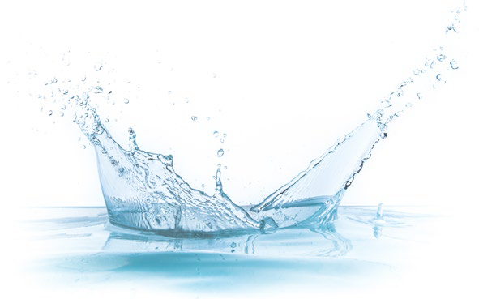
- Some grease-resistant paper, fast food containers/wrappers, microwave popcorn bags, pizza boxes
- Nonstick cookware
- Stain-resistant coatings used on carpets, upholstery, and other fabrics
- Water-resistant clothing
- Personal care products (shampoo, dental floss) and cosmetics (nail polish, eye makeup)
- Cleaning products
- Paints, varnishes, and sealants
Even though recent efforts to remove PFAS have reduced the likelihood of exposure, some products may still contain them. If you have questions or concerns about products you use in your home, contact the Consumer Product Safety Commission at (800) 638-2772. For a more detailed discussion on PFAS, please visit bit.ly/3Z5AMm8.

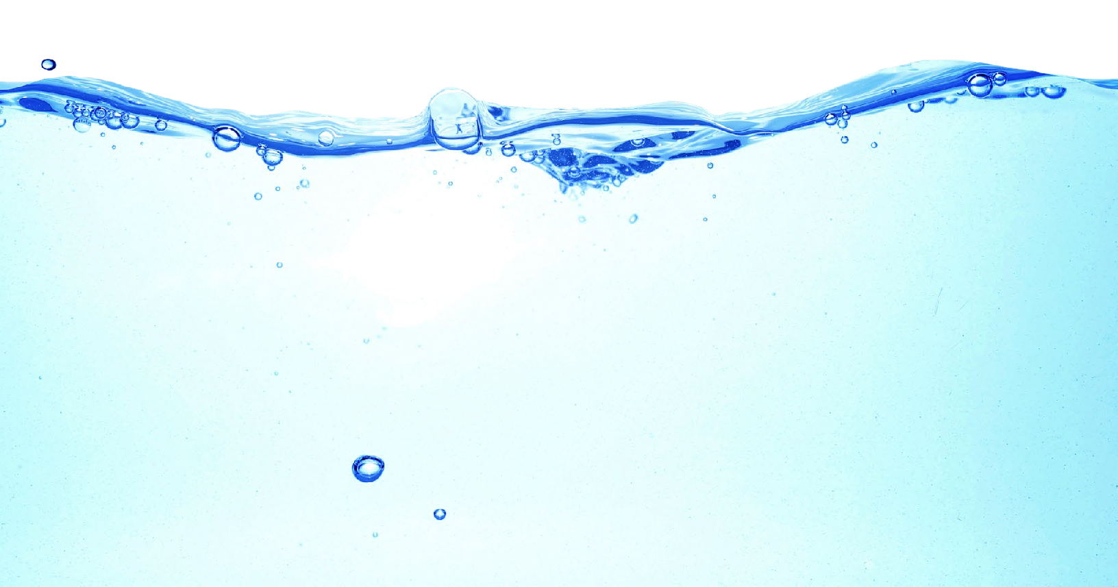
Failure in Flint
T
he national news coverage of water conditions in Flint, Michigan, has created a great deal of confusion and consterna-
tion. The water there has been described as being corrosive; images of corroded batteries and warning labels on bottles of acids come to mind. But is corrosive water bad?
Corrosive water can be defined as a condition of water quality that will dissolve metals (iron, lead, copper, etc.) from metallic plumbing at an excessive rate. There are a few contributing factors but, generally speaking, corrosive water has a pH of less than 7; the lower the pH, the more acidic, or corrosive, the water becomes. (By this definition, many natural waterways throughout the country can be described as corrosive.) While all plumbing will be somewhat affected over time by the water it carries, corrosive water will damage plumbing much more rapidly than water with low corrosivity.
By itself, corrosive water is not a health concern; your morning glass of orange juice is considerably more corrosive than the typical lake or river. What is of concern is that exposure in drinking water to elevated levels of the dissolved metals increases adverse health risks. And therein lies the problem.
Public water systems are required to maintain their water at optimal conditions to prevent it from reaching corrosive levels. Rest assured that we routinely monitor our water to make sure that what happened in Flint never happens here.

Water Conservation Tips
Y
ou can play a role in conserving water and save yourself money in the process by becoming conscious of the amount of water your household is using and looking for ways to use less whenever you can. It is not hard to conserve water. Here
are a few tips:
- Automatic dishwashers use three to six gallons for every cycle, regardless of how many dishes are loaded. So get a run for your money and load it to capacity.
- Turn off the tap when brushing your teeth.
- Check every faucet in your home for leaks. Just a slow drip can waste 15 to 20 gallons a day. Fix it and you can save almost 6,000 gallons per year.
- Check your toilets for leaks by putting a few drops of food coloring in the tank. Watch for a few minutes to see if the color shows up in the bowl. It is not uncommon to lose up to 100 gallons a day from an invisible toilet leak. Fix it and you save more than 30,000 gallons a year.
- Use your water meter to detect hidden leaks. Simply turn off all taps and water-using appliances. Then check the meter after 15 minutes. If it moved, you have a leak.

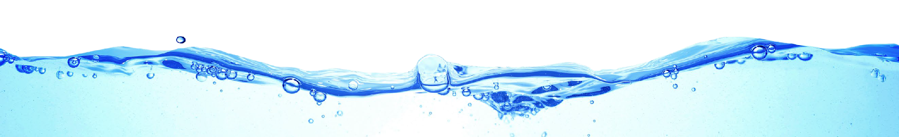
Test Results
O
ur water is monitored for many different kinds of substances on a very strict sampling schedule, and the water we deliver must meet specific health standards. Here, we only show those substances that were detected in our water (a complete list of all our analytical results is available upon request). Remember that detecting a substance does not mean the water
is unsafe to drink; our goal is to keep all detects below their respective maximum allowed levels.
The state recommends monitoring for certain substances less than once per year because the concentrations of these substances do not change frequently. In these cases, the most recent sample data is included, along with the year in which the sample was taken.
We participated in the fifth stage of the U.S. EPA’s Unregulated Contaminant Monitoring Rule (UCMR5) program by performing additional tests on our drinking water. UCMR5 sampling benefits the environment and public health by providing the U.S. EPA with data on the occurrence of contaminants suspected to be in drinking water to determine if it needs to introduce new regulatory standards to improve drinking water quality. Unregulated contaminant monitoring data is available to the public, so please feel free to contact us if you are interested in obtaining that information. If you would like more information on the U.S. EPA’s Unregulated Contaminant Monitoring Rule, please call the Safe Drinking Water Hotline at (800) 426-4791.
REGULATED SUBSTANCES

 |  |  |  | Apple Valley |  | Cedar Ridge |  | Columbia/Big Hill |  | Peaceful Pines
SUBSTANCE  (UNIT OF MEASURE) | YEAR SAMPLED | MCL [MRDL] | PHG (MCLG) [MRDLG] | AMOUNT DETECTED | RANGE  LOW-HIGH | AMOUNT DETECTED | RANGE  LOW-HIGH | AMOUNT DETECTED | RANGE  LOW-HIGH | AMOUNT DETECTED | RANGE  LOW-HIGH | VIOLATION | TYPICAL SOURCE
Asbestos (MFL) | 2019 | 7 | 7 | ND | NA | ND | NA | ND3 | NA | ND4 | NA | No | Internal corrosion of asbestos cement water mains; Erosion of natural deposits
Chlorine (ppm) | 2024 | [4.0  (as Cl2)] | [4 (as  Cl2)] | 1.15 | 0.9–1.4 | 1.61 | 1.3–1.91 | 1.7 | 1.6–1.8 | 0.99 | 0.80–1.17 | No | Drinking water disinfectant added for treatment
Control of DBP precursors [TOC] (ppm) | 2023 | TT | NA | NA | NA | 1.3 | 1.0–1.7 | NA | NA | NA | NA | No | Various natural and human-made sources
Fluoride (ppm) | 2024 | 2.0 | 1 | ND | NA | ND1 | NA | ND | NA | 0.202 | NA | No | Erosion of natural deposits; Water additive that promotes strong teeth; Discharge from fertilizer and aluminum factories
Gross Alpha Particle Activity (pCi/L) | 2020 | 15 | (0) | 2.45 | NA | 0.0991 | NA | 0.921 | ND–1.831 | 3.835 | NA | No | Erosion of natural deposits
HAA5 [sum of 5 haloacetic acids] (ppb) | 2023 | 60 | NA | ND | NA | 24.55 | 20–295 | 42.55 | 30–555 | ND | NA | No | By-product of drinking water disinfection
Magnesium (ppm) | 2024 | NS | NA | 22 | NA | 1.21 | NA | 0.84 | 0.84–0.84 | 7.82 | NA | No | Runoff/leaching from natural deposits.
Nitrate [as nitrogen] (ppm) | 2024 | 10 | 10 | ND | NA | ND1 | NA | ND | NA | ND2 | NA | No | Runoff and leaching from fertilizer use; Leaching from septic tanks and sewage; Erosion of natural deposits
TTHMs [total trihalomethanes] (ppb) | 2023 | 80 | NA | 2.5 | NA | 305 | 26–345 | 33.55 | 12–555 | 1.7 | NA | No | By-product of drinking water disinfection
Turbidity (NTU) | 2024 | TT | NA | 0.12 | NA | 0.081 | NA | 0.05 | NA | 0.122 | NA | No | Soil runoff

REGULATED SUBSTANCES
REGULATED SUBSTANCES
 |  |  |  | Phoenix Lake |  | Ponderosa |  | Scenic View |  | Sonora
SUBSTANCE  (UNIT OF MEASURE) | YEAR SAMPLED | MCL [MRDL] | PHG (MCLG) [MRDLG] | AMOUNT DETECTED | RANGE  LOW-HIGH | AMOUNT DETECTED | RANGE  LOW-HIGH | AMOUNT DETECTED | RANGE  LOW-HIGH | AMOUNT DETECTED | RANGE  LOW-HIGH | VIOLATION | TYPICAL SOURCE
Asbestos (MFL) | 2019 | 7 | 7 | ND4 | NA | ND2 | NA | ND3 | NA | 0.205 | NA | No | Internal corrosion of asbestos cement water mains; Erosion of natural deposits
Chlorine (ppm) | 2024 | [4.0  (as Cl2)] | [4 (as  Cl2)] | 1.24 | 1.01–1.46 | 1.8 | 1.7–1.9 | 1.10 | 0.87–1.32 | 1.65 | 1.5–1.8 | No | Drinking water disinfectant added for treatment
Control of DBP precursors [TOC] (ppm) | 2023 | TT | NA | NA | NA | 1.35 | 0.90–1.65 | 1.3 | 1.1–1.7 | 1.65 | 1.1–2.15 | No | Various natural and human-made sources
Fluoride (ppm) | 2024 | 2.0 | 1 | 0.132 | NA | ND | NA | ND1 | NA | ND | NA | No | Erosion of natural deposits; Water additive that promotes strong teeth; Discharge from fertilizer and aluminum factories
Gross Alpha Particle Activity (pCi/L) | 2020 | 15 | (0) | 2.892 | NA | 1.331 | NA | 3.532 | NA | ND1 | NA | No | Erosion of natural deposits
HAA5 [sum of 5 haloacetic acids] (ppb) | 2023 | 60 | NA | 36.0 | NA | 435 | 32–545 | 35.55 | 24–475 | 325 | 26–385 | No | By-product of drinking water disinfection
Magnesium (ppm) | 2024 | NS | NA | 222 | NA | 0.90 | NA | 3.141 | NA | 2.0 | NA | No | NA
Nitrate [as nitrogen]  (ppm) | 2024 | 10 | 10 | ND1 | NA | ND | NA | ND1 | NA | ND | NA | No | Runoff and leaching from fertilizer use; Leaching from septic tanks and sewage; Erosion of natural deposits
TTHMs [total trihalomethanes] (ppb) | 2023 | 80 | NA | 41.05 | NA | 47.55 | 36–595 | 355 | 25–455 | 625 | 49–755 | No | By-product of drinking water disinfection
Turbidity (NTU) | 2024 | TT | NA | 0.045 | NA | 0.06 | NA | 0.051 | NA | 0.051 | NA | No | Soil runoff

 |  |  |  | Tuolumne |  | Upper Basin |  | Wards Ferry
SUBSTANCE  (UNIT OF MEASURE) | YEAR SAMPLED | MCL [MRDL] | PHG (MCLG) [MRDLG] | AMOUNT DETECTED | RANGE  LOW-HIGH | AMOUNT DETECTED | RANGE  LOW-HIGH | AMOUNT DETECTED | RANGE  LOW-HIGH | VIOLATION | TYPICAL SOURCE
Asbestos (MFL) | 2019 | 7 | 7 | 1.03 | NA | ND3 | NA | ND6 | NA | No | Internal corrosion of asbestos cement water mains; Erosion of natural deposits
Chlorine (ppm) | 2024 | [4.0  (as Cl2)] | [4 (as  Cl2)] | 1.7 | 1.4–2.0 | 1.85 | 1.7–2.0 | 0.94 | 0.24–1.64 | No | Drinking water disinfectant added for treatment
Control of DBP precursors [TOC] (ppm) | 2023 | TT | NA | 1.35 | ND–2.65 | 1.55 | 1.23–1.85 | NA | NA | No | Various natural and human-made sources
Fluoride (ppm) | 2024 | 2.0 | 1 | ND | NA | ND1 | NA | ND | NA | No | Erosion of natural deposits; Water additive that promotes strong teeth; Discharge from fertilizer and aluminum factories
Gross Alpha Particle Activity (pCi/L) | 2020 | 15 | (0) | ND1 | NA | 0.725 | NA | 1.227 | NA | No | Erosion of natural deposits
HAA5 [sum of 5 haloacetic acids] (ppb) | 2023 | 60 | NA | 39.55 | 30–495 | 325 | 17–475 | ND | NA | No | By-product of drinking water disinfection
Magnesium (ppm) | 2024 | NS | NA | 0.90 | NA | 0.85 | 0.78–0.93 | 162 | NA | No | NA

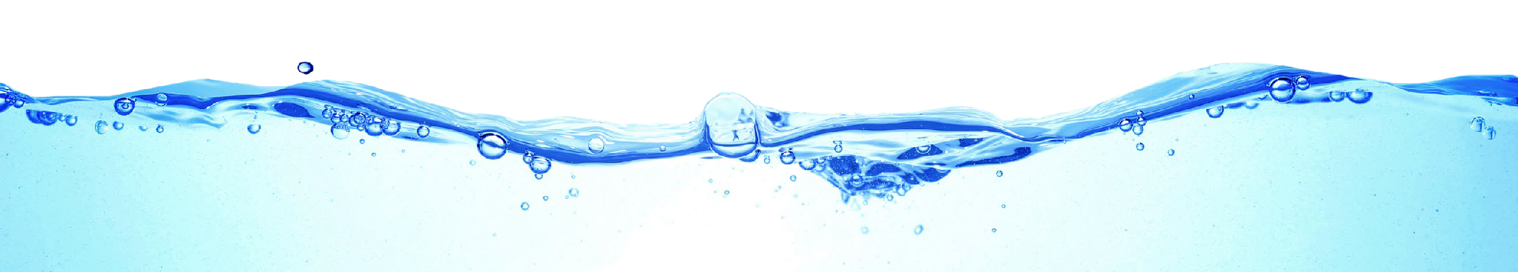
REGULATED SUBSTANCES
 |  |  |  |  |  |  |  |  |  |  | Tuolumne |  |  |  |  | Upper Basin |  |  |  |  | Wards Ferry
SUBSTANCE  (UNIT OF MEASURE) |  |  |  | YEAR SAMPLED |  | MCL [MRDL] |  | PHG (MCLG) [MRDLG] |  |  | AMOUNT DETECTED |  | RANGE  LOW-HIGH |  |  | AMOUNT DETECTED |  |  | RANGE  LOW-HIGH |  | AMOUNT DETECTED |  |  | RANGE  LOW-HIGH |  |  | VIOLATION |  | TYPICAL SOURCE
Nitrate [as nitrogen] (ppm) |  |  |  | 2024 |  | 10 |  | 10 |  |  | ND |  | NA |  |  | ND |  | NA |  |  | 4.7 |  |  | NA |  |  | No |  | Runoff and leaching from fertilizer use; Leaching from septic tanks and sewage; Erosion of natural deposits
TTHMs [total trihalomethanes] (ppb) |  |  |  | 2023 |  | 80 |  | NA |  |  | 44.55 |  | 38–515 |  |  | 345 |  | 20–485 |  |  | 2.7 |  |  | NA |  |  | No |  | By-product of drinking water disinfection
Turbidity (NTU) |  |  |  | 2024 |  | TT |  | NA |  |  | 0.06 |  | NA |  |  | 0.05 |  | NA |  |  | ND |  |  | NA |  |  | No |  | Soil runoff
LEAD AND COPPER: Tap water samples were collected for lead and copper analyses from sample sites throughout the community
 |  |  |  |  |  | Apple Valley |  |  |  |  |  |  |  | Cedar Ridge |  |  |  |  |  |  |  | Columbia/Big Hill
SUBSTANCE (UNIT OF MEASURE) | YEAR SAMPLED |  | AL | PHG (MCLG) |  | AMOUNT DETECTED (90TH %ILE) |  |  | RANGE  LOW-HIGH |  | SITES ABOVE AL/TOTAL SITES |  |  | AMOUNT DETECTED (90TH %ILE) |  |  | RANGE  LOW-HIGH |  | SITES ABOVE AL/TOTAL SITES |  |  | AMOUNT DETECTED (90TH %ILE) |  |  | RANGE  LOW-HIGH |  | SITES ABOVE AL/TOTAL SITES |  | VIOLATION |  | TYPICAL SOURCE
Copper | 2023 |  | 1.3 | 0.3 |  | 0.365 |  |  | NA |  | 0/5 |  |  | 0.110 |  |  | NA |  | 0/10 |  |  | 0.110 |  |  | NA |  | 0/20 |  | No |  | Internal corrosion of household plumbing
(ppm) |  |  |  |  |  |  |  |  |  |  |  |  |  |  |  |  |  |  |  |  |  |  |  |  |  |  |  |  |  |  | systems; Erosion of natural deposits; Leaching from wood preservatives
Lead  (ppb) | 2023 |  | 15 | 0.2 |  | ND |  |  | NA |  | 0/5 |  |  | 0.018 |  |  | NA |  | 1/10 |  |  | 0.005 |  |  | NA |  | 0/20 |  | No |  | Corrosion of household plumbing systems; Erosion of natural deposits
LEAD AND COPPER: Tap water samples were collected for lead and copper analyses from sample sites throughout the community
 |  |  |  |  |  |  | Peaceful Pines |  |  |  |  |  |  |  | Phoenix Lake |  |  |  |  |  |  |  | Ponderosa
SUBSTANCE  (UNIT OF MEASURE) |  | YEAR SAMPLED |  | AL | PHG (MCLG) |  | AMOUNT DETECTED (90TH %ILE) |  |  | RANGE  LOW-HIGH |  | SITES ABOVE AL/TOTAL SITES |  |  |  | AMOUNT DETECTED (90TH %ILE) |  | RANGE  LOW-HIGH |  | SITES ABOVE AL/TOTAL SITES |  |  |  | AMOUNT DETECTED (90TH %ILE) |  | RANGE  LOW-HIGH |  | SITES ABOVE AL/TOTAL SITES |  | VIOLATION |  | TYPICAL SOURCE
Copper (ppm) |  | 2023 |  | 1.3 | 0.3 |  | ND |  |  | NA |  | 0/5 |  |  | 0.130 |  |  | NA |  | 0/5 |  |  | 0.115 |  |  | NA |  | 0/115 |  | No |  | Internal corrosion of household plumbing
 |  |  |  |  |  |  |  |  |  |  |  |  |  |  |  |  |  |  |  |  |  |  |  |  |  |  |  |  |  |  |  | systems; Erosion of natural deposits; Leaching from wood preservatives
Lead (ppb) |  | 2023 |  | 15 | 0.2 |  | ND |  |  | NA |  | 0/5 |  |  | ND |  |  | NA |  | 0/5 |  |  | ND5 |  |  | NA |  | 0/115 |  | No |  | Corrosion of household plumbing systems; Erosion of natural deposits
LEAD AND COPPER: Tap water samples were collected for lead and copper analyses from sample sites throughout the community
 |  |  |  |  |  | Scenic View |  |  |  |  |  |  |  | Sonora |  |  |  |  |  |  |  | Tuolumne
SUBSTANCE (UNIT OF MEASURE) | YEAR SAMPLED |  | AL | PHG (MCLG) |  | AMOUNT DETECTED (90TH %ILE) |  |  | RANGE  LOW-HIGH |  | SITES ABOVE AL/TOTAL SITES |  |  | AMOUNT DETECTED (90TH %ILE) |  |  | RANGE  LOW-HIGH |  | SITES ABOVE AL/TOTAL SITES |  |  | AMOUNT DETECTED (90TH %ILE) |  |  | RANGE  LOW-HIGH |  | SITES ABOVE AL/TOTAL SITES |  | VIOLATION |  | TYPICAL SOURCE
Copper | 2023 |  | 1.3 | 0.3 |  | 0.065 |  |  | NA |  | 0/105 |  |  | 0.0873 |  |  | NA |  | 0/313 |  |  | 0.0855 |  |  | NA |  | 0/115 |  | No |  | Internal corrosion of household plumbing
(ppm) |  |  |  |  |  |  |  |  |  |  |  |  |  |  |  |  |  |  |  |  |  |  |  |  |  |  |  |  |  |  | systems; Erosion of natural deposits; Leaching from wood preservatives
Lead  (ppb) | 2023 |  | 15 | 0.2 |  | 0.015 |  |  | NA |  | 0/105 |  |  | ND3 |  |  | NA |  | 0/313 |  |  | ND5 |  |  | NA |  | 0/115 |  | No |  | Corrosion of household plumbing systems; Erosion of natural deposits

LEAD AND COPPER: Tap water samples were collected for lead and copper analyses from sample sites throughout the community
 |  |  |  | Upper Basin |  |  | Wards Ferry
SUBSTANCE (UNIT OF MEASURE) | YEAR SAMPLED | AL | PHG (MCLG) | AMOUNT DETECTED (90TH %ILE) | RANGE  LOW-HIGH | SITES ABOVE AL/TOTAL SITES | AMOUNT DETECTED (90TH %ILE) | RANGE  LOW-HIGH | SITES ABOVE AL/TOTAL SITES | VIOLATION | TYPICAL SOURCE
Copper | 2023 | 1.3 | 0.3 | 0.15 | NA | 0/20 | 0.475 | NA | 0/55 | No | Internal corrosion of household plumbing systems; Erosion of natural deposits;
(ppm) |  |  |  |  |  |  |  |  |  |  | Leaching from wood preservatives
Lead (ppb) | 2023 | 15 | 0.2 | ND | NA | 0/20 | ND5 | NA | 0/55 | No | Corrosion of household plumbing systems; Erosion of natural deposits
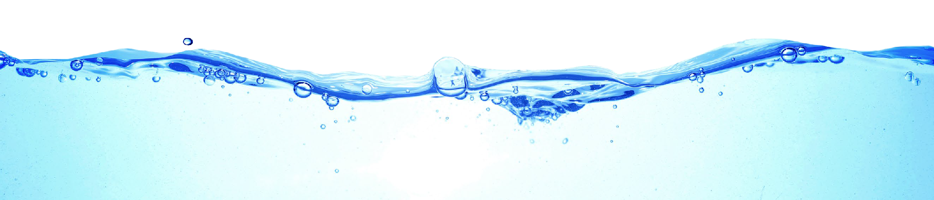
SECONDARY SUBSTANCES
SECONDARY SUBSTANCES
SECONDARY SUBSTANCES
 |  |  |  | Apple Valley |  | Cedar Ridge |  | Columbia/Big Hill |  | Peaceful Pines
SUBSTANCE  (UNIT OF MEASURE) | YEAR SAMPLED | SMCL | PHG (MCLG) | AMOUNT DETECTED | RANGE LOW- HIGH | AMOUNT DETECTED | RANGE LOW- HIGH | AMOUNT DETECTED | RANGE  LOW-HIGH | AMOUNT DETECTED | RANGE LOW- HIGH | VIOLATION | TYPICAL SOURCE
Chloride (ppm) | 2024 | 500 | NS | 7.0 | NA | 3.01 | NA | 1.9 | ND–3.8 | ND | NA | No | Runoff/leaching from natural deposits; Seawater influence
Iron (ppb) | 2024 | 300 | NS | ND | NA | 731 | NA | ND | NA | 18.54 | NA | No | Leaching from natural deposits; Industrial wastes
Manganese (ppb) | 2024 | 50 | NS | 48 | NA | ND1 | NA | ND | NA | 17.75 | NA | No | Leaching from natural deposits
Sulfate (ppm) | 2024 | 500 | NS | 17 | NA | ND1 | NA | ND | NA | 3.22 | NA | No | Runoff/leaching from natural deposits; Industrial wastes

 |  |  |  | Phoenix Lake |  | Ponderosa |  | Scenic View |  | Sonora
SUBSTANCE  (UNIT OF MEASURE) | YEAR SAMPLED | SMCL | PHG (MCLG) | AMOUNT DETECTED | RANGE LOW- HIGH | AMOUNT DETECTED | RANGE LOW- HIGH | AMOUNT DETECTED | RANGE LOW- HIGH | AMOUNT DETECTED | RANGE LOW- HIGH | VIOLATION | TYPICAL SOURCE
Chloride (ppm) | 2024 | 500 | NS | 9.52 | NA | ND | NA | 6.291 | NA | 3.0 | NA | No | Runoff/leaching from natural deposits; Seawater influence
Iron (ppb) | 2024 | 300 | NS | ND2 | NA | ND | NA | ND1 | NA | ND | NA | No | Leaching from natural deposits; Industrial wastes
Manganese (ppb) | 2024 | 50 | NS | ND3 | NA | ND | NA | 21.61 | NA | ND | NA | No | Leaching from natural deposits
Sulfate (ppm) | 2024 | 500 | NS | 3.32 | NA | ND | NA | ND1 | NA | ND | NA | No | Runoff/leaching from natural deposits; Industrial wastes

 |  |  |  | Tuolumne |  | Upper Basin |  | Wards Ferry
SUBSTANCE  (UNIT OF MEASURE) | YEAR SAMPLED | SMCL | PHG (MCLG) | AMOUNT DETECTED | RANGE LOW- HIGH | AMOUNT DETECTED | RANGE  LOW-HIGH | AMOUNT DETECTED | RANGE LOW- HIGH | VIOLATION | TYPICAL SOURCE
Chloride (ppm) | 2024 | 500 | NS | 1.2 | NA | 1.0 | ND–3.0 | 8.7 | NA | No | Runoff/leaching from natural deposits; Seawater influence
Iron (ppb) | 2024 | 300 | NS | ND | NA | ND | NA | ND | NA | No | Leaching from natural deposits; Industrial wastes
Manganese (ppb) | 2024 | 50 | NS | ND | NA | ND | NA | ND | NA | No | Leaching from natural deposits
Sulfate (ppm) | 2024 | 500 | NS | ND | NA | ND | NA | 6.0 | NA | No | Runoff/leaching from natural deposits; Industrial wastes

 |  | Apple Valley |  | Cedar Ridge |  | Columbia/Big Hill |  | Peaceful Pines |  | Phoenix Lake |  | Ponderosa
SUBSTANCE  (UNIT OF MEASURE) | YEAR SAMPLED | AMOUNT DETECTED | RANGE  LOW-HIGH | AMOUNT DETECTED | RANGE  LOW-HIGH | AMOUNT DETECTED | RANGE  LOW-HIGH | AMOUNT DETECTED | RANGE  LOW-HIGH | AMOUNT DETECTED | RANGE  LOW-HIGH | AMOUNT DETECTED | RANGE  LOW-HIGH | TYPICAL SOURCE
Hardness, Total [as CaCO3] (ppm) | 2024 | 220 | NA | 131 | NA | 10.0 | 10.0–10.0 | 792 | NA | 2702 | NA | 11 | NA | NA
Sodium (ppm) | 2024 | 11 | NA | 4.31 | NA | 4.4 | 1.5–7.3 | 182 | NA | 212 | NA | 1.6 | NA | NA

 |  | Scenic View |  | Sonora |  | Tuolumne |  | Upper Basin |  | Wards Ferry
SUBSTANCE  (UNIT OF MEASURE) | YEAR SAMPLED | AMOUNT DETECTED | RANGE  LOW-HIGH | AMOUNT DETECTED | RANGE  LOW-HIGH | AMOUNT DETECTED | RANGE  LOW-HIGH | AMOUNT DETECTED | RANGE  LOW-HIGH | AMOUNT DETECTED | RANGE  LOW-HIGH | TYPICAL SOURCE
Hardness, Total [as CaCO3] (ppm) | 2024 | 30.61 | NA | 22 | NA | 12 | NA | 10.3 | 9.0–12.0 | 150 | NA | NA
Sodium (ppm) | 2024 | 8.841 | NA | 3.6 | NA | 1.8 | NA | 3.6 | 1.5–7.1 | 9.7 | NA | NA

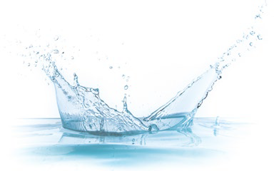
Water Main Flushing
UNREGULATED SUBSTANCES 8
D
istribution mains (pipes) convey water to homes, businesses, and hydrants in your neighborhood. The water entering distribution mains is of very high quality; however, water quality can deteriorate in areas of the distribution mains over time. Water main
flushing is the process of cleaning the interior of water distribution mains by sending a rapid flow of water through them.
Flushing maintains water quality in several ways. For example, flushing removes sediments like iron and manganese. Although
iron and manganese do not pose health concerns, they can affect the taste, clarity, and color of the water. Additionally, sediments can shield microorganisms from the disinfecting power of chlorine, contributing to the growth of microorganisms within distribution mains. Flushing helps remove stale water and ensures the presence of fresh water with sufficient dissolved oxygen and disinfectant levels and an acceptable taste and smell.
During flushing operations in your neighborhood, some short-term deterioration of water quality, though uncommon, is possible. You should avoid tap water for household uses at that time. If you do use the tap, allow your cold water to run for a few minutes at full velocity before use, and avoid using hot water to prevent sediment accumulation in your hot water tank. Please contact us if you have any questions or if you would like more information on our water main flushing schedule.

Definitions
1 Sampled in 2023.
2 Sampled in 2021.
3 Sampled in 2022.
4 Sampled in 2016.
5 Sampled in 2024.
6 Sampled in 2018.
7 Sampled in 2019.
8 Unregulated contaminant monitoring helps the
U.S. EPA and SWRCB
determine where certain contaminants occur and whether the contaminants need to be regulated.

90th %ile: The levels reported for lead and copper represent the 90th percentile of the total number of sites tested. The 90th
UNREGULATED SUBSTANCES 8
percentile is equal to or greater than 90% of our lead and copper detections.
AL (Regulatory Action Level): The concentration of a contaminant which, if exceeded, triggers treatment or other requirements that a water system must follow.
MCL (Maximum Contaminant Level): The highest level of a contaminant that is allowed in drinking water. Primary MCLs are set as close to the PHGs (or MCLGs) as is economically and technologically feasible. Secondary MCLs (SMCLs) are set to protect the odor, taste, and appearance of drinking water.
MCLG (Maximum Contaminant Level Goal): The level of a contaminant in drinking water below which there is no known or expected risk to health. MCLGs are set by the U.S. EPA.
MFL (million fibers per liter): A measure of the presence of asbestos fibers that are longer than 10 micrometers.
MRDL (Maximum Residual Disinfectant Level): The highest level of a disinfectant allowed in drinking water. There is convincing evidence that addition of a disinfectant is necessary for control of microbial contaminants.
MRDLG (Maximum Residual Disinfectant Level Goal): The level of a drinking water disinfectant below which there is no known or expected risk to health. MRDLGs do not reflect the benefits of the use of disinfectants to control microbial contaminants.
NA: Not applicable.
ND (Not detected): Indicates that the substance was not found by laboratory analysis.
NS: No standard.
NTU (Nephelometric Turbidity Units): Measurement of the clarity, or turbidity, of water. Turbidity in excess of 5 NTU is just noticeable to the average person.
pCi/L (picocuries per liter): A measure of radioactivity.
PDWS (Primary Drinking Water Standard): MCLs and MRDLs for contaminants that affect health, along with their monitoring and reporting requirements and water treatment requirements.
PHG (Public Health Goal): The level of a contaminant in drinking water below which there is no known or expected risk to health. PHGs are set by the California EPA.
ppb (parts per billion): One part substance per billion parts water (or micrograms per liter).
ppm (parts per million): One part substance per million parts water (or milligrams per liter).
TT (Treatment Technique): A required process intended to reduce the level of a contaminant in drinking water.

