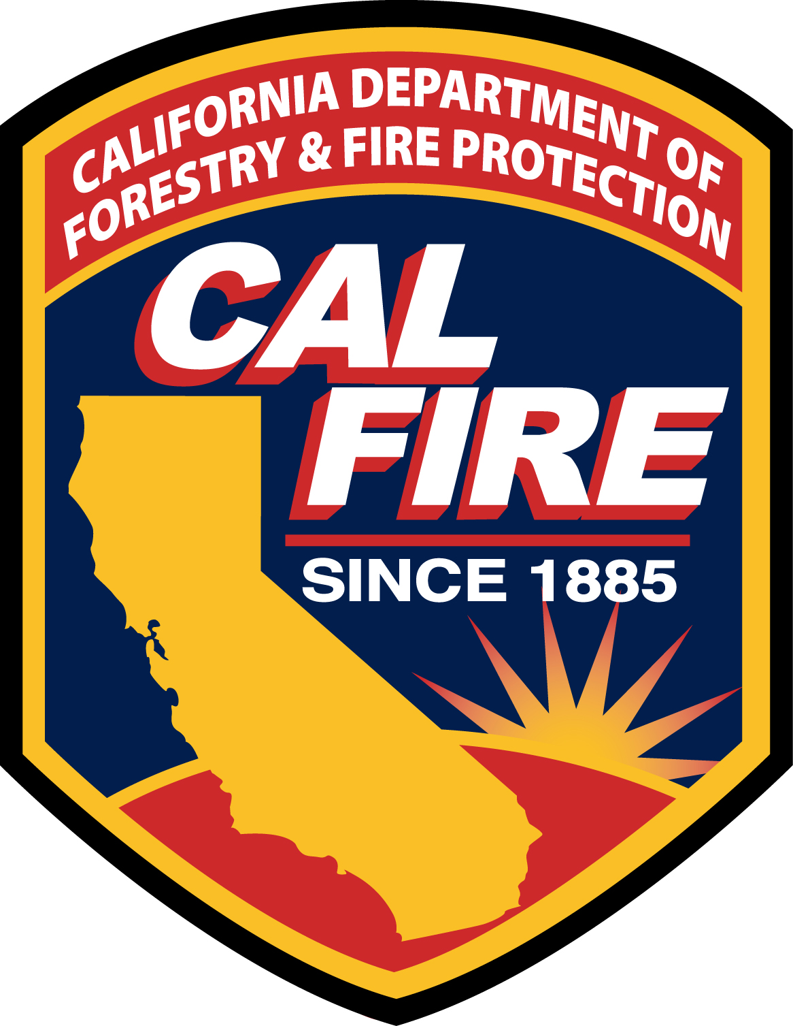

I am pleased to present to you this year’s Annual Water Quality Report. This report is designed to inform you about the quality of water and services that is delivered to you every day. Our constant goal is to provide you with a safe and dependable supply of drinking water. We want you to understand the efforts we make to continually improve the water treatment process and protect our water resources. We are committed to ensuring the quality of your drinking water.

We test the drinking water quality for many constituents as required by State and Federal Regulations. This report shows the results of our monitoring for the period of January 1 – December 31, 2021.

Our water source is a well located inside the camp’s boundaries. 12.5% sodium hypochlorite solution (chlorine) is added to the water supply to ensure proper disinfection. Monthly bacterial tests are done by the Solano County Environmental Health Department. Major testing of the drinking water is done every 3 years for organic and inorganic compounds as well as nitrite. Testing was recently done in August of 2021 and will be done again in 2022. Water is also tested yearly for the presence of nitrates. These tests are performed by Cal Test Analytical Lab in Napa, California. Water samples are taken both from the facility’s well and from the distribution system that delivers your drinking water to you.

All main line back flow devices are tested yearly for proper operation. Currently there are 2 of these devices in this facility. Testing was done in August of 2020 and will be done again in 2022 by a licensed certified back flow testing technician. These devices are to protect the source of your drinking water from possible contamination.

An on-site inspection of the Delta Camp water system was done by California State Water Resources Control Board personnel on March 11, 2018.
Minor corrections were made to Delta’s water system and Delta Camp is currently in full compliance with all State Water Resources Control Board recommendations.

In 2006 we added some filtration units to our system. 5 individual units were installed on lines to 5 different buildings. The filters use carbon to filter for better tasting water but also to change the condition of the water so that the hardness in the water does not stick to plumbing fixtures and piping which will greatly reduce the chance of damage, leaks, and possible water system shut down or failure.

A source water assessment was conducted on our well at the Delta Conservation Camp water system in January 2003. The source was considered most vulnerable to the following activities not associated with any detected contaminants: Septic Systems High Density
A copy of the assessment may be viewed at

Delta Conservation Camp
Cal Fire Administration Office
6246 Lambie Road
Suisun City, California 94585
Contact: John Kay – Water and Sewer Chief Plant Operator

Or a copy of the summary of the assessment may be requested from

State Water Resources Control Board - Drinking Water Division
Berkley/San Francisco District Office
850 Marina Bay Parkway, Building P 2nd Floor
Richmond, California 94804

I am pleased to report that our drinking water is safe and meets all federal and state requirements and our system had no violations. We are proud that your drinking water meets or exceeds all Federal and State requirements. We have learned through our monitoring and testing that some constituents have been detected. The EPA has determined that your water is SAFE at these levels.

Delta Conservation Camp routinely monitors for contaminants in your drinking water per Federal and State laws. The tables attached to this report show the results or our monitoring for the period of January 1 to December 31 2020
. All drinking water, including bottled drinking water, may be reasonably expected to contain at least small amounts of some contaminants. It’s important to remember that the presence of these contaminants does not necessarily pose a health risk.

In this table, you will find many terms and abbreviations you might not be familiar with. To help you better understand these terms we’ve provided the following definitions:

MCL or Maximum Contaminant Level: The highest level of a contaminant that is allowed in drinking water. Primary MCLs are set as close to the PHGs or (MCLGs) as is economically and technologically feasible. Secondary MCLs are set to protect the odor, taste and appearance of drinking water.

PDWS or Primary Drinking Water Standards: MCLs for contaminants that affect health along with their monitoring and reporting requirements and their water treatment requirements.

SDWS or Secondary Drinking Water Standards: MCLs for contaminants that affect taste, odor or appearance, not health, along with their monitoring and reporting requirements, and water treatment requirements.

MRDLG or maximum residual disinfectant level goal: The level of drinking water disinfectant below which there is no known or expected risk to human health. MRDLGs do not reflect the benefits of the use of disinfectants to control microbial contaminants.

MRDL or maximum residual disinfectant level: The highest level of disinfectant allowed in drinking water. There is convincing evidence that addition of a disinfectant is necessary for control of microbial contaminants.

PHG or Public Health Goal: The level of a contaminant in drinking water below which there is no known or expected risk to health. PHGs are set by the California Environmental Protection Agency

MCLG or Maximum Contaminant Level Goal: The level of a contaminant in drinking water below which there is no known or expected risk to health. MCLGs are set by the U.S. Environmental Protection Agency
(USEPA).

TT or Treatment Technique: A required process intended to reduce the level of a contaminant in drinking water.

Level 1 Assessment: A level 1 assessment is a study of the water system to identify potential problems and determine (if possible) why total coliform bacteria have been found in our water system.

Level 2 Assessment: A level 2 assessment is a very detailed study of the water system to identify potential problems and determine (if possible) why an E. coli MCL violation has occurred and or why total coliform bacteria have been found in our water system multiple times.

AL or Regulatory Action Level: the concentration of a contaminant, which, if exceeded, triggers treatment of other requirements, which a water system must follow.

ND: Not detectable at testing limit.

ppm: Parts per million or milligrams per liter (mg/l) or one penny in $10,000.

ppb: Parts per billion or micrograms per liter (ug/L) or one penny in $10,000,000

ppt: Parts per trillion or nanograms per liter (ng/L) or one penny in $10,000,000,000.

ppq: parts per quadrillion

pCi/L: Picocuries per liter (a measure of radiation)

ug/l: 1 ug/l = .001 mg/l

Note: Some people may be more vulnerable to contaminants in drinking water than the general population. Immuno-compromised persons such as persons with cancer undergoing chemotherapy, persons who have undergone organ transplants, people with HIV/AIDS or other immune system disorders, some elderly, and infants can be particularly at risk from infections. These people should seek advice about drinking water from their health care providers. EPA/CDC (Center for Disease Control) guidelines or appropriate means to lessen the risk of infection by cryptosporidium and other microbiological contaminants are available from the Safe Drinking Water Hotline (800) 426-4791.

SAMPLING RESULTS SHOWING THE DETECTION OF COLIFORM BACTERIA

Microbiological  Contaminants | Detections | Total no.  of months  In violation | MCL | MCLG  (PHG) | Typical source of  bacteria
Total Coliform Bacteria | 0 | 0 | More than one sample in a month with a detection | 0 | Naturally present in the environment
Fecal Coliform or  E. coli | 0 | 0 | Two or more routine or any repeat sample with a detection | 0 | Human and animal fecal wastes

SAMPLING RESULTS SHOWING THE DETECTION OF A CONTAMINANT WITH A PRIMARY
DRINKING WATER STANDARD
Primary meaning it would affect health

Contaminant | Unit of Measure | Level Detected  In water | MCL | Typical Source of Contaminant | Health Effects Language
Nitrate (as nitrate, NO₃) | MG/L | .28 | 45 | Runoff and leaching from fertilizer use; leaching from septic tanks and sewage; erosion of natural deposits | Infants below the age of six months who drink water containing nitrate in excess of the MCL may quickly become seriously ill and, if untreated, may die because high nitrate levels can interfere with the capacity of the infant’s blood to carry oxygen. Symptoms include shortness of breath and blueness of the skin. High nitrate levels may also affect the oxygen-carrying ability of the blood of pregnant women.

Disinfection Byproducts, Disinfectant Residuals, and Disinfection Byproduct Precursors

Contaminant | Unit of Measure | Level Detected  In water | Maximum Contaminant Level  In MG/L | Typical Source of Contaminant | Health Effects Language
TTHMs (total trihalomethanes) | ppb | ND | .001 | Bi product of drinking water disinfection | Some people who drink water containing trihalomethanes in excess of the MCL over many years may experience liver, kidney, or central nervous system problems and may have an increased risk of getting cancer
Haloacetic Acids | UG/L | <6.0 | 60 | Bi product of drinking water disinfection | Some people who drink water containing haloacetic acids in excess of the MCL over many years may have an increased risk of getting cancer.

Lead and Copper

Lead | ppb | ND | .015 | Internal corrosion of household water plumbing systems; discharges from industrial manufacturers and erosion of natural deposits | Infants and children who drink water containing lead in excess of the action level my experience delays in their physical development. Children may show slight deficits in attention span and learning abilities. Adults who drink this water over many years my develop kidney problems or high blood pressure.
Copper | ug/l | 0.295 | 1.0 | Internal corrosion of household plumbing systems; erosion of natural deposits; leaching from wood preservatives | Copper is an essential nutrient, but some people who drink water containing copper in excess of the action level over a relatively short amount of time may experience gastrointestinal distress. Some people who drinking water containing copper in excess of the action level over many years may suffer liver or kidney damage. People with Wilson’s disease should consult their personal doctor.

This report was prepared by
John Kay
Water & Sewer Chief Plant Operator
Cal Fire
Delta Conservation Camp

If you have any questions about this report or if you would like a copy of the report, please contact John Kay at (707) 428-4461 extension 107 or come to the Cal Fire Delta Camp administration office.

