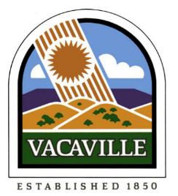 | EASTERLY WWTP PUBLIC WATER SYSTEM  2025  WATER QUALITY REPORT

INTRODUCTION:
The Easterly Public Water System is pleased to report that your drinking water is safe, reliable, and in compliance with all state and federal quality standards in 2025. These standards are established by the U.S. Environmental Protection Agency (USEPA) and the California State Water Resources Control Board (SWRCB). In 2025 approximately 7.4 million gallons of high-quality drinking water were distributed to the EWWTP facility. This water was subjected to extensive testing, not only for regulated contaminants, but for some non-regulated chemical properties as well. Water quality testing included over 174 analyses of raw and treated water in 2025, contributing to a total of more than 691 analyses completed since 2024.

Drinking water, including bottled water, may reasonably be expected to contain at least small amounts of some contaminants. The presence of contaminants does not necessarily indicate that water poses a health risk. More information about contaminants and potential health effects can be obtained by calling the USEPA’s Safe Drinking Water Hotline at (800) 426-4791. If you have further questions, please contact the Water Quality Laboratory Supervisor, Michael Torres, by phone at (707) 469-6439 or by email at Michael.Torres@cityofvacaville.gov. You may also attend City Council Meetings to voice your opinions - please check the City website for meeting notices to see if any water related topics are on the agenda.

Este informe contiene información muy importante sobre su agua para beber.
Favor de comunicarse con City of Vacaville Water Quality Laboratory al
(707) 469-6400 para asistirlo en español.

SOURCES OF WATER & SYSTEM DESCRIPTION:

The Easterly WWTP PWS is comprised of two wells, located within the facility, that provide the Easterly Wastewater Treatment Plant with potable water (1W) for personnel facilities and shower/eyewash units and non-potable water (2W) for process uses such as pump seals and polymer dilution. The system is permitted as a non-transient-non-community water system (NTNCWS) by the State Water Resources Control Board Division of Drinking Water under California Health and Safety Code 116275.

The potable water system is operated by Water Operations and includes wells, chlorination system, storage reservoir, 1W pumps, 1W hydro tank, fire pump, and the 1W distribution system. Non-potable water is operated by Wastewater Operations, starting at the air gap tank separating the 1W from the 2W and includes the 2W pumps, 2W hydro tank, and the 2W distribution system.

The potable water is supplied by either of two submersible well pumps, one located in the Well Building and the other next to the 1W/2W reservoir. Only one well pump can be operated at a time. The well pumps start and stop automatically in response to the level signal from the ultrasonic level detector in the water storage reservoir. When the well pump starts, a signal is sent to start the hypochlorite solution pump. Chlorine solution is injected to the well pump discharge to ensure that the water is disinfected. A chlorine residual is maintained in the potable water system to protect against contamination in the unlikely event of a cross connection. A tablet chlorinator is installed in the Well Building as a backup for the hypochlorite feed system.

The well pump discharges through a 4-inch line to the cylindrical concrete Storage Reservoir. There is also a 4-inch bypass line around the reservoir so that well water can be pumped directly to the potable water pumps when the reservoir is out of service. Potable water is drawn from the storage reservoir through an 8-inch line and pumped into the hydropneumatic tank by any of the three vertical-turbine pumps operating automatically. Water flows through the hydropneumatic tank and into the distribution system.

SOURCES OF WATER AND CONTAMINANTS:

The sources of drinking water (both tap and bottled) include rivers, lakes, streams, ponds, reservoirs, springs, and wells. As water travels over the surface of the land or through the ground, it dissolves naturally occurring minerals, and in some cases, radioactive material, and can pick up substances resulting from the presence of animals or from human activity. Potential contaminants include:
- Microbial contaminants, such as viruses and bacteria, that may come from sewage treatment plants, septic systems, agricultural livestock operations, and wildlife.
- Inorganic contaminants, such as salts and metals, that can be naturally occurring or result from urban stormwater runoff, industrial or domestic wastewater discharges, oil and gas production, mining, or farming.
- Pesticides and herbicides that may come from a variety of sources such as agriculture, urban stormwater runoff, and residential uses.
- Organic chemical contaminants, including synthetic and volatile organic chemicals, which are by-products of industrial processes and petroleum production and can also come from gas stations, urban stormwater runoff, agricultural application, and septic systems.
- Radioactive contaminants that can be naturally occurring or be the result of oil and gas production and mining activities.
To ensure that tap water is safe to drink, the USEPA and the SWRCB prescribe regulations that limit the amount of certain contaminants in water provided by public water systems. SWRCB regulations also establish limits for contaminants in bottled water that provide the same protection for public health.

DETECTED CONTAMINANTS:

The following tables list all of the drinking water contaminants that were detected during the most recent sampling for constituents. To read the tables, start with the far-left column titled “Constituent” and read across the row. Units express the amount measured. MCL shows the highest amount of the substance allowed. PHG (MCLG) is the goal amount for that substance, which may be a lower amount than the amount allowed. The “Range” reports the lowest and highest amounts detected and the “Average” is the annual average. “Contaminant Sources” describe where the substance usually originates. To better understand the report, use the legend that defines the terms used.

During 2024 and 2025, Well #2 served as the sole source of potable water produced by Easterly PWS.
Usage of Well #1 was restricted solely for the purpose of sample collection and monitoring.

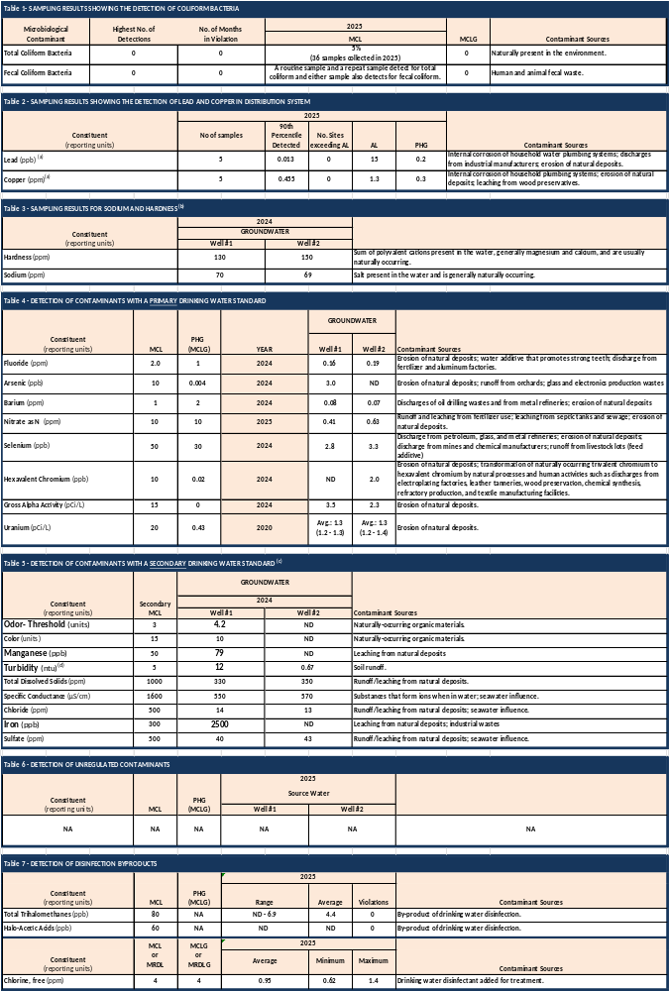

KEEP THE LEAD OUT OF DRINKING WATER:
If present, elevated levels of lead can cause serious health problems, especially for pregnant women and young children. Lead in drinking water is primarily from materials and components associated with service lines and home plumbing. The City is responsible for providing high quality drinking water but cannot always control the variety of materials used in plumbing components. When your water has been sitting for several hours, you can minimize the potential for lead exposure by flushing your tap for 30 seconds to 2 minutes before using water for drinking or cooking. Information on lead in drinking water, testing methods, and steps you can take to minimize exposure is available from the Safe Drinking Water Hotline or at http://www.epa.gov/lead.

HEALTH RELATED INFORMATION:
Some people may be more vulnerable to contaminants in drinking water than the general population. Immuno-compromised persons such as persons with cancer undergoing chemotherapy, persons who have undergone organ transplants, people with HIV/AIDS or other immune system disorders, some elderly, and infants can be particularly at risk for infections. These people should seek advice about drinking water from their health care providers. USEPA and Centers for Disease Control and Prevention (CDC) guidelines on appropriate means to lessen the risk of infection by Cryptosporidium and other microbial contaminants are available from the
USEPA’s Safe Drinking Water Hotline at (800) 426-4791.

LEGEND:
- MCL (Maximum Contaminant Level: The highest level of a contaminant that is allowed in drinking water. Primary MCLs are set as close to the PHGs (or MCLGs) as is economically and technologically feasible.
- Secondary MCL: Secondary MCLs are set to protect the odor, taste, and appearance of drinking water.
- MCLG (Maximum Contaminant Level Goal): The level of a contaminant in drinking water below which there is no known or expected risk to health. MCLGs are set by the U.S. Environmental Protection Agency.
- PHG (Public Health Goal): The level of a contaminant in drinking water below which there is no known or expected risk to health. PHGs are set by the California Environmental Protection Agency.
- PDWS (Primary Drinking Water Standard): MCLs, MRDLs and treatment techniques (TTs) for contaminants that affect health, along with their monitoring and reporting requirements.
- MRDL (Maximum Residual Disinfectant Level): The highest level of a disinfectant allowed in drinking water. There is convincing evidence that addition of a disinfectant is necessary for control of microbial contaminants.
- MRDLG (Maximum Residual Disinfectant Level Goal): The level of a drinking water disinfectant below which there is no known or expected risk to health. MRDLGs do not reflect the benefits of the use of disinfectants to control microbial contaminants.
- AL & NL (Regulatory Action Level or Notification Level): The concentration of a contaminant which, if exceeded, triggers treatment or other requirements that a water system must follow.
- TT (Treatment Technique): A required process intended to reduce the level of a contaminant in drinking water.
- NA: Not Applicable or Not Available.
- ND: Not Detected.
- ntu (Nephelometric Turbidity Units): Standard unit for turbidity.
- pCi/L: Picocuries per Liter.
- µS/cm: Microsiemens per Centimeter. Unit of measure for conductance.
- ppm: Parts per Million or Milligrams per Liter (mg/L). Equivalent to 1 second in 11.5 days.
- ppb: Parts per Billion or Micrograms per Liter (µg/L). Equivalent to 1 second in 32 years.

FOOTNOTES:
- This is the state action level for samples collected inside schools and homes. The 90th percentile reflects the concentration of lead or copper at which 90% of the samples tested were found to have not exceeded. Lead and copper results are from August 2025.
- There are no drinking water standards (MCLs, PHGs or MCLGs) for these constituents, they are just reported for customer information. To convert hardness data from ppm to grains per gallon, divide by 17.
- There are no PHGs, MCLGs or mandatory standard health effects language for these constituents because secondary MCLs are set on the basis of aesthetics.
- Turbidity is a measure of the cloudiness of the water. We monitor it because it is a good indicator of water quality. High turbidity can hinder the effectiveness of disinfectants.

POLICY ON NONDISCRIMINATION ON THE BASIS OF DISABILITY:
In accordance with the requirements of Title II of the Americans with Disabilities Act of 1990, the City of Vacaville (City) does not discriminate against qualified individuals with disabilities on the basis of disability in the City’s services, programs, activities, or employment. Information, comments, requests for accommodation or barrier removal, and/or complaints concerning the accessibility of City programs, services or activities to persons with disabilities should be directed to the City’s ADA Coordinator, 650 Merchant Street, (707) 449-5409 or (707) 449-5162 (TTY).

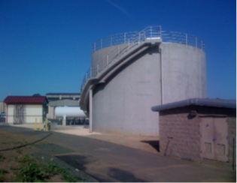 | 