Photo by Senior Plant Maintenance Mechanic Matt Baker

2023 Drinking Water Quality Report
City of Stockton Municipal Utilities Department

This report contains important information about your drinking water. Please contact the City of Stockton at
(209) 937-8762 for assistance in non-English languages.

What is in Your Water
Our area watersheds and groundwater wells provide raw water supplies to the City. As water flows over the land or through the groundwater aquifer, naturally occurring minerals can dissolve in it and, in some cases, contaminant materials can also be picked up from animal or human activities.

Contaminants That May Be Present in the Source Water Include:

The City of Stockton Municipal Utilities Department (MUD) has prepared its annual drinking water quality report, also known as a Consumer Confidence Report, to inform our customers about the quality of our drinking water delivered throughout our service area.
We provide the highest quality water available while meeting all State and Federal drinking water standards. This report includes a detailed water quality summary, monitoring and testing results, as well as the steps we take to protect health and safety.
From all of us here at the MUD, it is a privilege to serve you. If you have any questions about this report, please call
(209) 937-8762 or email WaterFacts@stocktonca.gov.

C. Mel Lytle, Ph.D. Director

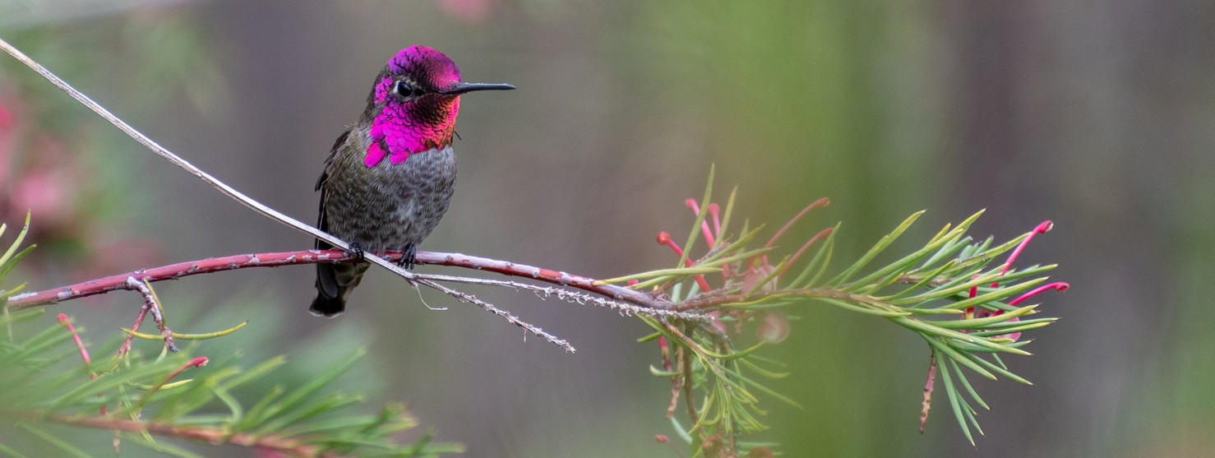


Water Sources
To meet the needs of the City's approximately 52,000 customers in north and south Stockton, we use a combination of water sources including:
Water from the Sacramento - San Joaquin Delta and Mokelumne River treated at the City’s Delta Water Treatment Plant.
Water from the Stanislaus River via New Melones Reservoir and the Calaveras River via New Hogan Reservoir which is treated and delivered by Stockton East Water District.
Local groundwater from wells owned and operated by the City.
Microbial contaminants, such as viruses and bacteria that may come from sewage treatment plants, septic systems, agricultural livestock operations, and wildlife.

Inorganic contaminants, such as salts and metals, that can be naturally-occurring or result from urban stormwater runoff, industrial or domestic wastewater discharges, oil and gas production, mining, or farming.

Pesticides and herbicides that may come from a variety of sources such as agriculture, urban stormwater runoff, and residential uses.

Organic chemical contaminants, including synthetic and volatile organic chemicals that are by-products of industrial processes and petroleum production, and can also come from gas stations, urban stormwater runoff, agricultural application, and septic systems.

Radioactive contaminants that can be naturally- occurring or be the result of oil and gas production and mining activities.

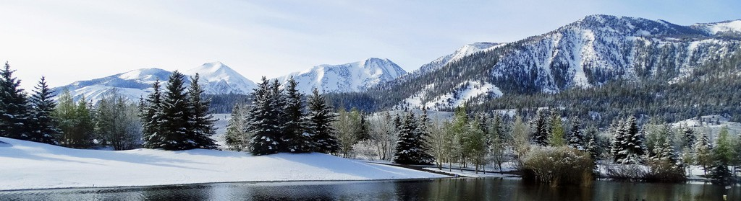

The Sierra Nevada watershed provides water to millions of Californians

In order to ensure that tap water is safe to drink, the U.S. Environmental Protection Agency (USEPA) and the State Water Resources Control Board (State Water Board) prescribe regulations that limit the amount of certain contaminants in water provided by public water systems. State Water Resources Control Board (State Water Board) regulations also establish limits for contaminants in bottled water that provide the same protection for public health. Drinking water, including bottled water, may reasonably be expected to contain at least small amounts of some contaminants. The presence of contaminants does not necessarily indicate that water poses a health risk. More information about contaminants and potential health effects can be obtained by calling the USEPA’s Safe Drinking Water Hotline (1-800-426-4791).

Information About Lead
If present, elevated levels of lead can cause serious health problems, especially for pregnant women and young children. Lead in drinking water derives primarily from materials and components associated with service lines and home plumbing. The City of Stockton is responsible for providing high quality drinking water but cannot control the variety of materials used in plumbing components. When your water has been sitting for several hours, you can minimize the potential for lead exposure by flushing your tap for 30 seconds to 2 minutes before using water for drinking or cooking. If you do so, you may wish to collect the flushed water and reuse it for another beneficial purpose such as watering plants. If you are concerned about lead in your water, you may wish to have it tested. Information about lead in drinking water, testing methods, and steps you can take to minimize exposure is available from the Safe Drinking Water Hotline or at http://www.epa.gov/lead. In addition, the “lead and copper rule,” or LCR, was introduced by the U.S. Environmental Protection Agency (U.S. EPA) in 1991 to limit the concentration of lead and copper allowed in public drinking water at the consumer’s tap as well as to limit the corrosivity due to the water itself.
On January 15, 2021, US EPA issued revisions to federal LCR. Under the Lead and Copper Rule Revisions (LCRR), water systems are required to prepare and maintain an inventory of service line materials by October 16, 2024. More information about the Lead and Copper Rule for Drinking Water is available at https://www.waterboards.ca.gov/drinking_water/certlic/dri nkingwater/leadandcopperrule.html

A Note for Sensitive Populations
Some people may be more vulnerable to contaminants in drinking water than the general population. Immuno- compromised persons such as persons with cancer undergoing chemotherapy, persons who have undergone organ transplants, people with HIV/AIDS or
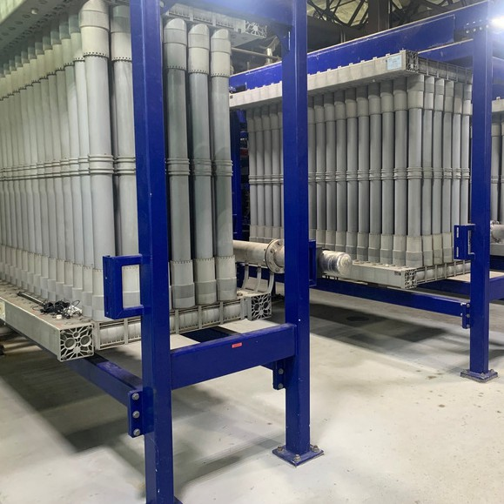
other immune system disorders, some elderly, and infants can be particularly at risk from infections. These people should seek advice about drinking water from their health care providers. USEPA/Centers for Disease Control (CDC) guidelines on appropriate means to lessen the risk of infection by Cryptosporidium and other microbial contaminants are available from the Safe Drinking Water Hotline (1-800-426-4791).

Delta Water Treatment Plant
Ultra Membrane Filtration System

Monitoring of Per- & Polyfluoroalkyl Substances (PFAS)
The State Water Board established drinking water guidelines in 2019 for water agencies to follow in detecting and reporting the presence of PFAS, including the chemicals perfluorooctanoic acid (PFOA) and perfluorooctanesulfonic acid (PFOS). PFOA and PFOS are chemicals that were used in many consumer products for their non-stick and grease- and stain- resistant properties. Found at or near manufacturing sites, landfills, and firefighting training sites (where they were used in firefighting foams), such as airports and military bases, these chemicals may enter the water cycle through runoff and wastewater, leading to elevated levels in wastewater discharges and groundwater.
Contamination of drinking water is usually associated with a specific drinking water facility and its relative location to where these chemicals were used or produced. The City is required to monitor and inform its governing body and all State and Federal regulatory agencies of detected concentrations of PFAS that exceed notification levels. A notification level is the concentration level that, based on available scientific information, does not pose a significant health risk but warrants informing the public of its presence. More information on PFAS, PFOA, and PFOS is available from the State Water Board at https://www.waterboards.ca.gov/drinking_water/certlic/dr inkingwater/PFOA_PFOS.html.

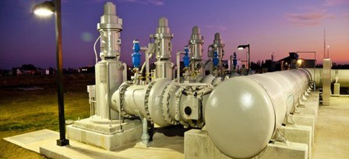

Raw Water Pump Station

Drinking Water Source Assessment & Protection Program
Drinking Water Source Assessments for the City’s water system were completed in 2001 and 2012. The water sources were considered most vulnerable to activities which were associated with contaminants found in the water supply, including urban stormwater, septic tanks and sewage spills, mining, construction, metal plating, electronics manufacturing, National Pollution Discharge Elimination System permitted discharges, dairy waste, and agricultural operations. The water sources were considered most vulnerable to the following activities, which were not associated with contaminants detected in the water supply: illegal activities/dumping, recreation, leaking underground storage tanks, vehicle fueling and maintenance and chemical/petroleum/plastics processing and storage. You may request assessment summaries by contacting Robert Lapp at the State Water Resources Control Board at (209) 948-3816.

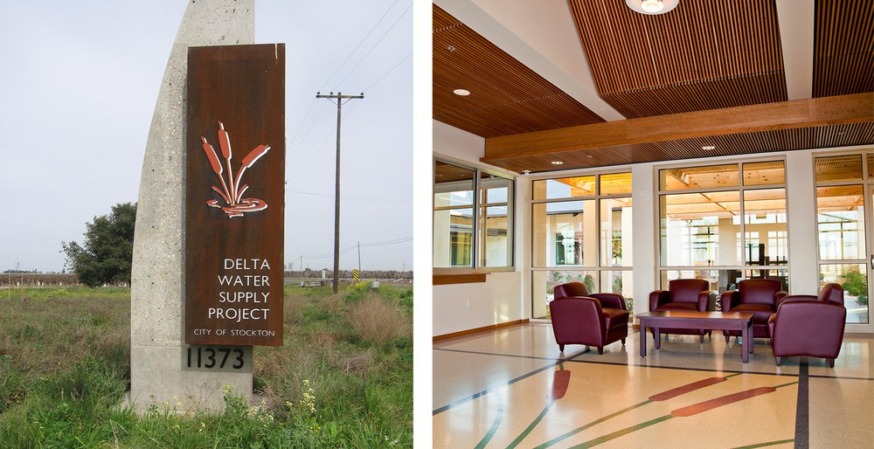

2023 Water Quality Analysis Results for 2023
Your water meets or exceeds all federal and state drinking water standards.
In 2023, we delivered about 8 billion gallons of treated water to more than 180,000
community members in north and south Stockton, enough to fill nearly 160 million bathtubs.

The City of Stockton tests your drinking water for several regulated and unregulated contaminants. Only those contaminants that were detected are listed. The following tables divide water quality test results into three main sections:
- Primary Drinking Water Standards, 2) Secondary Drinking Water Standards, and 3) Unregulated Compounds. Primary standards protect public health by limiting levels of certain constituents in drinking water. Secondary standards are set for substances that could aﬀect drinking water taste, odor, or clarity. Unregulated substances are listed for your information. Data in the table represents sampling from 2023, unless otherwise noted.
Primary Drinking Water Standards |  |  |  | Groundwater |  |  | Surface Water |  | Meets Regulation? | Source of Constituent
Constituent | Units | Primary MCL | PHG  (MCLG) | Range | Average |  | DWTP  Average | SEWD  Average | Meets Regulation? | Source of Constituent
Aluminum | mg/L | 1 | 0.6 | <0.05 | <0.05 |  | <0.05 | <0.07 | Yes | Erosion of natural deposits; residue from some surface water treatment processes
Arsenic | μg/L | 10 | 0.004 | <2.0 – 6.7 | 4.53 |  | <2.0 | <2.0 | Yes | Erosion of natural deposits; runoff from orchards, and glass and electronics production  wastes
Barium | mg/L | 1 | 2 | <0.1 – 0.26 | 0.184 |  | <0.1 | <0.1 | Yes | Discharges of oil and drilling wastes and metal refineries; erosion of natural deposits
Chromium, Total | μg/L | 10 | 50 | <10-12 | 1.8 |  | <10 | <10 | Yes | Discharge from electroplating facilities; erosion of natural deposits
Fluoride | mg/L | 2.0 | 1 | <0.1 | <0.1 |  | <0.1 | <0.1 | Yes | Erosion of natural deposits; discharge from fertilizer and aluminum factories
Nitrate (as N) | mg/L | 10 | 10 | 0.65– 6.2 | 3.49 |  | <0.4 | <0.4 | Yes | Runoff/leaching from fertilizer use; leaching from septic tanks and sewage; erosion of natural  deposits
Alpha Activity, Gross ⁽¹⁾ | pCi/L | 15 | (0) | 1.50 – 8.13 | 4.17 |  | NR | NR | N/A | Erosion of natural deposits
Radium 228 ^{(1,} ³⁾ | pCi/L |  | 0.019 | 0.0 – 1.71 | 0.50 |  | NR | NR | N/A | Erosion of natural deposits
Uranium ⁽¹⁾ | pCi/L | 20 | 0.43 | 1.03 – 5.80 | 3.93 |  | NR | NR | N/A | Erosion of natural deposits
 | Units | MCL | PHG  (MCLG) | Highest  Level | Lowest Monthly % ⁽⁵⁾ |  | Highest  Level | Lowest Monthly % ⁽⁶⁾ | Meets Regulation? | Source of Constituent
Turbidity | NTU | TT | N/A | 0.92 | 99.7 |  | 0.39 | 93.5 | Yes | Soil runoff
 | Units | MCL  (MRDL) | MCLG  (MRDLG) | Distribution System |  |  |  |  | Meets Regulation? | Source of Constituent
 |  |  |  | Range |  | Average |  |  | Meets Regulation? | Source of Constituent
Total Coliform Bacteria | % positive  samples | 5% | 0 | 0 – 0.7 |  | 0.1 |  |  | Y | Naturally present in the environment
Chlorine as Cl₂ | mg/L | (4.0) | (4.0) | 0.03 – 3.53 |  | 2.65 |  |  | Y | Drinking water disinfectant added for treatment
Total Trihalomethanes (TTHM) ⁽⁸⁾ | μg/L | 80 | N/A | 13.1 – 117 |  | 54.8 |  |  | Y | By-product of drinking water disinfection
Haloacetic Acids 5 (HAA5) ⁽⁸⁾ | μg/L | 60 | N/A | 7.6 – 126.6 |  | 33.9 |  |  | Y | By-product of drinking water disinfection
 | Units | Action Level (AL) | PHG | Level Detected at the  90th percentile |  | Samples exceeding the AL |  |  | Meets Regulation? | Source of Constituent
Copper ⁽⁹⁾ | mg/L | 1.3 | 0.3 | 0.000 |  | 0 of 50 |  |  | Yes | Internal corrosion of household plumbing systems
Lead ⁽⁹⁾ | μg/L | 15 | 0.2 | 0.130 |  | 0 of 50 |  |  | Yes | Internal corrosion of household plumbing systems
  - The compliance cycle for monitoring this constituent can vary from three to nine years; some data may be from before 2010.
Key Terms and Abbreviations
(AL) Regulatory Action Level

(MCL) Maximum Contaminant Level

(MCLG) Maximum Contaminant Level Goal

(MRDL) Maximum Residual Disinfectant Level

(MRDLG) Maximum Residual Disinfectant Level Goal
(PDWS) Primary Drinking Water Standard (PHG) Public Health Goal
(TT) Treatment Technique
The concentration of a contaminant which, if exceeded, triggers treatment or other requirements that a water system must follow.
The highest level of a contaminant that is allowed in drinking water. Primary MCLs are set as close to the PHGs (or MCLGs) as is economically and technologically feasible. Secondary MCLs are set to protect the odor, taste and appearance of drinking water.
The level of a contaminant in drinking water below which there is no known or expected risk to health. MCLGs are set by the U.S. Environmental Protection Agency.
The highest level of a disinfectant allowed in drinking water. There is convincing evidence that addition of a disinfectant is necessary for control of microbial contaminants.
The level of a drinking water disinfectant below which there is no known or expected risk to health. MRDLGs do not reflect the benefits of the use of disinfectants to control microbial contaminants.
MCLs and MRDLs for contaminants that affect health along with their monitoring and reporting requirements, and water treatment requirements.
The level of a contaminant in drinking water below which there is no known or expected risk to health. PHGs are set by the California Environmental Protection Agency.
A required process intended to reduce the level of a contaminant in drinking water.
Units
mg/L µg/L µS/cm ng/L pCi/L NTU
N/A
NR
Milligrams per Liter Micrograms per Liter
Micro-siemens per centimeter Nanograms per Liter Picocuries per Liter Nephelometric Turbidity Unit Not Applicable
Testing not required
  - Compliance may be based on average values for four quarters.
  - Radium 228 testing was conducted for initial monitoring required by new regulations.
  - The MCL is based on Combined Radium (Radium 226 + Radium 228). Radium 226 and Radium 228 do not have individual MCLs. The MCL for Combined Radium is 5 pCi/L. Radium 226 was not detected.
  - For surface water systems, the Treatment Technique requires that each month the turbidity level of the filtered water for Membrane Filtration facilities is less than or equal to 0.1 NTU in 95% of the measurements and shall not exceed 1.0 NTU at any time. Turbidity is a measure of the cloudiness of the water. It is monitored as a good indicator of the effectiveness of the filtration system.
  - For surface water systems, the Treatment Technique requires that each month the turbidity level of the filtered water is less than or equal to 0.3 NTU in 95% of the measurements, and shall not exceed 1.0 NTU at any time. Turbidity is a measure of the cloudiness of the water. It is monitored as a good indicator of the effectiveness of the filtration system.
  - Presence of coliform bacteria in no more than 5% of monthly samples.
  - Compliance is based on the quarterly Running Annual Average. The highest level reported in the range is the result of an individual sample.
  - Lead and copper are required to be monitored every three years. This data is from 2020.

Secondary Drinking Water Standards |  |  | Groundwater |  | Surface Water |  |  |  | Source of Constituent
 |  |  |  |  | DWTP |  | SEWD |  | Source of Constituent
Constituent | Units | MCL | Range | Average | Range | Average | Range | Average | Source of Constituent
Chloride | mg/L | 500 | 6.9 - 95 | 30.8 | - | 8.3 | - | 9 | Runoff/leaching from natural deposits; seawater influence
Manganese | μg/L | 50 | 14 - 33 | 25.3 | - | <20 | - | <20 | Leaching from natural deposits
Odor | units | 3 | <1.0 - 2.0 | 0.17 | <1.0 – 2.0 | <1.1 | <1.0 | <1.0 | Naturally occurring organic materials
Specific Conductance | μS/cm | 1,600 | 290 - 730 | 528 | 72 – 551 | 266 | 96 - 282 | 217 | Substances that form ions when in water; seawater influence
Sulfate | mg/L | 500 | 15 - 49 | 32 | - | 2.4 | - | 18.9 | Runoff/leaching from natural deposits; industrial wastes
Total Dissolved Solids | mg/L | 1,000 | 210 - 500 | 362 | 40 – 310 | 153 | 80 – 200 | 140 | Runoff/leaching from natural deposits
Unregulated Compounds |  |  | Groundwater |  | Surface Water
Constituent | Units |  | Range | Average | DWTP  Average |  | SEWD  Average
Total Hardness (as CaCO₃) ⁽¹⁾ | mg/L |  | 119 - 321 | 244 | 18 |  | 72
Boron | μg/L |  | <100 – 130 | 19 | <100 |  | <100
Sodium | mg/L |  | 4.9 – 36 | 20.2 | 8.0 |  | 14
Vanadium | μg/L |  | 16 - 32 | 25 | <3.0 |  | <3.0
Other Compounds |  |  | Groundwater |  | Surface Water
Constituent | Units |  | Range | Average | DWTP  Average |  | SEWD  Average
Total Alkalinity | mg/L |  | 120 – 220 | 185 | 21 |  | 73
Calcium | mg/L |  | 25 – 74 | 57 | 4.8 |  | 18
Magnesium | mg/L |  | 14 – 33 | 25.3 | 1.4 |  | 7
Potassium | mg/L |  | 3.9 – 17 | 6.1 | <1.0 |  | 2
- Conversion: hardness (gains per gallon) = hardness as CaCO3 (mg/L) multiplied by 0.0584.
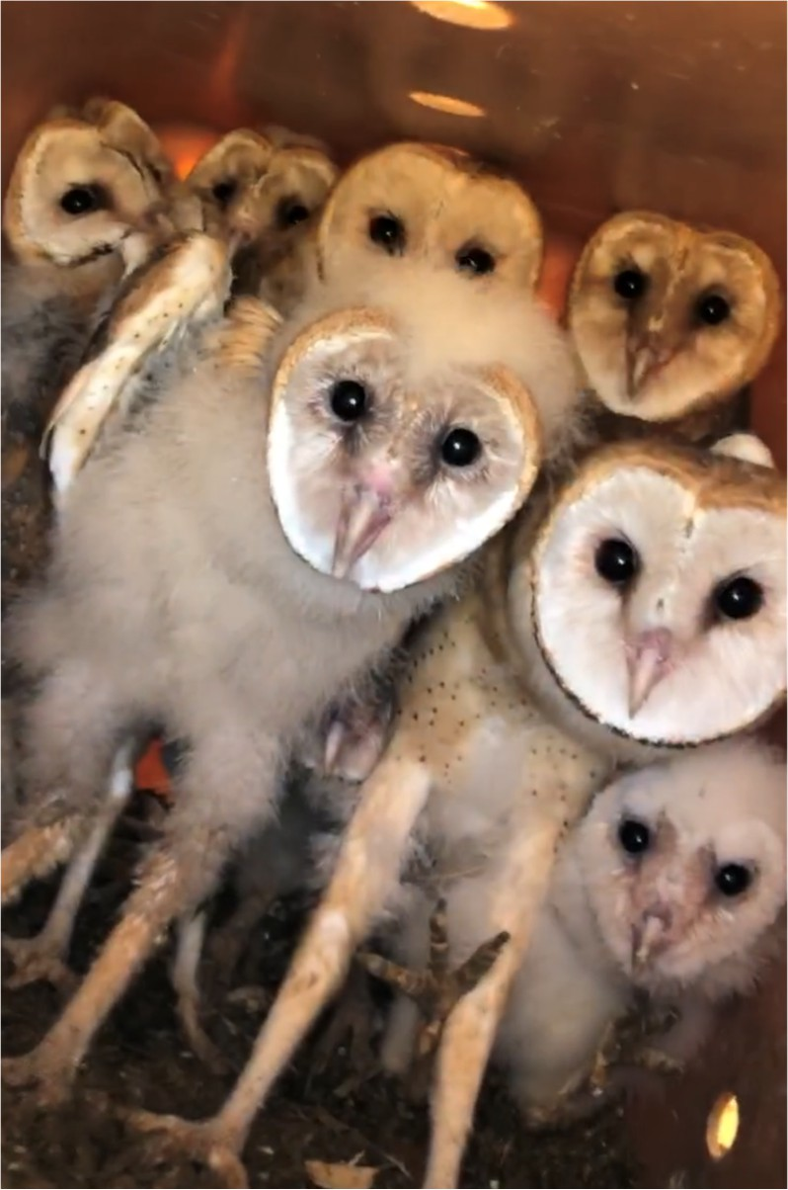

Unregulated Contaminant Monitoring Rule (UCMR3) Contaminants Monitored in 2015 ^{(1),} ⁽²⁾ |  | Groundwater |  | Surface Water - DWTP
Constituent | Units | Range | Average | Range | Average
Chlorate | μg/L | < 20 – 310 | 31 | 94 – 440 | 223
Chromium, Total | μg/L | < 0.20 – 6.3 | 4.4 | < 0.20 – 3.2 | 0.85
Hexavalent Chromium | μg/L | 0.049 – 6.6 | 4.4 | < 0.030 – 0.061 | 0.043
Molybdenum | μg/L | < 1.0 – 1.2 | < 1.0 | < 1.0 – 1.6 | 1.0
Strontium | μg/L | 160 – 590 | 452 | 48 – 260 | 167
Vanadium | μg/L | 2.9 – 29 | 23 | 0.60 – 2.8 | 1.7

Unregulated Contaminant Monitoring Rule (UCMR4) Contaminants Monitored in 2019 ^{(1),} ⁽³⁾
Constituent | Units | Groundwater |  | Surface Water - DWTP |  | Distribution System |  | DWTP Sources
Constituent | Units | Range | Average | Range | Average | Range | Average | Range | Average
Manganese | μg/L | < 0.40 – 77 | 12 | 1.6 – 15 | 6.1
HAA-6 | μg/L |  |  |  |  | <2.0 – 34.0 | 11.5
HAA-9 | μg/L |  |  |  |  | 2.8 – 79.3 | 39.5
Bromide | μg/L |  |  |  |  |  |  | < 20 – 150 | 37
TOC | μg/L |  |  |  |  |  |  | 1500 – 5300 | 2375
- Once every five years, the U.S. Environmental Protection Agency (EPA) issues a list of unregulated contaminants to be monitored by public water systems. The UCMR provides the EPA and other interested parties with scientifically valid data on the occurrence of certain contaminants in drinking water. An MCL for these contaminants listed above does not exist. The UCMR program examines what is in the drinking water, but additional health information is needed to know whether these contaminants pose a health risk. Further information on UCMR3 can be found at www.epa.gov/dwucmr/fact-sheets-about-third-unregulated- contaminant-monitoring-rule-ucmr-3, or contact the Safe Drinking Water Hotline (1-800-426-4791).
- Of the 30 unregulated contaminants tested for in UCMR3, only 6 were detected in the drinking water produced in 2015.
- Of the 30 unregulated contaminants tested for in UCMR4, only one chemical analyte was detected. Within the HAA-6 and HAA-9 groups, 9 of the 30 analytes were detected. No cyanotoxins were detected in the drinking water produced in 2019.
A family of owls nesting at the Delta Water Treatment Plant

To Report a Concern
City of Stockton, 24-Hour Emergency Service Center
(209) 937-8341
Please report broken or malfunctioning sprinklers, street flooding, illegal dumping, sewer backups.

For Questions About This Report, Contact
City of Stockton Municipal Utilities Department
(209) 937-8762 or WaterFacts@stocktonca.gov

Additional Water Quality Information is Available
www.stocktonca.gov/water
U.S. EPA Safe Drinking Water Hotline 1-800-426-4791
http://epa.gov/ground-water-and-drinking-water

Potability Statement

The City of Stockton water supply meets all potability requirements as set forth by the United States Environmental Protection Agency (USEPA) and the California Safe Drinking Water Act, Title 22. This certification relates to City of Stockton water that is provided up to the property line or backflow preventer, whichever comes first.
Este informe contiene información muy importante sobre su agua para beber. Favor de comunicarse City of Stockton a (209) 937-5001 para asistirlo en español.
ETsab ntawv no muaj cov ntsiab lus tseem ceeb txog koj cov dej haus. Thov hu rau City of Stockton ntawm
(209) 937-5001 rau kev pab hauv lus Askiv.

Ang pag-uulat na ito ay naglalaman ng mahalagang impormasyon tungkol sa inyong inuming tubig.
Mangyaring makipag-ugnayan sa City of Stockton o tumawag sa (209) 937-5001 para matulungan sa wikang Tagalog.
">ਸ ਿਰਪੋਟ ਿਵਚ ਤੁਵਾੜੇ ਪੀਣੇ ਦੇ ਵਾਰੇ ਮਹੱਤਵਪੂਰਨ ਸੂਚਨਾ ਹੈ l ਪੰਜਾਬੀ
ਿਵਚ ਮਦਦ ਲਈ, City of Stockton � 11373 N. Lower Sacramento Road, Lodi, CA 95242 ਜਾਂ (209) 937-5001 ਤੇ ਸੰਪਰਕ ਕਰੋ |
">Báo cáo này chứa thông tin quan trọng về nước uống của bạn. Xin vui lòng liên hệ City of Stockton tại


(209) 937-5001 để được trợ giúp bằng tiếng Việt.
Stay Connected!
Visit: www.stocktonca.gov/water
www.facebook.com/CityofStockton www.twitter.com/StocktonUpdates

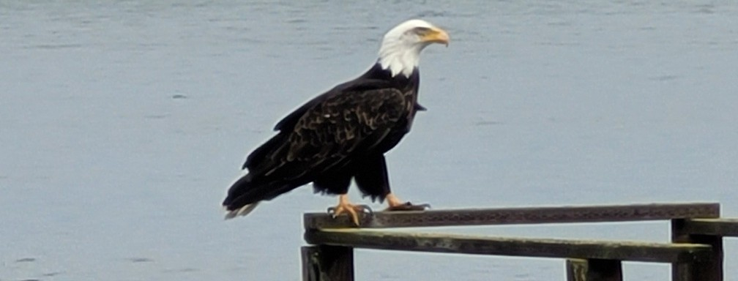
A Bald Eagle visits the San Joaquin Delta Wetlands

