.

2024 Consumer Confidence Report
We test the drinking water quality for many constituents as required by State and Federal Regulations.
This report shows the results of our monitoring for the period of January 1 – December 31, 2023.

Este informe contiene información muy importante sobre su agua potable. Tradúzcalo ó
hable con alguien que lo entienda bien.
Dated: July 1, 2025

BORREGO WATER DISTRICT
806 Palm Canyon Drive
Borrego Springs, CA 92004
760-767-5806 Fax: 760-767-5994
www.borregowd.org
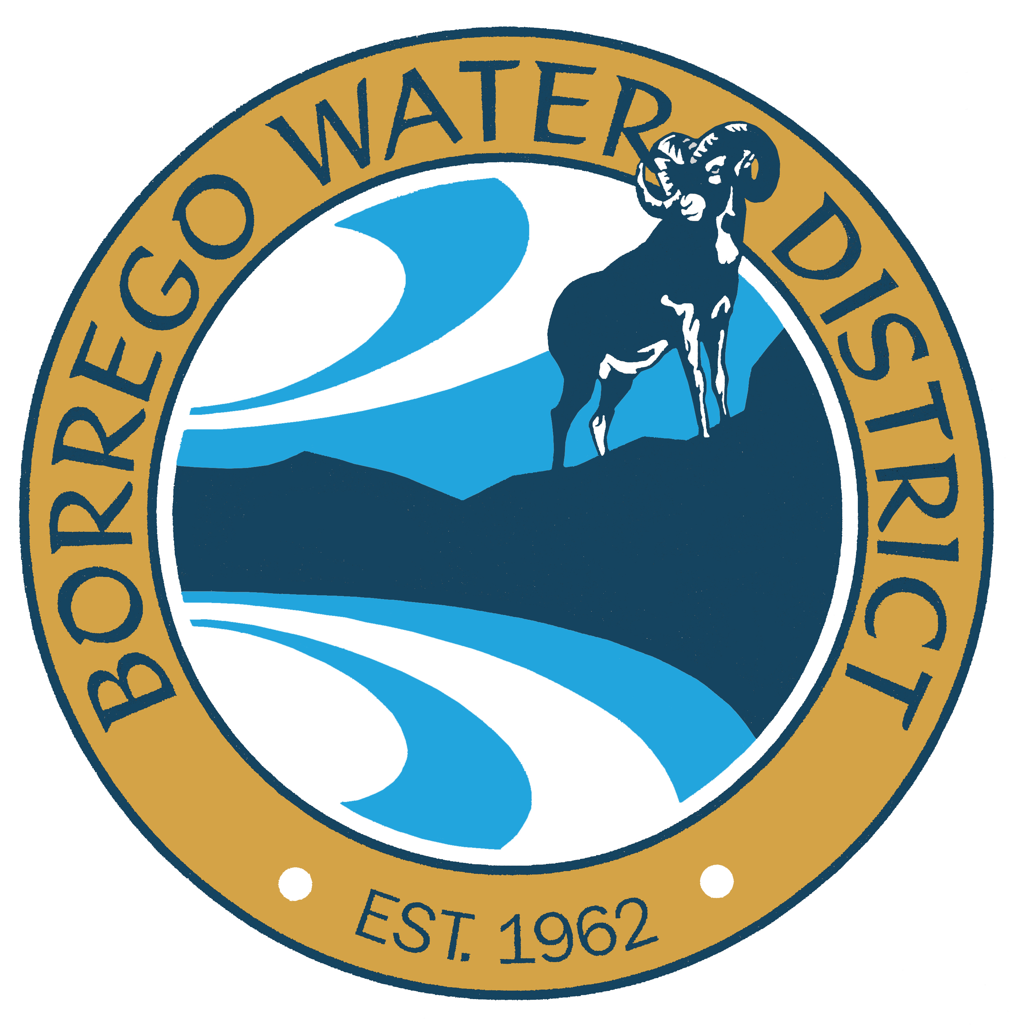

The Borrego Water District (BWD) has prepared this report to inform its customers concerning the quality of water it supplies. In 1996, Congress amended the Safe Drinking Water Act and added a requirement that water systems deliver to their customers a brief annual water quality report. This report, the Consumer Confidence Report (CCR) is more specific and detailed in content. The State Water Resources Control Board, Division of Drinking Water (DDW), in order to implement state and national policy, oversees and approves the issuance of this report. BWD is a community water system providing the public water supply service to most of the community of Borrego Springs. The following report provides information to BWD customers regarding test results available through December 31, 2023. Data from previous years may be reported if it’s the most recent data.

To receive more information about your water, to ask questions about this report or to receive additional copies of the report, you may call Alan Asche, Operations Manager at (760) 767-5806. Written questions should be addressed to the Operations Manager at 806 Palm Canyon Drive, Borrego Springs, CA 92004.

This report explains:
- Where your water comes from
- Information about water quality
- How it compares with state and federal drinking water standards for safety, appearance, taste and smell
- Regulations that protect your health
- Where to go if you have questions

Water Source: The District relies solely on groundwater pumped from deep underground wells. This aquifer is known as the Borrego Valley Groundwater Basin. It is the only source of water available at this time. The District disinfects its water distribution system to ensure that it is free from

bacteria that can exist in warm climates. The District is not required to do any further treatment, as those agencies must do that use surface water. Surface water by definition is water from lakes and streams usually impounded in open reservoirs where the water is subject to the pollutants in the watershed of its origin. The Borrego Water District does not have surface water available to it.

The sources of drinking water (both tap water and bottled water) include rivers, lakes, streams, ponds, reservoirs, springs and wells. As water travels over the surface of the land or through the ground, it dissolves naturally occurring minerals and, in some cases, radioactive material and can pick up substances resulting from the presence of animals or from human activity.

Staff
Geoff Poole, General Manager
Alan Asche, Operations Manager
Jessica Clabaugh, Finance Officer
Best Best & Krieger, District Counsel

Board of Directors
Kathy Dice, President
Tammy Baker, Vice President
Diane Johnson, Secretary/Treasurer
Dave Duncan, Director
Gina Moran, Director

Regular meetings of the Board of Directors are held every fourth Tuesday at 9:00 a.m. at the District office, 806 Palm Canyon Drive, Borrego Springs. Each agenda has a scheduled time for public comments and is posted on our website.

HELP CONSERVE OUR WATER

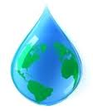

Contaminants that MAY be present in source water
before we treat it include:

- Microbial contaminants, such as viruses and bacteria that may come from sewage treatment plants, septic systems, agricultural livestock operations and wildlife.
- Inorganic contaminants, such as salts and metals, which can be naturally-occurring or result from urban storm water runoff, industrial or domestic wastewater discharges, oil and gas production, mining or farming.
- Pesticides and herbicides, which may come from a variety of sources such as agriculture, urban storm water runoff, and residential uses.
- Organic chemical contaminants, including synthetic and volatile organic chemicals, which are by-products of industrial processes and petroleum production, and can also come from gas stations, agricultural application, urban storm water runoff and septic systems.
- Radioactive contaminants, which can be naturally occurring or be the result of oil and gas production and mining activities.

Additional General Information on Drinking Water
All drinking water, including bottled water, may reasonably be expected to contain at least small amounts of some contaminants. The presence of contaminants does not necessarily indicate that the water poses a health risk. More information about contaminants and potential health effects can be obtained by calling the U.S. Environmental Protection Agency (USEPA) Safe Drinking Water Hotline (1-800-426-4791).
Water Quality Data
The following tables list all of the drinking water contaminants that were detected during the most recent sampling for the constituent. The presence of these contaminants in the water does not necessarily indicate that the water poses a health risk. The State allows us to monitor for certain contaminants less than once per year because the concentrations of these contaminants do not change frequently. Some of the data, though representative of the water quality, is more than one year old.
TERMS USED IN THIS REPORT:
- Maximum Contaminant Level (MCL): The highest level of a contaminant that is allowed in drinking water. Primary MCL’s are set as close to the PHG’s (or MCLG’s) as is economically and technologically feasible. Secondary MCL’s are set to protect the odor, taste, and appearance of drinking water.
- Maximum Contaminant Level Goal (MCLG): The level of a contaminant in drinking water below which there is no known or expected risk to health. MCLG’s are set by the U.S. Environmental Protection Agency (USEPA).
- Public Health Goal (PHG): The level of a contaminant in drinking water below which there is no known or expected risk to health. PHG’s are set by the California Environmental Protection Agency.
- Primary Drinking Water Standards (PDWS): MCL’s for contaminants that affect health along with their monitoring and reporting requirements, and water treatment requirements.
- Secondary Drinking Water Standards (SDWS): MCL’s for contaminants that affect taste, odor, or appearance of the drinking water. Contaminants with SDWS’s do not affect the health at the MCL levels.
- Regulatory Action Level (AL): The concentration of a contaminant which, when exceeded, triggers treatment or other requirement that a water system must follow.
- NA: not applicable; ND: not detectable at testing limit; NL: notification level; ppb: parts per billion or micrograms per liter (ug/l); ppm: parts per million or milligrams per liter (mg/l); pCi/L: picocuries per liter (a measure of radiation) AL: Action level; Avg: Average;

Some people may be more vulnerable to contaminants in drinking water than the general population. Immuno-compromised persons such as persons with cancer undergoing chemotherapy, persons who have undergone organ transplants, people with HIV/AIDS or other immune system disorders, some elderly and infants can be particularly at risk from infections. These people should seek advice about drinking water from their health care providers. USEPA/Centers for Disease Control (CDC) guidelines on appropriate means to lessen the risk of infection by Cryptosporidium and other microbial contaminants are available from the Safe Drinking Water Hotline (1-800-426-4791).

If present, elevated levels of lead can cause serious health problems, especially for pregnant women and young children. Lead in drinking water is primarily from materials and components associated with service lines and home plumbing. Borrego Water District is responsible for providing high quality drinking water, but cannot control the variety of materials used in plumbing components. When your water has been sitting for several hours, you can minimize the potential for lead exposure by flushing your tap for 30 seconds to 2 minutes before using water for drinking or cooking. If you are concerned about lead in your water, you may wish to have your water tested. Information on lead in drinking water, testing methods, and steps you can take to minimize exposure is available from the Safe Drinking Water Hotline or at http://www.epa.gov/safewater/lead

TABLE 1 - SAMPLING RESULTS SHOWING THE DETECTION OF COLIFORM BACTERIA - 2023
Microbiological | Highest # | No. of months |  |  | Typical Source
Contaminants | of Detections | in violation | MCL | MCLG | of Bacteria
 |  |  | More than 1 sample in a |  | Naturally present in the
Total Coliform Bacteria: | 0 | 0 | month with a detection | 0 | Environment
 |  |  | A routine sample and a repeat |  | Human & animal fecal
Fecal Coliform or | 0 | 0 | sample detect total coliform & | 0 | Waste
E. coli: |  |  | either sample also detects
 |  |  | fecal coliform or E.coli

TABLE 2 - SAMPLING RESULTS SHOWING THE DETECTION OF LEAD & COPPER – 11/2023
Lead & Copper  (& reporting units) | No. of Samples  Collected | 90% Percentile  level detected | No. sites  Exceeding AL | AL | PHG | Typical Source
 |  |  |  |  |  | of Contaminant
 |  |  |  |  |  | Internal corrosion of household
Lead (ppb) | 11 | ND | 0 | 15 | 0.2 | water, plumbing systems; erosion
 |  |  |  |  |  | of natural deposits
Copper (ppm) | 11 | 0.36 | 0 | 1.3 | 0.3 | (same as above)
All three schools in Borrego Springs Unified School District requested lead sampling. All samples came back with No Detection.

TABLE 3 - SAMPLING RESULTS FOR SODIUM & HARDNESS 10/2023
Chemical or Constituent | Sample | Range of |  |  | PHG | Typical Source
(& reporting units) | Date | Detections | Average | MCL | (MCLG) | of Contaminant
Sodium (ppm) | 2025 | 54-120 | 81.4 | None | None | Generally found in ground and
 |  |  |  |  |  | surface water
Hardness (ppm) | 2025 | 66-230 | 119.5 | None | None | (same as above)

TABLE 4 - DETECTION OF CONTAMINANTS WITH A PRIMARY DRINKING WATER STANDARD
 |  | Sample | Range of |  |  | PHG
Chemical or Constituent | Units | Date | Detections | Avg. | MCL | (MCLG) | Typical Source of Contaminant
Inorganic Chemicals:
Arsenic | ppb | 2025 | 3.6 – 9.2 | 5.7 | 10 | 0.004 | Erosion natural deposits, runoff /orchards
Barium | ppm | Nov ‘21 | ND – 29 | 0.06 | 1 | 2 | Discharge oil drilling wastes, erosion natural deposits
Fluoride | ppm | 2025 | 0.14- 1.1 | 0.44 | 2 | 1 | Erosion of natural deposits, water additive promotes
 |  |  |  |  |  |  | strong teeth, discharge - fertilizer & aluminum factories
Nitrate (N) | ppm | 2025 | 1.1 – 5.8 | 3.6 | 10 | 10 | Runoff & leaching from fertilizer use, leaching from
 |  |  |  |  |  |  | septic tanks, erosion of natural deposits
Selenium | ppb | April '19 | ND | ND | 50 | 30 | Discharge from petroleum, erosion of natural deposits
Radiological: Gross Alpha:  Radiological: Uranium | pCi/L  pCi/L | 2018  2018 | 0.49 – 7.69  1 – 3.99 | 2.63  2.40 | 15  20 | (0)  0.43 | Erosion of natural deposits  Erosion of natural deposits

TABLE 5 - DETECTION OF CONTAMINANTS WITH A SECONDARY DRINKING WATER STANDARD
 |  | Sample | Range of |  |  | PHG
Chemical or Constituent | Units | Date | Detections | Avg. | MCL | (MCLG) | Typical Source of Contaminant
General Mineral:
Sulfate | ppm | 2025 | 18-280 | 103.4 | 500 | NA | Runoff/leaching from natural deposits
General Physical:
Total Dissolved Solids (TDS) | ppm | 2025 | 270-630 | 365.5 | 1000 | NA | Runoff/leaching from natural deposits
pH | pH | April '19 | 8.0 - 8.3 | 8.16 | NA | NA

TABLE 6 - DETECTION OF UNREGULATED CONTAMINANTS
 |  | Sample | Range of |  |  | PHG | Major Sources in Drinking Water
Chemical or Constituent | Units | Date | Detections | Avg. | NL | (MCLG) | Health Effects Language
Inorganic Chemicals:
Boron | ppm | May '07 | ND-0.204 | 0.082 | 1 | NA | Runoff/leaching of natural deposits
Vanadium | ppb | May '07 | 8 - 69 | 29.5 | 50 | NA | Leaching natural deposits
Chromium-6 (Hexavalent Chromium) | ppb | Nov ‘24 | NC – 1.9 | 0.61 | 10 | 20 | AL: N/A - natural erosion

TABLE 7 - SUMMARY OF ALL DRINKING WATER SOURCE ASSESSMENTS:
The Borrego Water District completed a Source Water Assessment on ten wells in 2002 and one well in 2019. No contaminants have been detected in these sources of water. A copy of the complete assessment may be viewed at the District office. The data presented is from the most recent monitoring done in compliance with regulations. The most vulnerable activities are as follows:
Wells | Current Vulnerability | Possible Contamination
ID1-10, ID1-12, | Location near transportation | Fuels & lubrication, residue, which
Wilcox Well | corridors, roads & streets | may enter the aquifer by percolation
ID4-11 | Septic tank systems | Percolation of septic tank effluent
ID4-18 | Irrigated crops | Percolation of return water from irrigation
ID5-5, ID1-16, ID4 -9, ID5-15 | None | None

TABLE 8 - DISINFECTION BYPRODUCTS, DISINFECTANT RESIDUALS & DISINFECTION BYPRODUCT PRECURSORS
 |  | Sample | Range of |  |  | PHG
Chemical or Constituent | Units | Date | Detection | RESULT | MCL | (MCLG) | Major Source
Total Trihalomethanes (TTHM) | ppb | 2024 | 4.4 -5.5 | AVG 4.95 | 80 | N/A | Byproduct-Drinking Water Chlorination
Haloacetic acids (HAA5) | ppb | 2024 | N/A | ND | 60 | N/A | Byproduct-Drinking Water Chlorination

This data is presented from the most recent monitoring done in compliance with SWRCB.
All monitoring and monitoring intervals are regulated by SWRCB.

In order to ensure that tap water is safe to drink, the U.S. Environmental Protection Agency (USEPA), and the State Water Resources Control Board, Division of Drinking Water (Division) prescribe regulations that limit the amount of certain contaminants in water provided by public water systems. Division regulations also establish limits for contaminants in bottled water that provide the same protection for public health.

2024 Borrego Water District Statistics
Total Connections: 2053
Total Length of Pipelines: 100 Miles
Annual Water Pumped: 1,213.7 Acre Feet or 395,485,358 Gallons
Average Daily Pumping: 1,083,521 gallons per day
Total Production Wells: 9-Total Capacity: 5,240 Gallons per minute
Total Storage Reservoirs: 6-Total Capacity: 4,890,000 Gallons

这份报告含有关于您的饮用水的重要讯息。请用以下地址和电话联系 Borrego Water District 以获得中文的帮助: 806 Palm Canyon Drive, Borrego Springs, 760-767-5806
Language in Tagalog: Ang pag-uulat na ito ay naglalaman ng mahalagang impormasyon tungkol sa inyong inuming tubig. Mangyaring makipag-ugnayan sa Borrego Water District, 806 Palm Canyon Drive, Borrego Springs o tumawag sa 760-767-5806 para matulungan sa wikang Tagalog.
Language in Vietnamese: Báo cáo này chứa thông tin quan trọng về nước uống của bạn. Xin vui lòng liên hệ Borrego Water District tại 806 Palm Canyon Drive, Borrego Springs, 760-767-5806 để được hỗ trợ giúp bằng tiếng Việt.
Language in Hmong: Tsab ntawv no muaj cov ntsiab lus tseem ceeb txog koj cov dej haus. Thov hu rau Borrego Water District ntawm 806 Palm Canyon Drive, Borrego Springs, 760-767-5806 rau kev pab hauv lus Askiv.

