

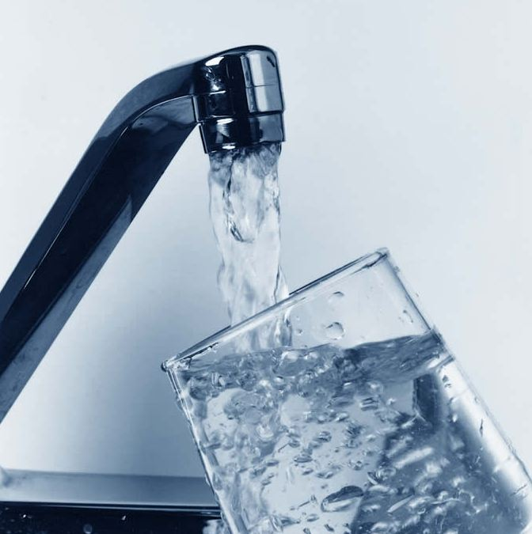

Annual Water Quality Consumers Confidence Report

YEAR 2017



YEAR 2017

This Consumer Confidence Report is mandated by the United States Environmental Protection Agency (USEPA) and is designed to give you, the consumer, all pertinent information relative to the production and distribution of safe drinking water for Needles.

The City of Needles Water Department is dedicated to providing a safe and reliable supply of water. We continually test our water to make sure that it meets State and Federal standards for quality and safety.

GROUND WATER is the source of the Needles water supply. Currently approximately 781 million gallons per year are pumped from four (4) wells. The wells are approximately 100 feet deep and are located in the lower part of the City.

WATER DISTRIBUTION system consists of 66 miles of lines varying in diameter from 2” to 16”. Lines are constructed of ductile iron, asbestos cement, steel and plastic pipe

WATER STORAGE capacity for the Needles water supply is provided by two 1.5 million gallon tanks for the lower pressure zone and one 1.5 million gallon tank and one 100,000 gallon tank for the upper pressure zone.

WATER QUALITY drinking water standards are established both by the State Water Resources Control Board (State Board), Division of Drinking Water and by the United States Environmental Protection Agency (USEPA) in compliance with the Safe Water Drinking Act. The standards fall into two categories:

- Primary Standards relate specifically to the health of the community as it might be affected by the water supply. mandatory maximum contaminant levels are established for specific constituents
- Secondary Standards relate to aesthetic qualities of the water including taste, odor, color and some metals. In California, maximum contaminant levels are established for those constituents as well.

Water samples are taken monthly from Needles water wells and distribution system to assure compliance with Primary and Secondary standards. Results of all analyses indicate compliance with all primary health standards.

Iron and Manganese is a secondary standard (which occurs naturally in some ground waters) that may, even at low concentrations, cause staining of fixtures or laundry. The concern about these minerals is solely aesthetic and has no health significance whatsoever.

All drinking water, including bottled water, may be reasonably expected to contain at least small amounts of some contaminants. The presence of contaminants does not necessarily indicate that water poses a health risk. More information about contaminants and potential health effects can be obtained by calling the USEPA’s Safe Drinking Water Hotline (1-800-426-4791).

Some people may be more vulnerable to contaminants in drinking water than the general population. Immuno-compromised persons such as persons with cancer undergoing chemotherapy, persons who have undergone organ transplants, people with HIV/AIDS or other immune system disorders, some elderly and infants can be particularly at risk from infections. These people should seek advice about drinking water from their health care providers. EPA/CDC (Centers for Disease Control) guidelines on appropriate means to lessen the risk of infection by cryptosporidium and other microbiological contaminants are available from the Safe Drinking Water Hotline (800-426-4791).

Through this annual report, we hope to have furthered your understanding and confidence in the quality and integrity of the water supplied and delivered directly to you by the City of Needles Water Department.

A source water assessment was conducted for Wells 8, 11,12 and 15 of the City of Needles
In March 2002 (samples taken in 2015 and 2017) and is summarized in the table below:
Source Number | Source ID | Most Vulnerable Activities (PCA’s) | Chemical Detected
005 | Well 08 | Housing, Schools | Arsenic* (see below)
005 | Well 08 | Automobile repair shops, Septic systems, Sewers, Historic waste dumps/landfills | None
007 | Well 11 | Campground/recreational areas, Apartments and condominiums, RV parks, Schools, Septic systems | Arsenic* (see below)
007 | Well 11 | Automobile repair shops, Historic gas stations, Sewers | None
008 | Well 12 | Irrigated crops, Septic systems | Nitrate* (see below)
008 | Well 12 | Parks, RV parks, Apartments and condominiums, Schools, Campgrounds/recreational areas, Septic systems | Arsenic* (see below)
008 | Well 12 | Automobile gas stations, Wastewater treatment plants | None
011 | Well 15 | Irrigated crops | Nitrate* (see below)
011 | Well 15 | Parks, Apartments and condominiums, RV parks, Campground/recreational areas septic systems Low density | Arsenic * (see below)
011 | Well 15 | Automobile gas stations | None
* Note: Even though some arsenic and nitrates were detected, all are below the state and federal regulations for maximum contaminant level. All water meets the primary drinking water standards.
A copy of the complete assessment may be viewed at the City of Needles office, or at the SWRCB, DDW San Bernardino District Office, 464 W. 4th Street, Suite 437, San Bernardino, CA 92401.You may request a summary of the assessment be sent to you by contacting the SWRCB District Engineer at (909) 383-4308.

PRIMARY DRINKING WATER STANDARDS (Test Results)
YEAR TESTED 2015/2017
INORGANIC CONTAMINANTS
Chemical Constituent | Unit of Measure | Needles  Range | Needles  Average | State  MCL | MCL Goal / PHG | Typical Source of Contamination
Hardness | mg/L | 350 - 820 | 520 | ns | ns | Erosion of Natural Deposits
Calcium | mg/L | 85 - 200 | 128.3 | ns | ns | Erosion of Natural Deposits
Sulfate | mg/L | 280 - 610 | 372.5 | 600 | ns | Erosion of Natural Deposits
Chloride | ug/L | 120 - 320 | 200 | 600 | ns | Erosion of Natural Deposits
Nitrate (NO3) | mg/L | ND – 2.3 | 0.817 | 45 | 45 | Erosion of Natural Deposits
Fluoride | ug/L | 0 -1.9 | 1.26 | 2 | 1 | Erosion of Natural Deposits
Specific Conductance | Umho/cm | 1000 - 2100 | 1425 | 2200 | n/a | Erosion of Natural Deposits
Total Dissolved Solids | mg/L | 720 - 1600 | 1050 | 1500 | n/a | Erosion of Natural Deposits
Turbidity | NTU | 0 – 4.6 | 1.69 | 5 | n/a | Erosion of Natural Deposits
Iron | ug/L | 0 - 79 | 75.5 | 300 | n/a | Erosion of Natural Deposits
Aluminum | ug/L | 0 - 0 | 0 | 1000 | n/a | Erosion of Natural Deposits
METALS - OTHER
Chemical Constituent | Unit of Measure | Needles  Range | Needles  Average | State  MCL | MCL Goal / PHG | Typical Source of Contamination
Arsenic | ug/L | 0 – 3.3 | 3.3 | 10 | none | Erosion of Natural Deposits
Manganese | ug/L | 27-54 | 40.5 | 50 | n/a | Erosion of Natural Deposits
Magnesium | mg/L | .63 - 43 | 29.9 | ns | ns | Erosion of Natural Deposits
Sodium | mg/L | 160 - 420 | 262.5 | ns | ns | Erosion of Natural Deposits
Chromium | ug/L | ND – 2.1 | 2.1 | 10 | ns | Erosion of Natural Deposits
Carbonate Alkalinity | mg/L | ND - ND | ND | ns | ns | Erosion of Natural Deposits
Bicarbonate | mg/L | 170 - 260 | 202.5 | ns | ns | Erosion of Natural Deposits
pH | units | 7.55 – 7.87 | 7.7 | n/s | ns | Erosion of Natural Deposits
Barium | ug/L | 20 - 49 | 33 | 1000 | 1000 | Erosion of Natural Deposits
Selenium | ug/L | 0 – 3.2 | 2.9 | 50 | n/a | Erosion of Natural Deposits
Chloroform | ug/L | ND | ND | 100 | n/a | Erosion of Natural Deposits
MTBE | ug/L | < 3 | < 3 | 5 | n/a | Leaking Underground Tanks
RADIOACTIVE CONTAMINANTS – 2015 and 2016
Radioactive | Unit of Measure | Range | Average | MCL | MCL Goal / PHG | Typical Source of Contamination
Contaminant
Gross Alpha | pCi/L | .856 – 7.23 | 4.5 | 15 | Zero | Erosion of Natural Deposits
Total Radium -228 | pCi/L | 0.0 - .081 | .05 | 3 | N/A | Erosion of Natural Deposits

DISTRIBUTION SYSTEM WATER QUALITY

Micobiological Contaminents  (units) | PRMARY MCL | PHG  (MCLG) | Value | MCL Violation? | Most Recent Sampling Date | Typical Source of Constituent
Total Coliform Bacteria (% of monthly positive samples) | More than 5% of monthly samples are positive | (0) | ND | No | 2017 | Naturally present in the environment
Fecal Coliform and E. coli Bacteria (number of monthly positive samples) | A routine sample and a repeat sample are total coliform positive, and one is also Fecal Coliform or E.coli positive | (0) | 0 | No | 2017 | Human and animal fecal waste

LEAD AND COPPER  (units) | ACTION LEVEL | PHG (MCLG) | Range of Detection | 90th % Level | MCL Violation? | Most Recent Sampling Date | Typical Source of Constituent
Copper (mg/L) | 1.3 | 0.17 | .013 - .36 | .28 | No | 2016 | Internal corrosion of household plumbing systems; erosion of natural deposits; leaching from wood preservatives. No samples collected exceeded the action level.
Lead (mg/L) | .015 | 0 | 0 - .013 | .0039 | No | 2016 | Internal corrosion of household water plumbing systems; discharges from industrial manufacturers, erosion of natural deposits. No samples collected exceeded the action level.

What Do All These Terms Mean?  SWRCB: State Water resources Control Board  Maximum Contaminant Level Goal (MCGL)  The level of a contaminant in drinking water below which there is no known or expected risk to health.  Maximum Contaminant Level (MCL)  The highest level of a contaminant that is allowed in drinking water.  Public Health Goal (PHG)    The goal set for water quality by public health agencies.  Primary Drinking Water Standards  Primary MCLs, specific treatment techniques adopted in lieu of primary MCLs, and monitoring and reporting requirements for MCLs that are specified in regulations.  mg/L: milligrams per liter (parts per million)  ug/L: micrograms per liter (parts per billion)  ND: not detectable testing limit  Questions regarding this report can be directed to the  City Utility Services Office  At 760-326-5700  pCi/L: Pico curies per liter (a measure of radiation)  Range: the lowest to the highest level detected  ns: no standard  n/a: not applicable  pca: possible contaminating activities |  | Water Conservation  Water- Just turn on the faucet and it’s there. But that does not mean we should take it for granted or waste this precious resource.  The high-quality water we need and expect is not an infinite resource. We must be responsible in our use of water. Keeping our waterways clean and free of pollutants is one way to do this. Another is to be conservative in how we use water.

Parts per million: Parts per billion:
3 drops in 42 gallons ~ 1 second in 12 days 1 drop in 14,000 gallons ~ 1 second in 32 years
1 inch in 16 miles ~ 1 penny in $10,000 1 penny in $10 million ~ 1 inch in 16,000 miles

This report contains important information about your drinking water. Translate it, or speak with someone who understands it.
 - Spanish: Este informe contiene informacion muy importante sobre su agua potable. Traduzcalo o hable con alguien que lo entienda bien.

