
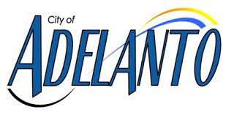
CONSUMER
CONFIDENCE
REPORT
2025
Issued June 2026

The City of Adelanto and Woodard & Curran are
pleased to provide our annual Consumer
Confidence Report (CCR). It provides the
results of our extensive water quality tests
City Council Meetings are open to the public at 11:00 am on the 2nd and 4th Wednesday of each month at Adelanto Governmental Center, 11600 Air Expressway, Adelanto.
conducted in 2025.
We test the drinking water quality for many
constituents as required by state and federal
regulations. This report shows the results of


our monitoring for the period of January 1 to December 31, 2025 and may include earlier monitoring data.
Questions:
For questions about this report or the water system,
contact Area Manager, Chris McMahon at
cmcmahon@woodardcurran.com or (207)-558-3866.
Este informe contiene información muy importante sobre su agua para beber. Favor de comunicarse City of Adelanto a (760) 246-2300 para asistirlo en español.
Where Does My Water Come From?
In 2025, about 2.3 million gallons of water were pumped each day from a combination of six (6) of the city’s active wells. This pumped water comes from underground storage areas (called “aquifers”) located within the city and along the Mojave River. These aquifers are recharged by rainfall, snowmelt, and (artificially) by the State Water Project. The City of Adelanto is also connected to the Mojave Water Agency’s Regional Recharge and Recovery (R3) Project. In addition, the city has an emergency source connection with the City of Victorville for backup or emergency needs.

Understanding
Your Water
Before the water reaches your tap, samples from wells and 36 individual locations throughout the City of Adelanto have been collected and tested in State certified laboratories. In this report, we summarize the extensive certified third-party laboratory data and test results in a simple manner to inform you of the high-quality drinking water provided for the City of Adelanto. In 2001, the California Department of Public Health (CDPHS) conducted a source water assessment of all fifteen (15) of the City’s water wells. The purpose of this assessment was to determine the vulnerability of the wells to “possible contaminating activities.” A copy of the complete assessment may be viewed at the City of Adelanto Water Department or at the CDPHS San Bernardino District Office, 464 W. Street, Suite 437, San Bernardino, CA 92401.
Is My Water Clean And Safe?


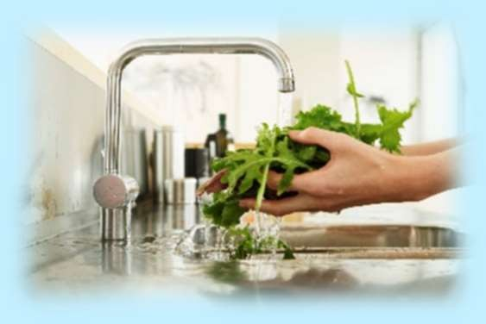
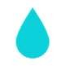
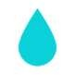
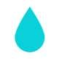
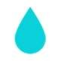
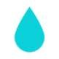
The sources of drinking water (both tap water and bottled water) include rivers, lakes, streams, ponds, reservoirs, springs, and wells.

Throughout California, the EPA wants you to be aware that contaminants that may be present in source water include:
Microbial contaminants, such as viruses and bacteria, that may come from sewage treatment plants, septic systems, agricultural livestock operations, and wildlife.

Inorganic contaminants, such as salts and metals, that can be naturally-occurring or result from urban stormwater runoff, industrial or domestic wastewater discharges, oil and gas production, mining, or farming.

Pesticides and herbicides, that may come from a variety of sources such as agriculture, urban stormwater runoff, and residential uses.

Organic chemical contaminants, including synthetic and volatile organic chemicals, that are byproducts of industrial processes and petroleum production, and can also come from gas stations, urban stormwater runoff, agricultural application, and septic systems.

Radioactive contaminants, that can be naturally-occurring or be the result of oil and gas production and mining activities.

The EPA would like you to know:
“As water travels over the surface of the land or through the ground, it dissolves naturally-occurring minerals and, in some cases, radioactive material, and can pick up substances resulting from the presence of animals or from human activity. In order to
ensure that tap water is safe to drink, the U.S. EPA and the State Board prescribe regulations that limit the amount of certain contaminants in water provided by public water systems. The U.S. Food and Drug Administration regulations and California law also establish limits for contaminants in bottled water that provide the same protection for public health.”

This section of the report contains summary information for contaminants exceeding an MCL, MRDL, AL or a violation of any treatment technique or monitoring reporting requirement. We are required to monitor your drinking water for specific contaminants on a regular basis. Results of regular monitoring are an indicator of whether our drinking water meets health standards. While your drinking water meets the federal and state standard for arsenic, it does contain low levels of this contaminant. The arsenic standard balances the current understanding of arsenic’s possible health effects against the costs of removing arsenic from drinking water. The U.S. Environmental Protection Agency continues to research the health effects of low levels of arsenic, which is a mineral known to cause cancer in humans at high concentrations and is linked to other health effects such as skin damage and circulatory problems. Throughout 2025, water in Adelanto was tested to have, on average, very low levels of Arsenic.
Drinking Water Quality
Test Results
2025
Wells 1G, 3G2, 4G, 8G2, 14A, 15, and other compliance sampling points
Inorganic Contaminants – Primary Drinking Water Standards
Contaminant | Average | Sample Range | MCL | Violation | Sample Date | Major Sources in Drinking Water
Arsenic (ppb) | 0.15 | 0.00 - 9.1 | 10 | NO | 2025 | Erosion of natural deposits (post treatment)
Fluoride (ppm) | 0.53 | 0.28 - 1.4 | 2 | NO | 2025 | Naturally present in the environment (post treatment)
Gross Alpha (pCi/L) | <3 | <3 | 15 | NO | 2025 | Erosion of natural deposits (pretreatment)
Nitrate (ppm) | <0.4 | <0.4 | 10 | NO | 2025 | Runoff and leaching from: fertilizer use, septic tanks, sewage, erosion of natural deposits
Total Chromium (ug/L) | <10 | <10 | 50 | NO | 2025 | Discharge from steel and pulp mill, chrome plating, erosion of natural deposits
Disinfection By-Products
Haloacetic Acid (ug /L) (HAA5) | 3.35 | 0.00 - 8.9 | 60 | NO | 2025 | By‐product of disinfecting drinking water
Total Trihalomethanes (ug/L) (TTHM) | 18.43 | 1 – 49 | 80 | NO | 2025 | By‐product of disinfecting drinking water
Radioactive Contaminants
Gross Alpha (pCi/L) 3.98 0.00 – 6.60 15 NO 2023 Erosion of natural deposits
Regulated Contaminants with Secondary Maximum Contaminant Levels
Contaminant | Average | Sample Range | Secondary MCL | Violation | Sample Date | Major Sources in Drinking Water
Chloride (ppm) | 39 | 16 - 52 | 500 | NO | 2025 | Runoff/leaching from natural deposits; seawater influence
Iron (ug/L) | 0.00 | 0.00 | 300 | NO | 2025 | Naturally present; industrial waste (post treatment)
Manganese (ug/l) | 0.93 | 0.00 - 33 | 50 | NO | 2025 | Naturally present in the environment (post treatment)
Odor (units) | 1 | 1.00 | 3 | NO | 2025 | Naturally present in the environment
Specific Conductance (µS/cm) | 567 | 350 - 790 | 1600 | NO | 2025 | Naturally present in the environment
Sulfate (mg/L) | 52 | 33 - 220 | 500 | NO | 2025 | Naturally present in the environment
Total Dissolved Solids (mg/L) | 338 | 190 - 500 | 1000 | NO | 2025 | Naturally present in the environment
Turbidity (NTU) | 0.19 | 0.00 – 0.48 | 5.00 | NO | 2025 | Naturally present in the environment
Lead and Copper
Contaminant | No. of  Samples | 90th  Percentile | Level Detected | Action Level | Sites Over AL | PHG | Sources
Lead (ug/L) | 31 | None | 0.55 | 1.3 | None | 0.03 | Customer household plumbing
Copper (ug/L) | 31 | None | ND | 0.015 | None | 0.0002 | Customer household plumbing
Microbial Contaminants
Contaminant | No. of Detections | Months in Violation | MCL |  |  | MCLG | Source
Total Coliform | 0 | 0 | More than 5% of positive monthly samples |  |  | 0 | Naturally present in the environment
Fecal Coliform or E. Coli | 0 | 0 | Routine or repeat sample detects coliform and E. Coli |  |  | 0 | Human and animal fecal waste
Unregulated Constituents That May Be of Interest to Consumers
Constituent | Average | Range | Sample Date | Notes
Calcium (mg/L) | 44 | 29 - 68 | 2025 | No MCL or PHG
Hardness (mg/L) | 138 | 72 - 210 | 2025 | No MCL or PHG
Magnesium (mg/L) | 4.3 | 2.6 - 9.6 | 2025 | No MCL or PHG
Sodium (mg/L) | 69 | 40 - 140 | 2025 | No MCL or PHG
Total Alkalinity (mg/L) (as CaCO3) | 152 | 93 - 230 | 2025 | No MCL or PHG
Filtration treatment is required for Iron and Manganese for wells 1G, 3G2, 4G, and 8G2 and is performed at the city’s water treatment plant on Turner Road.

Drinking Water Quality
Test Results
2025
City of Victorville
The City of Victorville imports water from the Mojave Water Agency. The City of Adelanto also began importing water from the Mojave Water Agency Regional Recharge and Recovery (R3) project in July of 2021 and continued for all of 2025. The following two tables include sample results from the distribution system and source water supply, including water imported from the City of Victorville and Mojave Water Agency.

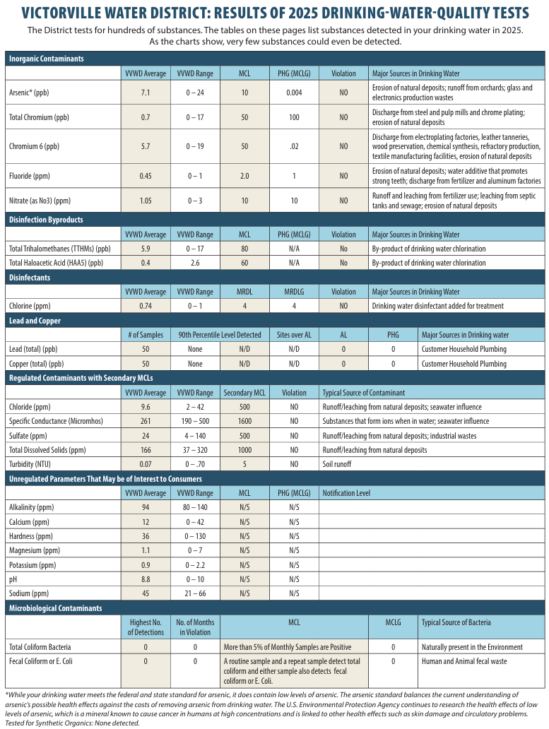
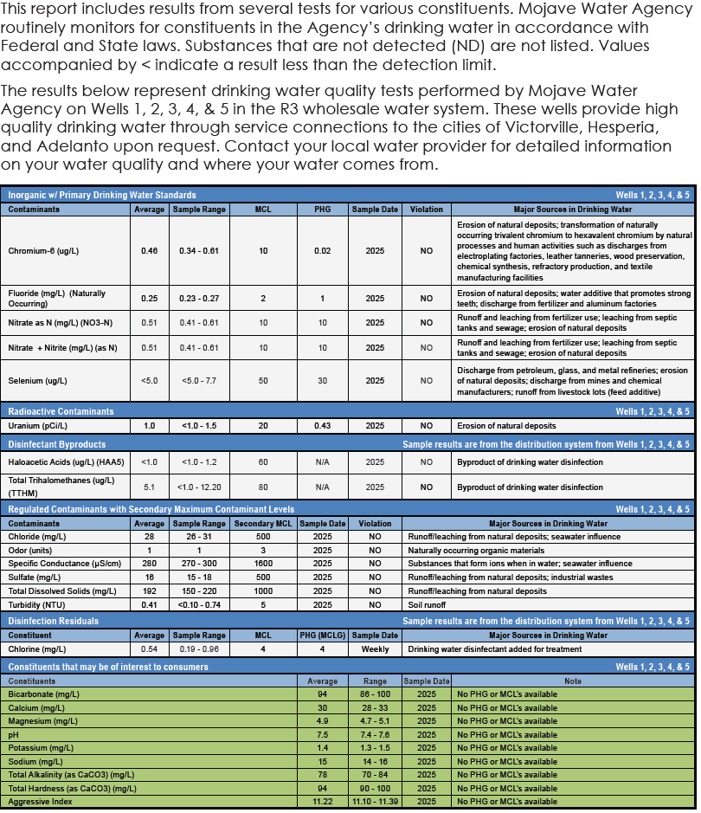
Drinking Water Quality
Test Results
2025
Mojave Water Agency
&
Additional Information About
Drinking Water
Conservation
Tips

Water quality regulations are strictly enforced on a state and federal level. The California State Water Resources Control Board (SWRCB) monitors all listed contaminants plus bacteriological samples taken on a weekly basis.

Drinking water, including bottled water, may reasonably be expected to contain at least small amounts of some contaminants. The presence of contaminants does not necessarily indicate that water poses a health risk.

More information about contaminants and potential health effects can be obtained by calling the USEPA’s Safe Drinking Water Hotline (1-800-426-4791).

Sensitive Populations May Be More Vulnerable
Some people may be more vulnerable to contaminants in drinking water than the general population. Immunocompromised persons such as persons with cancer undergoing chemotherapy, persons who have undergone organ transplants, people with HIV/AIDS or other immune system disorders, some elderly and infants can be particularly at risk from infections. These people should seek advice about drinking water from their health care providers. USEPA/Centers for Disease Control (CDC) guidelines on appropriate means to lessen the risk of infection by Cryptosporidium and other microbial contaminants are available from the Safe Drinking Water Hotline (1-800-426-4791).

Conservation Tips

Conservation Tips
Did you know that almost 20% of electricity and more than 30% of natural gas in California is used to treat, transport, and use water? It’s a win-win situation - when you save water, you save energy too! That’s good for the earth, and good for your energy bill.



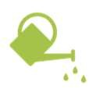




Below are some tips for you and your family to save water, energy, and money. By working together, we can do our part to minimize the effects of drought in CA.
Take shorter showers: reduce you shower by 1-2 minutes and save 5 gallons.
Turn the water off while brushing your teeth: Save 3 gallons each time.
Fix leaky faucets: Save 15 to 50 gallons per day.
Water your lawn before 8 am: Reduce evaporation and save about 25 gallons each time.
Mow your lawn with the blade set at 2-3 inches: longer grass shades the soil, reduces evaporation, and encourages deeper roots to develop. This helps grass survive drought, tolerate insect damage and fend off disease.
While shaving, plug the sink instead of letting the water run: Save 300 gallons per month.
Always use a broom to clean walkways, driveways, decks and porches, rather than hosing off these areas: You can save as much as 100 gallons of water cleaning your driveway and yard by sweeping instead of using the hose. Plus, it’s good exercise!
Replace your grass with turf or drought-resistant plants: Outdoor water use accounts for 50%-70% of all household water use. Making the switch will save water and cash.


PFAS (Per- and Poly- fluoroalkyl Substances) Notification
Notifications

Important Information About Your Drinking Water

All PFAS detections in the listed wells remain below the Response Levels established by the State Water Resources Control Board and are currently considered acceptable for continued use. No wells were removed from service, and monitoring will continue in accordance with State requirements.
In accordance with the State Water Resources Control Board – Division of Drinking Water’s (DDW) General Order No. DW-2024-0002-DDW, the City of Adelanto monitored its water sources for PFAS (Per- and Polyfluoroalkyl Substances). The following detections were reported in multiple wells during sampling conducted in 2025:
Health Effects (language recommended by the State Water Board):
Please note that there are thousands of different PFAS, some of which have been more widely used and studied than others. Scientific research suggests that exposure to certain PFAS may lead to adverse health outcomes. Research is still ongoing to determine how exposure to these different PFAS chemicals occurs and how they can affect human health.
PFAS Compound | Sample Locations | Detected  Level  (ng/L) | CCRDL  (ng/L) | Notification Level | Response Level (ng/L)
PFOA | Lower Booster, Well 01G | 2.6 - 3.0 | 4 | 5.1 | 10
PFOS | Lower Booster, Well 01G | <2.0 - 5.1 | 4 | 6.5 | 40
PFHxS | Lower Booster, Well 01G | 3.2 - 20 | 3 | 3 | 20
PFBS | Lower Booster, Well 01G | <2.0 - 2.4 | 3 | 500 | 5,000
PFOA | PFOS | PFHxS | PFBS
Perfluorooctanoic acid exposures resulted in increased liver weight and cancer in laboratory animals. | Perfluorooctanesulfonic acid exposures resulted in immune suppression and cancer in laboratory animals. | Perfluorohexane sulfonic acid exposures resulted in decreased total thyroid hormone in male rats. | Perfluorobutane sulfonic acid exposures resulted in decreased thyroid hormone in pregnant female mice.
About PFAS:
PFAS are synthetic chemicals used in a wide variety of industrial and consumer products. Some PFAS have been found to persist in the environment and accumulate in the human body. Although scientific research is ongoing, studies suggest that exposure to certain PFAS may result in adverse health effects. For additional information on PFAS testing and regulations, please visit the State Water Board’s PFAS
General Order webpage: https://www.waterboards.ca.gov/drinking_water/certlic/drinkingwater/pfas_ddw_general_order/ A multilingual fact sheet on PFAS is also available through California State University, Sacramento’s Office of Water Programs at: https://pfas.owp.csus.edu/
NA: Not applicable.
ND: Not detectable at testing limit.
NTD: Nephelometric Turbidity Units.
ppm: parts per million or milligrams per liter (mg/L)
ppb: parts per billion or micrograms per liter (μg/L)
ppt: parts per trillion or nanograms per liter (ng/L)
ppq: parts per quadrillion or picogram per liter (pg/L)
pCi/L: picocuries per liter (a measure of radiation)
Maximum Contaminant Level (MCL): The highest level of a contaminant that is allowed in drinking water. Primary MCLs are set as close to the PHGs (or MCLGs) as is economically and technologically feasible. Secondary MCLs are set to protect the odor, taste, and appearance of drinking water.
Maximum Contaminant Level Goal (MCLG): The level of a contaminant in drinking water below which there is no known or expected risk to health. MCLGs are set by the U.S. Environmental Protection Agency (USEPA).
Maximum Residual Disinfectant Level (MRDL): The highest level of a disinfectant allowed in drinking water. There is convincing evidence that addition of a disinfectant is necessary for control of microbial contaminants.
Maximum Residual Disinfectant Level Goal (MRDLG): The level of a drinking water disinfectant below which there is no known or expected risk to health. MRDLGs do not reflect the benefits of the use of disinfectants to control microbial contaminants.
Notification Level (NL): Notification levels are health based advisory levels established by CDPH for chemicals in drinking water that lack maximum contaminant levels (MCLs).
Primary Drinking Water Standards (PDWS): MCLs and MRDLs for contaminants that affect health along with their monitoring and reporting requirements, and water treatment requirements.
Public Health Goal (PHG): The level of a contaminant in drinking water below which there is no known or expected risk to health. PHGs are set by the California Environmental Protection Agency.
Regulatory Action Level (AL): The concentration of a contaminant which, if exceeded, triggers treatment or other requirements that a water system must follow.
Secondary Drinking Water Standards (SDWS): MCLs for contaminants that affect taste, odor, or appearance of the drinking water. Contaminants with SDWSs do not affect the health at the MCL levels.
Treatment Technique (TT): A required process intended to reduce the level of a contaminant in drinking water.
Variances and Exemptions: Permissions from the State Water Resources Control Board (State Board) to exceed an MCL or not comply with a treatment technique under certain conditions.
NA: Not applicable.
ND: Not detectable at testing limit.
NTD: Nephelometric Turbidity Units.
ppm: parts per million or milligrams per liter (mg/L)
ppb: parts per billion or micrograms per liter (μg/L)
ppt: parts per trillion or nanograms per liter (ng/L)
ppq: parts per quadrillion or picogram per liter (pg/L)
pCi/L: picocuries per liter (a measure of radiation)
Maximum Contaminant Level (MCL): The highest level of a contaminant that is allowed in drinking water. Primary MCLs are set as close to the PHGs (or MCLGs) as is economically and technologically feasible. Secondary MCLs are set to protect the odor, taste, and appearance of drinking water.
Maximum Contaminant Level Goal (MCLG): The level of a contaminant in drinking water below which there is no known or expected risk to health. MCLGs are set by the U.S. Environmental Protection Agency (USEPA).
Maximum Residual Disinfectant Level (MRDL): The highest level of a disinfectant allowed in drinking water. There is convincing evidence that addition of a disinfectant is necessary for control of microbial contaminants.
Maximum Residual Disinfectant Level Goal (MRDLG): The level of a drinking water disinfectant below which there is no known or expected risk to health. MRDLGs do not reflect the benefits of the use of disinfectants to control microbial contaminants.
Notification Level (NL): Notification levels are health based advisory levels established by CDPH for chemicals in drinking water that lack maximum contaminant levels (MCLs).
Primary Drinking Water Standards (PDWS): MCLs and MRDLs for contaminants that affect health along with their monitoring and reporting requirements, and water treatment requirements.
Public Health Goal (PHG): The level of a contaminant in drinking water below which there is no known or expected risk to health. PHGs are set by the California Environmental Protection Agency.
Regulatory Action Level (AL): The concentration of a contaminant which, if exceeded, triggers treatment or other requirements that a water system must follow.
Secondary Drinking Water Standards (SDWS): MCLs for contaminants that affect taste, odor, or appearance of the drinking water. Contaminants with SDWSs do not affect the health at the MCL levels.
Treatment Technique (TT): A required process intended to reduce the level of a contaminant in drinking water.
Variances and Exemptions: Permissions from the State Water Resources Control Board (State Board) to exceed an MCL or not comply with a treatment technique under certain conditions.




Definitions

