Consumer Confidence
Water Quality Report
2025

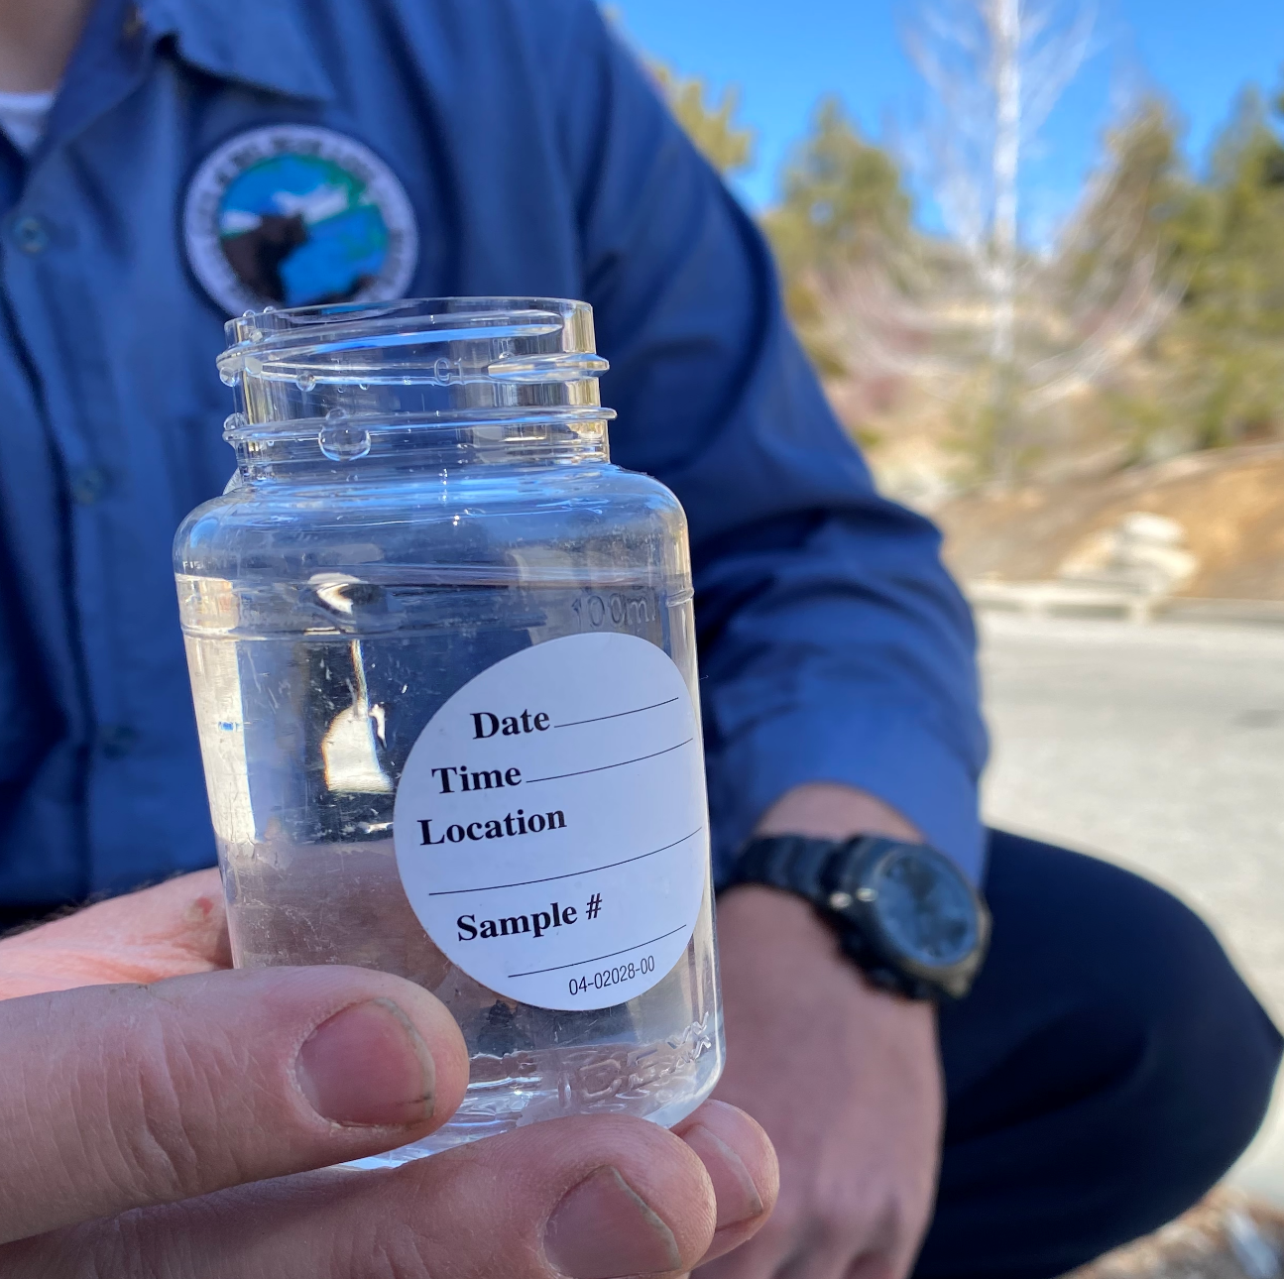
City of Big Bear Lake Department of Water
Lake William System
41972 Garstin Drive Big Bear Lake, CA 92315
www.BBLDWP.com
(909) 866-5050
This institution is an equal opportunity provider and employer.

TO OUR CUSTOMERS
The City of Big Bear Lake Department of Water is proud to present our Annual Water Quality Report, also referred to as a Consumer Confidence Report (CCR). By law, each community water system is required to provide this report to its customers each year.
If you don’t pay your own water bill because you live in an apartment, condo, or rental property or you get your water from a private ground water well, you may not receive a CCR, but it is still accessible on our website.
Your CCR Provides Need-To-Know Information such as:
 | 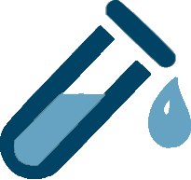 |  | 
Where your water comes from. | A list of regulated contaminants detected and the level. | Potential health effects from consuming contaminated water and safeguards against water-related illnesses. | Contaminant levels in your area compared to national standards and any violations of health-based standards.

Water System Information
This report is a summary of the quality of water provided to our customers. Throughout the year we conduct hundreds of tests for multiple types of water contaminants. In order to ensure that tap water is safe to drink, the U.S. Environmental Protection Agency (USEPA) and the State Water Resources Control Board prescribe regulations that limit the amount of certain contaminants in water provided by public water systems. Department regulations also establish limits for contaminants in bottled water that provide similar protection for public health.

DWP’s Sources
The City of Big Bear Lake Department of Water produces all its water from local ground water sources. There are 3 wells and 1 reservoir with a total storage capacity of 160,000 gallons in the Lake William system. We also have 4 portable generators, and 2 portable booster pumps. In 2025 there were 9.97 million gallons of water produced out of the Lake William system.

Drinking Water Sources
Sources of drinking water (both tap water and bottled water) can include rivers, lakes, streams, ponds, reservoirs, springs, and wells. As water travels over the surface of the land or through the ground, it dissolves naturally occurring minerals and, in some cases, radioactive material, and can pick up substances resulting from the presence of animals or from human activity. As a result, all drinking water, including bottled water, may reasonably be expected to contain at least small amounts of some contaminants. The presence of contaminants does not necessarily indicate that the water poses a health risk. More information about contaminants and potential health effects can be obtained by calling the USEPA's Safe Drinking Water Hotline at (800) 426-4791.
We test the drinking water quality for many contaminants as required by state and federal regulations. This report shows the results of our monitoring for the period of January 1 - December 31, 2025.
Este informe contiene informacion muy importante sobre su agua potable. Traduzcalo o hable con alguien que lo entienda bien.

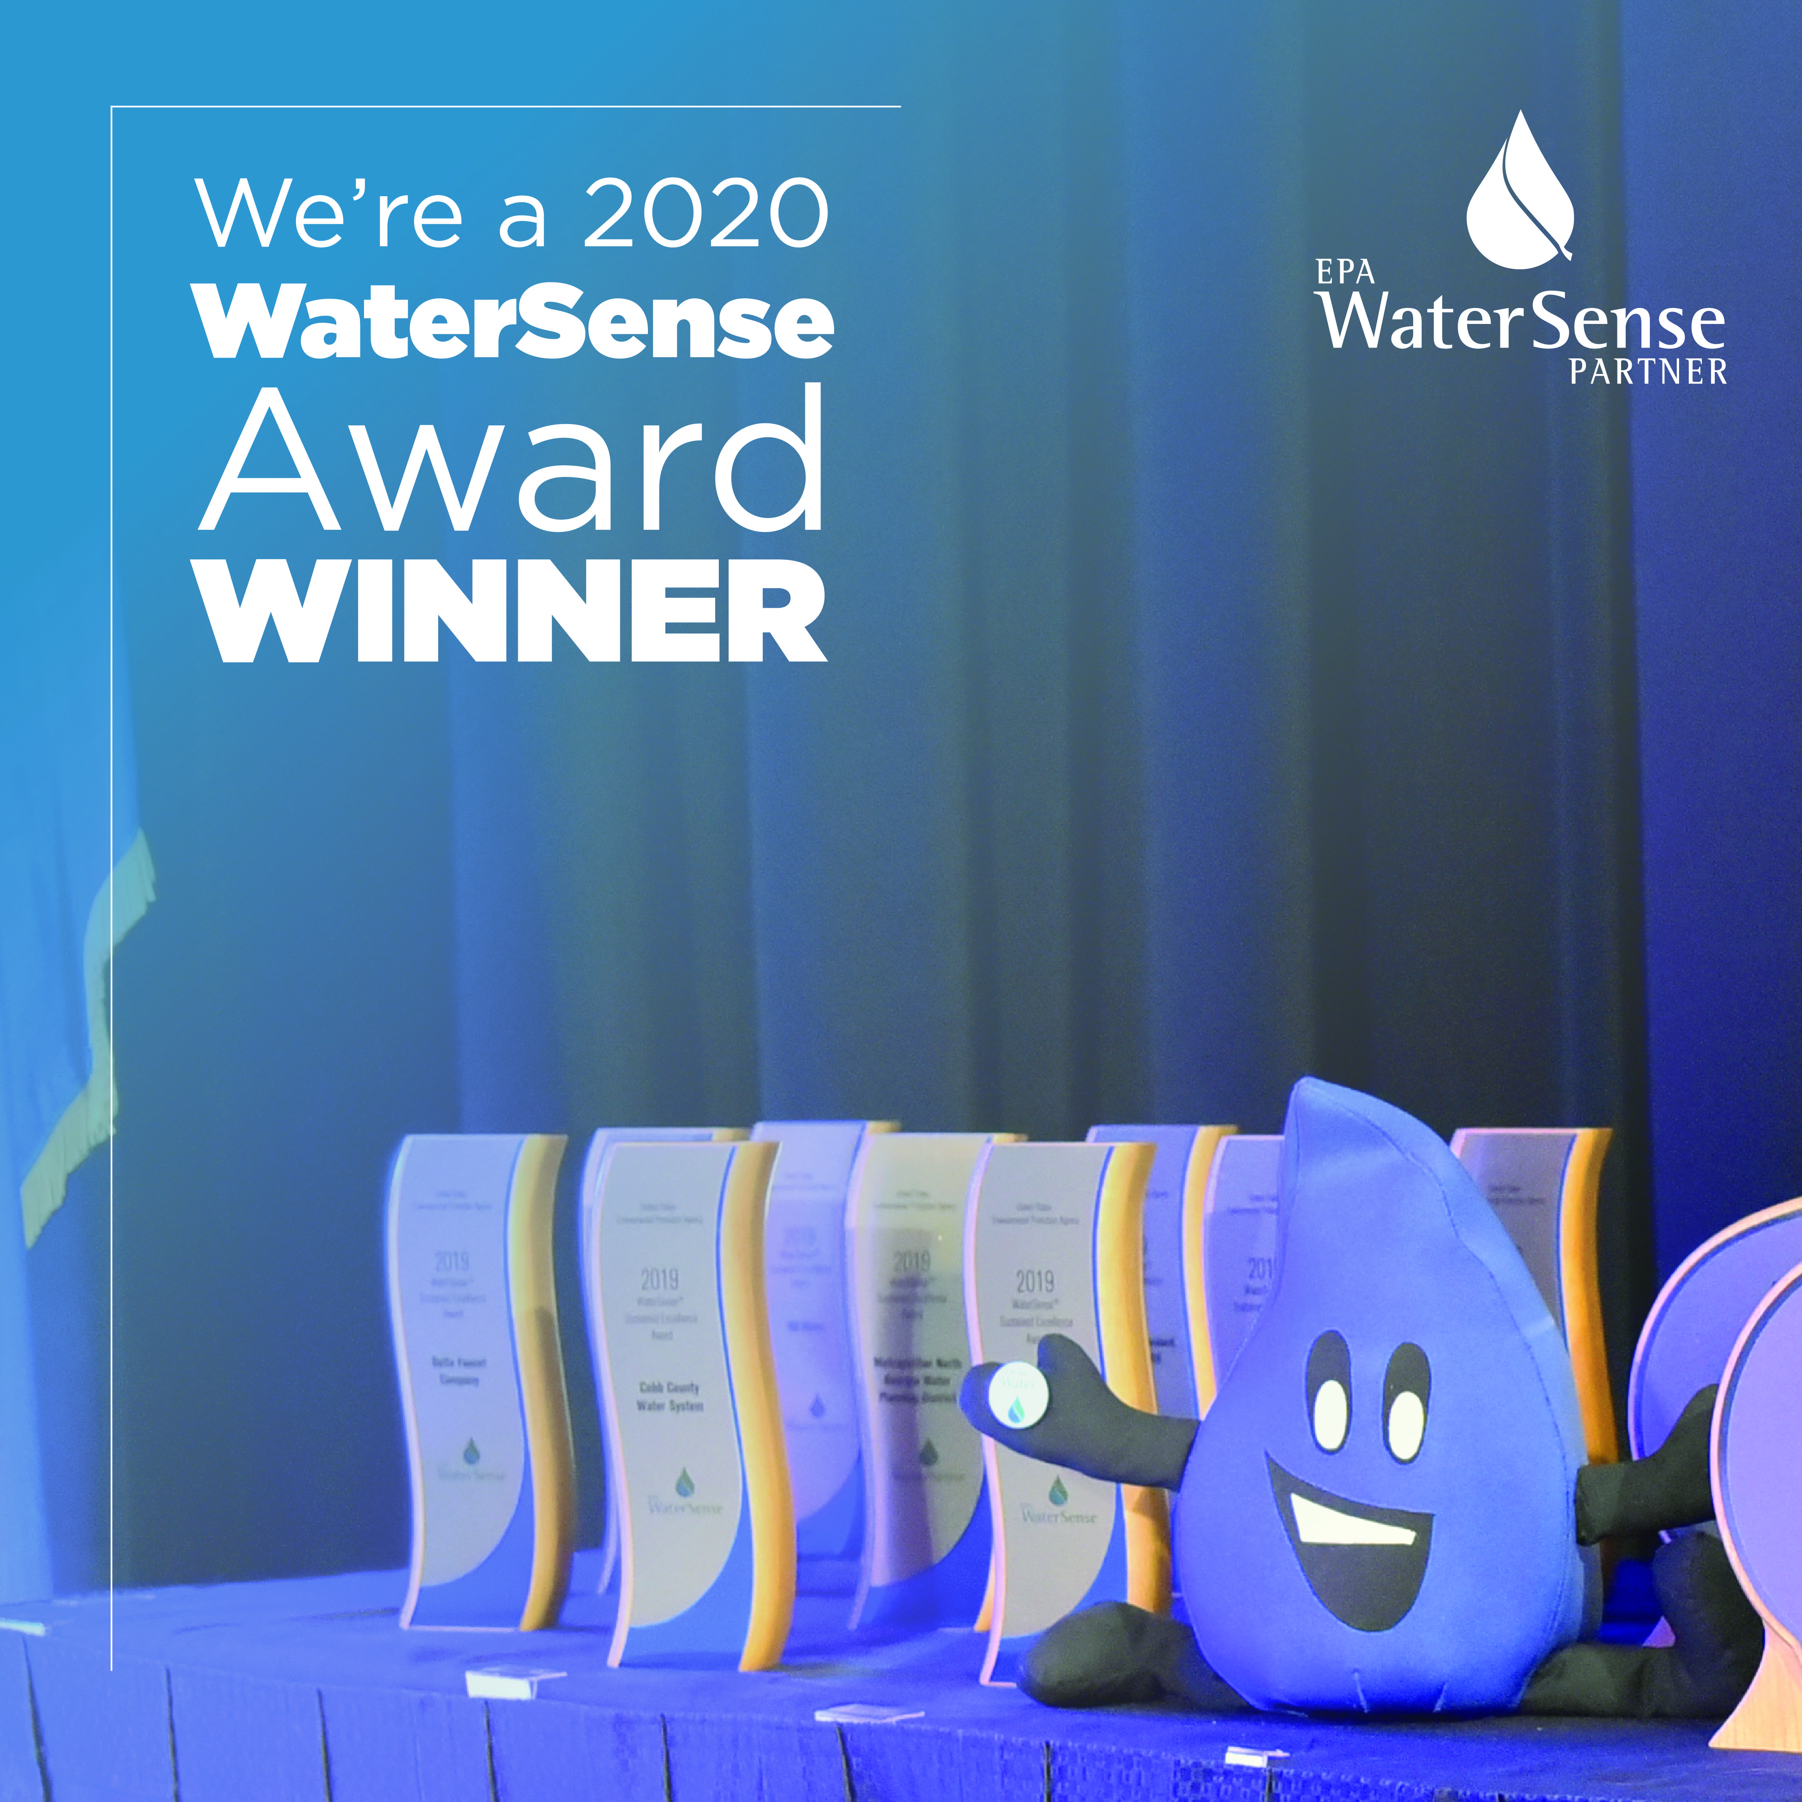
Use Only What You Need
The BBLDWP is a champion for water use efficiency. In 2020 we were recognized as a WaterSense Partner of the Year for our efforts. We give away WaterSense certified sink faucet aerators and showerheads and offer toilet rebates (pre-inspection of the old toilet is required). We offer outdoor efficiency rebates for turf removal, WaterSense labeled weather-based irrigation controllers, WaterSense labeled efficient sprinkler heads, native plants, rain barrels and more. To learn more, email Conservation@BBLDWP.com.
Our Motto is Service, Quality, Community.
Our Mission is to cost effectively deliver quality water to meet the needs of our current and future customers.
The City of Big Bear Lake Department of Water is located at 41972 Garstin Drive Big Bear Lake, CA 92315 and is open Monday through Friday from 8:00 a.m. until 4:30 p.m. Our Board of Directors meets on the fourth Tuesday of every month at 9:00 a.m. at our Garstin office. The public is welcome to participate in these meetings. Our phone number is (909) 866-5050.
For questions regarding your water quality, ask for Ben Berge, or contact The Environmental Protection Agency's Safe Drinking Water Hotline at (800) 426-4791.

DEFINITIONS
The following terms and abbreviations are used in tables 1, 2, 3 and 4:
  - Action Level (AL): The concentration of a contaminant, which, if exceeded, triggers treatment or other requirements that a water system must follow.
  - Contaminant: Any physical, chemical, biological or radiological substance or matter in water. Drinking water may reasonably be expected to contain at least small amounts of some contaminants. Some contaminants may be harmful if consumed at certain levels in drinking water. The presence of contaminants does not necessarily indicate that the water poses a health risk.
  - Maximum Contaminant Level (MCL): The highest level of a contaminant that is allowed in drinking water. Primary MCLs are set as close to the PHGs (or MCLGs) as is economically and technologically feasible. Secondary MCLs are set to protect the odor, taste, and appearance of drinking water.
  - Maximum Contaminant Level Goal (MCLG): The level of a contaminant in drinking water, below which, there is no known or expected risk to health. MCLGs are set by the USEPA.
  - N/A: Not applicable
  - N/S: No standard
  - ND: Not detectable at testing limit.
  - Nephelometric Turbidity Units (NTU): This is a measure of suspended material in water.
  - ppm: parts of substance per million parts of water or milligrams per liter
  - ppb: parts of substance per billion parts of water or micrograms per liter
  - pCi/L: picocuries per liter (a measure of radiation)
  - Public Health Goal (PHG): The level of a contaminant in drinking water, below which, there is no known or expected risk to health. PHG's are set by the California Environmental Protection Agency.

Contaminants
Contaminants that may be present in source water before we treat it include:
  - Microbial contaminants, such as viruses and bacteria, may come from sewage treatment plants, septic systems, agricultural livestock operations, and wildlife.
  - Inorganic contaminants, such as salts and metals, can be naturally occurring or result from urban storm water runoff, industrial or domestic wastewater discharges, oil and gas production, mining, or farming.
  - Pesticides and herbicides may come from a variety of sources such as agriculture, urban storm water runoff, and residential uses.
  - Organic chemical contaminants, including synthetic and volatile organic chemicals, are byproducts of industrial processes and petroleum production, and can also come from gas stations, urban storm water runoff, agricultural application, and septic systems.
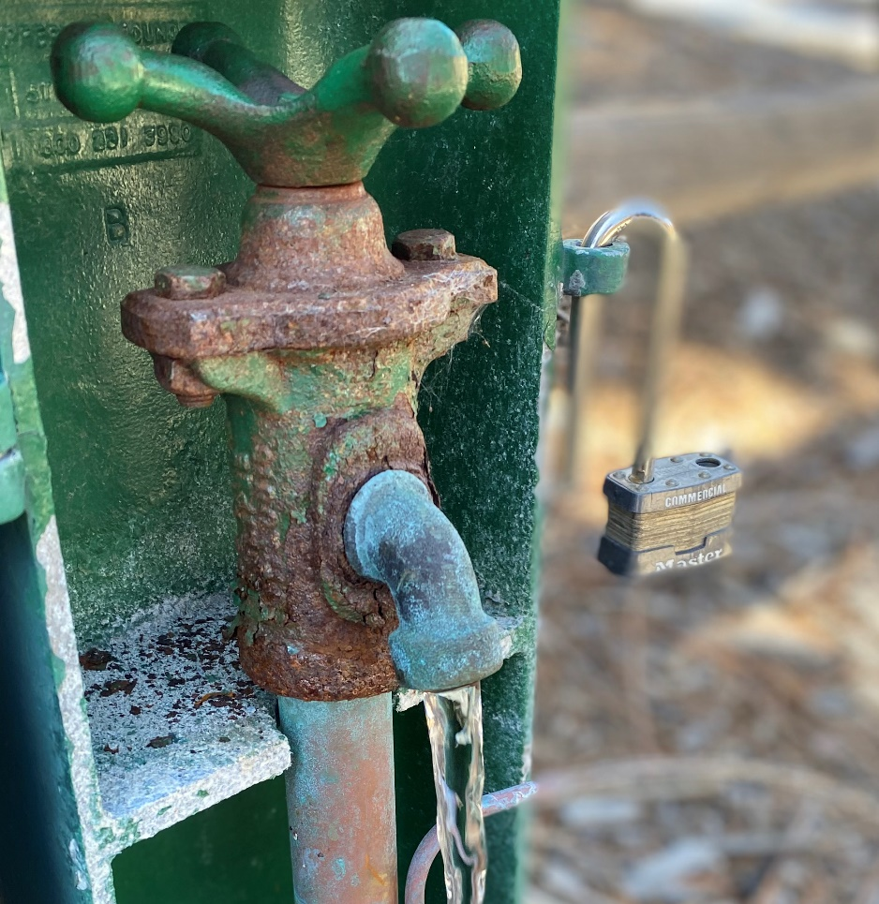
  - Radioactive contaminants can be naturally occurring or be the result of oil and gas production and mining activities.

How To Read The Tables
  - Starting with a Substance, read across.
  - Last sample is the year the sample was taken.
  - Range tells the highest and lowest amounts measured.
  - Goal, MCLG or PHG is the goal level for that substance (this may be lower than what is allowed).
  - State MCL shows the highest level of substance (contaminant) allowed.
  - Average Detected represents the measured amount (less is better).
  - A No under Violation indicates government requirements were met.
  - Major Sources in Drinking Water tells where the substance usually originates.

Water Information Sources
  - American Water Works Association: www.awwa.org
  - Centers for Disease Control and Prevention: www.cdc.gov
  - City of Big Bear Lake Department of Water: www.bbldwp.com
  - National Library of Medicine/National Institute of Health: www.nlm.nih.gov/medlineplus/drinkingwater.html
  - State Water Resources Control Board, Division of Drinking Water: www.waterboards.ca.gov/drinking_water/programs/
  - United States Environmental Protection Agency (USEPA): www.epa.gov
Some people may become more vulnerable to contaminants in drinking water than the general population. Immuno-compromised persons such as persons with cancer undergoing chemotherapy, persons who have undergone organ transplants, people with HIV/AIDS or other immune system disorders, some elderly, and infants can be particularly at risk from infections.
These people should seek advice about drinking water from their health care providers. USEPA/Centers for Disease Control (CDC) guidelines on appropriate means to lessen the risk of infection by Cryptosporidium and other microbial contaminants are available from the Safe Drinking Water Hotline (800) 426-4791.

WATER QUALITY DATA FOR 2025
The following tables list all the drinking water contaminants detected during the most recent sampling. The presence of contaminants in the water does not necessarily indicate that the water poses a health risk. The state requires us to monitor for certain contaminants less than once per year because the concentrations of these contaminants do not change frequently. Some data, though representative of the water quality, is more than one year old.
Table 1: Primary Regulated Contaminants
Regulated Contaminants | Last Sample | Range Detected |  | Goal (PHG or MCLG) | State MCL | Average Detected | Violation | Major Sources
Regulated Contaminants | Last Sample | Low | High
Microbiological (sampled monthly)
Total Coliform Bacteria (# positive) | 2025 | 0 | 0 | 0 | 2/  month | 0 | No | Naturally present in the environment
Clarity (sampled every 3 years)
Turbidity (NTU) | 2023 | ND | ND | N/A | 5 | 0 | No | Soil runoff
Inorganic Chemicals (sampled every 3 years, except Nitrates which are every year)
Fluoride (ppm) | 2023 | 0.1 | 0.1 | 1 | 2 | 0.1 | No | Erosion of natural deposits
Nitrate (as NO3-N) (ppm) | 2025 | ND | ND | 10 | 10 | 0 | No | Fertilizer runoff/leaching; septic/sewage leaching; erosion of natural deposits
Radioactivity (sampled every 9 years)
Gross Alpha Activity (pCi/L) | 2021 | ND | ND | 0 | 15 | 0 | No | Erosion of natural deposits
Uranium (pCi/L) | 2021 | ND | ND | 0.43 | 20 | 0 | No | Erosion of natural deposits
Additional Contaminants (sampled every 3 years)
PH (units) | 2023 | 7.0 | 7.0 | N/S | N/S | 7.0 | No | N/A
Hardness (CaCO3) (ppm) | 2023 | 56 | 56 | N/S | N/S | 56 | No | N/A
Calcium (ppm) | 2023 | 15 | 15 | N/S | N/S | 15 | No | N/A
Magnesium (ppm) | 2023 | 4.6 | 4.6 | N/S | N/S | 4.6 | No | N/A
Sodium (ppm) | 2023 | 9.4 | 9.4 | N/S | N/S | 9.4 | No | N/A
Potassium (ppm) | 2023 | 1.6 | 1.6 | N/S | N/S | 1.6 | No | N/A
Bicarbonate (ppm) | 2023 | 80 | 80 | N/S | N/S | 80 | No | N/A
Total Alkalinity (ppm) | 2023 | 66 | 66 | N/S | N/S | 66 | No | N/A

Table 2: Secondary Standards
Regulated Contaminants | Last Sample | Range Detected |  | Goal (PHG or MCLG) | State MCL | Average Detected | Violation | Major Sources
Regulated Contaminants | Last Sample | Low | High
Secondary Standards (sampled every 3 years)
Odor-Threshold (units) | 2023 | 1 | 1 | N/S | 3 | 1 | No | Naturally-occurring organic materials
Chloride (ppm) | 2023 | 2.7 | 2.7 | N/S | 500 | 2.7 | No | Runoff/leaching from natural deposits
Sulfate (ppm) | 2023 | 2.4 | 2.4 | N/S | 500 | 2.4 | No | Runoff/leaching from natural deposits
Total Dissolved Solids (ppm) | 2023 | 83 | 83 | N/S | 1000 | 83 | NO | Runoff/leaching from natural deposits
Specific Conductance (E.C.) (umhos?cm) | 2023 | 150 | 150 | N/S | 1000 | 150 | No | Substances that form ions when in water; seawater influence
Secondary Standards are for contaminants that can affect the taste, odor, or appearance of the drinking water. There are no PHGs, or mandatory standard health effects language for these contaminants because secondary MCLs are set on the basis of aesthetics.
Table 3: Lead and Copper
Regulated Contaminants | No. Samples Collected | Goal (PHG or MCLG) | State AL | Detected Level (90th Percentile) | # of Sites Exceeding AL | Major Sources
Lead and Copper (sampled every 3 years, next sample due 2026)
*Lead (ppm) | 0 | 0.002 | 0.015 | 0 | 0 | Internal corrosion of household water plumbing systems
*Copper (ppm) | 0 | 0.17 | 1.3 | 0 | 0 | Internal corrosion of household water plumbing systems
*Lead: If present, elevated levels of lead can cause serious health problems, especially for pregnant women and young children. Lead in drinking water is primarily from materials and components associated with service lines and home plumbing. The City of Big Bear Lake Department of Water is responsible for providing high quality drinking water, but cannot control the variety of materials used in plumbing components. When your water has been sitting for several hours, you can minimize the potential for lead exposure by flushing your tap for 30 seconds to 2 minutes before using water for drinking or cooking. If you are concerned about lead in your water, you may wish to have your water tested. Information on lead in drinking water, testing methods, and steps you can take to minimize exposure is available from the Safe Drinking Water Hotline (800) 426-4791 or at https://www.epa.gov/safewater/lead.

Lead in Schools
We conducted lead sampling at four schools, including Baldwin Lane Elementary School, North Shore Elementary School, Big Bear Middle School and Big Bear Elementary School. We collected four samples at each site; all of them were non-detect.
*Copper: Copper is an essential nutrient, but some people who drink water containing copper in excess of the action level over a relatively short amount of time may experience gastrointestinal distress. Some people who drink water containing copper in excess of the action level over many years may suffer liver or kidney damage. People with Wilsons Disease should contact their personal doctor.
Table 4: Unregulated Contaminants
Unregulated Contaminants | Last Sample | Range Detected |  | Goal (PHG or MCLG) | State MCL | Average Detected | Violation | Major Sources
Unregulated Contaminants | Last Sample | Low | High
Unregulated Inorganic Chemicals (sampled every 3 years)
There were no Unregulated Inorganic Contaminants Detected in 2023 when last sampled.

__________________________________________________________________________________________________

The City of Big Bear Lake Department of Water sampled for Hundreds of regulated and unregulated chemicals, both organic and inorganic. Unless noted, the other results were non-detectable.
A source water assessment (SWA) summarizes the likelihood of individual drinking water sources becoming contaminated (usually a short-term "contamination event") and serves as a foundation for public water systems to prepare source water (drinking water) protection plans and implement protection measures.
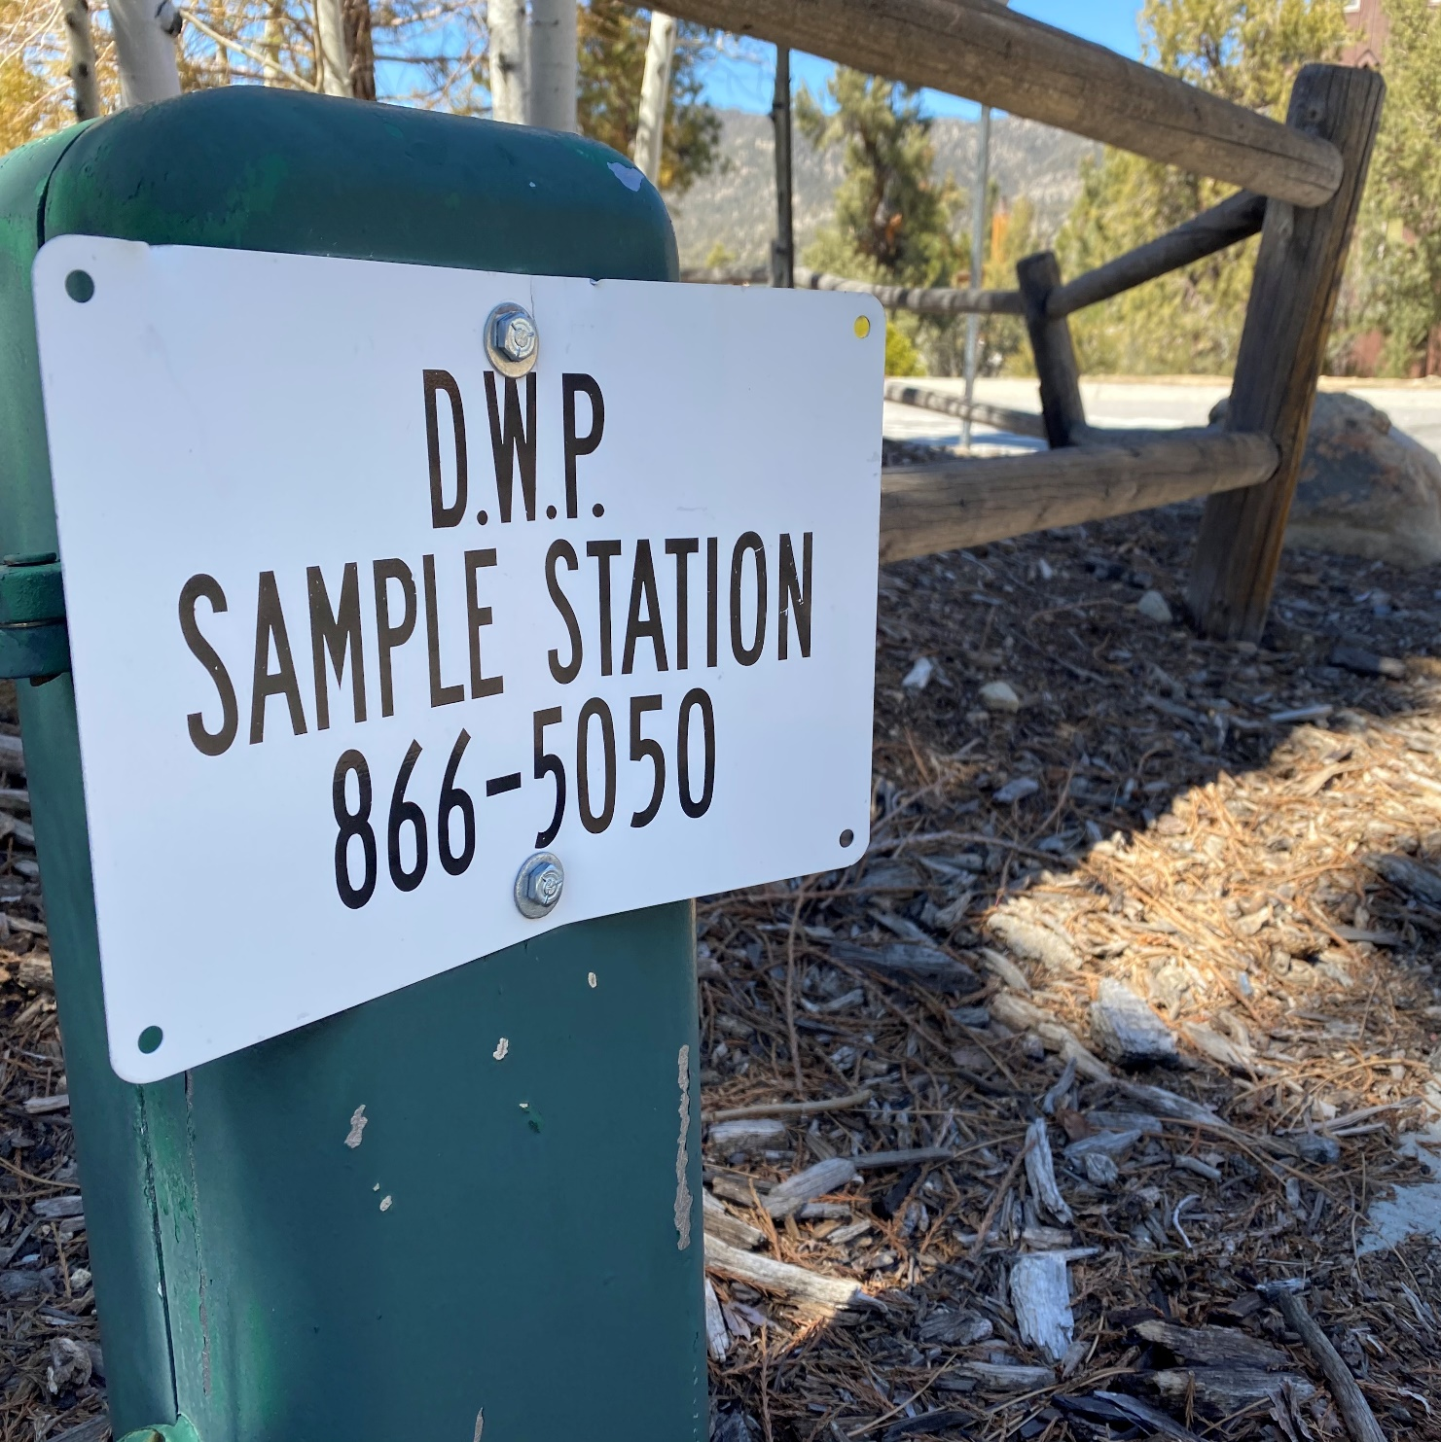
A source water assessment was conducted of the domestic water wells for the City of Big Bear Lake Department of Water Lake William system in December 2001. A copy of the complete assessment may be viewed at the Water Department's office at 41972 Garstin Drive in Big Bear Lake or at the SWRCB San Bernardino District office, 464 West 4th Street, Suite 437, San Bernardino, CA 92401. You may also request a summary of the assessment be sent to you by contacting Ben Berge, Production Supervisor, City of Big Bear Lake Department of Water, P.O. Box 1929, Big Bear Lake, CA 92315, or call (909) 866-5050.

