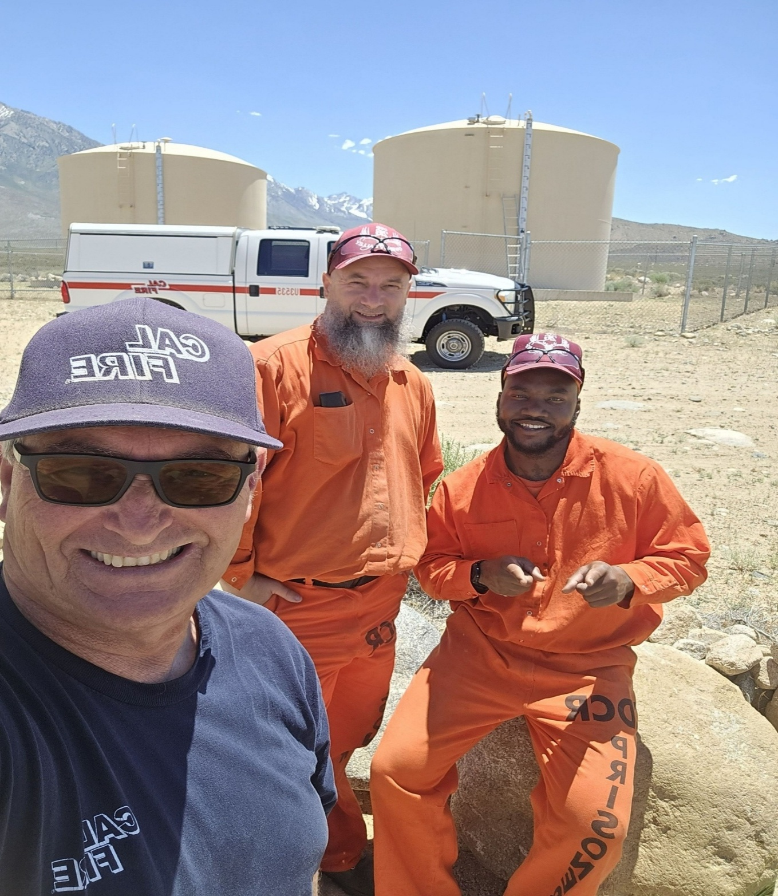
Attached is the Owens Valley Conservation Camp Consumer Confidence Report for 2025. If you have any questions please feel free to contact me, Joe Tabush at (760) 702-1602. As a reminder we are under drought conditions and all restrictions still apply. Irrigation is by far our largest use of water! We go from our low month total usage of 258,200 gallons to 2,599,000 gallons at our peak last year. This will be my last Consumer Confidence Report for this facility. Thank you for the opportunity to provide quality drinking water to the facility for the past 25 years.

2025 Consumer Confidence Report

Water System Information
Water System Name: Owens Valley Conservation Camp
Report Date: 06/24/20266/24/2026
Type of Water Source(s) in Use: Groundwater
Name and General Location of Source(s): Well # 1 (WID# 1410800-001)
Well # 2 (WID# 1410800-002)
Drinking Water Source Assessment Information:
Source ID Most Vulnerable Activities (PCA)
001 Well 001 Septic systems (low density), Sewer collection system, liquid waste ponds
002 Well 002 Septic systems (low density), Sewer collection system, liquid waste ponds
Time and Place of Regularly Scheduled Board Meetings for Public Participation: N/A
For More Information, Contact: Joe Tabush- Chief Operator, Phone: 760-702-1602

About This Report
We test the drinking water quality for many constituents as required by state and federal regulations. This report shows the results of our monitoring for the period of January 1 to December 31, 2025, and may include earlier monitoring data.

Importance of This Report Statement in Five Non-English Languages (Spanish, Mandarin, Tagalog, Vietnamese, and Hmong)
Language in Spanish: Este informe contiene información muy importante sobre su agua para beber. Favor de comunicarse Owens Valley Conservation Camp a 2781 South Round Valley Road Bishop, CA 93514 Ph.: 760-702-1602 para asistirlo en español.
Language in Mandarin: 这份报告含有关于您的饮用水的重要讯息。请用以下地址和电话联系 [Enter Water System Name]以获得中文的帮助: Owens Valley Conservation Camp 2781 South Round Valley Road Bishop, CA 93514 Ph.: 760-702-1602.
Language in Tagalog: Ang pag-uulat na ito ay naglalaman ng mahalagang impormasyon tungkol sa inyong inuming tubig. Mangyaring makipag-ugnayan sa Owens Valley Conservation Camp o tumawag sa 2781 South Round Valley Road Bishop, CA 93514 Ph.: 760-702-1602 para matulungan sa wikang Tagalog.
Language in Vietnamese: Báo cáo này chứa thông tin quan trọng về nước uống của bạn. Xin vui lòng liên hệ Owens Valley Conservation Camp tại 2781 South Round Valley Road Bishop, CA 93514 Ph.: 760-702-1602 để được hỗ trợ giúp bằng tiếng Việt.
Language in Hmong: Tsab ntawv no muaj cov ntsiab lus tseem ceeb txog koj cov dej haus. Thov hu rau Owens Valley Conservation Camp ntawm 2781 South Round Valley Road Bishop, CA 93514 Ph.: 760-702-1602 rau kev pab hauv lus Askiv.

Terms Used in This Report
Term | Definition
Level 1 Assessment | A Level 1 assessment is a study of the water system to identify potential problems and determine (if possible) why total coliform bacteria have been found in our water system.
Level 2 Assessment | A Level 2 assessment is a very detailed study of the water system to identify potential problems and determine (if possible) why an E. coli MCL violation has occurred and/or why total coliform bacteria have been found in our water system on multiple occasions.
Maximum Contaminant Level (MCL) | The highest level of a contaminant that is allowed in drinking water. Primary MCLs are set as close to the PHGs (or MCLGs) as is economically and technologically feasible. Secondary MCLs are set to protect the odor, taste, and appearance of drinking water.
Maximum Contaminant Level Goal (MCLG) | The level of a contaminant in drinking water below which there is no known or expected risk to health. MCLGs are set by the U.S. Environmental Protection Agency (U.S. EPA).
Maximum Residual Disinfectant Level (MRDL) | The highest level of a disinfectant allowed in drinking water. There is convincing evidence that addition of a disinfectant is necessary for control of microbial contaminants.
Maximum Residual Disinfectant Level Goal (MRDLG) | The level of a drinking water disinfectant below which there is no known or expected risk to health. MRDLGs do not reflect the benefits of the use of disinfectants to control microbial contaminants.
Primary Drinking Water Standards (PDWS) | MCLs and MRDLs for contaminants that affect health along with their monitoring and reporting requirements, and water treatment requirements.
Public Health Goal  (PHG) | The level of a contaminant in drinking water below which there is no known or expected risk to health. PHGs are set by the California Environmental Protection Agency.
Regulatory Action Level  (AL) | The concentration of a contaminant which, if exceeded, triggers treatment or other requirements that a water system must follow.
Secondary Drinking Water Standards (SDWS) | MCLs for contaminants that affect taste, odor, or appearance of the drinking water. Contaminants with SDWSs do not affect the health at the MCL levels.
Treatment Technique  (TT) | A required process intended to reduce the level of a contaminant in drinking water.
Variances and Exemptions | Permissions from the State Water Resources Control Board (State Board) to exceed an MCL or not comply with a treatment technique under certain conditions.
ND | Not detectable at testing limit.
ppm | parts per million or milligrams per liter (mg/L)
ppb | parts per billion or micrograms per liter (µg/L)
ppt | parts per trillion or nanograms per liter (ng/L)
ppq | parts per quadrillion or picogram per liter (pg/L)
pCi/L | picocuries per liter (a measure of radiation)

Sources of Drinking Water and Contaminants that May Be Present in Source Water
The sources of drinking water (both tap water and bottled water) include rivers, lakes, streams, ponds, reservoirs, springs, and wells. As water travels over the surface of the land or through the ground, it dissolves naturally-occurring minerals and, in some cases, radioactive material, and can pick up substances resulting from the presence of animals or from human activity.
Contaminants that may be present in source water include:
- Microbial contaminants, such as viruses and bacteria, that may come from sewage treatment plants, septic systems, agricultural livestock operations, and wildlife.
- Inorganic contaminants, such as salts and metals, that can be naturally-occurring or result from urban stormwater runoff, industrial or domestic wastewater discharges, oil and gas production, mining, or farming.
- Pesticides and herbicides, that may come from a variety of sources such as agriculture, urban stormwater runoff, and residential uses.
- Organic chemical contaminants, including synthetic and volatile organic chemicals, that are byproducts of industrial processes and petroleum production, and can also come from gas stations, urban stormwater runoff, agricultural application, and septic systems.
- Radioactive contaminants, that can be naturally-occurring or be the result of oil and gas production and mining activities.

Regulation of Drinking Water and Bottled Water Quality
In order to ensure that tap water is safe to drink, the U.S. EPA and the State Board prescribe regulations that limit the amount of certain contaminants in water provided by public water systems. The U.S. Food and Drug Administration regulations and California law also establish limits for contaminants in bottled water that provide the same protection for public health.

About Your Drinking Water Quality

Drinking Water Contaminants Detected
Tables 1, 2, 3, 4, 5, 6, and 8 list all of the drinking water contaminants that were detected during the most recent sampling for the constituent. The presence of these contaminants in the water does not necessarily indicate that the water poses a health risk. The State Board allows us to monitor for certain contaminants less than once per year because the concentrations of these contaminants do not change frequently. Some of the data, though representative of the water quality, are more than one year old. Any violation of an AL, MCL, MRDL, or TT is asterisked. Additional information regarding the violation is provided later in this report.
Table 1. Sampling Results Showing the Detection of Coliform Bacteria
Complete if bacteria are detected.
Microbiological Contaminants | Highest No. of Detections | No. of Months in Violation | MCL | MCLG | Typical Source of Bacteria
E. coli | 0 | 0 | 1 | 0 | Human and animal fecal waste

(a) Routine and repeat samples are total coliform-positive and either is E. coli-positive or system fails to take repeat samples following E. coli-positive routine sample or system fails to analyze total coliform-positive repeat sample for E. coli.
Table 2. Sampling Results Showing the Detection of Lead and Copper
Complete if lead or copper is detected in the last sample set.
Lead and Copper | Sample Date | No. of Samples Collected | 90th Percentile Level Detected | No. Sites Exceeding AL | Range of Results | AL | PHG | Typical Source of  Contaminant
Lead (ppb) | 9-13-23 | 7 | 0 | 0 | 0 | 15 | 0.2 | Corrosion of household plumbing systems; Erosion of natural deposits
Copper (ppm) | 9-13-23 | 7 | 0 | 0 | 0 | 1.3 | 0.3 | Internal corrosion of household plumbing systems; erosion of natural deposits; leaching from wood preservatives
Table 3. Sampling Results for Sodium and Hardness
Chemical or Constituent (and reporting units) | Sample Date | Level Detected | Range of Detections | MCL | PHG (MCLG) | Typical Source of Contaminant
Sodium (ppm) | 5-25-23  12-29-25 | 7.6 | 6.8-8.4 | None | None | Salt present in the water and is generally naturally occurring
Hardness (ppm) | 5-25-23  12-29-25 | 45 | 44-46 | None | None | Sum of polyvalent cations present in the water, generally magnesium and calcium, and are usually naturally occurring
Table 4. Detection of Contaminants with a Primary Drinking Water Standard
Chemical or Constituent  (and  reporting units) | Sample Date | Level Detected | Range of Detections | MCL [MRDL] | PHG (MCLG) [MRDLG] | Typical Source of Contaminant
Nitrates (mg/L) | 2-26-25 | < 0.23 | < 0.23 | 10 | 0.4 | Runoff/Leaching From Natural Deposits: Seawater Influences
Fluoride (mg/L) | 5-25-23  12-29-25 | 0.155 | 0.14 - 0.17 | 2 | 0.1 | Erosion of Natural Deposits, Water Additive which Promotes Strong Teeth, Discharge form Fertilizer and Aluminum Factories
Table 5. Detection of Contaminants with a Secondary Drinking Water Standard
Chemical or Constituent (and reporting units) | Sample Date | Level Detected | Range of Detections | SMCL | PHG (MCLG) | Typical Source  of  Contaminant
Sulfate (mg/L) | 5-25-23  12-29-25 | 6.4 | 6.1-6.7 | 500 | N/A | Runoff/Leaching From Natural Deposits: Seawater Influences
Chloride (mg/L) | 5-25-23  12-29-25 | 1.05 | <1.0- 1.1 | 500 | N/A | Runoff/Leaching From Natural Deposits: Seawater Influences

Conductivity (umhos) | 5-25-23 12-29-25 | 120 | 120.0-120.0 | 1600 | N/A | Runoff/Leaching From Natural Deposits: Seawater Influences
TDS (mg/L) | 5-25-23 12-29-25 | 99.0 | 99.0-99.0 | 1000 | N/A | Runoff/Leaching From Natural Deposits: Seawater Influences
Turbidity (NTU) | 5-25-23 12-29-25 | 0.175 | <0.1-0.34 | 5 | N/A | Runoff/Leaching From Natural Deposits: Seawater Influences
Table 6. Detection of Unregulated Contaminants
Chemical or Constituent (and reporting units) | Sample Date | Level Detected | Range of Detections | Notification Level | Health Effects
None

Additional General Information on Drinking Water
Drinking water, including bottled water, may reasonably be expected to contain at least small amounts of some contaminants. The presence of contaminants does not necessarily indicate that the water poses a health risk. More information about contaminants and potential health effects can be obtained by calling the U.S. EPA’s Safe Drinking Water Hotline (1-800-426-4791).
Some people may be more vulnerable to contaminants in drinking water than the general population. Immuno-compromised persons such as persons with cancer undergoing chemotherapy, persons who have undergone organ transplants, people with HIV/AIDS or other immune system disorders, some elderly, and infants can be particularly at risk from infections. These people should seek advice about drinking water from their health care providers. U.S. EPA/Centers for Disease Control (CDC) guidelines on appropriate means to lessen the risk of infection by Cryptosporidium and other microbial contaminants are available from the Safe Drinking Water Hotline (1-800-426-4791).
Lead-Specific Language: Lead can cause serious health problems, especially for pregnant women and young children. Lead in drinking water is primarily from materials and components associated with service lines and home plumbing. Owens Valley Conservation Camp is responsible for providing high quality drinking water and removing lead pipes, but cannot control the variety of materials used in plumbing components in your home. You share the responsibility for protecting yourself and your family from the lead in your home plumbing. You can take responsibility by identifying and removing lead materials within your home plumbing and taking steps to reduce your family's risk. Before drinking tap water, flush your pipes for several minutes by running your tap, taking a shower, doing laundry or a load of dishes. You can also use a filter certified by an American National Standards Institute accredited certifier to reduce lead in drinking water. If you are concerned about lead in your water and wish to have your water tested, contact Owens Valley Conservation Camp, Joe Tabush (760) 702-1602. Information on lead in drinking water, testing methods, and steps you can take to minimize exposure is available at http://www.epa.gov/safewater/lead.

State Revised Total Coliform Rule (RTCR): This Consumer Confidence Report (CCR) reflects changes in drinking water regulatory requirements during 2016. All water systems are required to comply with the state Total Coliform Rule. Effective April 1, 2016, all water systems are also required to comply with the federal Revised Total Coliform Rule. The new federal rule maintains the purpose to protect public health by ensuring the integrity of the drinking water distribution system and monitoring for the presence of microbials (i.e., total coliform and E. coli bacteria). The U.S. EPA anticipates greater public health protection as the new rule requires water systems that are vulnerable to microbial contamination to identify and fix problems. Water systems that exceed a specified frequency of total coliform occurrences are required to conduct an assessment to determine if any sanitary defects exist. If found, these must be corrected by the water system.

